THE BESB BUZZ….

A Newsletter for Families of Children who are Blind or Visually Impaired

Volume 25 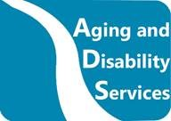 Winter 2020

Published by the State of Connecticut

Department of Aging and Disability Services
Bureau of Education and Services for the Blind (BESB)

Feature Articles:
Welcome New TVIs, Skills for Life, Braille Games, Retirements, Disability Mentoring Day, Blind Americans Equality Day, Leap into Life Events, APH Connect Center, CVI Tips for Remote Learners, Preschool Music

In an effort to provide you with faster delivery of our newsletter and program flyers, save paper, and contain printing costs, we are now posting an expanded electronic version on our website:
https://portal.ct.gov/AgingandDisability
(Newsletter is also available in Spanish on our website)
If you provide us with your e-mail address, we will send a copy of the newsletter by e-mail. Please give your preferred e-mail address to your child’s Teacher of Students with Visual Impairments.

We’re going Digital!
This is the last print copy of our newsletter that will be sent in the mail, but don’t worry! Our newsletter is always available on our website.

If you need a print copy, please let your Teacher of Students with Visual Impairments know and it will be provided. Thank you!

Feel free to contact the newsletter’s co-editors with any suggestions at
lisa.pruner@ct.gov or adrienne.brown@ct.gov
We welcome your comments and ideas for future newsletter topics.

Welcome New TVIs!

We were thrilled to welcome three new Teachers of the Students with Visual Impairments (Education Consultants) this year. Welcome to Champagne Marsh-Williams, Jessica Gibson, and Jacqueline Dettore! Here is a bit about each of our newest BESBees!

My name is Champagne Marsh-Williams and I am one of the newest Education Consultant “bees” to join the “BES-BEE beehive”! I am a New York City native and Danbury, Connecticut transplant. I attended Fordham University for my undergraduate degree in Political Science and Business Administration and Hunter College for my master’s in education with a focus on Blind and Visually Impaired. I began my teaching career in 2012 as a paraprofessional and assistant teacher, working with a high school English teacher who is legally blind and who inspired me to be a TVI. I became Greenwich Public School’s district itinerant TVI for the 2019-2020 school year. I was ecstatic when a position opened at BESB. I knew applying for the job was the correct decision to make because it would give me the opportunity to truly collaborate, be a part of a team, and to hone my craft as a TVI. I am thrilled to be the newest “bee” and hopefully soon we will all be “buzzing” around visiting students in person!
**************************************
Hi! My name is Jessica Gibson and I am thrilled to be joining the team at BESB as an Education Consultant. I started my career as a classroom TVI in Houston, TX, then moved to Baton Rouge, LA where I worked as a district itinerant. I spent a year teaching in Philadelphia at the Overbrook School for the Blind. Most recently I was an itinerant TVI in Waterbury before making the decision to stay home with our two young boys. I love hiking with my husband and sons, running, and all baked goods. Staying home with my boys was a gift, but I have truly missed teaching! I am so happy to be returning to the field after six years away.
**************************************

My name is Jackie Dettore and I’m the newest Education Consultant at BESB. After receiving my undergraduate degree in Special Education and Elementary Education, I had a hard time deciding on what to get my master’s degree in. That is when I met an Education Consultant from BESB who introduced me to the VI world. As I learned braille, I fell in love with the code. When I began student teaching, I worked with another Education Consultant from BESB who showed me the ropes and some amazing assistive technology. My favorite piece of technology is the BrailleNote Touch Plus. If you are curious what brought me to BESB, it was working with these two Education Consultants, who are so passionate and genuine about their love for this career and their students. Outside of BESB, I enjoy gardening, sewing, canning and spending time with my family. Over quarantine, my husband and I completed a kitchen remodel. I have surprisingly found enjoyment in completing our home renovation projects.

June of 2020 marked the retirement of three longtime BESB TVIs, Jill Baker, Andrea Garewski and Peg Palmer. Jill served school-aged students at BESB for 30 years and was instrumental in the development of the Braille training classes for paraprofessionals. Andrea spent the last 15 years working with students with complex needs, taking a particular interest in supporting families. Peg worked with preschool students in Connecticut for over 31 years, developing and sharing her considerable expertise in the area of CVI with families and teams.

We wish these teachers and friends a wonderful retirement!

Skills for Life
The Skills for Life summer program went virtual this year. A total of eight students between the ages of 10-15 years old participated. The group met every Tuesday from 7/21/20-8/11/20 for a total of four sessions. Staff included two certified orientation and mobility specialists, two teachers of students with visual impairments (TVI) and a technology specialist. The program provided lessons in Orientation and Mobility, Daily Living Skills, Recreation, and Assistive Technology. Parents participated in the program to assist with set-up and to observe sessions. At the end of the program, each parent received a packet with a lesson summary and resources as reference.
Lesson modules included:

- Independence in the kitchen: cleaning, cutting and pouring skills
- Grocery shopping skills: creating a shopping list based on store layout and reviewing various sections of the grocery store
- Organizing the personal environment through audio and tactile strategies
- Identifying and organizing money
- Review of basic map features, exploring tactile and large print maps
- Room familiarization
- Navigating the neighborhood: understanding address systems, using landmarks and clues
- Using accessibility features in Microsoft Teams
- Recreation/leisure skills: exploring accessible games
We want to thank our students and parents for making this year's Skills for Life a success despite the challenges of going virtual!

Braille Games!

In the past few years, several of the most popular games for children have been popping up with braille or other tactile adaptations. These games not only entertain our students with visual impairments, they also teach concepts like literacy, problem solving, and directionality. Students with visual impairments can play these games right alongside their sighted peers, furthering social skills for students with and without disabilities.

LEGO blocks are an all-time favorite toy for young learners. They are now available with braille letters formed by the studs of the blocks. Lego braille bricks have the print equivalent of each letter on the blocks as well so that students with vision can form words with their friends who are visually impaired. For more information, please visit the following website:
https://www.legobraillebricks.com/

Bananagrams is a great way to make forming words fun! This version of the game has the braille letters configured over the print version so players of all visually abilities can play together. For more information, please visit the following website:
https://www.maxiaids.com/bananagrams-word-game-with-braille-tiles

This Rubik’s cube has tactile patterns which correspond to each color! For more information, please visit the following website:
https://www.amazon.com/Winning-Moves-Games-Rubiks-Tactile/dp/B07FDMRRBC

When an educator or a team can think outside of the box, any game can be adapted for students with visual impairments. It’s just a matter of thinking about how to make the game accessible using the student’s tactile, auditory, or olfactory/gustatory senses. This article, by BESB Education Consultant Beth Borysewicz, describes some creative ways to adapt Twister!
https://www.pathstoliteracy.org/strategies/braille-twister

Go have some fun and learn at the same time!

Disability Mentoring Day!

On Wednesday, October 21, 2020, BESB hosted a teleconference to celebrate Disability Mentoring Day. The focus of the teleconference was to hear from three exciting BESB Mentors to learn about their pathways to career success and how participants might apply these mentors’ strategies to their own career development. Disability Mentoring Day is a national celebration of people with disabilities sharing strategies and success stories about careers. The three mentors were exceptionally motivational and full of excitement as they shared their pathways to success, as well some missteps which taught them along the way.

The presenters were:

- Dawn Russell, an Intake Facilitator with MARCinc., an agency serving the needs of people with disabilities.
- John Carnemolla, a Data Analyst with Cigna, which is a large insurance company.
- Lucretia Jones, a Housing Program Assistant with Neighborhood Housing Services of New Britain.
Fifteen BESB students and young adults signed up to participate and all learned a lot. Please watch for more opportunities like this to come.

The best and most beautiful things in the world cannot be seen or even touched – they must be felt with the heart.

- Helen Keller
Blind Americans Equality Day!
During the month of October, students were encouraged to submit works of art to the Advisory Board for Persons who are Blind or Visually Impaired in celebration of Blind Americans Equality Day. Below is one beautiful submission and a description written by the artist.

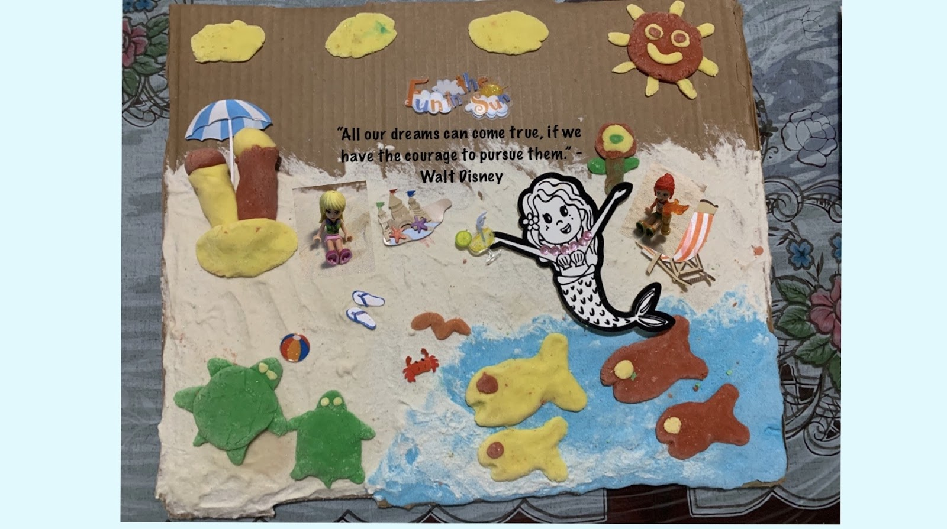

This is a photo of my artwork. I’ll tell you about this art project.
The project is about a beach scene with the sand made of a special kind of material that my teacher assistant likes to make. She sent me some for my project. The special material is kind of like clay but more like play-doh. It was used for the sand and the clouds. I used my mom’s homemade clay to do the rest of the art project. Using the materials and some stickers and a mermaid cutout with a magnet at the back, I was able to put together this tactile project. It has the quote, “All our dreams can come true, if we have the courage to pursue them” by Walt Disney. There is a mermaid sitting on the beach surrounded by some fish in the water and turtles on the sand. It is a sunny day at the beach. Now, the reason I chose this project for Blind Americans Equality Day is because I want to let everyone know that anyone can pursue their dreams if they believe in themselves. By believing in yourself and your dreams you can show the world who you really are! Thanks for reading!

Sophia Lee
Grade 7

Leap into Life Events

Leap into Life, BESB’s transition program, is offering a monthly mentor workshop for high school students transitioning to college.

January 20th Ally Cates will share her experiences with her furry friend, Jefferson in her presentation, “A Tail of Independence.”

February 18th Gannon Olson is working on his Master’s in Education at Spring College. He will present on how to “Advocate for Thyself: How to Be Successful in College.”

In November, Brielle Cayer, a junior at Fordham University joined us to talk about securing internships in college, travelling independently in a big city using public transportation and her social experience with hiding her visual impairment. Thank you, Brielle, for sharing your amazing experiences.

All sessions will begin at 4pm through the Windows platform Teams. If interested in registering email patricia.leonard@ct.gov.

Have you Heard About APH Connect Center?

APH Connect Center is a suite of sites and services for people with visual impairments and their families. They include: Family Connect - a place parents and professionals can get support and advice on raising or teaching a child with a visual impairment, as well as Vision Aware for adults and Career Connect for job seekers! Check out all the new offerings at the link below:

https://www.aph.org/aph-connectcenter-revamped-and-making-a-difference/

Remote Learning Tips for Students with CVI

A remote learning model can make access more challenging than usual for students with CVI. Here are some tips for each Phase of CVI to help your child stay more engaged in the remote learning process.

Phase 1: What’s happening? Your child is learning to use vision. Your child relies on simple attributes and movement of real objects to engage the vision.
- Limit auditory distractions by turning off the television and making sure that siblings’ school calls/videos are not able to be heard. If you use a shared learning space, consider headphones or earbuds for others.
- Reduce visual clutter and complexity. Always consider the background of any visual target and make it as simple as possible. Put your head where you would like your child’s head to be. Stay there for a quiet minute. Is there too much other information competing for your child’s attention?
- Try to find space with minimal background movement. Avoid things such as people, pets, or even leaves. Just as movement of visual targets may help attract visual attention, movement of non-targets can distract the child’s attention.
Phase 2: What’s happening now? Your child is beginning to integrate vision with function. In this phase, your child is moving towards using vision to make things happen!
- If your child has just started to reach for and grasp objects, consider wrapping mylar of your child’s preferred color around the object which they intend to hold. For example, wrap your child’s toothbrush or spoon handle in red mylar. This will make it easier for the child to fixate on the target while using visually guided reach to grasp it.
- Is your child becoming more comfortable with integrating auditory and visual stimuli? This YouTube channel has books which are read aloud and nicely adapted for children in Phase 2. https://www.youtube.com/channel/UC-wZA4w-_Lz4_N_71vCzXLA/videos
Phase 3: What’s happening now? Your child is using vision as the most reliable way to gain information about the world. However, your child’s ability to access materials and use vision efficiently without fatigue and stress is dependent on the visual complexity of the educational materials and the environment.
- Partner with your child in creating a workspace that fits his or her visual/sensory needs. Many children in Phase 3 CVI prefer to work in a quiet environment that is free from visual clutter and unintended sources of movement (such as people walking around).
- Often, when assessing the visual demands on a child in Phase III, it is important to ask the question, “Should my child do it?” rather than, “Can my child do it?” Often children in Phase III can push through a visual task and seem okay at the time only to become fatigued and less available for learning later on.
- Teams may need feedback from home to ensure visual accessibility of virtual work. It is important that the work is visually adapted so that it is comfortable for the child, rather than something they need to struggle through. These adaptations may mean one math problem per page instead of 10, a colored-in map of the world rather than a black and white one, extra spacing between lines of text, or real color photographs instead of black and white line drawings. In general, color-coding, spacing and masking can be very powerful adaptation tools for students in Phase 3.
- Visual breaks! Many children in Phase 3 find it critical to take visual breaks when they are engaging in complex visual activities. These breaks can be scheduled both proactively between complex visual activities, throughout visually complex activities, as well as reactively when it seems the child needs a break. It can also be very effective to involve your child in deciding when to take a visual break and what to do on their break. Some children enjoy having a menu of pictures, words, or objects that represent activities they can choose during their visual breaks.
- For virtual learning, it may be helpful to minimize clutter on the screen by pinning the teacher’s video when appropriate, so your child doesn’t have to try to visually block out all the other information on the screen. It may be helpful to have the lights dimmed in the environment where your child is viewing so that the brightness of the computer screen stands out and there is no glare. Some children with CVI may have difficulty looking down at a screen for long periods of time and may do better if the display is elevated to eye level.
(CVI Phases based on the work of Christine Roman-Lantzy.
Roman-Lantzy, Christine. (2018). Cortical Visual Impairment: An
Approach to Assessment and Intervention. 2nd Ed. Louisville, KY; American Foundation for the Blind.)

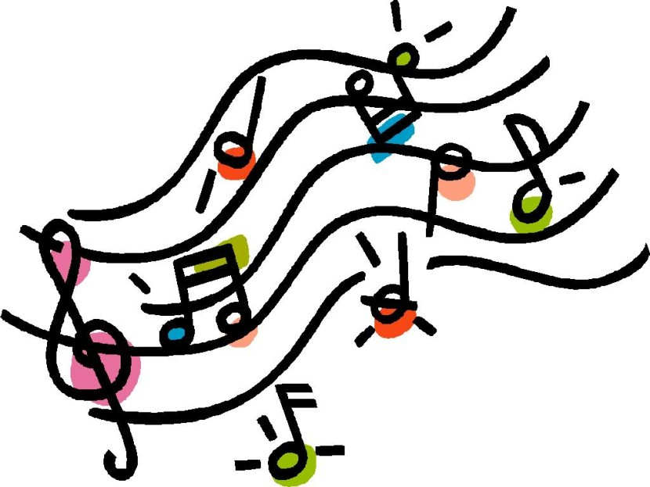

Music Therapy Group for Young Learners

During July and August, twenty-three preschool learners and their families participated in virtual music therapy groups lead by Emily Belavaqua of Connecticut Music Therapy. Emily focused participants on the Expanded Core Curriculum Skill area of Orientation and Mobility, targeting body parts and concepts of the body in space.

The summer programs were so well-received that music therapy sessions with Emily have been added on a monthly basis. A new class is offered on the first Wednesday of each month, focusing on early childhood ECC skills including Orientation and Mobility, Social Interaction Skills and Compensatory Skills.

Please contact your TVI for additional information.

