BESB PreEts Buzzzzzzz

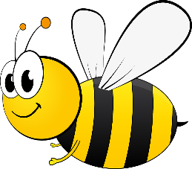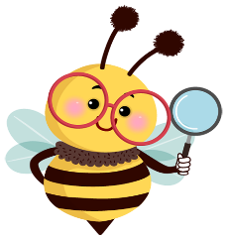

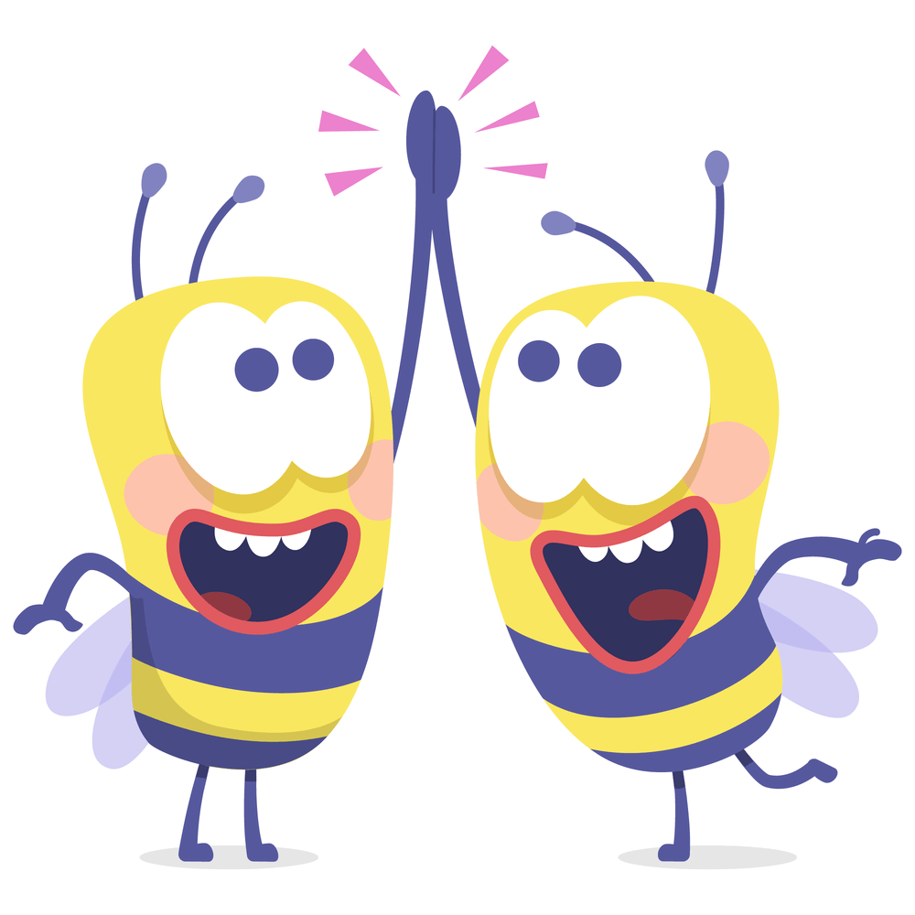
July 2024 Quarterly Edition

To all BESB students, families, educators, and staff!
This past quarter our students have been involved with so many great activities and opportunities. Our big event from early summer this year was our weeklong summer astronomy program at UConn in Storrs, which you can read about in our student article section at the end of this newsletter. The BESB Buzzz comes out quarterly and is filled with past and upcoming events going on in Pre-Ets. You will find articles from students, comments from parents, resources for families, creative writing, and a few puzzles and games. This newsletter is intended to be a coordinated project to share ideas, thoughts, and news, from everyone who is part of Pre-Ets.
What is Pre-Ets?
Pre-Ets stands for Pre-Employment Transition Services- This program provides 5 core services to students ages 16 through 22. These core services include 1- Job Exploration 2- Work Based Learning Experiences 3- Counseling on Post-Secondary College Planning 4- Workplace Readiness Training including social and independent living skills 5- Instruction on Self Advocacy and Peer Mentoring. These core services are provided to the students through our Vocational Rehabilitation Program in a variety of ways. Please contact me if you or your student are interested in getting involved in this fun and informative program.
Meet the staff:
Charlotte Copenhaver- Educational Projects Coordinator
Coordinates work based experiences in local communities and special group and individual projects and programs for students throughout the state
Charlotte.copenhaver@ct.gov or cell (860)692-4251
Paula Rivers Vocational Rehabilitation Counselor
Paula.Rivers2@ct.gov
Covers individualized caseload and transition planning for Pre-Ets students in the Southern half of the state.
Stacey Ann Lewis is no longer with BESB. For those who had been working with Stacey in the Northern half of the state, please contact Jonathan Richmond, our Vocational Rehabilitation Counselor Coordinator, to discuss services for your student. Jonathan can be reached at Jonathan.Richmond@ct.gov or cell phone (860)748-7484
Some of our partners and services:
Our Pre-Ets program collaborates with several different organizations to provide services for our eligible students. Some of these organizations are listed below. If you are interested in hearing more about these organizations, please contact the Vocational Rehabilitation Counselor assigned to you or your student to discuss the most suitable service.
LEAP Resource Vermont- LEAP provides blind and visually impaired youth, virtual and in-person programming opportunities to gain the skills needed to become independent, confident, and productive with the outcome of increased employability. Many of our students have participated in the LEAP programs paid virtual work-based learning experiences throughout the year as well as their residential work-based learning program over the summer. They also have weekend retreats in the fall, winter, and spring.
The Carroll Center for the Blind- Serves individuals of all ages who are legally blind or visually impaired. Many of our students have attended Carroll Centers youth programs in Newton MA. These are residential program for students and adults who are blind and visually impaired to learn skills and strategies for work and independent living.
Visions Services for the Blind- Services students who are legally blind or visually impaired in Spring Valley New York. They have summer transition residential program for students who are 14-18; Pre-Ets Employment program with a focus more on career planning for students who are 18- 21; and their pre-college program for blind and visually impaired students who are planning to attend college.
Youth Leadership Forum – Every summer the Youth Leadership forum is held at UConn in Storrs. This is a residential program for students with disabilities who show leadership potential. In this program, students participate with other students with various disabilities, from around Connecticut, towards group work for projects which serve the greater good in the community. This program is open to students who are recommended by a Teacher or Vocational Rehabilitation Counselor.
Skys the limit- This program has provided our students with wonderful programming for our students. This program provides engaging, fun group activities, both virtually and in person, that fulfil our 5 core services. In this upcoming year, we expect to do 2 virtual programs with STL and 1 in person programs.
Work based learning experiences with employers in your community- Many of our students have also opted to work in paid work experiences in their own towns and communities. We utilize Community Rehabilitation Providers to work with our students who want to work in their own communities. These providers assist students with all aspects of finding positions and supporting students on the job with the goal of providing supported real-world work/learn experiences.
Upcoming Pre-Ets activities and events to watch for
STEM programs at UConn- We recently completed a STEM program at UConn that was a great success. We have already started to plan a new STEM program in the field of Robotics for next summer at UConn. Keep your eyes out for details on that once we get closer.
Spring College Prep workshop- Each Spring we do a workshop for BESB students who are considering attending college after high school. In this workshop we present BESB program policies and supports that we provide to students who are going to college. We invite speakers from disabilities offices from various colleges in CT, and we have students come in and speak on their experiences with navigating college campus, paperwork, roommates, and a variety of topics that are of interest to our up-and-coming college students. This spring we plan to provide 2 workshops in person. One in the Northern region and one in the Southern region. I will be putting out a notice with details early in the spring term.
Mentorship opportunities /program- Over the course of this past school year, our mentor program has taken off. We have BESB college students and adults who have completed BESB programs and are successfully employed, who have applied and been accepted to our mentorship program. If you are interested in having a BESB mentor or being a mentor please contact Charlotte Copenhaver, Educational Projects Coordinator.
Beginning in the fall school term we will be taking applications for all the programs mentioned above. These programs will be offered only through your Vocational Rehabilitation Counselors. Please contact your Vocational Rehabilitation Counselor for further information to discuss the options and eligibility. Please do not contact the programs directly.
Resources for families and students
This year, BESB will be participating in the annual Back to School Meeting which will be held on September 6, 2024, at the Connecticut Convention Center between the hours of 8:30 AM and 1:15 PM. Look for our table with the BESB agency name on it for BESB resources. There is no admission cost to attend this event and is opened to students, families, and educators.
Hadley school for the Blind has free resources for individuals who are interested in help and support for blind and visually impaired individuals. They have workshops, audio podcasts, and live chat discussion groups. They can help you with daily living, adjusting to vision loss, recreational activities, technology, braille, and work. Go to Hadley Vision Resources | 100 Years of Empowering Adults with Vision Loss (hadleyhelps.org) to learn more about them.
CPAC- Connecticut Parent Advocacy Center The mission of the Connecticut Parent Advocacy Center is to educate, support, and empower Connecticut's diverse families of children and youth with any disability or chronic conditions, ages birth to 26, and the professionals who serve them. Please go to Connecticut Parent Advocacy Center - CPAC (cpacinc.org) to learn more about them
SERC (State Education Resource Center) - SERC is a quasi-public agency established under statute to serve the CT State Board of Education in supporting educational equity and excellence. This is done by providing professional development and information dissemination in the latest research and best practices to educators, service providers, and families throughout the state, as well as job-embedded technical assistance and training within schools, programs, and districts. Please go to: Home - State Education Resource Center (ctserc.org)
Student Section
BESB STEM UConn program- article Written by Molly Butcher

I loved the STEM Astronomy program at UCONN. I learned so much, like that some galaxies can’t be seen from Earth. Not to mention, the dining hall food was delicious! The program was well put together and fun. Evening activities varied, adding a fun element to each day. For example, we took a self-defense class, learning different nose strikes. We also used a laser engraver and made soap! Mine was cinnamon scented. We also built and operated our own 3D printer, working in teams of three or four. At the end of the week, we had a lovely little commencement ceremony, where we each got a certificate in both print and Braille. Everyone said a little something, and it was very heartwarming. This was an amazing experience.

My experiences at a program called the STEM Career Exploration Lab at UConn
By Aiden Gaucher

My name is Aidan Gaucher, and in this article I am going to describe some of the experiences I had at an astronomy camp or program called the STEM Career Exploration Lab, which was at UConn and sponsored by BESB. Attending a week-long camp at the University of Connecticut was an exciting opportunity for me because learning about anything astronomy is an interest of mine.
I learned a lot more than astronomy, though. I didn’t know if I was going to be able to handle the life of living in a dorm and being independent. Throughout that week, I participated in a ton of group activities, including a tour of the campus and astronomy related tasks. The dorm that I lived in is called Goodyear Hall, which is located in the Northwest Quad. This was the first time I ever had a roommate. I had breakfast and dinner at the dining hall in the quad and is very close to the dorm. The variety of different foods and how they tasted were great. The daily activities took place in the Student Union, including lunch. Even though UConn is big, it is still a manageable campus. The crosswalks, stairs, and elevators make it accessible. One of the tasks I helped complete at the Student Union was building 3-D printers in groups. I was in a self-defense class at the Biology and Physics building. One of the stops during the campus tour I took part in was the Babbidge Library, which is huge, has a lot of books, and contains quiet places for studying.
On a different day, I went to the Fine Arts Complex to do arts and crafts. I even took a bus to Hartford to go to the Connecticut Science Center that same day. On one of the last days, I was at the planetarium that UConn has. The presenter was a scientist named Noreen Grice. The group of students I was in was the first group to go inside and view the newly renovated planetarium. With them, I looked at a number of constellations. Ursa Major was one of the featured constellations pointed out and talked about. Andromeda was another of these constellations. The Andromeda Galaxy was pointed out next after the constellation Andromeda, which is in that constellation. A third constellation was Cygnus, which is supposed to be a swan. Deneb was one of the stars in Cygnus that was pointed out. The Cosmic Microwave Background was also talked about and shown. It is a map of some of the earliest light, which is coming from the Big Bang.
Another task completed was constructing a 3-D model of the constellation Orion. This helped visually impaired individuals develop their understanding of constellations better. We used 3-D printed creations to represent the constellation parts and for the parts of the model itself. The stars of Orion were represented by spherical objects. These 3-D printed spherical objects were placed on cube-like cylinders, which were inserted into a base at different distances from the front. The Orion Nebula was also constructed for this particular model. It was irregularly shaped with jagged edges. The Orion Nebula model was also 3-D printed and used in the same way as the spherical objects. The distances were scaled to light-years from Earth.
Overall, the week passed quickly. The activities, tasks, and lessons were fun and interesting. I also learned new knowledge and skills, including socialization skills. I met and talked to people I haven’t met before. I liked every activity including the ice cream social, self-defense class, and talent show. I was able to use my self-advocating skills for my auditory needs since I have hearing loss and wear hearing aids, and my visual needs since I am visually impaired and wear glasses. If this program will be in Connecticut next summer, I would definitely go again.

I am always looking for students to write articles-jokes- funny stories or whatever you would like, for our quarterly newsletter- please submit any articles for the newsletter to:
Charlotte.Copenhaver@ct.gov
Or call or text (860)692-4251
Next newsletter published in October

