BESB Pre-ETS Buzzzzzzz



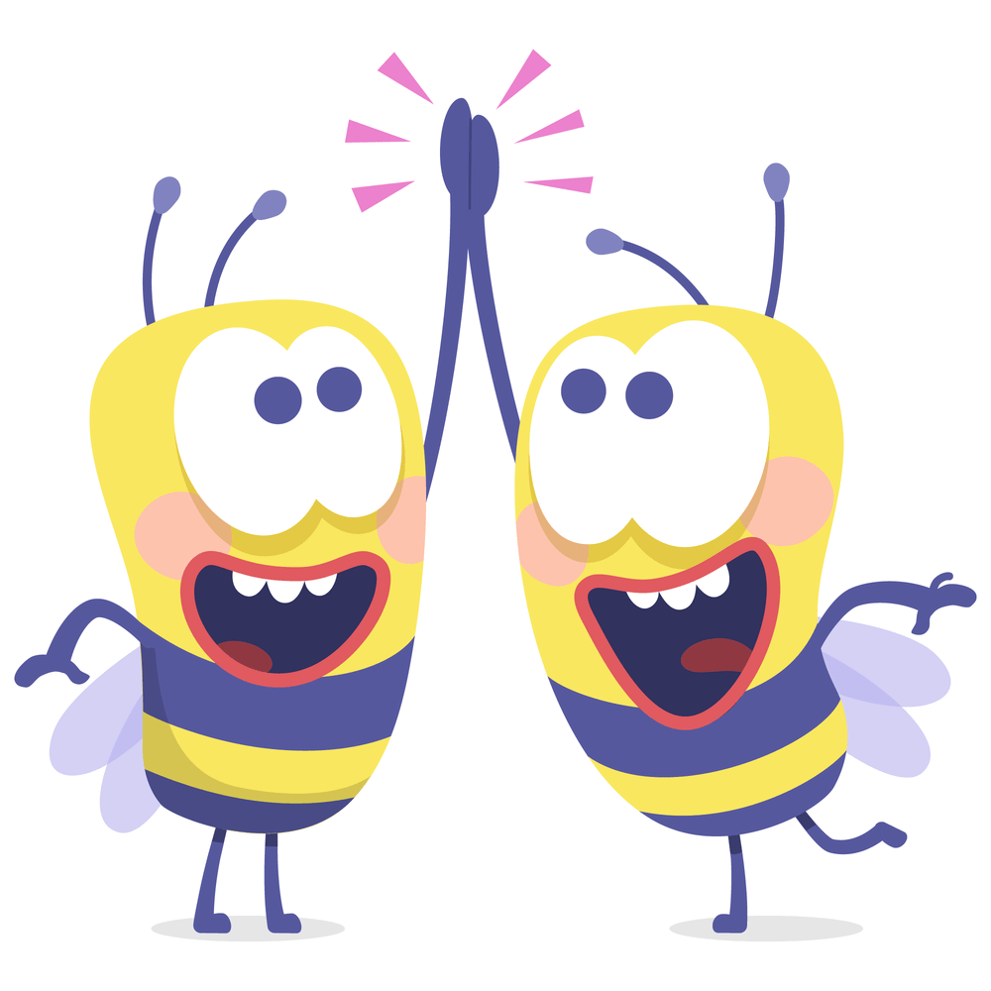
October 2024 Quarterly Edition

To all BESB Students, Families, Educators, and Staff!
Happy Fall to everyone!!! And happy start to the new school year!!! The BESB Buzz comes out quarterly and is filled with past and upcoming events going on in Pre-ETS. You will find articles from students, comments from parents, resources for families, creative writing, and a few puzzles and games. This newsletter is intended to be a coordinated project to share ideas, thoughts, and news from everyone who is part of Pre-ETS.
What is Pre-ETS?
Pre-ETS stands for Pre-Employment Transition Services. This program provides 5 core services to students ages 16 through 22. These core services include:
- Job Exploration
- Work Based Learning Experiences
- Counseling on Post-Secondary College Planning
- Workplace Readiness Training including social and independent living skills
- Instruction on Self Advocacy and Peer Mentoring.
These core services are provided to the students in a variety of ways. Please contact me if you or your student are interested in getting involved in this fun and educational program.

What is happening:
This quarter we have seen many students actively involved in so many great activities. We have had students who have finished up their community-based work experiences over the summer and have started new ones for the fall term. We have students who are working in retail stores such as CVS and DSW. We have a student working in the janitorial department at his school, and a student at a restaurant in New Haven. We have had many students who have signed up for the fall virtual work-based learning experience through LEAP, and getting ready to start their job this month working and earning while they learn.
Youth Advisory Board: This year we have had a big interest in participating in the Youth Advisory board through CPAC (Connecticut Parent Child Advocacy). (More information about CPAC in the Resources section of this newsletter). Working with CPAC our students are practicing speaking on a panel to talk about how students can play a more active role in their own education plans. We currently have 5 students who are signed up as Youth Advisory Board members and they are practicing for a panel discussion which will be held in November. One of our student board members, Lily Watkins, recited her poem for an audience of about 500 school professionals and sat on a panel of student YAB members at the Annual Back to School Conference held at the Connecticut Convention Center in September. You can read her poem that she read in the student articles of this newsletter.
Mentor program- This month our mentors have started in a partnership with LEAP Vermont, a mentor training program. They will be participating in a 2 month long virtual workshop run by LEAP. After they complete the workshop, they will do some practical work and bring their skills back to Connecticut to work with our students.
Resource fair- A resource fair for BESB clients was held on September 12th in Bridgeport at the neighborhood studios. We had organizations from as far away as New York, Massachusetts, and Vermont as well as in state agencies and organizations. Please keep your eye out for our next Resource fair in the spring.
Skys the Limit-For our fall term virtual workshop through Skys the Limit, we are doing a 5-session career exploration workshop. Students who are registered have completed the O*Net interest survey and will be doing informational interviews with professionals who are in the fields that they are interested in exploring. Hopefully by the end of the workshop, they will have a good impression of the various fields that will be represented at the workshop, and an idea of the direction that they would like to go after graduation.
Upcoming Pre-ETS activities and events to watch for
STEM programs at UConn- This past summer, we completed a weeklong STEM astronomy program at UConn that was a huge success. Students lived on campus, learned about astronomy using 3D printers which they built, and experienced much of college life on the Storrs campus at UConn. We have already started to plan a new STEM program focusing on technology and cyber security for next summer at UConn. Keep your eyes out for details on that once we get closer.
Spring College Prep workshop- Each Spring we do a workshop for BESB students who are considering attending college after high school. In this workshop we present BESB program policies and supports that we provide to students who are going to college. We invite speakers from disabilities offices from various colleges in CT, and we have students come in and speak on their experiences with navigating college campus, paperwork, roommates, and a variety of topics that are of interest to our up-and-coming college students. This spring we are hoping to provide 2 workshops in person. One in the Northern Region has been confirmed and will be at CCSU on April 11, 2025, from 9am-3pm. The Southern Region has not been determined yet. I will be putting out a notice with details early in the spring term.
Mentor Day- In celebration of Disability Awareness Month in October we are having a virtual mentor panel discussion. The mentor day will be virtual and held October 22, 2024, at 5:00pm. In this meeting you will have the opportunity to hear from BESB young adults who have been through Pre-ETS, college, and are either working now or are still in college. You will also have the opportunity to ask them questions about their experiences. Anyone who is interested in attending please let Charlotte Copenhaver know via phone 860-692-4251 or email Charlotte.Copenhaver@ct.gov so you can receive the link to the discussion.
We have been developing a nice group of young mentors who will be working with our students here in Connecticut. If you know of a student who would like a mentor, or a young adult who has been a BESB client who would like to be a mentor, please contact Charlotte Copenhaver, EPC.
Towards the end of the fall/winter school term we will be taking applications for spring programs through LEAP, Carroll Center, Skys the Limit, community-based employment, and other programs. Please be sure you are communicating with your counselor to discuss options that are suited to your students’ needs and interests.
Resources for families and students
Hadley school for the Blind- Has loads of free resources for individuals who are interested in help and support for blind and visually impaired individuals. They have workshops, audio podcasts, and live chat discussion groups. They can help you with daily living, adjusting to vision loss, recreational activities, technology, braille, and work. Go to Hadley Vision Resources | 100 Years of Empowering Adults with Vision Loss (hadleyhelps.org) to learn more about them.
CPAC- Connecticut Parent Advocacy Center- The mission of the Connecticut Parent Advocacy Center is to educate, support, and empower Connecticut's diverse families of children and youth with any disability or chronic conditions, ages birth to 26, and the professionals who serve them. Please go to Connecticut Parent Advocacy Center - CPAC (cpacinc.org) to learn more about them.
SERC (State Education Resource Center) - SERC is a quasi-public agency established under statute to serve the CT State Board of Education in supporting educational equity and excellence. This is done by providing professional development and information dissemination in the latest research and best practices to educators, service providers, and families throughout the state, as well as job-embedded technical assistance and training within schools, programs, and districts. Please go to: Home - State Education Resource Center (ctserc.org)
Student Section
For each newsletter, I ask certain students to write an article about an experience that they have had with a Pre-ETS program over the past quarter. Please let me know if you are interested in writing for our newsletter. I am always taking ideas, articles, games, news.
Belonging
Poem by Lily Watkins

It’s that warm space in the middle of a room,
where the air feels easier to breathe,
and the noise of your thoughts finds harmony
with every voice around you.

It’s knowing when you speak,
someone will listen,
not just out of kindness
but because they understand
how the words twist and turn
in ways only you can shape.

It’s the soft landing
after endless free falls,
a hand waiting in the dark
that doesn’t ask for anything
but to hold you still.

It’s feeling at home
in places you’ve never been,
like your name has always been whispered
through the walls and floors
long before you arrived.

It’s not always loud,
not always bright.
Sometimes it’s just the quiet comfort
of existing in a space
where you don’t have to explain
who you are
or why you’re here.

My BESB Pre-ETS experiences
By Mia Giantonio
I have had many BESB Pre-ETS experiences. Those experiences have helped me develop a lot of different skills. I have gained so much from these experiences. I plan to continue to do the same things while I am in college.
I began participating in LEAP programs in the fall of 2023. I started by participating in LEAP’s fall virtual Work-Based Learning program, where I worked with groups to create a campaign based on Assistive Technology. Since then, I have participated in the following LEAP programs: the Winter retreat in Killington, Vermont, where I skied for the first time, Spring Work-Based learning program, where I worked with groups to create a Café Communications campaign for the Innovation Café, Spring coding retreat in Williston, Vermont through Cyber.org where I built my website based on chocolate rankings, and the Summer Work Immersion Program’s My Voice My Future workshops. My favorite things about LEAP are working with others who are Blind/Visually impaired, helping my team members create the Assistive Technology and Innovation Café campaign, and attending all the retreats to learn new skills. From the LEAP programs, I have gained marketing skills, interview skills, the ability to ski with a guide, and the ability to build a website.
I began participating in the Sky’s the Limit groups in the fall of 2023. I started by attending Sky’s the Limit’s college prep group, where I learned about some attributes of a successful student, why notes matter, the ABCs of Blindness, self-advocacy, storytelling, and time management skills. Since then, I have attended Sky’s the Limit’s peer mentor weekend, where I developed skills in self-advocacy, networking, cooking, managing stress, and dealing with difficult situations in college. We also talked about the power of a story, the importance of voting, the importance of campus life and involvement with organizations, using AI during job search, and disability disclosure. My favorite things from both events are learning the power of a story, networking with everyone and meeting new people, cooking using a George Foreman Grill, creating a self-advocacy sandwich (how to best advocate for yourself), and hearing from Matt V, who is an Apple instructor and taught us how to keep track of time using reminders. I have gained strategies for making an excellent first impression, an understanding of the importance of voting, an understanding of the importance of campus life and involvement in organizations, networking skills, disability disclosure skills, the importance of notetaking, self-advocacy skills, and time management skills.
From June 23 to June 28th of this year, I attended the UCONN Astronomy camp for BESB Students. We learned about how the stars developed and their distance from the sun, the moon's phases/how they were modeled, and how the moon orbits the sun. We also looked at the benefits of 3D Models. My favorite things from the Astronomy camp were building 3D printers, making UCONN key chains, and team-building challenges like creating a tower out of balloons and noodles. I also went to the Science Center to see some of the different exhibits. I have gained the importance of team building, understanding of 3D printers, and knowledge of astronomy.
Most recently, I have been a part of the Youth Advisory Board since June 5th, 2024. Since then, I attended three meetings. So far, we have discussed meeting expectations, ideas around transition planning, and storytelling. From those three meetings, I have gained self-advocacy skills.
I am very grateful to be able to attend these wonderful learning experiences that are offered by some great organizations with incredible staff. I couldn’t be happier to have met new people and seen how much I have grown. I plan on continuing to attend these programs and investing in learning more new skills!

Summer at World of Work- BY: Kyle William Skora Thomas

Perkins School for the Blind is a wonderful school where all children and young adults can go and learn different skills. They have a summer program for young adults called the World of Work. Adults can live there for five weeks during the summer while they learn new work skills and techniques.

Last year in 2023, I attended the World of Work for my first time EVER! I spent my wonderful summer working at a job called Perkins Solutions. My job tasks were preparing items for the Perkins Braillers, shipping Braillers, and going to the bomb shelter to bring other items up to the Perkins Solutions building. I was proud because I loved learning new skills.

This summer I worked at two jobs. For a couple weeks, I was working at the Perkins Food Service Department, and every day I was making a lot of foods including egg salad, macaroni salad, and pizza as well. For desserts, I made chocolate chip cookies, brownies, and even cannoli. I also had fun delivering food to the different dorms this summer at Perkins.

My second job was off campus, working at Perkins Facilities. I would walk to work every day, and then check in with my main boss and the person that I was working with. Since it was summer, I moved a lot of furniture out of the campus dorms, and I also did lots of cleaning. I loved the people that I was working with because they were very nice.

When I wasn’t working, I did O&M Cane training on campus and out in the community to go grocery shopping. I just want to add one last thing before I forget. We also went out to eat and we ordered a lot online. This helped us learn how to stay within our budget, and how much money we should be spending.

On Friday, we all got our paychecks and went to the bank to cash the checks in, to get the real money. Then we used it for fun activities like sailing on the bay, going to the waterpark in New Hampshire, and seeing the special light show at the Franklin Park Zoo.

My summer was wonderful because I learned a lot and I made a lot of good friends, who were very kind, but also nice. I hung out with them every day either before work or after work. Then lastly, at the end of the program I got their phone numbers so that we can stay in touch. I cannot wait to go back to the World of Work at Perkins!

THE END

I am always looking for students to write articles-jokes- funny stories or whatever you would like, for our quarterly newsletter- please submit any articles for the newsletter to Charlotte Copenhaver, EPC

Notifications of events and activities happening with Pre-ETS
Please keep your eye out for any activities or events that are being planned in our Pre-ETS program. Flyers and announcements will be emailed to you from Ashley Morgan at BESB. Please be sure that we have an up to date email address for you in our system so that you will receive notifications. Please keep an eye on your email. Notifications are also sent to your Teacher for the Visually Impaired (TVI’s) and your Vocational Rehabilitation (VR) Counselor so you can get information from them as well. As always, please do not hesitate to contact Charlotte Copenhaver or Jonathan Richmond for further information.

Charlotte.Copenhaver@ct.gov
Or call or text (860)692-4251
Charlotte Copenhaver- Educational Projects Coordinator
Coordinates work based experiences in local communities and special group and individual projects and programs for students throughout the state.
Charlotte.copenhaver@ct.gov or cell (860)692-4251
Jonathan Richmond- Counselor Coordinator
Works with the counselors who are assigned to working with our Pre-ETS students individually.
Jonathan.Richmond@ct.gov or cell (959) 282-0387

Next newsletter published in January 2025.

