THE BESB BUZZ….

A Newsletter for Families of Children who are Blind or Visually Impaired

Volume 23 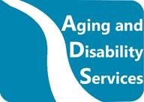 Fall 2019

Published by the State of Connecticut

Department of Aging and Disability Services
Bureau of Education and Services for the Blind (BESB)

Feature Articles:
Speak Up, Everwonder Museum, Fire Safety, Dinosaur State Park, Skills for Life, BESB Teacher Trainings, Student Spotlight, Braille Challenge, CVI for the TVI Webinar Series, Rainy Day Activities

In an effort to provide you with faster delivery of our newsletter and program flyers, save paper, and contain printing costs, we are now posting an expanded electronic version on our website:
https://portal.ct.gov/AgingandDisability
(Newsletter is also available in Spanish on our website)
If you provide us with your e-mail address, we will send a copy of the newsletter directly to you by e-mail. Please give your preferred e-mail address to your child’s Teacher of Students with Visual Impairments.

Feel free to contact the newsletter’s co-editors with any suggestions at
lisa.pruner@ct.gov or adrienne.brown@ct.gov
We welcome your comments and ideas for future newsletter topics.

Look What We’ve Been Doing!

This Photo by Unknown Author is licensed under CC BY
Speak Up!


On March 9, 2019, nine BESB high school students were given a gift for their future from Moth Radio international storyteller and Speak Up founder, Matthew Dicks. Matthew presented a four-hour workshop with strategies on preparing a story to present to the public. Students learned to communicate, connect and entertain. He provided students with a comfortable platform to develop a story and present it to their group.
The students were introduced to strategies for developing a story through a process developed by Matthew called “Homework for Life.” This is a simple way to document life’s moments: Before you go to bed, write down a moment of your day that meant something to you with the initial goal of creating one story per month. These documented moments will be memories of your past that otherwise might have been lost.
“Little moments are the best moment.” Matthew Dicks

EverWonder Children’s Museum
On September 14, 2019, five BESB students, ages two through seven, and their families, attended a program at EverWonder Children’s Museum in Newtown. Highlights included a wind machine, petting a live bearded dragon, sound machines, an incline plane and an activity wall. Museum educators then provided a program on sound, allowing students to manipulate a variety of instruments and noise-makers and to make and decorate their own rain stick to take home. Families were then free to stay and further explore the museum!

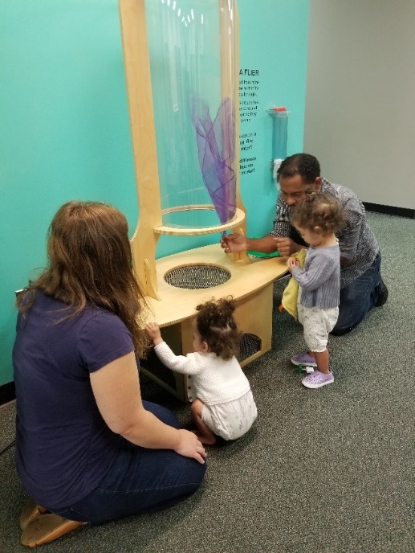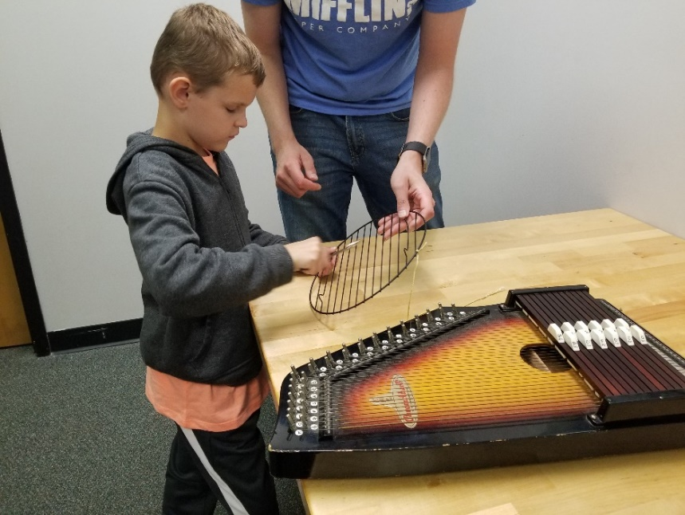

Children enjoying a visit to EverWonder Children’s Museum

Fire Safety Day
On Saturday, April 13, 2019, four families attended a Fire Safety Day at the Connecticut Fire Academy in Windsor Locks.

Children were able to learn from a fire fighter how to stay safe in their home and how to prevent fires from occurring. They learned about what to do if there is a fire in their home and got to explore some fire prevention safety items such as a smoke detector, carbon monoxide detector, and a fire extinguisher.

The students and families were then able to walk through the training area and see real life firefighters training and putting out fires using their hoses. They got to explore a fire truck and touch dials, hoses, and additional apparatus which a firefighter needs to manage in a call. They were able to try on a firefighter’s helmet and jacket as well as his oxygen mask.
Each participant and their siblings got to go home with an adapted coloring book based on their preferred literacy medium (regular print, large print, tactile – braille, and a CVI modified version as well.) They also each got to take home a story bag with a book and manipulatives to explore with their families at home.
It was a wonderful day that all the children and parents fully enjoyed.

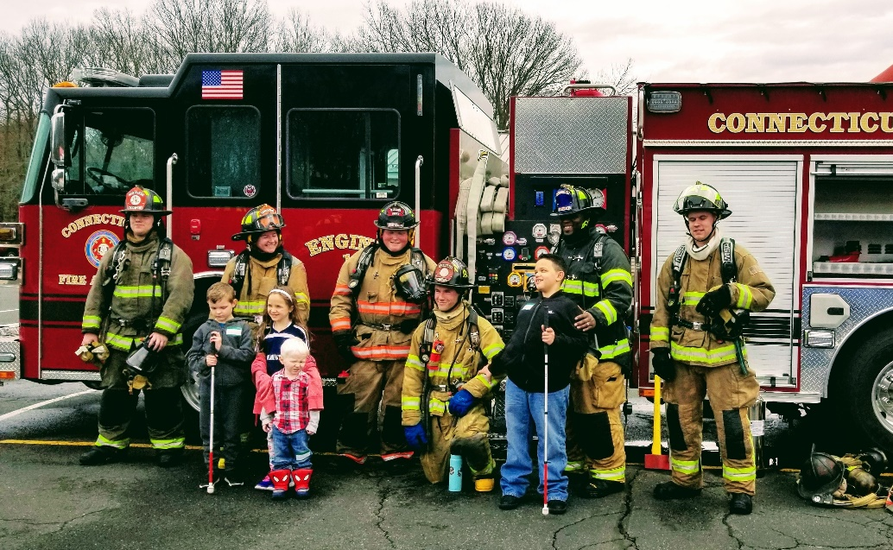

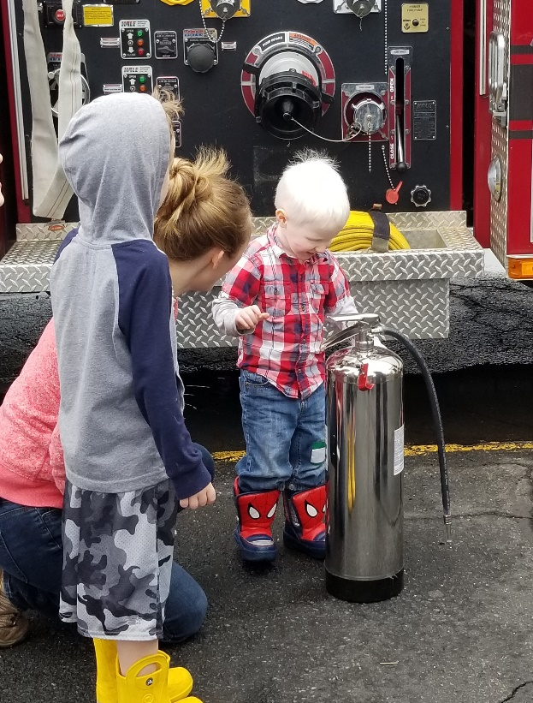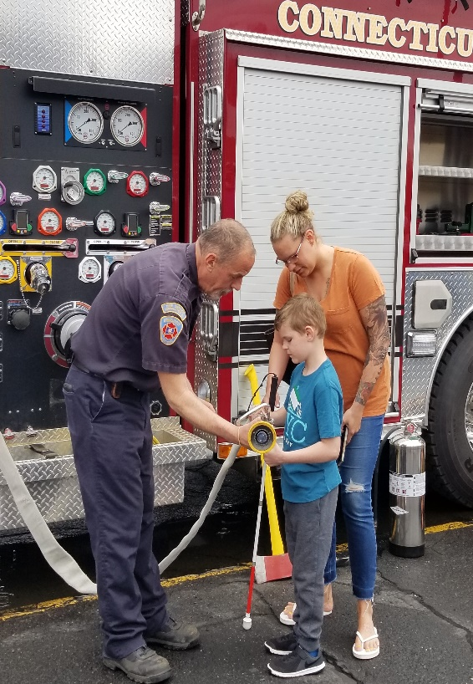

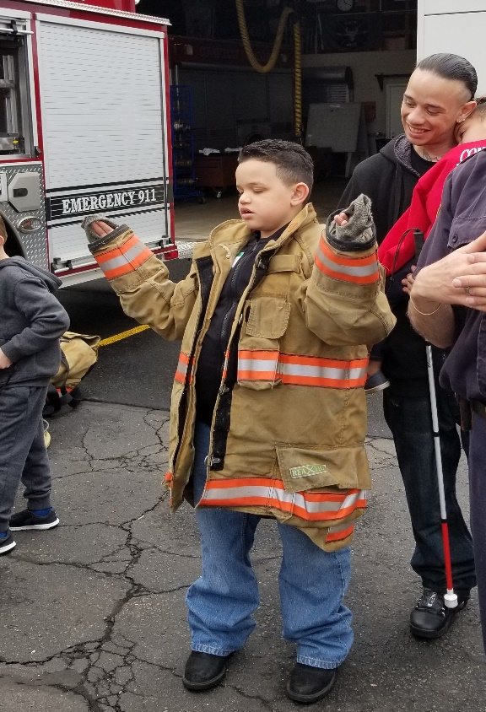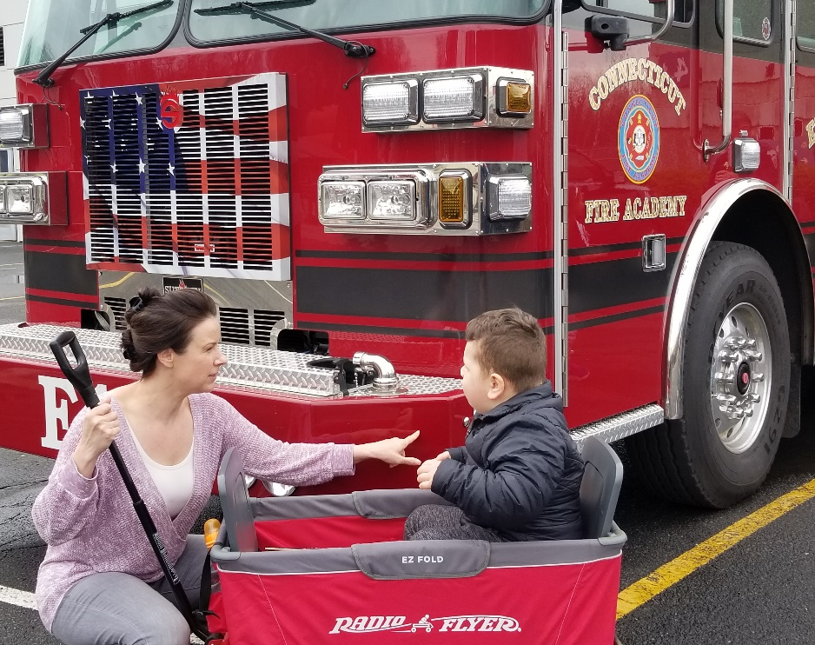

Students exploring the firefighting equipment at Fire Safety Day!

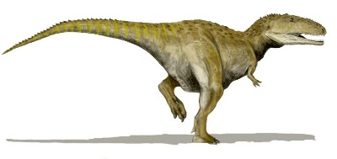 Dinosaur State Park 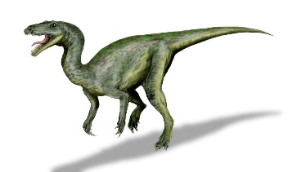
This Photo by Unknown Author is licensed under CC BY-SA
This Photo by Unknown Author is licensed under CC BY-SA

On March 26th, 2019, at Dinosaur State Park in Rocky Hill, six parents and seven children participated in a hands-on program designed just for BESB preschoolers and kindergarteners. Attendees had the unique opportunity to touch dinosaur tracks, hear a dinosaur story told by a puppeteer, and engage in activities in the dinosaur discovery room. Roar!

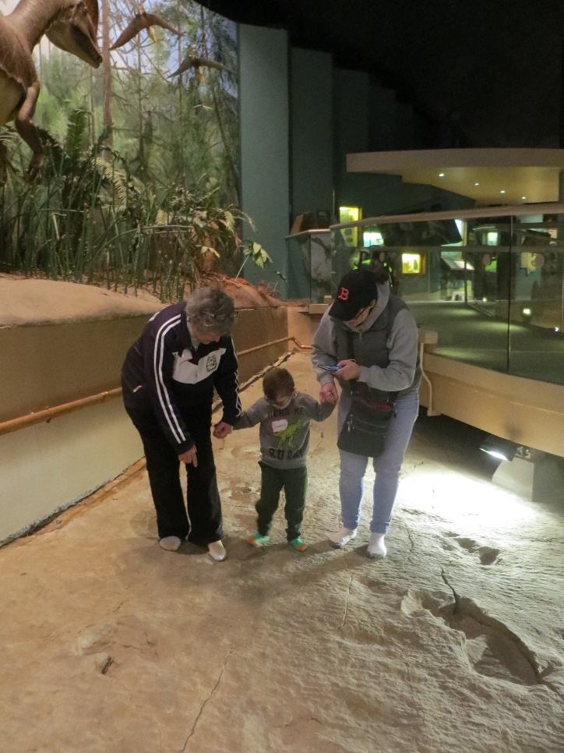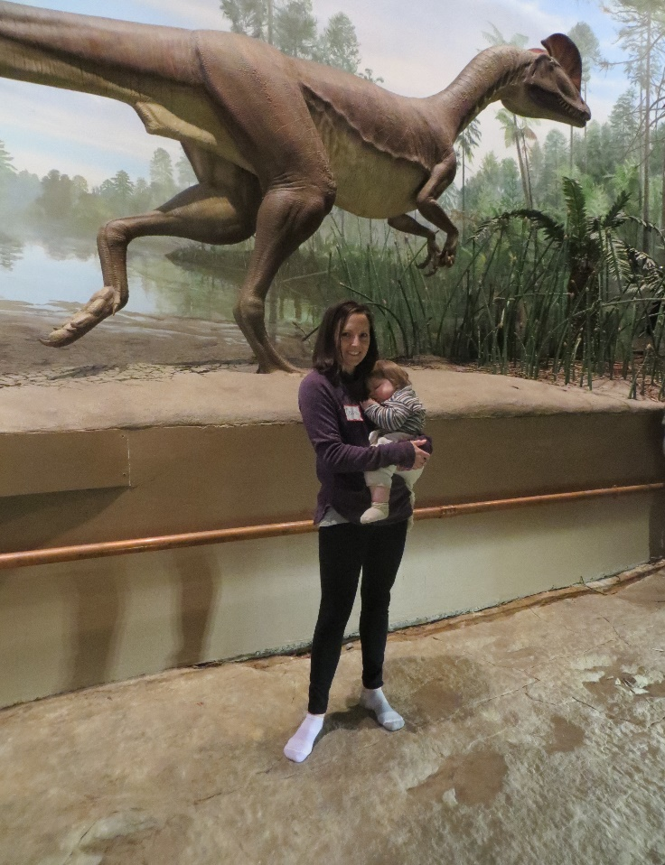
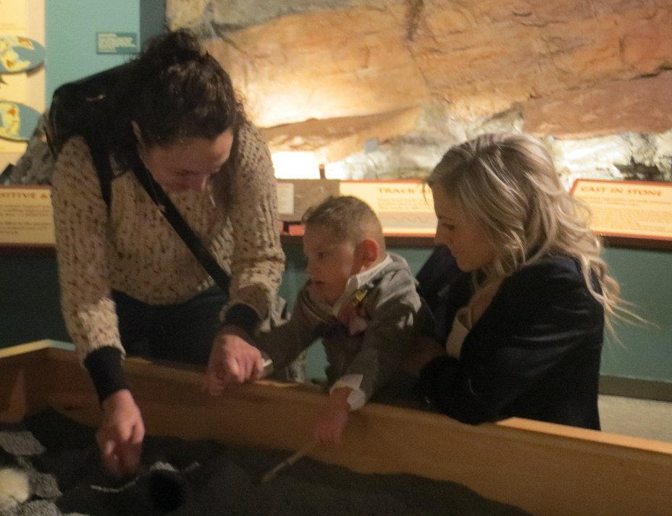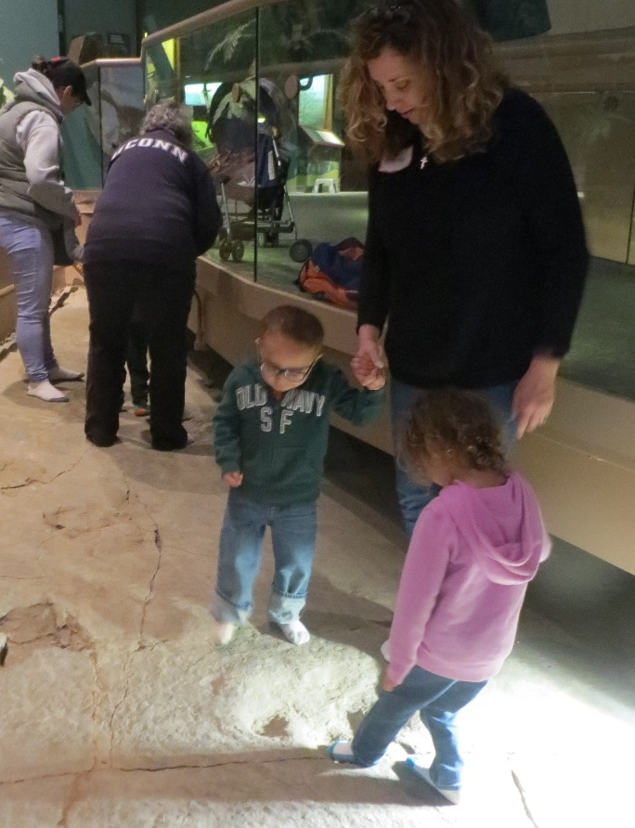

Students explore dinosaur prints at Dinosaur State Park

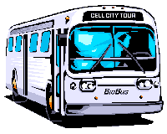
Skills for Life

BESB students from across the state practiced their orientation and mobility skills last summer at BESB’s Skills for Life program in West Haven! A total of thirteen students, ranging in age from ten to sixteen, honed their abilities under the guidance of Certified Orientation and Mobility Specialists, Teachers of Students with Visual Impairments, and BESB’s Children’s Services Access Technologist. While the program focused on orientation and mobility, the staff made sure to include other independent living skills such as dining etiquette, meal preparation, and money organization. From crossing an intersection to planning a picnic on the beach, the students enthusiastically took part in each opportunity to practice their skills!
. . . . . . . . . . . . . . . . . . . . . . . . . . . . . . . . . . . . . . . . . . . . . . . . . . . . . . . . . . . . .

Teacher Trainings at BESB

Each fall, BESB Education Consultants and Orientation and Mobility Specialists hold several workshops to train educators on strategies for working with students with visual impairments. A broad spectrum of topics is addressed such as technology, social interaction, and strategies to increase independence. In order for educators to gain a better understanding of their student’s daily challenges, educators are asked to accomplish classroom activities under simulation of a visual impairment.

A grand total of 230 educators and parents attended the Fall 2019 workshops at BESB!

In addition to the six traditional workshops, BESB piloted a workshop this year for educators and parents of students with Cortical Visual Impairment (CVI).

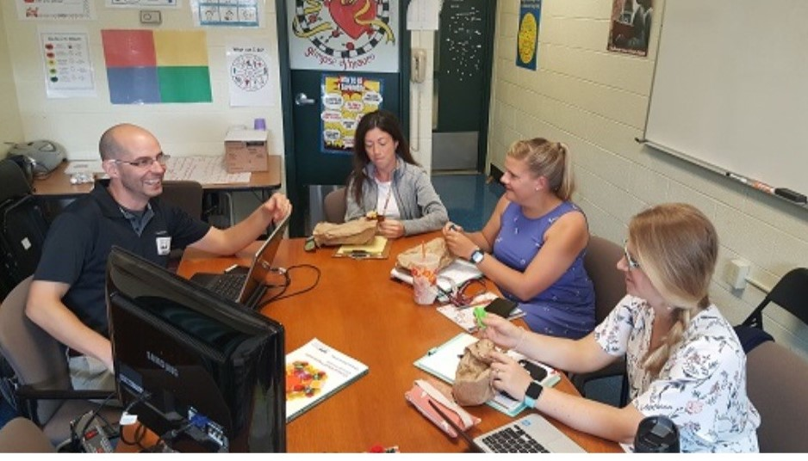

BESB Education Consultant, Matt Tietjen, providing training to a school team


Senior Spotlight
This Photo by Unknown Author is licensed under CC BY-SA-NC

Jenifer Eukers, a BESB transition counselor, shares the accomplishments of one notable high school senior.

As a Transitional Counselor in BESB’s Vocational Rehabilitation Program, working directly with students on their goals for the future is a great experience. I want to highlight one of those students here: Aleese Lawrence! She is a senior at Middletown High School. However, she has been so motivated academically she is taking three courses at Middlesex Community College this year! With these courses and previous AP (Advance Placement) courses she took last year – Aleese will graduate High School with a diploma and a full semester of college under her belt.

Aleese will be making applications to colleges in the near future. She is interested in early childhood education with a vocational goal of teaching. Aleese has been very fond of her Teachers of Students with Visual Impairments (TVIs) – particularly noting Mrs. Patti Leonard as an inspiration to go into the teaching field.

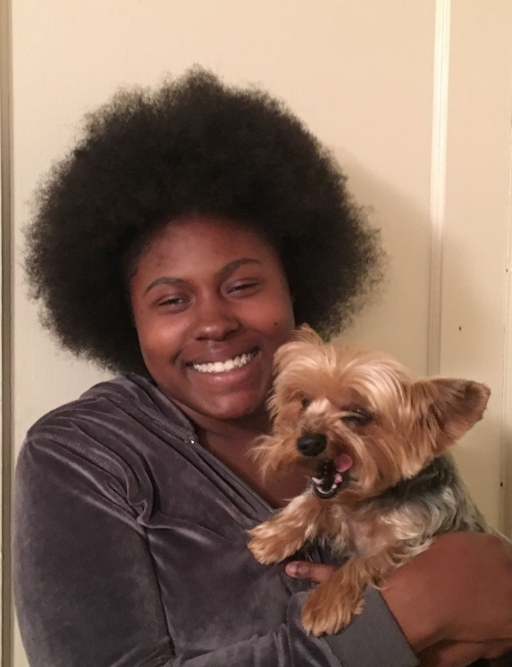
Aleese has participated in extracurricular activities while at Middletown High School. She worked on the yearbook committee as a photographer. Aleese has also taken advantage of Level Up Work Based Learning experiences and spent the summer at the Carroll Center’s Real World of Work.

When she is not studying or working, Aleese enjoys spending time with her friends. This student exemplifies the best traits which a student in Transition can have - she is self-directed, motivated and willing to learn. Congratulations to this Class of 2020 graduate!

Braille Challenge

An Interview by Beth Borsywicz, Education Consultant

Connecticut’s own Darby Lalumiere from Killingly, CT is a ten-year-old who is currently in the fifth grade. Last school year, she competed in the Braille Challenge and was selected to compete at the FINALS in California this past June.

The Braille Challenge is an academic competition for students who are blind or visually impaired. I like to refer to it as “The Braille Olympics”. It is designed to test students in areas of braille literacy and fundamental braille skills. The testing areas for Darby’s age group (third and fourth graders) included reading comprehension, proofreading and spelling.

Students from ALL over the country and Canada are invited to enter, and there are regional testing days hosted in places such as Perkins School for the Blind, Kansas School for the Blind, etc. where students can go and take the test, or a student’s TVI (Teacher of Students with Visual Impairments) can request the test and administer themselves – which is what we did.

Upon completion, Darby’s test results were sent back to California for scoring and grading. After results are calculated, only 50 students (10 in each category) from the United States and Canada are selected to move on to the National Finals… so this means, Darby was 1 of 10 students in the third and fourth (Freshman Class) grade from the entire country and Canada who were able to move on… AND the only student from Connecticut this year!

Her skills were in the top ten! She went to California to compete for #1 on June 21, 2019!

Darby agreed to answer some interview questions regarding her experience with the Braille Challenge this year, and you can see her responses below:

Q: What is the Braille Challenge?
A: The Braille Challenge is a continent-wide challenge that children can participate in. It tests their intelligence with a series of tests which get harder as the child progresses through grade after grade.
Q: What braille skills did the test assess?
A: The challenge assesses reading comprehension, proof reading, and spelling. The tests are quite challenging with spelling using words like conquistador.
Q: How did you do on the regional test?
A: I did better than I expected. I got into the finals and was one of 10 children in my age group. I was the only one from Connecticut. There were twelve thousand children who entered the challenge.
Q: What was the prize for winning the regional competition?
A: The prize is you get to go to California. They do a red-carpet dinner with fancy everything. They also do a tactile version of your face.
Q: What fun things did you get to do in California?
A: I got to go to California and got a lot of cool things. I also got to see the American Printing House.
Q: How did you do at the finals?
A: I did not win or place but I feel like I was in the top five.
Q: Do you think you would like to take the Braille Challenge again this coming year?
A: Yes, I would like to take it again. This year, I WILL WIN.
Q: Do you have any advice for students wanting to do the Braille Challenge?
A: I think any student joining the Braille Challenge should go into it with having studied and having an open mind, and they should know that the test is harder than the practice and they need to be prepared.
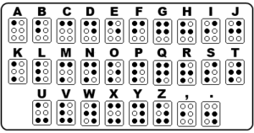

Congratulations Darby!
Learning About CVI:

CVI for the TVI (and other professionals) Webinar series

CVI, the leading cause of visual impairment in the U.S., is a fascinating topic! There is a lot to learn, as researchers and educators learn more and more about this visual impairment nearly every day! It’s so important that neuro strategies be used for a neuro (or brain based) vision loss when working with our students with CVI. But how best to keep up and continue learning?

We created the “CVI for the TVI” Webinar series to give TVI’s, and other concerned professionals a monthly forum to learn about CVI and to make it easy to keep up with some of the latest information. Parents and family members are, of course, welcome to view them as well!
Last year, TVI’s from BESB and Perkins School for the Blind collaborated to create this monthly offering. Each Webinar runs approximately 45-55 minutes. They are free of charge and can be watched from anywhere and at any time.
The Webinar series is also available in live format. You’ll need to sign up to view it live. Email Mary Zatta and let her know you want to register for the CVI for the TVI webinars.
mary.zatta@perkins.org
You’ll also get alerted when one is coming up. We recommend registering whether you watch live or recorded- this way you’ll know when new Webinars are available.
Webinars are then banked at this site for viewing anytime:
http://www.perkinselearning.org/cvi/educators/cvi-tvi

Topics we have addressed thus far and available anytime:
- The CVI Umbrella: A community of ideas
- My Expanding Understanding: The Visual Behaviors of CVI
- Considerations for CVI & Social Inclusion
- Does this Child have CVI?
- Visual Search in CVI: Novel Assessment Using Virtual Reality

Peg Palmer, Education Consultant

This Photo by Unknown Author is licensed under CC BY-NC-ND
Trips for a Rainy Day:
Fun Places for Families to Explore This Fall and Winter

Looking for a family-friendly day trip this season? Check out this list of great places which have hosted BESB trips recently!

- Mystic Aquarium, Mystic – all ages - https://www.mysticaquarium.org/
- EverWonder Children’s Museum, Newtown – preschool/elementary ages http://www.everwondermuseum.org/
- Beardsley Zoo, Bridgeport – all ages https://www.beardsleyzoo.org/
- Mystic Seaport, Mystic – all ages - https://www.mysticseaport.org/
- ImagineNation Children’s Museum, Bristol – preschool/early elementary - https://www.imaginenation.org/
- Rock Climb Fairfield, Fairfield – elementary to adult - https://www.rockclimbfairfield.com/
- The Connecticut Children’s Museum, New Haven – preschool/early elementary - http://childrensbuilding.org/
- Dinosaur State Park, Rocky Hill - preschool/elementary -https://www.dinosaurstatepark.org/
- Ski Sundown, New Hartford – elementary to adult - http://www.skisundown.com/Lessons-Packages/Lessons-Packages/Private-Lessons-Packages/Adaptive-Lessons.

