FAB

Fun, Advocacy, and Brainpower

FAB Topic
Teamwork /Support System


Agenda:


Introductions:


Welcome everyone to your meeting.

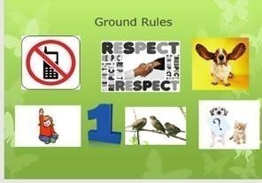
Ground Rules


- Go over your ground rules for your meeting to see if anyone would like to add a new rule or take a rule off.




- Share some of the things you have learned that interest you from the FAB topic links, with your group for the appropriate month

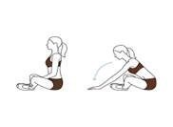
- Have fun learning, sharing and doing some of the exercises you find for the month we are in.


Fun Games

- Enjoy playing one or more of the games for the month.

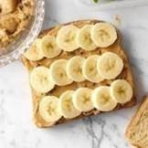
- See if anyone wants to volunteer to make one of the recipes to show at your next month’s meeting




- End with asking if anyone has any questions or comments.



Games

https://youtu.be/JmcmffiXgFY?si=c53dXxFHlUQsoXUC
Support Systems Jeopardy Template
https://www.youtube.com/watch?v=-WUAmtffj58
General Knowledge Trivia Quiz! 🧠 | 100 Questions Everyone Should Know – Do You?


Brainpower – Information and resources to empower SA members to be Self-Advocates

If you are looking to run a Self-Advocacy meeting, you may find the information below extremely useful. The Self-Advocate Coordinators enjoy finding and sharing the following: Links with good information, games, icebreakers, recipes and exercises that that you can learn from and have fun with as well as meet and be with other people virtually.

10 Tips for Effective Teamwork in the Workplace - Alabama Cooperative Extension System

12 Reasons Why Teamwork Is Important in the Workplace | Indeed.com
5 Strategies for Promoting Diversity in the Workplace | Hult International Business School

support system definition - Google Search

Highland Springs Specialty Clinic - The Benefits And Importance Of A Support System

5 Strategies to Self-Advocacy Better Using Emotional Intelligence - WISE Initiative for Stigma Elimination

https://www.ada.gov/topics/effective-communication/

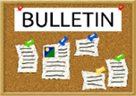
Virtual Board

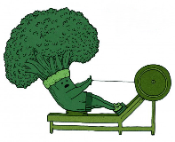
Cooking Ideas and Exercise

Recipes



Ham it up Cresent Rolls Recipe

Ingredients

1 8-oz pkg crescent roll dough
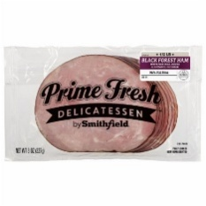8 slices deli ham (precooked)
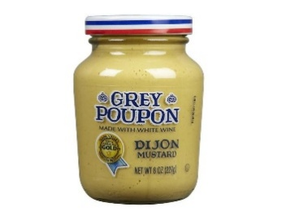4 tsp Dijon mustard
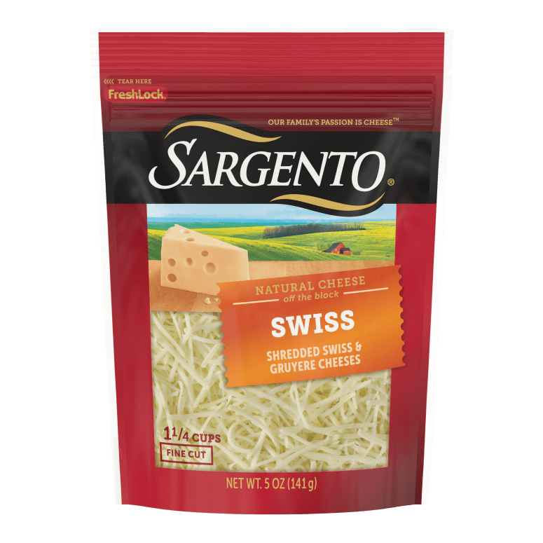1 cup shredded Swiss or cheddar cheese
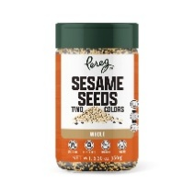2 tbsp sesame seeds (optional)

Ham-It-Up Crescent Rolls | Partnership for Food Safety Education
Yummy Summer Pea Salad 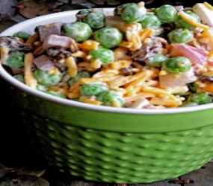
Salad:


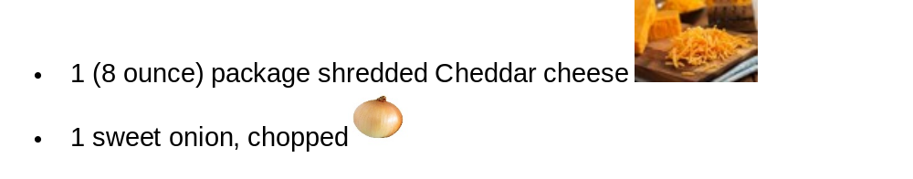

- Toss bacon, peas, raisins, Cheddar cheese, onion, and sunflower seeds together in a bowl until well combined
- Whisk mayonnaise, vinegar, and sugar together in a small bowl until smooth.
- Pour dressing over salad; toss to coat.
- Cover the bowl; refrigerate until chilled, for about 1 hour.

Stop Making Boring Breakfast! 4 Easy Egg Toast Recipes Ready

in 5 Minutes

https://youtu.be/Uy_UiNZSqaE?si=lRYHKwgc-HqBMaMi
Cheesy Garlic Bread – Accessible Chef

Exercises

10 resistance band exercises you can do at home

https://youtu.be/fgKHFLe654U?si=UtVSqSkqpzOMI3_P

Chair exercises for people with mobility impairments - JUMP IN™ for Women’s Heart Health

https://www.youtube.com/watch?v=4zww0h9cHu0&t=111s

7 Minute Standing Abs🔥 Exercises to Lose Belly Fat 🔥

