December 29, 2020

Office of the Secretary of the State
30 Trinity Street
Hartford, CT 06106

RE: 2021 Schedule of the State Water Planning Council Meetings

In accordance with the provisions of Section 1-225(b) of the Connecticut General Statutes, the following is a schedule of the regular State Water Planning Council meetings for the year 2021.

MEETING DATES | TIME | LOCATION
January 5, 2021 | 1:30 p.m. | Remote Access/Zoom or
February 2, 2021 |  | Public Utilities Regulatory Authority
March 2, 2021 |  | Ten Franklin Square
April 6, 2021 |  | New Britain, CT 06051
May 4, 2021
June 1, 2021
July 6, 2021
August 3, 2021
September 7, 2021
October 5, 2021
November 2, 2021
December 7, 2021

Sincerely,

Public Utilities Regulatory Authority
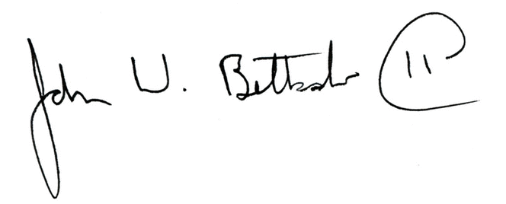
John W. Betkoski, III
Chairperson, Water Planning Council

