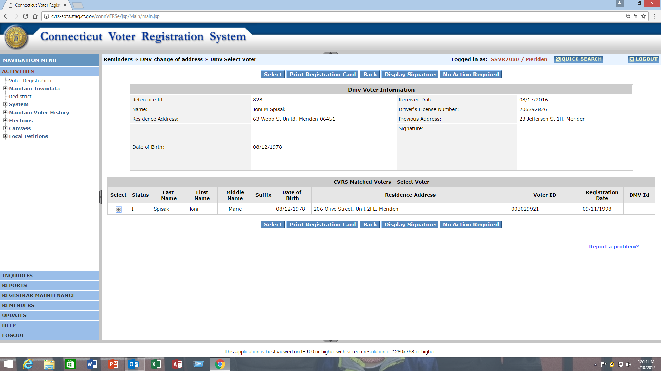
Print
Radio Button
Once you have selected a record to work on from the DMV tumbleweed list and enter the record by selecting the “Go To VR” button, the system will automatically perform a statewide search for any potential matches for the record. If one of the potential matches is correct and you want to print a voter registration card, select the radio button (by clicking on the radio button itself) in front of the voter record BEFORE you print the voter registration card.
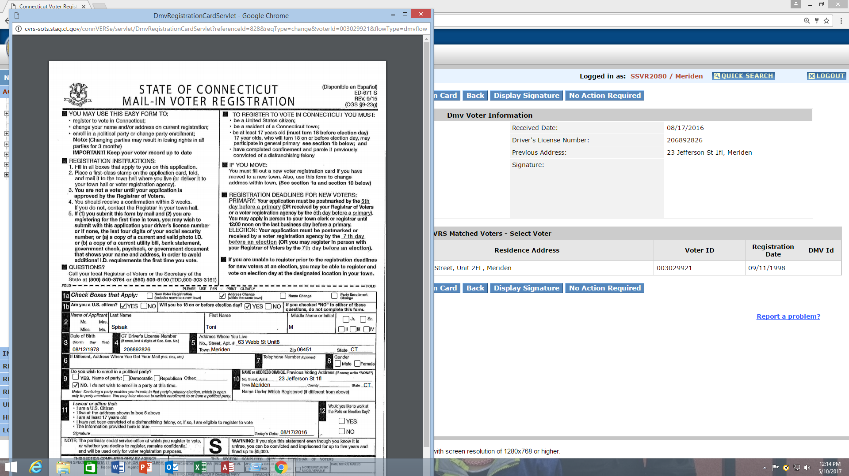
Party Info

Once you print the voter registration application, the appropriate voter registration information, including any appropriate party information, will be displayed on the card.

