IVS LLC
12910 Shelbyville Rd, Suite 102
Louisville, KY 40243

888-888-6952
FAX 502-425-9549

www.ivsllc.com

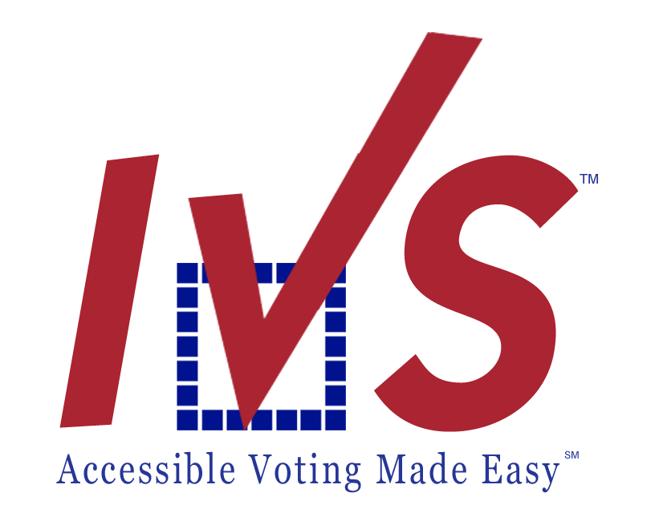

To: | ROVs | From: | Tammy Wells, VP
Fax: |  | Pages: | 1
Phone: |  | Date: | April 6, 2016

RE: Phone/Fax Equipment Testing, Election Day

Quick Reference:
Field Equipment Testing 866-486-3841
Election Day Line 866-486-3843

FIELD EQUIPMENT TESTING

- Set up the Vote-By-Phone equipment (Phone and Fax Machine) at your Polling Location.

- FROM THE PHONE LINE YOU WILL USE ON ELECTION DAY (HAVA line), dial the toll free number for Field Equipment Testing: 866-486-3841

- The system will play the recording “Welcome to the Equipment Readiness Test for the State of Connecticut. Press any key to continue.

If the system does not detect a TONE from your telephone, the system will say:
“We do not detect any key press. Please make sure the dial switch on the right side of the telephone is in the “T” for
Tone position. When you are ready, press any key to continue.”

If the system detects a TONE from your telephone, the system will say:
“Your fax confirmation will be sent to you momentarily. If the ballot access IDs listed on the fax are not correct, or if you do not receive this fax within 5 minutes, please contact IVS at 888-888-6952. You may hang up now. Thank you!

ELECTION DAY REMINDERS

Election Day Line: On Election Day, poll workers should call (866) 486-3843, the Election Day Line, in order for voters to access and vote with their actual ballot. This line will be open at 6:00 a.m.

Poll Workers will enter their four-digit Poll Worker ID number AND Ballot Access ID number (the Poll Worker ID and Ballot Access ID number are the same numbers in Connecticut). This number is located on the www.ct.vbpems.com web portal (HAVA numbers screen). In the audio instructions, Poll Workers will select Republican or Democratic ballot to provide the correct ballot for the voter.

During this process if you have any issues or questions, please contact me at 502-797-7787 or toll free at 888-888-6952.

Thank you!

