

School Representative

*Certificate of Achievement*

***IN***

**PHYSICAL FITNESS**

*Presented to:*

For Outstanding Performance In The

2018-2019 Connecticut State Physical Fitness Assessment

A Test in Strength, Endurance, and Flexibility

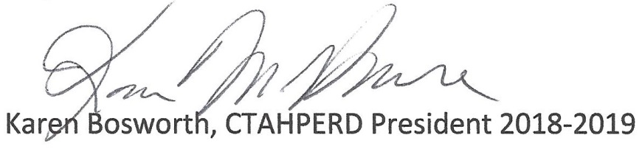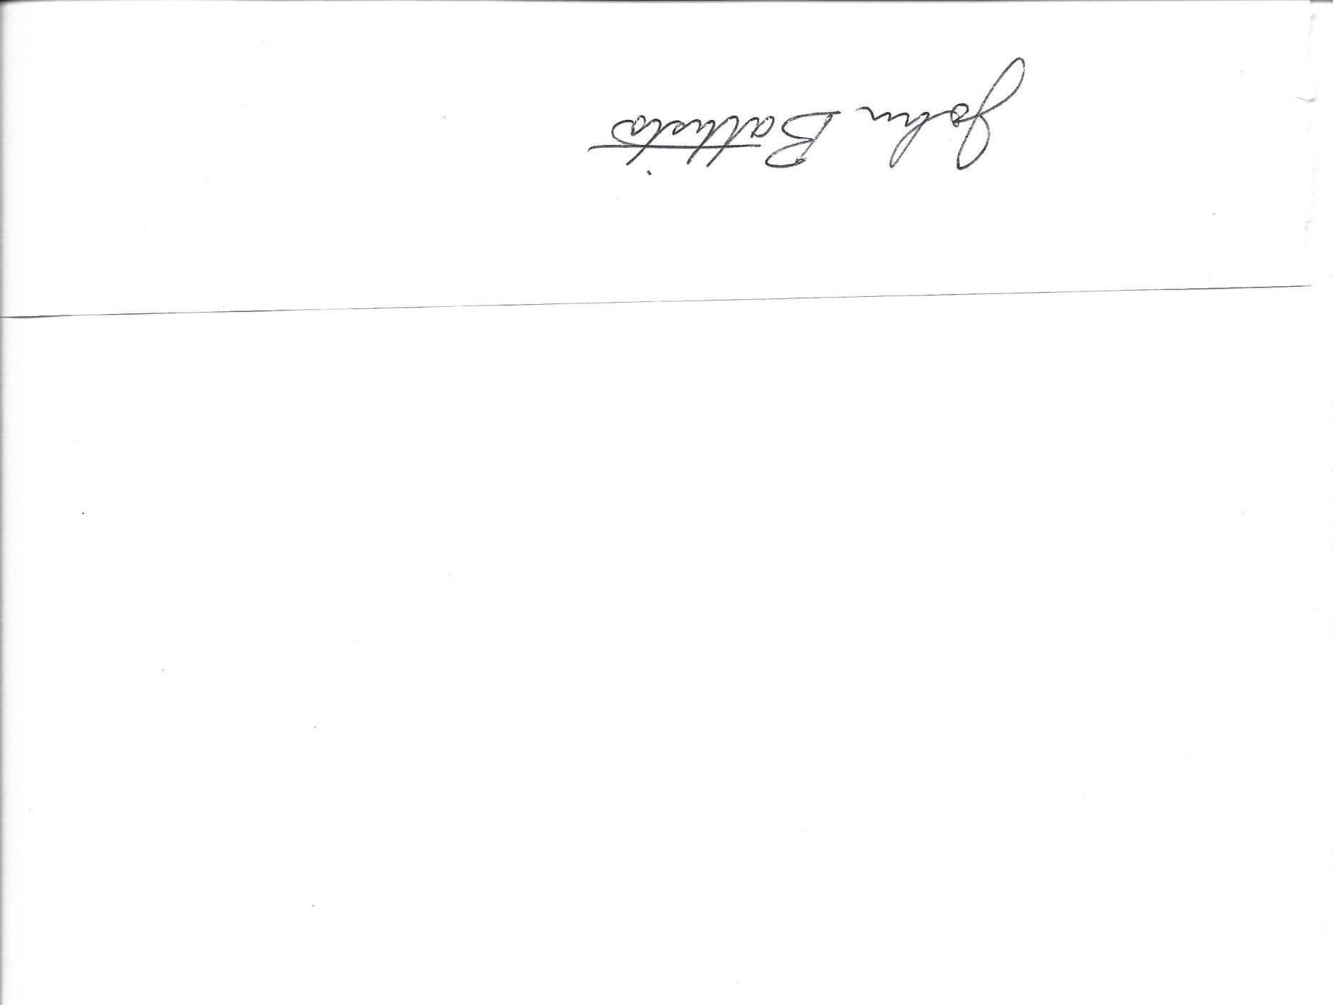*Our Congratulations On This Accomplishment*

