|  |
| --- |
| Connecticut State Department of Education - Performance Office |
| **Directory Manager (DM) User Guide** |
|  |

|  |
| --- |
| Version 3.0  10/3/2022 |

Table of Contents

Documentation Change Log 3

Using Navigation Pane 3

Contact Information 4

Directory Manager (DM) 4

Applications/Roles in the DM Portal 4

How to Access Directory Manager 6

How to Manage Users 8

How to get a List of Users and their Roles 8

How to Create an Account 9

How to Assign Roles 13

How to Edit an Account 16

How to Unassign Roles 18

How to Inactivate an Account 20

How to re-Activate an Account 21

How to Manage Organizations 24

How to get a list of schools/programs? 24

Do we need to Request a Code? 25

School vs. Program Code 25

New Programs 25

How to Report in PSIS 26

How to Request a Program Code 27

How to Request a School Code 29

How to Edit a Program/School 31

How to Close a Program/School 33

Annual Verification of Programs/Schools 36

FAQs 37

I am having trouble logging in to the Portal? 37

I cannot remember my password? 37

APPENDIX 38

Table A: Program Types 38

Table B: School Type 39

Table C: Organization Type 40

# Documentation Change Log

| Version | Section / Page | Date | Description |
| --- | --- | --- | --- |
| 1.0 |  | 7/17/2020 | Published |
|  | How to Manage Users |  | Updated bullets. |
|  | How to get a list of schools/programs? |  | Added section |
|  | How to Edit a Program/School |  | Added  DESIGNATED HIGH SCHOOL, FEEDER TOWNS *[Under Available Towns (select applicable town, then >>)] and [Under Selected Towns with Grades (put a check mark next to the same Town & Grades)],* |
|  | Program Types |  | Public Transition Program (PTP) revised 9/9/2020 |
|  | Applications/Roles in the DM Portal |  | Updated **Contacts Manager**  Updated **EdSight Secure**  Updated **Direct Certification** |
|  | New Programs |  | Added bullet All alternative schools and programs must have a code. Refer to C.G.S. Section [10-74j](https://www.cga.ct.gov/current/pub/chap_164.htm#sec_10-74j) and [10-74k](https://www.cga.ct.gov/current/pub/chap_164.htm#sec_10-74k) for additional information. |
|  | Do we need to Request a Code?  How to Request a Program Code  How to Request a School Code |  | Added **Note:** if a district is opening a new program or school in the upcoming school year, they can request a code in DM one school year in advance. This allows the district to prepare and use the code in their SIS systems. |
|  | How to Manage Organizations |  | Added **Note**: section does not pertain to Approved Private Special Education Programs (APSEPs). APSEPs are managed by the CSDE. |
| 2.0 |  | 3/29/2021 | Published |
|  | Table C: Organization Type | 6/30/2021 | Closed all Community Pre-Ks codes effective 6/30/2021 |
|  | Table C: Organization Type | 7/1/2021 | Added Nonpublic Elementary and Secondary Schools added non_public_subtype_id = 3 Hospital |
|  | Table C: Organization Type | 7/1/2021 | Added College Affiliated School Districts and College Affiliated Schools |
|  | Applications/Roles |  | Added ED159-Nonpublic School Report |
|  | How to Re-Open a School | 2/6/2022 | Added Section |
|  | Table D: Grades Offered |  | Added Section |
| 3.0 |  | 10/3/2022 | Published |

# Using Navigation Pane

Helpful Tip: select the Navigation Pane.  The Navigation Pane opens on the left side of the Word window. It enables you to quickly click on a section within the document or in the “Search Document” at the top of the pane, enter the word or phrase you want to find.

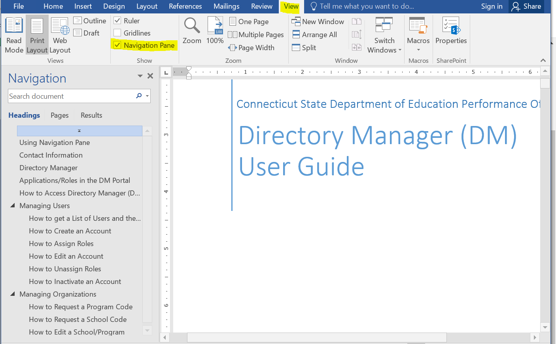

# Contact Information

| **Contact** | **Name** | **Email** | **Phone** |
| --- | --- | --- | --- |
| SDE DM Administrator | Laura Guerrera | [Laura.Guerrera@ct.gov](mailto:Laura.Guerrera@ct.gov) | 860-713-6898 |
| SDE DM Administrator | Raymond Martin | [Raymond.Martin@ct.gov](mailto:Raymond.Martin@ct.gov) | [860-713-6876](tel:%208607136876) |

# Directory Manager (DM)

Directory Manager (DM) is located in the Portal Applications website. DM is the official listing of all districts, schools and other educational facilities. DM is used to manage users and their roles for all Portal Applications. Accuracy is critical as these data are used by all other CSDE data collection systems. For this reason, the CSDE requires districts to verify their information annually.

# Applications/Roles in the DM Portal

* **Certifier** roles - the CSDE requires all final data submissions be reviewed and certified by **certified administrators only**.
* **Writer** (User/Entry User) roles – the user can enters data and review reports.
* **Reader**” roles – the user can review data and reports.

| **Application Name**  *- as listed when logging in to DM if user has Application role*  *-links to Help Site if available* | [**Description**](javascript:__doPostBack('dtgApplications$ctl02$ctl01','')) | **Role(s)** | **SDE Data Manager** |
| --- | --- | --- | --- |
| Contacts Manager | **Contacts Manager** is used to streamline the collection of contact information. | * **Contacts Manager Writer** – manages the contact lists in Contacts Manager. | Contacts Manager Writer role assignment  [**Keryn Felder**](mailto:Keryn.Felder@ct.gov) |
| [Direct Certification](https://portal.ct.gov/SDE/Nutrition/Direct-Certification) | **Direct Certification** is a process conducted by states and local educational agencies (LEAs) to certify eligible children for free or reduced-price meals without the need for household applications. The CSDE works with the Department of Social Services to match school children who are receiving SNAP, Temporary Family Assistance (TFA), Free Medicaid, and Reduced Medicaid benefits. This match is done weekly and, as indicated previously, the children are automatically eligible for free or reduced-priced meals without having to submit an application. The CSDE also works with the Department of Children and Family Services to provide foster children with automatic free meals and this is also a part of the CSDE Direct Certification Web Application process. | * **DirectCertLEAUser**   **Important:** These data are highly confidential.   * + Only one person per district may have access to the direct certification data.   + This is the same person listed as the Direct Certification contact in the online Child Nutrition Program (CNP) application. | [**Teri Dandeneau**](mailto:teri.dandeneau@ct.gov) |
| [Directory Manager](https://portal.ct.gov/SDE/Performance/Data-Collection-Help-Sites/Directory-Manager-Help-Site) | **Directory Manager (DM)** is used to collect and is the official listing of all districts, schools and other educational facilities information. DM is also used to manage users and their roles for all Portal Applications. | * **LEA Security Manager** - manages users and their roles for Portal Applications. * **LEA Directory Certifier** - manages changes to the district’s schools and programs, operating status, name, grades offered, open/close dates and all other required attributes | [**Laura Guerrera**](mailto:Laura.Guerrera@ct.gov)  [**Ray Martin**](mailto:Raymond.Martin@ct.gov) |
| [ED165](https://portal.ct.gov/SDE/Performance/Data-Collection-Help-Sites/ED165) | **Connecticut School Data Report** is used to collect a wide variety of data elements at the school-level for state and federal reporting. | * **ED165 Certifier** * **ED165 Data Entry User** * **ED165 Pre-certifier** - allows the user to enter and verify data prior to certification. | [**Ray Martin**](mailto:Raymond.Martin@ct.gov) |
| [EDS](https://portal.ct.gov/SDE/Performance/Data-Collection-Help-Sites/EDS-Help-SIte) | **Educator Data Collection System (EDS)** is used to collect data educators for each of the roles that they hold. | * **EDS LEA Certifier** * **EDS LEA TEAM** - administration of the TEAM module of EDS * **EDS LEA Writer** | [**Ray Martin**](mailto:Raymond.Martin@ct.gov) |
| [EdSight Secure](http://edsight.ct.gov/relatedreports/EdSight%20Secure%20Intro%20and%20FAQs.pdf) | **EdSight Secure** provides access to analysis tools, data visualizations and student-level data across various domains. | EdSight Secure is intended for district school leaders and coordinators (e.g., principal, assistant principals, counselors, social workers) and NOT intended for classroom teachers as there is no rostering.   * **EdSight Secure District Analyst** * **EdSight Secure School Analyst** | [**edsight.sde@ct.gov**](mailto:edsight.sde@ct.gov) |
| [EEDC](https://portal.ct.gov/SDE/Performance/Data-Collection-Help-Sites/EEDC-Help-Site) | **Educator Evaluation Data Collection (EEDC)** is used to collect aggregate counts of educators by their final summative rating. | * **EEDC LEA Certifier** | [**Ray Martin**](mailto:Raymond.Martin@ct.gov) |
| [EFS](https://portal.ct.gov/SDE/Fiscal-Services/EFS/EducationFinancialSystem) | **Education Financial System (EFS)** is used to collect financial information. | * **EFS LEA Certifier** * **EFS LEA Reader** * **EFS LEA Writer** | [**SDE.efs@ct.gov**](mailto:SDE.efs@ct.gov) |
| [Noncertified Staff](https://portal.ct.gov/SDE/Performance/Data-Collection-Help-Sites/Noncertified-Staff-Help-Site) | **Noncertified Staff Data** is used to collect full-time equivalent (FTE) counts of noncertified staff. | * **NonCert Staff Certifier** * **NonCert Staff Writer** | [**Ray Martin**](mailto:Raymond.Martin@ct.gov) |
| [ED159](https://portal.ct.gov/SDE/Performance/Data-Collection-Help-Sites/ED159) | **Public Schools do NOT submit ED159 data.**  **Nonpublic School Report** is used to collect student enrollment and staffing data. | * **ED159 LEA Certifier** | [**Rosado, Michelle**](mailto:Michelle.Rosado@ct.gov) |
| [Restraint and Seclusion](https://portal.ct.gov/SDE/Performance/Data-Collection-Help-Sites/Restraint-and-Seclusion-Help-Site/) | **Restraint and Seclusion (R/S)** is used to collect R/S incidents for persons at risk. | * **RS Certifier** * **RS Writer** | [**Laura Guerrera**](mailto:Laura.Guerrera@ct.gov) |
| [Special Education Excess Cost Grants](https://portal.ct.gov/SDE/Fiscal-Services/Special-Education) | **Special Education Excess Cost Grant Application (SEECG)** is used to collect LEA Excess Cost and State Agency Placement Grant data from school districts. | * **SEECG LEA Certifier** * **SEECG LEA Writer** | [**Kevin Chambers**](mailto:Kevin.Chambers@ct.gov) |
| [TCS](https://portal.ct.gov/SDE/Performance/Data-Collection-Help-Sites/TCS-Help-Site) | **Teacher-Course-Student (TCS)** is used to collect student, teacher and course data. | * **TCS Certifier** * **TCS LEA User** | [**Keryn Felder**](mailto:Keryn.Felder@ct.gov) |

# How to Access Directory Manager

**Step Action**

1. Go to the <https://csde.ct.gov> website. The system displays the State of Connecticut Login screen.

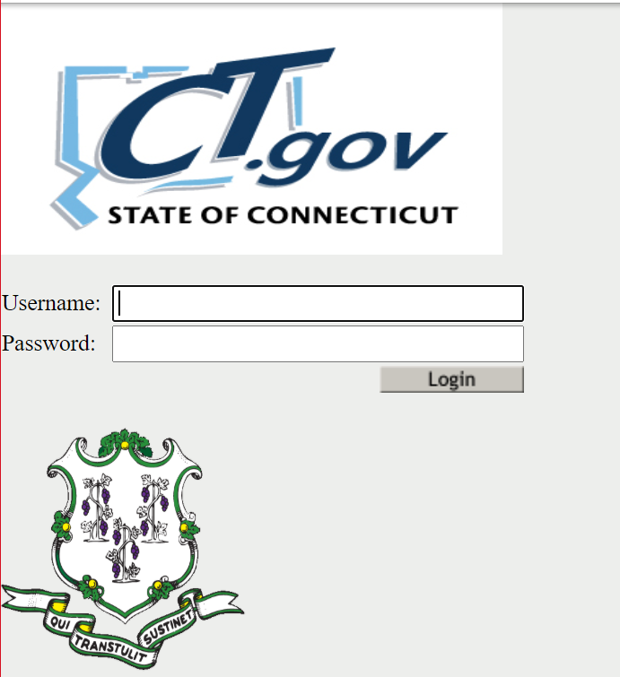

 **Important:** **Usernames and passwords must NOT be shared**, as each are unique to the assigned individual. This process improves accountability for any errors or changes entered into the system and allow the department to identify exactly who to contact should we have questions about a specific record.

1. Enter your **Username** and **Password** and select Login.
   1. If you only have access to DM, the system displays the *Directory Manager* Homescreen - Go to Step 3.
   2. If you have access to more than one application, the system displays the *State Department of Education Home Page*.

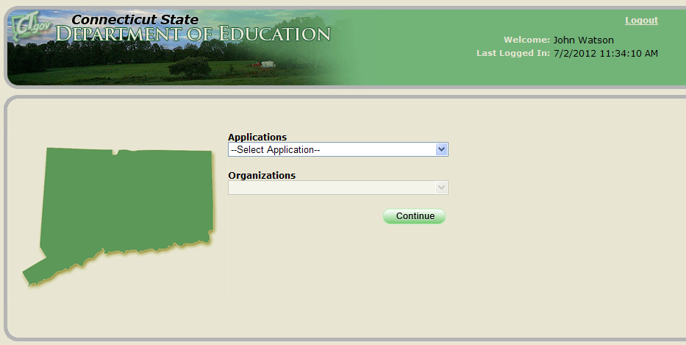

 Note: If you do not have access to DM, contact your LEA Security Manager. If you do not know who your LEA Security Manager is click [here](http://edsight.ct.gov/SASStoredProcess/guest?orgname=&role=LEA+Security+Manager&namelast=&namefirst=&_program=%2FCTDOE%2FEdSight%2FRelease%2FReporting%2FPublic%2FReports%2FStoredProcesses%2FDMRolesSearchReport&_select=Submit) for the LEA Security Manager Contact List.

 Note: If you get Error! There was an error while processing your request.



* First, try closing ALL browser windows and log into the application again. *For Portal Applications if you walk away from your computer or do not do anything for a certain period of time, you will be timed out (automatically logged out of the application you were in).*
* If that does not work, *the link you are using may be corrupted*, try using this link: [https://csde.ct.gov/](https://linkprotect.cudasvc.com/url?a=https%3a%2f%2fcsde.ct.gov%2f&c=E,1,19idiwdTRvlHKZWZM6054c3n25-q-_t9G7_aiX227ilLm0fNvCMccSHxbogfOsl_ths1IHv3XF5yC-z3h16RqHY1LZ9jOH3DxfPojvvuSLA3SoTTtbI,&typo=1).
* If that does not work, click this link ([http://sdeportal.ct.gov/portaluser/](https://linkprotect.cudasvc.com/url?a=http%3a%2f%2fsdeportal.ct.gov%2fportaluser%2f&c=E,1,k_Ht_d2cVJegUTmCZf2KnaBZpwZNFkKJfjPu_K9ZMyjyHlXDHFM7YT13uU_Mm4fSGbiSC8M--VAjENxVw62s_5xvbXXWWpxiOjhSeJzB&typo=1)), then Forgot Password to re-set your password.

1. Select **Directory Manager** from the Application drop-down menu and click **Continue**. The system displays the *Directory Manager* Homescreen.

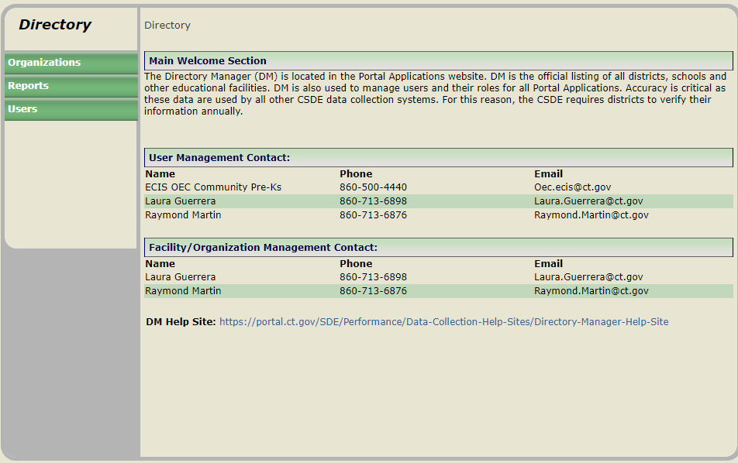

1. This procedure is complete.

# How to Manage Users

The **LEA Security Manager** manages the districts’ users and their roles for Portal Applications. At least once a year, districts should review all of their users and their associated roles to ensure that the role assignments are appropriate and meet their district needs. The CSDE recommends having more than one staff member assigned the LEA Security Manager role.

 **Important:**

* The superintendent must approve all users and their access level (applications/roles assigned) in DM.
* **Usernames are unique to the assigned individual**. Do not update one user’s account with another person’s name. Usernames and passwords **must NOT be shared**. This process improves accountability for any errors or changes entered into the system and allow the department to identify exactly who to contact should we have questions about a specific record.
* When a person is no longer employed by your school district, best practice is to immediately inactivate the person’s account to prevent any confidentiality or security issues.
* The CSDE requires all final data submissions be reviewed and certified by **certified administrators only**.

## How to get a List of Users and their Roles

The **Secure Users by Role Report** allows organizations to run a report that includes a list of All their DM users, applications they are assigned and their roles.

**cid:image001.png@01D62376.4D441970Note:** the Security Org column displays either the “School District” or the actual school the role is assigned.

1. Select **Reports** from the left-hand navigation menu.



1. Select **Secure Users by Role Report**

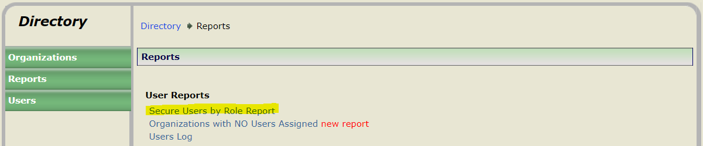

1. Select Organization=**your Organization** and Application=**All**

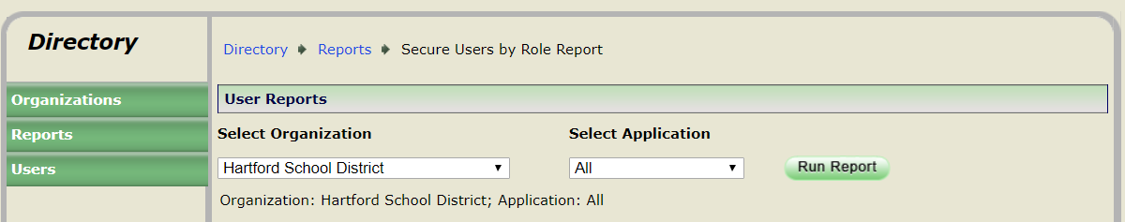

1. Select **Run Report**

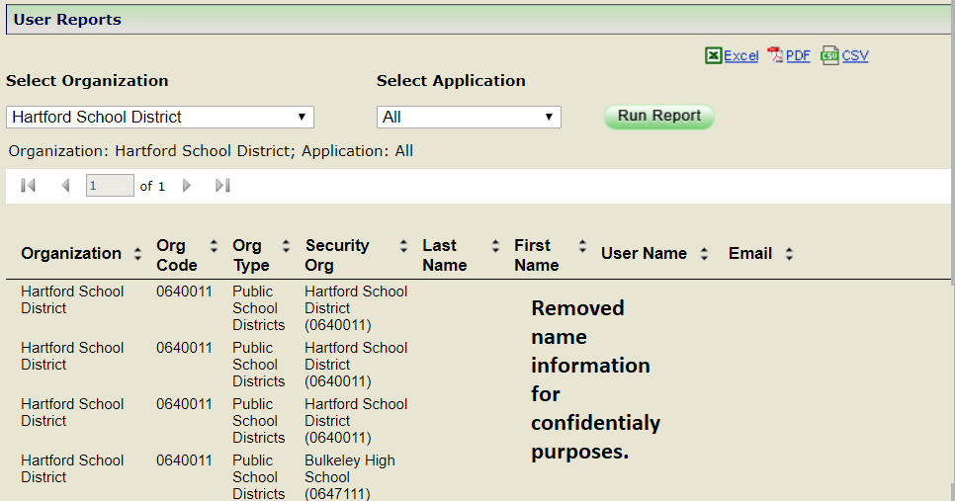

1. Select **Excel**
2. Review the list of users and their roles.

Recommendation on How to Review:

1. **Sort** list by Last Name/First Name
2. **Highlight** any users who are no longer employed by your district

If there are users no longer employed by your district:

* 1. **Sort** list by Application>Role>User Name
  2. **Review** roles assigned to the user no longer employed by your district (do not delete any roles)
  3. **Verify** another user has the same role(s) as the user no longer employed by your district
  4. **Assign** role(s) to other User(s), *if necessary*
  5. Do not delete roles, just **Inactivate** account of user no longer employed by your district

**cid:image001.png@01D62376.4D441970Note:** For further information, refer to How to Inactivate an Account.

For users who are no longer responsible for a collection:

* 1. If multiple roles assigned to their account, **unassign** the appropriate role

**cid:image001.png@01D62376.4D441970Note:** For further information, refer to How to Unassign Roles.

* 1. If only one role assigned, **inactivate** the user’s account

**cid:image001.png@01D62376.4D441970Note:** For further information, refer to How to Inactivate an Account.

1. Create new accounts and assign roles when appropriate.

**cid:image001.png@01D62376.4D441970Note:** For further information, refer to How to Create an Account.

## How to Create an Account

1. Select **Users** from the left-hand navigation menu.



1. Select **Create a user** and click **Go**.

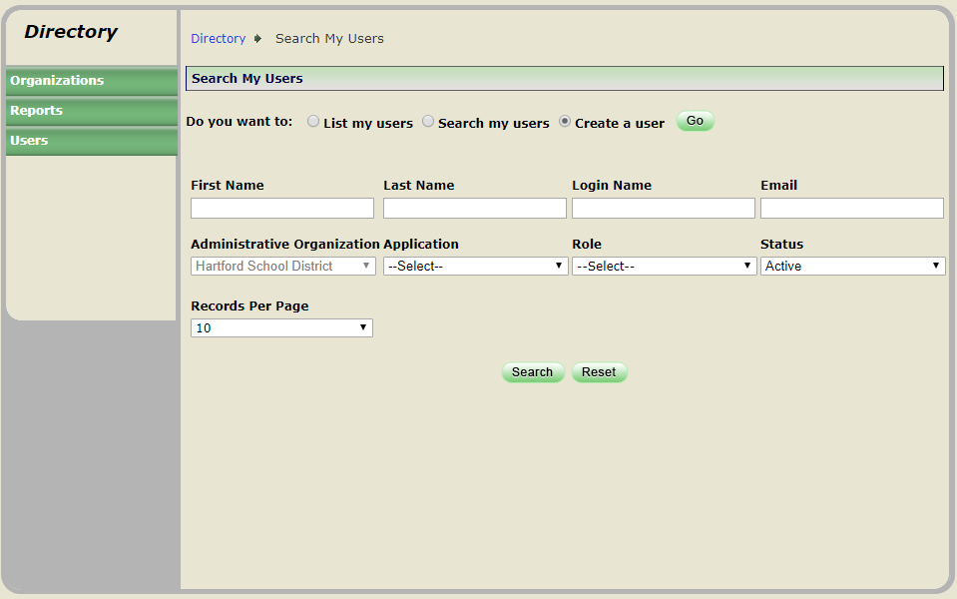

1. Enter the staff member’s FIRST NAME, LAST NAME, PHONE, EXTENSION (if applicable), EMAIL, ADMINISTRATIVE ORGANIZATION and select **Submit**.

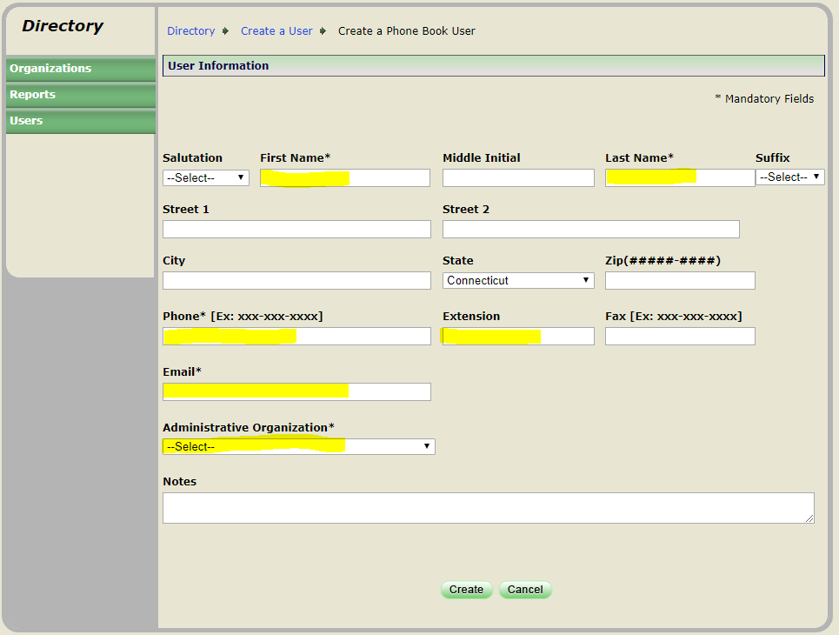

 **Important:** the staff member will receive one email with a unique username and a second email with a temporary password and a link to the portal.

1. Click Assign Role(s).

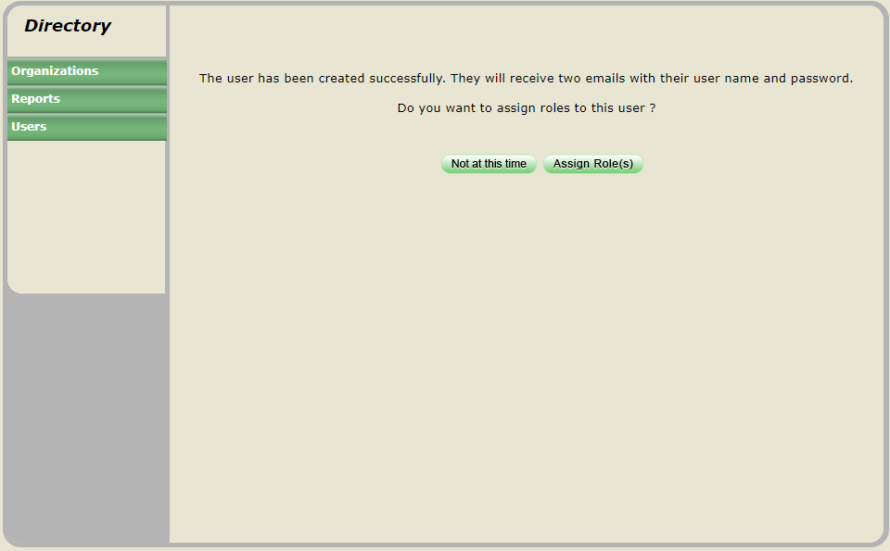

1. Under Available Applications select the Application that needs to be assigned.

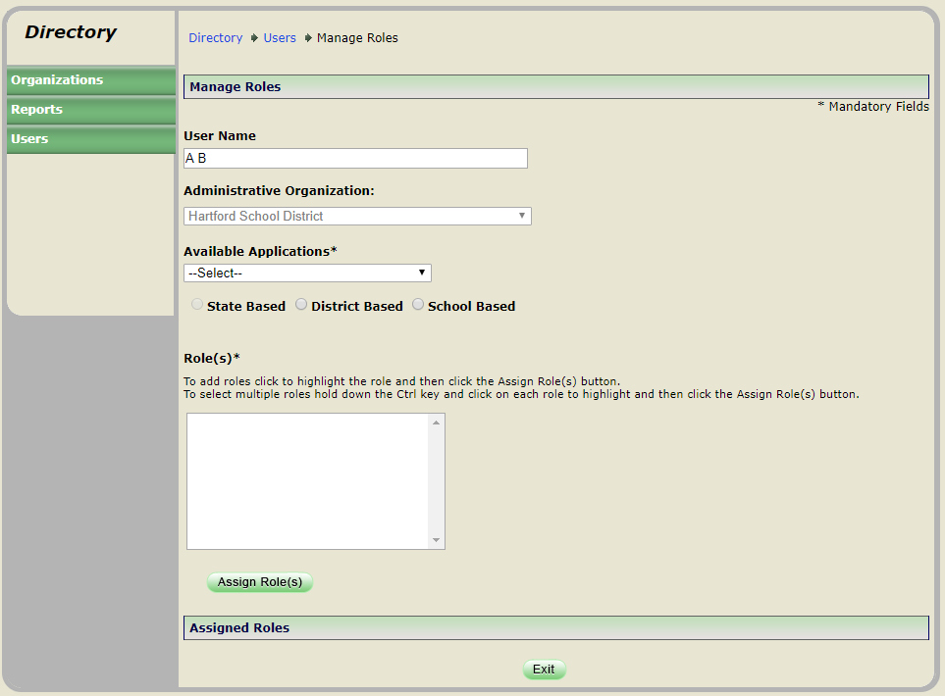

1. Select District Based or School Based.

**cid:image001.png@01D62376.4D441970 Note: School Based** is only available for **ED165 and EdSight Secure.**

**cid:image001.png@01D62376.4D441970 Note:** If you select School Based, then a School for one of the other Applications you will get the message No Roles available!

**cid:image001.png@01D62376.4D441970 Note:** The available roles will display below under Role(s)

1. Under Role(s) select the role to be assigned.

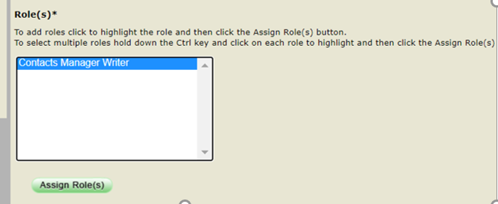

1. Select **Assign Role(s)**
2. If you need to assign additional applications/roles repeat steps 5 through 8. If you do not need to assign additional applications/roles go to the next Step.
3. Click Exit.

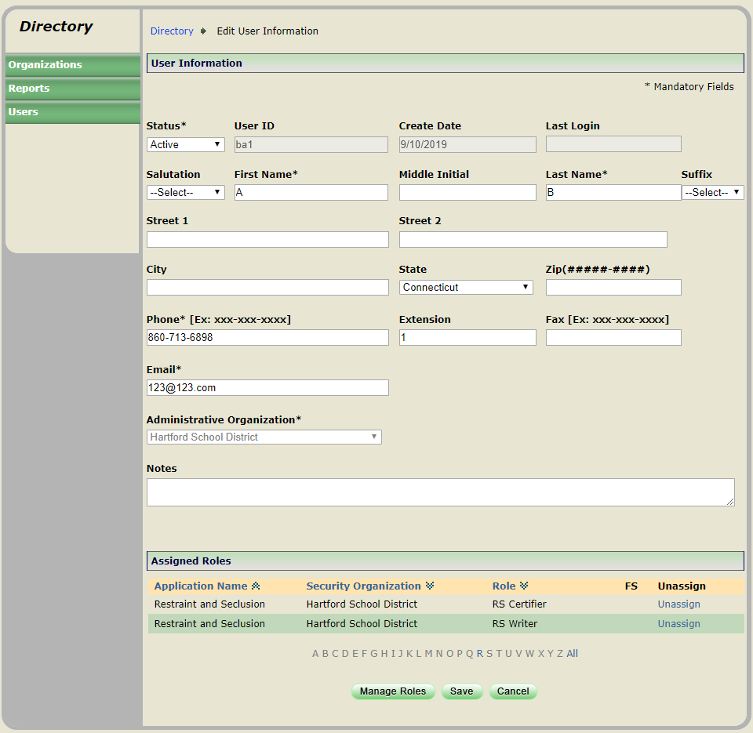

1. Click Save

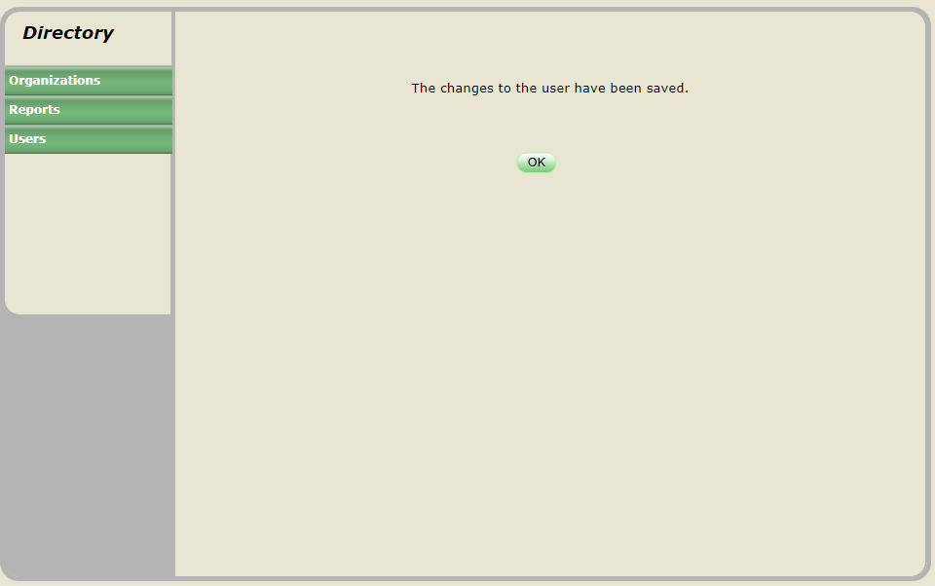

1. Click OK. This procedure is complete.

## How to Assign Roles

1. Select **Users** from the left-hand navigation menu.



1. Select **List my users** and click **Go**.

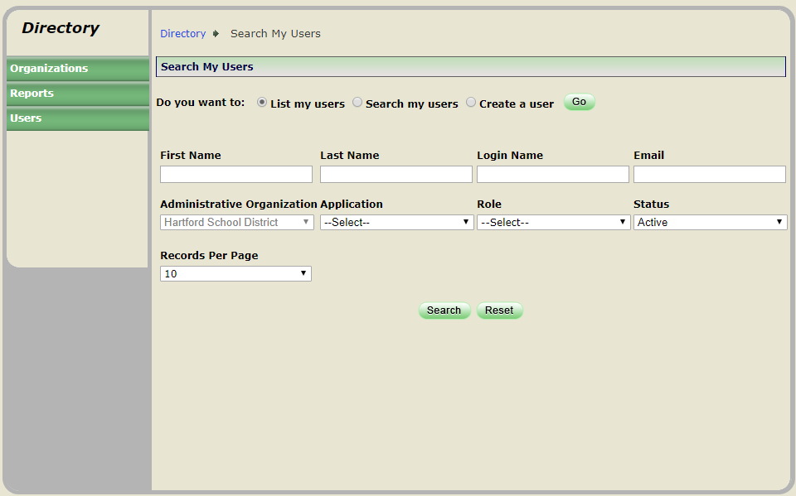

1. Select **User ID link** to open the User’s Record.

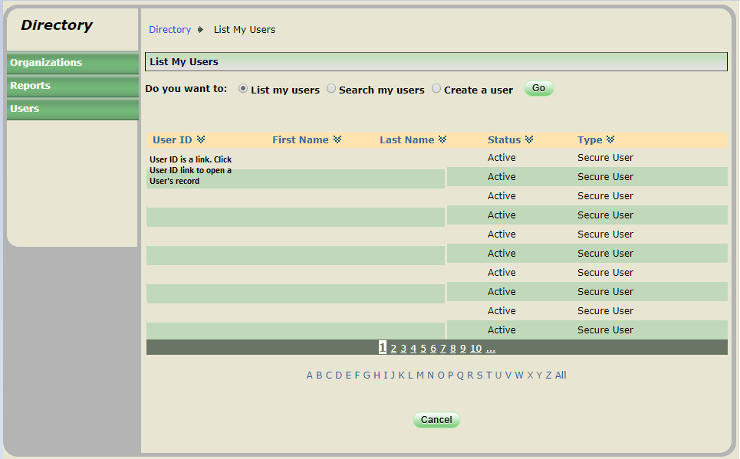

** Note:** For quick access to a User’s Account click the first letter of their last name in the Alphabet strip below.

1. Select **Edit** *at the bottom of the screen.*

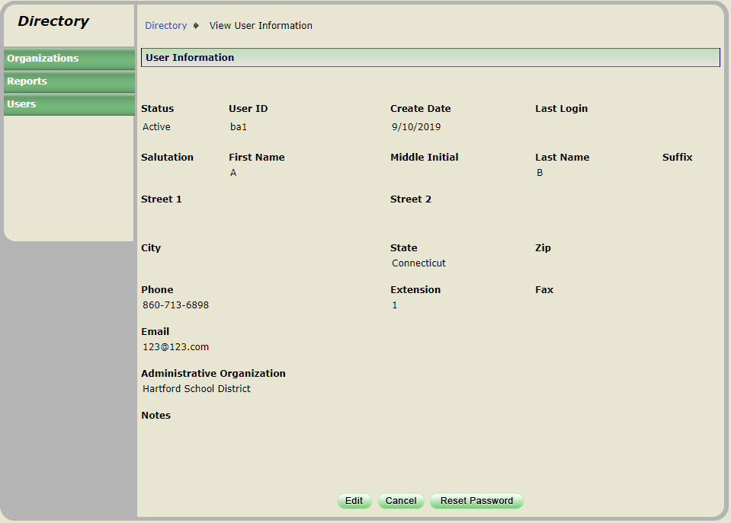

1. Select **Manage Roles** *at the bottom of the screen.*

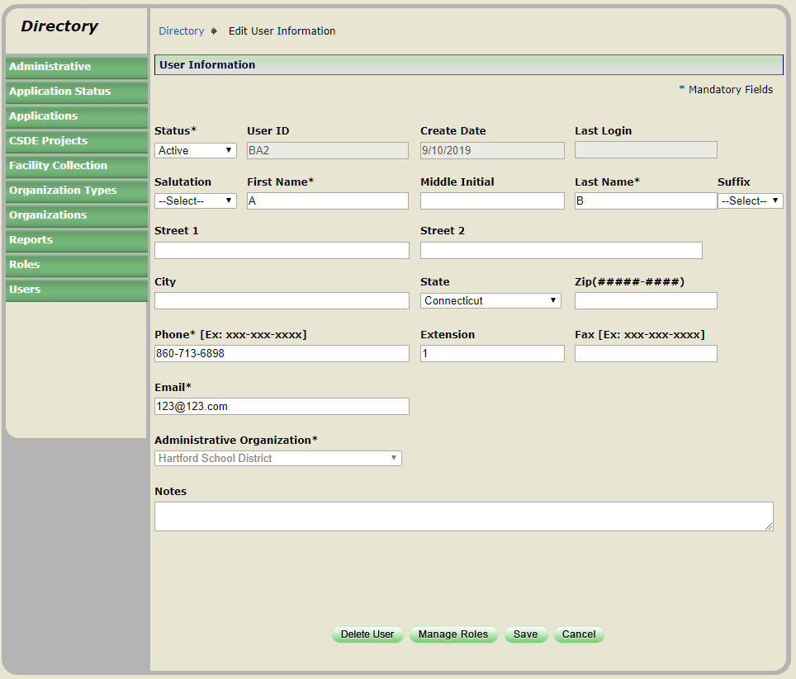

1. Under Available Applications select the Application that needs to be assigned.



1. Select District or School Based.

**cid:image001.png@01D62376.4D441970Note: School Based** is only available for **ED165 and EdSight Secure.** (For other applications, you will get a message No Roles available ! if you try to assign school based roles).

**cid:image001.png@01D62376.4D441970 Note:** The available roles will display below under Role(s)

1. Under Role(s) **select the role to be assigned**.
2. Select **Assign Role(s)**
3. If you need to assign additional applications/roles repeat steps 6 through 9. If you do not need to assign additional applications/roles go to the next step.



1. Click Exit.



1. Click Save



1. Click OK. This procedure is complete.

## How to Edit an Account

1. Select **Users** from the left-hand navigation menu.



1. Select **List my users** and click **Go**.



1. Select **User ID link** to open the User’s Record.



**cid:image001.png@01D62376.4D441970 Note:** For quick access to a User’s Account click the first letter of their last name in the Alphabet strip below.

1. Select **Edit** *at the bottom of the screen.*

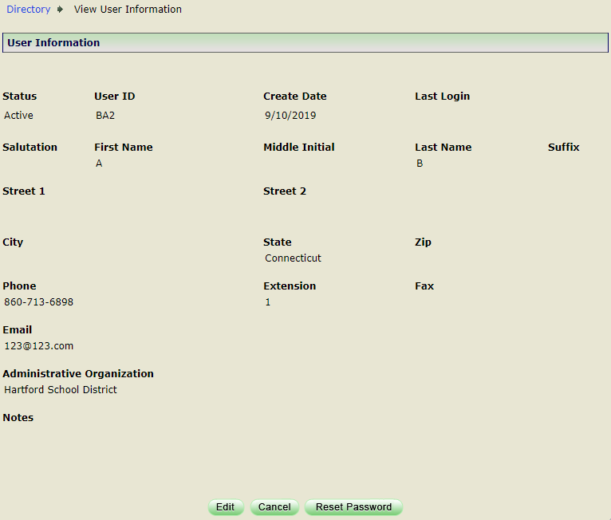

1. Update the User’s FIRST NAME, LAST NAME, PHONE, EXTENSION or EMAIL and select **Save.**

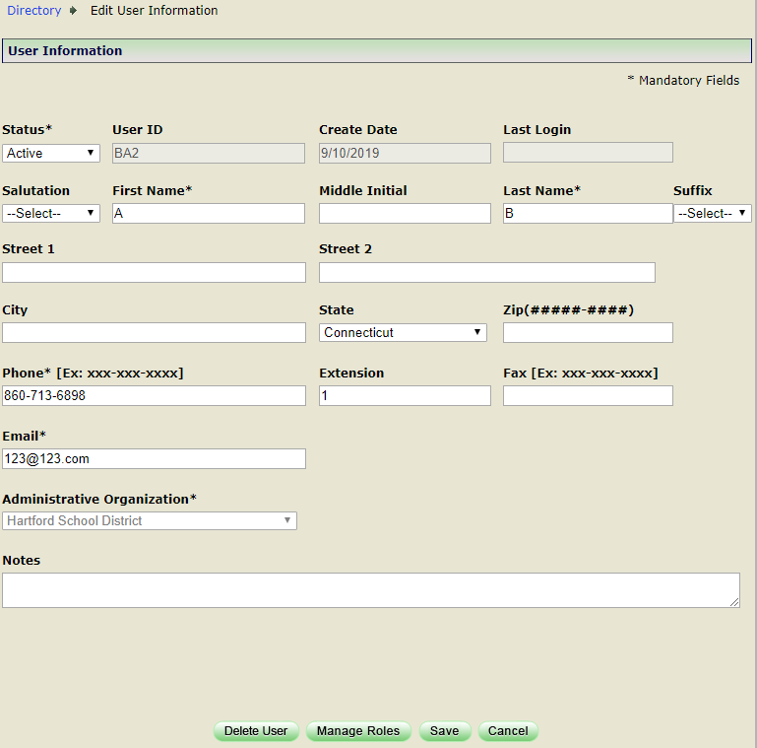

1. The changes to the user have been saved screen is displayed.



## How to Unassign Roles

Use this procedure if a user has multiple roles assigned and they will no longer be responsible for an assigned application.

**cid:image001.png@01D62376.4D441970 Note:** if the user only has one role assigned and they will no longer be responsible for this application, do not unassign the role, Inactive the users account.

1. Select **Users** from the left-hand navigation menu.



1. Select **List my users** and click **Go**.



1. Select **User ID link** to open the User’s Record.



**cid:image001.png@01D62376.4D441970 Note:** For quick access to a User’s Account click the first letter of their last name in the Alphabet strip below.

1. Select **Edit** *at the bottom of the screen.*



1. Under Assigned Roles select **Unassign** next to the right of the role that needs to be unassigned.



1. Click Save. The changes to the user have been saved screen is displayed.



1. Select OK.
2. This procedure is complete.

## How to Inactivate an Account

Use this procedure if 1) a user is no longer employed by your organization or 2) the user is no longer responsible for the assigned applications.

** Note: do not unassign the roles, just inactive the account.**

1. Select **Users** from the left-hand navigation menu.



1. Select **List my users** and click **Go**.



1. Select **User ID link** to open the User’s Record.



**cid:image001.png@01D62376.4D441970 Note:** For quick access to a User’s Account click the first letter of their last name in the Alphabet strip below.

1. Select **Edit** *at the bottom of the screen.*



1. Do not delete roles, *at the top of the screen,* Select Status=**Inactive***.*

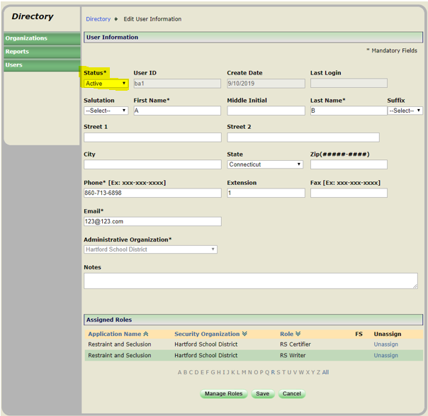

1. Click Save. The changes to the user have been saved screen is displayed.



1. Select OK.
2. This procedure is complete.

## How to re-Activate an Account

Use this procedure if a user’s account is inactive and you want to make it active again.

1. Select **Users** from the left-hand navigation menu.



1. Select **List my users** and click **Go**.



1. Select **User ID link** to open the User’s Record.



**cid:image001.png@01D62376.4D441970Note:** For quick access to a User’s Account click the first letter of their last name in the Alphabet strip below.

1. Select **Edit** *at the bottom of the screen.*



1. Select Status=**Active***.*

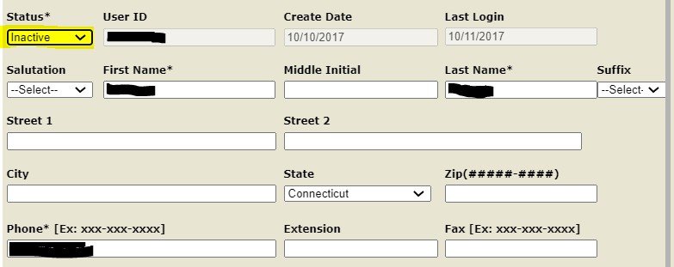

1. Click Save. The changes to the user have been saved screen is displayed.



1. Select OK.
2. This procedure is complete.

# How to Manage Organizations

The **LEA Directory Certifier** manages changes to the district’s schools and programs, operating status, name, grades offered, open/close dates and all other required attributes. Changes are pending until approved by an SDE staff member. School and program information is verified annually in DM by each districts LEA Directory Certifier.

 **Important:** All DM school and program information is used to populate EdSight, Connecticut State Department of Education’s interactive data website.

**cid:image001.png@01D62376.4D441970Note:** *How to Manage Organizations section* does not pertain to Approved Private Special Education Programs (APSEPs). APSEPs are managed by the CSDE.

## How to get a list of schools/programs?

1. Select **Organizations** from the left-hand navigation menu.

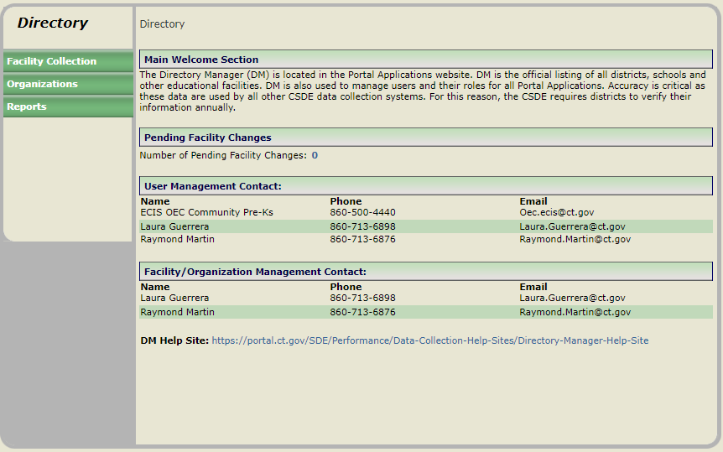

1. The organizations are displayed.

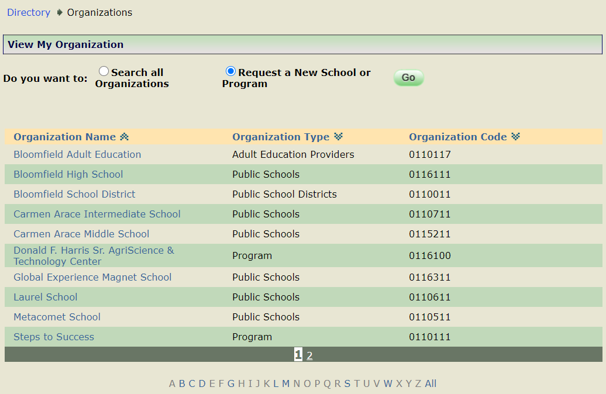

1. This procedure is complete.

## Do we need to Request a Code?

**cid:image001.png@01D62376.4D441970 Note:** if a district is opening a new program or school in the upcoming school year, they can request a code in DM one school year in advance. This allows the district to prepare and use the code in their SIS systems.

### School vs. Program Code

Determining if an Organization Should be School or Program (7/29/2019)

The following considerations are provided to help guide the superintendent and the local/regional Board of Education in making a determination as to whether an organization (new or existing) should be designated as a public school or a public school program.

A public school generally exhibits the following characteristics:

* It is housed in a separate identifiable building/facility.
* Students are enrolled for the full school year.
* The building is overseen by one or more certified administrators who do not report to another school’s administrator.
* Students receive a completely separate and self-contained learning experience that encompasses all of the subject matter required under Section10-16b of the Connecticut General Statutes (prescribed courses of study).
* At the secondary level, this organization grants high school diplomas.
* The local board and community view it as a school.

A public school **program** generally exhibits the following characteristics:

* The organization addresses a specialized need (e.g., dropout diversion/credit recovery, alternative education, special education).
* Not all students may be enrolled for the full school year.
* The organization provides instruction in *some* of the subject matter required under Section10-16b of the Connecticut General Statutes (prescribed courses of study); learning in the other areas is supplemented through other sources offered by the district (e.g., other schools in the district).
* It may be co-located in a school building though it could also have its own separate location.
* The daily schedule may be nontraditional (e.g., starting later in the day and extending into the evening hours).
* At the secondary level, the organization does not grant diplomas.
* The local board and community view it as a program and not a school.

Data for public schools and public school programs are reported on the CSDE’s data portal, EdSight at <http://edsight.ct.gov>. Formal accountability however is limited to public schools; for accountability purposes, data of students in public school programs are included with the district that operates the program.

If there are any questions about this matter, please contact Raymond Martin at [Raymond.Martin@ct.gov](mailto:Raymond.Martin@ct.gov) or Laura Guerrera at [Laura.Guerrera@ct.gov](mailto:Laura.Guerrera@ct.gov)

### New Programs

The following programs will need to request an Organization Code using Directory Manager. (see Table A: Program Type Definitions)

* All programs that educate students from multiple sending schools within the district.
* All district run programs located at an off-site location from the sending school the students would otherwise attend.
* Multisite programs must obtain separate codes for each program location/site.
* If students, whom are not expelled, can be placed into the district’s expulsion program as an alternative setting or by PPT; the Expulsion program must have an Organization Code.
* Any program that runs after normal school hours must obtain a separate program code in DM to represent the evening programming.
* All alternative schools and programs must have a code. Refer to C.G.S. Section [10-74j](https://www.cga.ct.gov/current/pub/chap_164.htm#sec_10-74j) and [10-74k](https://www.cga.ct.gov/current/pub/chap_164.htm#sec_10-74k) for additional information.

The following programs will not need to request Organization Codes in Directory Manager

* Homebound programs. This is a special program status code collected in the Public School Information System (PSIS) collection.

### How to Report in PSIS

The existing rule in PSIS is as follows:

If a student attends two educational facilities within the school day, report the facility where the student receives the majority of their core academic curriculum in Facility Code 1.

Students enrolled in any kind of program for the entire day must have that program’s Organization Code reported as Facility Code 1 in PSIS.  When students have split schedules that place them at two locations within the school day, there are two questions that should be considered when determining which location should be reported as Facility Code 1  and which as Facility Code 2 in PSIS.  First, if the majority of time is spent on one location, that location should be reported as Facility Code 1.  If the student’s time is split fairly evenly across the two locations, consider the location where the student receives the majority of their core academic instruction and report that program as Facility Code 1.

For example: If a student attends the regular high school for 4 hours of their day and spends 2 ½ hours each day at the alternative HS program, report the high school’s organization code in Facility Code 1 and the alternative program’s organization code in Facility Code 2.

It is important to distinguish between segregated special education classrooms and districtwide special education programs. Segregated special education classrooms only serve students from that “community” school whereas districtwide special education programs are designed to serve students from multiple sending district buildings.

For example: a district with 3 elementary schools may have 0-5 students at each building with significant behavior issues that require a segregated classroom with a full-time ED teacher. Districts may create one ED classroom in each elementary school or may choose to consolidate those three smaller classes into one districtwide ED program that is housed in one of the elementary schools.

The district that offers the separate class at each building to serve the needs of the students within that building does not need a separate code. The district that consolidates the classes into a program that accepts placements from all three building is required to obtain a separate code to allow for the identification of the students placed into the program.

The code is not intended to be a deterrent to districts interested in creating districtwide programs. The code will allow for proper coding of students for federal FAPE environments and allow the department to identify the existence and location of programs that exist in the state.

## How to Request a Program Code

**cid:image001.png@01D62376.4D441970 Note:** if a district is opening a new program or school in the upcoming school year, they can request a code in DM one school year in advance. This allows the district to prepare and use the code in their SIS systems.

1. Select **Organizations** from the left-hand navigation menu.



1. Select **Request a New School or Program** and click **Go**.

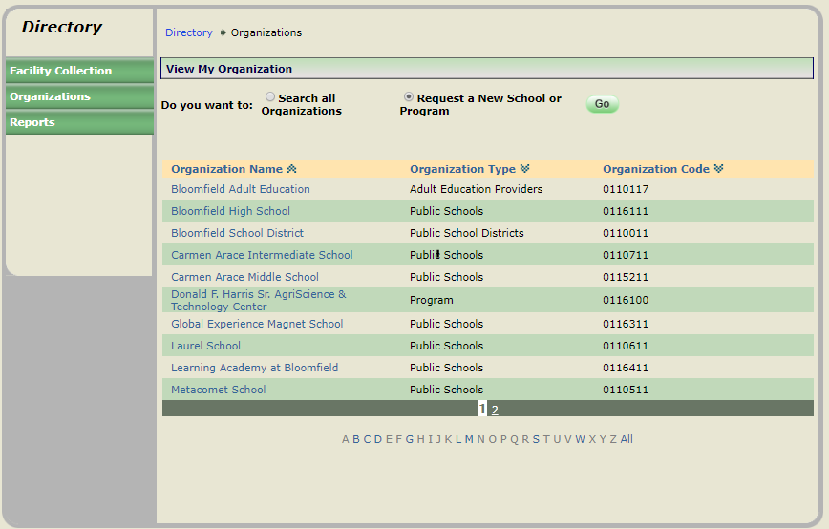

1. Select **Program** under Choose a type of organization to create and select **Continue**.

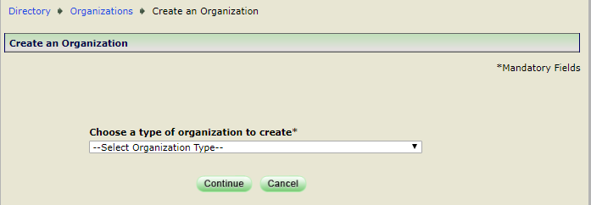

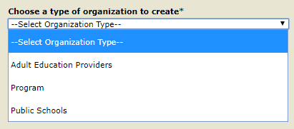

1. The Create an Organization page displays.

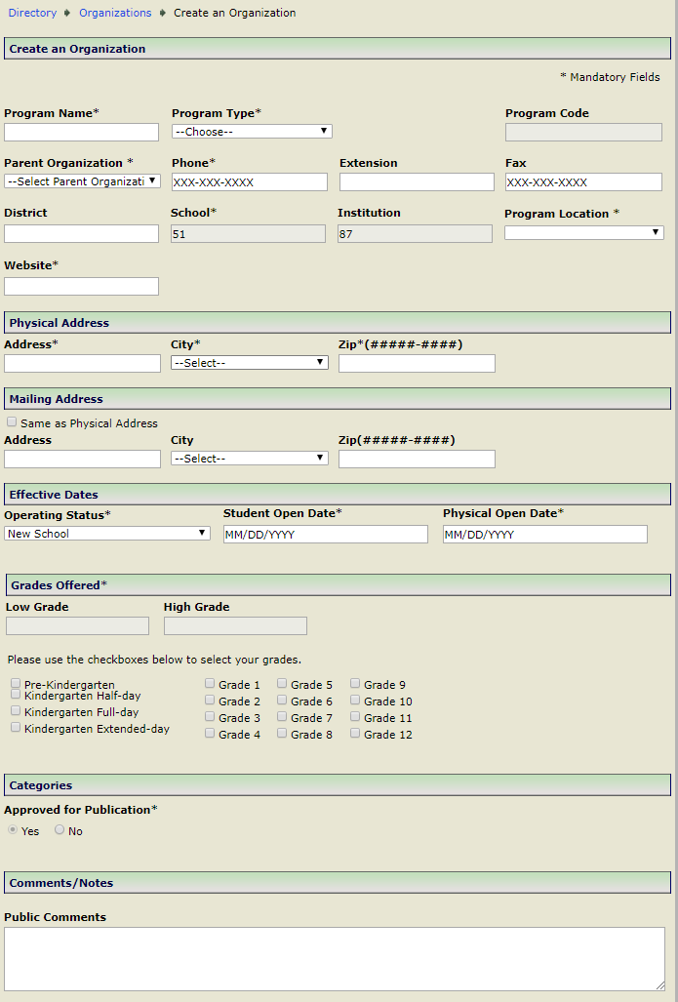

1. Enter the PROGRAM NAME, PROGRAM TYPE, PARENT ORGANIZATION (select default, your district), PHONE, EXTENSION (if applicable), FAX (if applicable), PROGRAM LOCATION, WEBSITE, PHYSICAL ADDRESS, CITY, ZIP CODE, MAILING ADDRESS, Select Same as Physical Address (if applicable), CITY, ZIP CODE, OPERATING STATUS (defaults to New School), STUDENT/PHYSICAL OPEN DATE (Use the same Date), GRADES OFFERED and select **Save**.

 **Important: Note about OPEN DATES:** DM follows the school year start and end dates set in state statutes (July 1 – June 30).  The OPEN DATE will determine the school year the organization shows in. If a program/school is opening at the beginning of the school year, use 07/01/YYYY for Open Date/Effective Date, this allows districts to do their PSIS Summer Roll Up prior to the first day of school.

1. The new organization request screen is displayed.

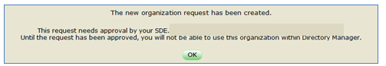

1. Click OK. This procedure is complete.

** Note:** New program/school code requests require approval from the SDE DM Administrator.

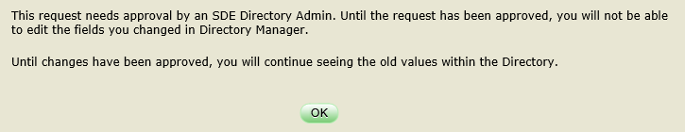

## How to Request a School Code

**cid:image001.png@01D62376.4D441970 Note:** if a district is opening a new program or school in the upcoming school year, they can request a code in DM one school year in advance. This allows the district to prepare and use the code in their SIS systems.

1. Select **Organizations** from the left-hand navigation menu.



1. Select **Request a New School or Program** and click **Go**.



1. Select **Public Schools** under Choose a type of organization to create and select **Continue**.





1. The Create an Organization page displays.

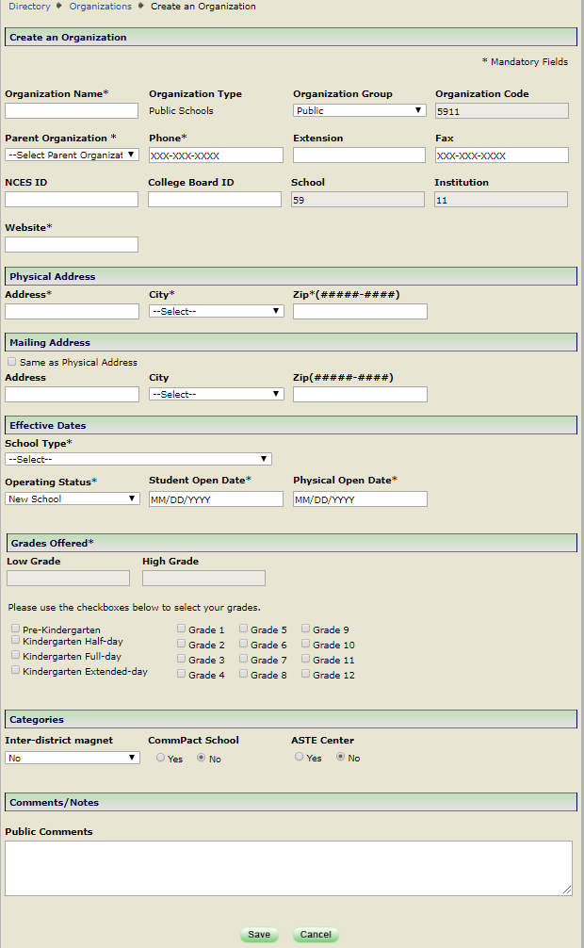

1. Enter the ORGANIZATION NAME, PARENT ORGANIZATION (select default, your district), PHONE, EXTENSION (if applicable), FAX (if applicable), WEBSITE, PHYSICAL ADDRESS, CITY, ZIP CODE, MAILING ADDRESS, Select Same as Physical Address (if applicable), CITY, ZIP CODE, OPERATING STATUS (defaults to New School), SCHOOL TYPE, STUDENT/PHYSICAL OPEN DATE (Use the same Date), GRADES OFFERED, INTER-DISTRICT MAGNET, COMMPACT SCHOOL, ASTE CENTER and select **Save**.

 **Important: Note about OPEN DATES:** DM follows the school year start and end dates set in state statutes (July 1 – June 30).  The OPEN DATE will determine the school year the organization shows in.

DM follows the school year start and end dates set in state statutes (July 1 – June 30). If a program/school is opening at the beginning of the school year, use 07/01/YYYY for Open Date/Effective Date, this allows districts to do their PSIS Summer Roll Up prior to the first day of school.

1. The new organization request screen is displayed.



1. Click OK. This procedure is complete.

** Note:** New program/school code requests require approval from the SDE DM Administrator.



## How to Edit a Program/School

1. Select **Organizations** from the left-hand navigation menu.



1. Select **Organization** to be edited.

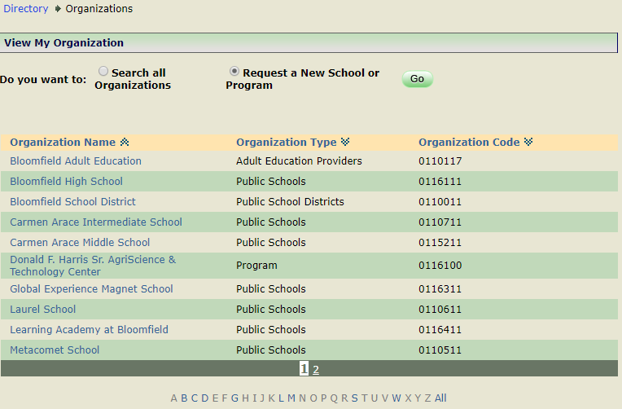

** Note:** For quick access to an Organization click the first letter of the Organization’s Name in the Alphabet strip below.

1. Select **Edit** *at the bottom of the screen.*

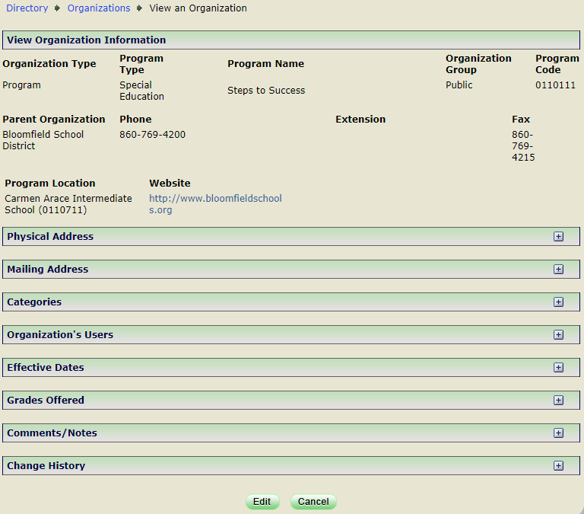

1. Update PROGRAM TYPE *(Programs Only)*, NAME, PHONE, EXTENSION, FAX, PROGRAM LOCATION *(Programs Only)*, WEBSITE, PHYSICAL & MAILING ADDRESS, CITY, ZIP, SCHOOL TYPE *(Schools Only),* OPERATING STATUS, TITLE I *(Schools Only)*, INTER-DISTRICT MAGNET *(Schools Only)*, COMMPACT SCHOOL *(Schools Only)*, DESIGNATED HIGH SCHOOL, ASTE CENTER *(Schools Only)*, STUDENT CLOSE DATE, FEEDER TOWNS *[Under Available Towns (select applicable town, then >>)] and [Under Selected Towns with Grades (put a check mark next to the same Town & Grades)],* GRADES OFFERED and select **Save***.*

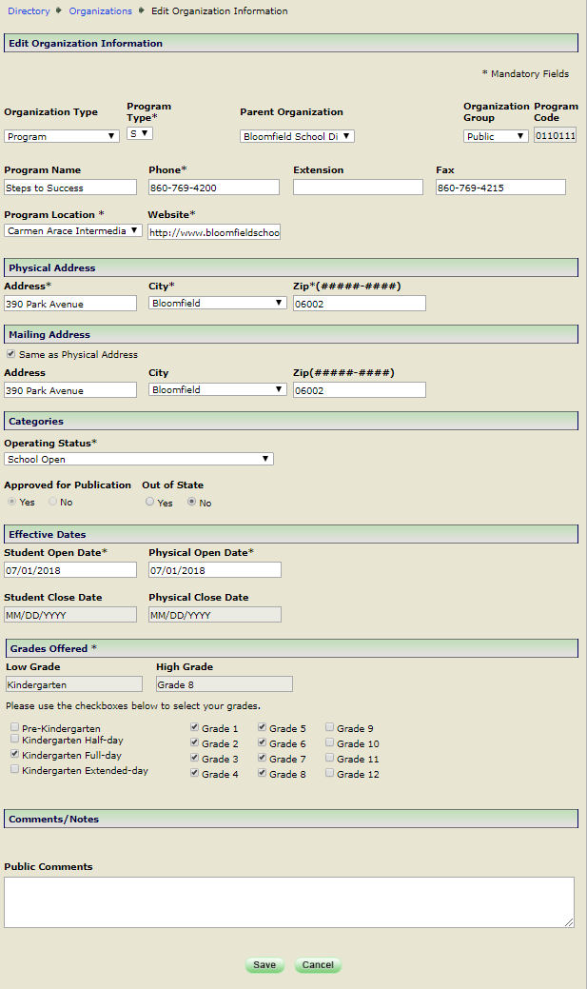

** Note:** The following fields will require you to enter an Effective Date: OPERATING STATUS, FEEDER TOWN, ASTE CENTER, GRADES OFFERED, DESIGNATED HIGH SCHOOL, INTER-DISTRICT MAGNET AND ORGANIZATION NAME.

 **Important: Note about EFFECTIVE DATES:** DM follows the school year start and end dates set in state statutes (July 1 – June 30).  The EFFECTIVE DATE will determine the school year the change shows in. If a change is happening at the beginning of the school year, use 07/01/YYYY for Effective Date. For programs/schools closing at the end of a school year, 6/30/YYYY would be used.

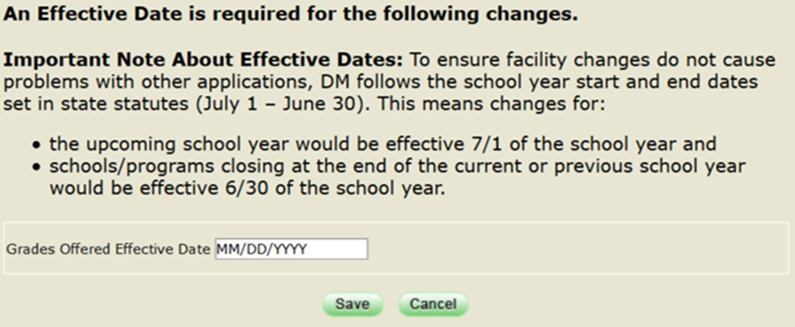

 **Important:** All other fields (i.e. PHYSICAL ADDRESS, SCHOOL TYPE, PROGRAM TYPE, and PROGRAM LOCATION) do NOT have EFFECTIVE DATES.This means the field should not be updated until such time the change occurs.

1. The changes to the user have been saved screen is displayed.

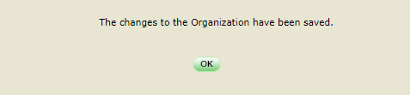

1. Click OK. This procedure is complete.

** Note:** The following fields will require approval by the SDE DM Administrator: ORGANIZATION NAME, OPERATING STATUS; STUDENT/PHYSICAL OPEN DATE, STUDENT/PHYSICAL CLOSE DATE, GRADES OFFERED and SCHOOL TYPE.



## How to Close a Program/School

1. Select **Organizations** from the left-hand navigation menu.



1. Select **Organization** to be edited.



** Note:** For quick access to an Organization click the first letter of the Organization’s Name in the Alphabet strip below.

1. Select **Edit** *at the bottom of the screen.*



1. Update OPERATING STATUS to **School Closed** and select **Save***.*



** Note:** The following fields will require you to enter an Effective Date: OPERATING STATUS, FEEDER TOWN, ASTE CENTER, GRADES OFFERED, DESIGNATED HIGH SCHOOL, INTER-DISTRICT MAGNET AND ORGANIZATION NAME.

 **Important: Note about EFFECTIVE DATES:** DM follows the school year start and end dates set in state statutes (July 1 – June 30).  The EFFECTIVE DATE will determine the school year the change shows in. If a change is happening at the beginning of the school year, use 07/01/YYYY for Effective Date. For programs/schools closing at the end of a school year, 6/30/YYYY would be used.



1. The changes to the user have been saved screen is displayed.



1. Click OK. This procedure is complete.

** Note:** Request to close a program/school code requires approval from the SDE DM Administrator.



## How to Re-Open a Program/School

1. Select **Organizations** from the left-hand navigation menu.
2. Select **Closed.**
3. Select **Organization** to be re-opened.

** Note:** For quick access click the first letter of the Organization’s Name in the Alphabet strip below.

1. Select **Edit** *at the bottom of the screen.*
2. Update OPERATING STATUS to **School Open***.*

** Note:** the Student/Physical Open Dates, Student/Physical Close Dates, and Grades Offered are cleared.

1. Verify the SCHOOL/PROGRAM NAME, SCHOOL/PROGRAM TYPE, PHONE, EXTENSION (if applicable), FAX (if applicable), PROGRAM LOCATION (if applicable), WEBSITE, PHYSICAL ADDRESS, CITY, ZIP CODE, MAILING ADDRESS, CITY, ZIP CODE.
2. ENTER the STUDENT/PHYSICAL OPEN DATE (use the same Date) and GRADES OFFERED and select **Save***.*

 **Important: Note about OPEN/EFFECTIVE DATES:** DM follows the school year start and end dates set in state statutes (July 1 – June 30).  The OPEN DATE will determine the school year the organization shows in. If a program/school is re-opening at the beginning of the school year, use 07/01/YYYY for Open Date/Effective Date, this allows districts to do their PSIS Summer Roll Up prior to the first day of school.

** Note:** The following fields will require you to enter an Effective Date: OPERATING STATUS, FEEDER TOWN, ASTE CENTER, GRADES OFFERED, DESIGNATED HIGH SCHOOL, INTER-DISTRICT MAGNET AND ORGANIZATION NAME.

1. The changes have been saved screen is displayed.
2. Click OK. This procedure is complete.

** Note:** Request to re-open a program/school code requires approval from the SDE DM Administrator.



## Annual Verification of Programs/Schools

Check with your Superintendent/Special Education office:

* + Is your district opening any new programs/schools?
  + Is your district closing any programs/schools?
  + Are existing programs/schools changing:
    - PROGRAM/ORGANIZATION NAME
    - PROGRAM TYPE (for programs only)
    - PROGRAM LOCATION (for programs only)
    - SCHOOL TYPE (for schools only)
    - PHONE
    - WEBSITE
    - PHYSICAL ADDRESS
    - MAILING ADDRESS
    - GRADES OFFERED - *Accuracy is critical for student systems like PSIS.  Even small changes like changes in the types of kindergarten offered can cause errors.*
    - Effective Dates

 **Important: Note about EFFECTIVE DATES:** DM follows the school year start and end dates set in state statutes (July 1 – June 30).  The EFFECTIVE DATE will determine the school year the change shows in. If a change is happening at the beginning of the school year, use 07/01/YYYY for Effective Date. For programs/schools closing at the end of a school year, 6/30/YYYY would be used.



# FAQs

## I am having trouble logging in to the Portal?

1. First, try closing ALL browser windows and log into the application again. *For Portal Applications if you walk away from your computer or do not do anything for a certain period of time, you will be timed out (automatically logged out of the application you were in).*
2. If that does not work, *the link you are using may be corrupted*, try using this link: <https://csde.ct.gov/>.
3. If that does not work, click this link (<http://sdeportal.ct.gov/portaluser/>), then Forgot Password to re-set your password.

## I cannot remember my password?

Click this link (<http://sdeportal.ct.gov/portaluser/>), then Forgot Password to re-set your password.

# APPENDIX

## Table A: Program Types

| **Value** | **Program Type** | **Definition** |
| --- | --- | --- |
| 7 | Agricultural Science & Technology Education (ASTE) | Shared- time agricultural science and technology education programs serving secondary students on a part-time basis.  Each program, located at a comprehensive high school, includes instruction in agricultural science and technology education.  The purpose is to prepare individuals for entry-level employment or higher education and to develop leadership skills in the field of agriculture.  Part-time vocational agriculture programs do not include full time interdistrict magnet schools. |
| 3 | Alternative Education | Alternative programs exist to engage and educate students who may not have realized their fullest potential in the regular setting.  These programs use curriculum and methods that are nontraditional and offer more flexible programs of study.  Alternative programs can be off-site of the typical school setting or embedded using school-within-a-school models. |
| 9 | Dropout Diversion/Credit Recovery | Dropout diversion programs are designed to provide a positive and rewarding school learning experiences for students who are at risk of dropping out of school.  These programs focus on improving work/study habits such as organizational skills and productivity.  The purpose of credit recovery programs are to allow students in grades 9-12 to recover academic credit lost due to course failure and to complete coursework required for graduation. |
| 10 | Expulsion | Expulsion programs that require organization codes exist at a separate physical location, are run year-round and can have students placed into them who are not there due to a suspension/expulsion.  If students, whom are not expelled, can be placed into the district’s expulsion program as an alternative setting or by PPT; the Expulsion program must have an Organization Code. Education programming for students serving expulsions or long-term out-of-school suspensions, as required under C.G.S. Section 10-233c.  Do not use this code for homebound programs for expelled students. |
| 8 | Other | Use this option only when the above descriptors are inappropriate descriptions of the main design and intent of the program.  Any use of this option will be reviewed by the SDE for selection accuracy and consideration for creating a new program type. |
| 5 | Part-Time Magnet | Interdistrict, part-time programs that support racial, ethnic and economic diversity, and offer a theme-based, high-quality curriculum (*Connecticut General Statutes Section 10-264h and 10-264l et seq.*).  Part-time magnet programs do not include full-time interdistrict magnet schools, regional agricultural science and technology schools, technical high schools or a regional special education centers. |
| 2 | Pre-Kindergarten | Programs designed solely to deliver pre-kindergarten services/early childhood education in separate settings.  For example, obtain an organization code with a pre-K program type for buildings that only house preschool classes or district-wide pre-K programs that place all pre-K students into one location even though the district has more than one elementary school. |
| 4 | Special Education | Programs designed for students with disabilities receiving special education and related services under IDEA.  These programs are generally designed to serve students with a specific primary disability and/or behaviors.  This code exists for segregated special education programs designed to draw students with disabilities from multiple schools across the district or which are situated in a separate building. Only district-wide special education programs should be reported using this program code; do not use this code to report all special education classrooms/resource rooms in a district. |
| 12 | Special Education-Pre-K Only | Use this option if your Special Education program only serves Pre-Kindergarten students. |
| 1 | Technical Satellite | Full-time or part-time programs designed to offer vocational, technical and technological education and training.  This code should be used for programs like the Bristol Technical Education Center.  (Do not use this field to report CTHSS schools; this attribute is for programs only.) |
| 13 | Public Transition Program (PTP)  cid:image001.png@01D55E6F.EB0EE3A0Please Note: Effective July 1, 2019 Public School-Based Transition Program (PSBTP (value 6)) and Transition Community-Based Program (TCBP (value 11)) have been collapsed into one. | 1. A transition program operated by a public school district/RESC (governed by the CT State Board of Education); 2. **Located in a district high school, on a high school campus, or in a community location**; 3. Provided to students between the ages of 18 and 21 years old who have completed academic credits toward a regular High School Diploma, OR who are not working on academic credits toward a regular High School diploma; 4. Provided to students who are working solely on secondary transition goals and objectives through an individualized education program (IEP), which may include functional academics. |

## Table B: School Type

|  |  |
| --- | --- |
| Value | List |
| 1 | Traditional/Regular Education |
| 2 | Alternative School |
| 3 | Special Education School |
| 5 | Intradistrict Magnet School |
| 7 | Charter School |
| 8 | Technical High School |

## Table C: Organization Type

They ID numbers and groups are used for analysis and grouping. We are no longer using the organization code to determine the specifics about an organization/facility.

|  |  |  |  |
| --- | --- | --- | --- |
| **ORGANIZATION_TYPE (NAME)** | **ORG_GROUP_ID\***  1=Public;  2=Non-Public | **ORGANIZATION_**  **TYPE_ID** | **non_public_subtype_id** |
| Adult Education Providers | 1 | 17 |  |
| Colleges and Universities | 1 | 113 |  |
| Community Pre-K \***\*All Closed Effective 6/30/2021\*\*** | 2 | 7 |  |
| Cooperative Educational Service Center *(Project Oceanology, Shared Services)* | 1 | 120 |  |
| CSDE | 1 | 1 |  |
| CT Technical Education Career System (CTECS) Districts | 1 | 8 |  |
| CT Technical Education Career System (CTECS) Schools | 1 | 16 |  |
| Endowed and Incorporated Academies Districts | 1 | 20 |  |
| Endowed and Incorporated Academies Schools | 1 | 22 |  |
| Generic | 2 | 99 |  |
| Hospitals | 1 | 114 |  |
| Non-profit Organizations | 2 | 71 |  |
| Nonpublic Elementary and Secondary Schools | 2 | 21 | * **Null** = Standard Non-Public * **1** = Transition Vocational Service Provider (**TVSP**), * **2** = Approved Private Special Education Program (**APSEP**) * **3** = Hospital |
| Non-Public Group | 2 | 6 |  |
| Permanent Family Residence | 2 | 27 |  |
| Private Colleges and Universities | 2 | 124 |  |
| Program (Public School Districts, Regional School Districts, Regional Education Service Center School Districts, Connecticut Technical Education and Career System District, Endowed and Incorporated Academies Districts, College Affiliated School Districts) ) | 1 | 87 |  |
| Public Charter School Districts | 1 | 9 |  |
| Public Charter Schools | 1 | 13 |  |
| Public School Districts (Town-Based, i.e. districts 1-169) | 1 | 10 |  |
| Public Schools | 1 | 11 |  |
| Regional Education Service Center School Districts *(ACES, CREC, CES, EASTCONN, EdAdvance, LEARN)* | 1 | 14 |  |
| Regional Education Service Center Schools | 1 | 112 |  |
| Regional School Districts | 1 | 12 |  |
| Regional Schools | 1 | 23 |  |
| State Agencies  *(****336****-*[*Unified School District #1*](javascript:__doPostBack('dtgOrganization$ctl09$ctl00','')) *(USD#1),*  ***337****- Department of Mental Health and Addiction Services (DMHAS),* ***347****- Unified School District #2 (USD#2 DCF), 349-OEC)* | 1 | 15 |  |
| State Agency Facilities | 1 | 18 |  |
| College Affiliated School Districts | 1 | 24 |  |
| College Affiliated Schools | 1 | 115 |  |

## Table D: Grades Offered

|  |  |
| --- | --- |
| Value | List |
|  | Pre-kindergarten |
|  | Kindergarten Half-day |
|  | Kindergarten Full-day |
|  | Kindergarten Extended-day |
|  | Grade 1 |
|  | Grade 2 |
|  | Grade 3 |
|  | Grade 4 |
|  | Grade 5 |
|  | Grade 6 |
|  | Grade 7 |
|  | Grade 8 |
|  | Grade 9 |
|  | Grade 10 |
|  | Grade 11 |
|  | Grade 12 |