Activity 8.7.1 Exploring the Archimedean Solids
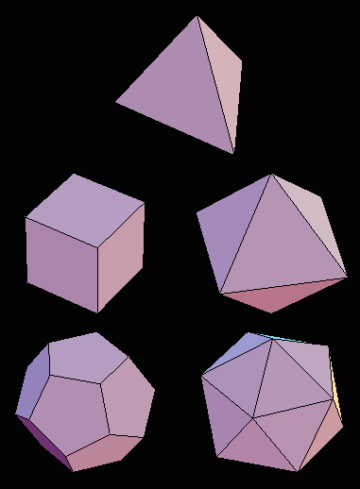
In Unit 6 you studied the five regular polyhedra, also called Platonic solids, shown at the right. You may want to review Activity 6.1.3 at this time.
1. Identify by name each of the regular polyhedron in the figure at the right.

When we tried to build solid shapes out of one regular polygon we found that the sum of the angles at each surface must be less than 360°. (This property is true for all convex polyhedra. Non-convex polyhedra are another story!) Consequently we needed at least 3 polygons around a vertex and no more than 5 around a vertex.
www.geom.uiuc.edu
Let us now explore what happens if we make Archimedean solids, which belong to the set of figures called semi-regular polyhedra. The faces of these polyhedra are all regular polygons, but there are two or more types of polygons. At each vertex, however, the polygons must be arranged in exactly the same way. In Unit 6 we proved that there are exactly 5 regular polyhedra. The question now arises, how many semi-regular polyhedra are there?

- Let’s begin by making a table of the measure of the interior angles of regular polygons as we did in Unit 3.

Regular Polygon | Number of Sides | Angle in degrees
Triangle | 3
Square | 4
Pentagon | 5
Hexagon | 6
Heptagon | 7
Octagon | 8
Nonagon | 9
Decagon | 10
Dodecagon | 12

- Why do we need at least 3 polygons at a vertex in order to make a polyhedron?

- Recall the term Schläfli symbol from Unit 6. The Schläfli symbol for a regular dodecahedron is 5.5.5. Write the Schläfli symbols for the other 4 regular polyhedra.

- Recall from Unit 6 that a regular dodecahedron has 3 regular pentagons at each vertex. Why did we conclude that it would be impossible to make a regular polyhedron with regular polygons having 6 or more sides?
- Looking at the chart above, what is the largest number of regular polygons that could fit around the vertex of a convex polyhedron? Explain.
- Suppose that we try to build a convex polyhedron with four different polygons meeting at each vertex. The simplest way to do this would be to use a triangle, a square, a pentagon and a hexagon, with Schläfli symbol 3.4.5.6. What would be the sum of the measures of the angles at one vertex? What does that tell you?

- If we substitute any one of these with another regular polygon then the sum of the measures of the vertex angles would be even larger. So what can we conclude about the number of different types of polygons that meet at each vertex? State your rule here:

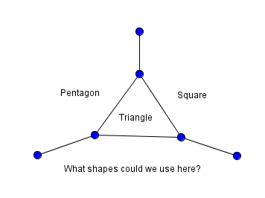
- So now we have three restrictions on the vertex configuration of a semi-regular polyhedron: (1) there must be a least 3 polygons at each vertex, (2) there can be no more than 5 polygons at each vertex and (3) there cannot be more than 3 different types of polygons at a vertex.
Some experiments will suggest some other restrictions.

The diagram at the right shows one triangular face with its adjacent polygons:
  - Recall that each vertex configuration must be the same. So here we have 3.4.5 at the top vertex of the triangle. What would be the vertex configuration on the lower right vertex of the triangle?_________________ And what would be the vertex configuration on the lower left vertex of the triangle?_________________. Why is this a problem?
  - We seem to have a problem here! We have to conclude that we can only have a vertex configuration of 3.m.n under what condition?
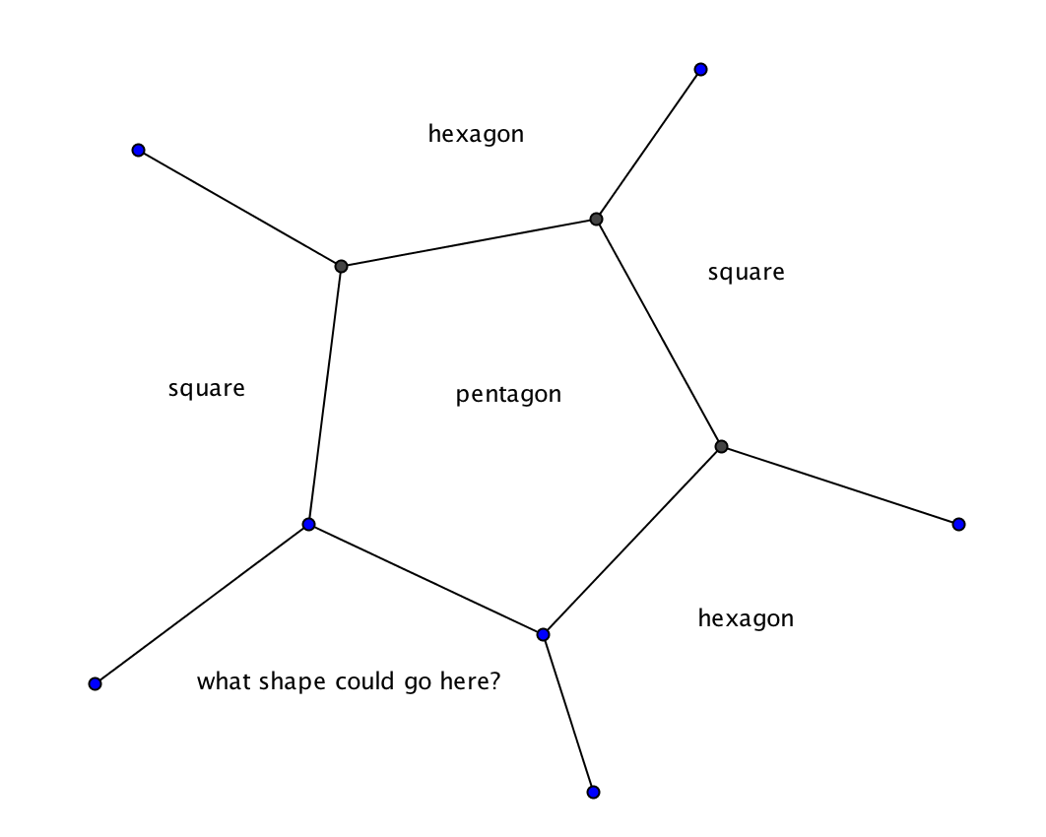
  - Now extend this concept to find restrictions on 5.m.n. Use this figure to help your reasoning.
Under what conditions can we have the vertex configuration of 5.m.n? Explain.

  - Generalize to every polygon with an odd number of sides: Suppose three regular polygons with k, m, and n sides meet at the vertex of a convex polyhedron and k is an odd number, then what can we say about m and n?
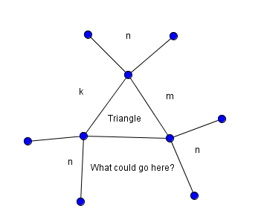
- Here is another diagram to explore. Here we have a triangle at the center and we are attempting to have the same vertex configuration at each of the vertices.
At the top vertex we have 3.m.n.k.
At the lower left vertex we have 3.k.n.?
At the lower right vertex we have 3.?.n.m
How can we resolve this so that all of the vertex configurations are the same? Fill in the blank:
No semi-regular polyhedron can have a vertex configuration 3.k.n.m unless k = ______.

Now let’s systematically explore the possibilities for semi-regular polyhedra.

- Start by listing possibilities with three polygons at each vertex. Cross out those that are regular polyhedra, that have a sum greater than or equal to 360°, or violate the rule in question 9 above. Check boxes that show why the possibility was eliminated.

Schläflli symbol | Regular polyhedron? | Sum too large? | k.m.n with k odd and m ≠ n.
3.3.3
3.3.4
3.3.5
3.4.4
3.5.5
3.6.6
3.7.7
3.8.8
3.10.10
3.12.12
4.4.4
4.4.5
4.4.6
4.4.n for any n ≥ 3
4.5.6
4.6.6
4.6.8
4.6.10
4.6.12
5.5.5
5.5.6
5.6.6
6.6.6
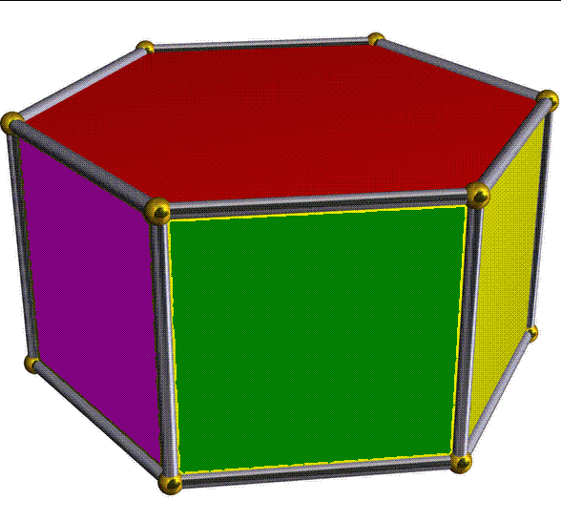
- The solid formed with two squares and a regular polygon (of any number of sides) at each vertex is a special type of prism. Write “P” next to each configuration that gives a prism. Although these figures satisfy the definition of “semi-regular polyhedron” they are not usually considered Archimedean solids.

Image from getmathfreehelp.jimdo.com
- Now list the remaining configurations. These represent possible Archimedean solids.
- Are there any possibilities with three regular polygons at a vertex that we overlooked and did not list in the chart? If so test them.
- Now let’s consider possible arrangements of 4 regular polygons at a vertex. Cross out those that are regular polyhedra, that have a sum greater than or equal to 360°, or violate the rule in question 10 above. Check boxes that show why the possibility was eliminated.

Schläflli symbol | Regular polyhedron? | Sum too large? | 3.k.m.n with k ≠ n
3.3.3.3
3.3.3.4 =3.3.4.3
3.3.3.5 = 3.3.5.3
3.3.n. 3 for n ≥ 3
3.4.3.4
3.4.3.5
3.4.4.4
3.4.5.4
3.5.3.5
3.4.5.5
3.4.6.4
3.5.5.5
3.6.3.6
4.4.4.4

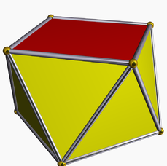
- The solid formed with three equilateral triangles and a regular polygon (of any number of sides) at each vertex is a special type of anti-prism. Write “A” next to each configuration that gives an anti-prism. Although when n ≥ 4 these figures satisfy the definition of “semi-regular polyhedron” they are not usually considered Archimedean solids. (Note the regular octahedron is also an anti-prism.)
Image from en.wikipedia.org
- Now list the remaining configurations. These represent possible Archimedean solids.
- Are there any possibilities with four regular polygons at a vertex that we overlooked and did not list in the chart? If so test them.
- Now let’s consider possible arrangements of 5 regular polygons at a vertex. Cross out those that are regular polyhedra or have a sum greater than or equal to 360. Check boxes that show why the possibility was eliminated.

Schläflli symbol | Regular polyhedron? | Sum too large?
3.3.3.3.3
3.3.3.3.4
3.3.3.3.5
3.3.3.3.6
3.3.3.4.4
19. List the remaining configurations. These represent possible Archimedean solids.

20. We have now found 13 possible Archimedean solids. In fact, each of these configurations does result in a semi-regular polyhedron. Select one or more of them to construct. (If you are working in a group you may be able to create all 13.)

  - Use GeoGebra, Geometer’s Sketchpad or hand geometry tools to make a net on cardstock for the shape.

  - Fold and glue it together. Record any patterns that you see here. Does it have any mirror symmetry? Does it have any rotational symmetry? These properties will be discussed in a future activity.
  - Verify that your polyhedron satisfies Euler’s formula (V + F = E + 2).

