Activity 8.6.1 Golden Ratio and Rectangles

Materials: compasses, straightedge

a. b.

c. d.

- The Senior Class at your school is preparing to design a rectangular logo for itself. Four rectangular frames have been suggested as a starting shape.
- Without consulting others, indicate which shape (a, b, c, or d) you think is most appealing. Prepare to share your reasons.

- Compare your preferences with those of others. Share your reasons.

- One of the rectangles above has a special proportion in how its width and length are related.

$\frac{length}{width}$ =$\frac{length+width}{length}$ OR $\frac{longer piece}{shorter piece}$ =$\frac{whole}{longer piece}$

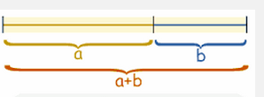
Here is a diagram with the same property. Imagine the rectangle’s width b is laid out beside the rectangle’s length a. Which rectangle seems closest to having the proportion shown?

- a. Translate the proportion in question 2 from words into symbols substituting a for the length and b for the width of the rectangle.
- Another way to express the ratio uses colon notation for ratios.

Length : Width :: Length + Width : Length

We read this as “The length is to the width as the sum of length and width is to the length.”

Write another version of the divine proportion using colons. Translate the statement into English.

- The ratio $\frac{a}{b}$from question 3 is considered very special. Architects, graphic designers, artists, and others have used this particular ratio as a basis for many famous creations. The ratio is named with the Greek letter phi (usually pronounced fie to rhyme with pie) symbolized ϕ. Phi goes by many names including golden ratio and golden mean.
The proportion from which it comes in question 3 is called the divine proportion.
When a line is divided in this ratio like the one in question 2, it is called a golden section. Rectangles with this l:w ratio are called golden rectangles.
- Find an equivalent expression for the right hand side of your equation in question 3(a).
- Write in words how the right hand side relates to the left hand side.
- Use the symbol ϕ to write the sentence again.

- For simplicity, let’s assume b = 1.
- Write the same proportion from 3(a) again with b = 1.
- Rewrite the sentence to clear the fractions. You should have a quadratic equation in the one variable a.
- Solve the quadratic equation. The positive root of the equation is an algebraic expression for the golden ratio, ϕ.

- Let’s construct a rectangle that has this golden ratio between length and width.
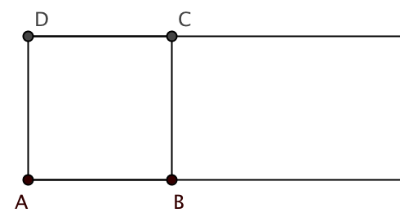
Use this diagram to help you follow the steps.
- Construct square ABCD.

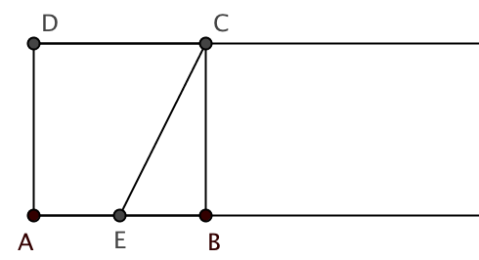
- Extend sides $\overline{AB}$ and $\overline{DC}$. Steps (a) and (b)

- Find the midpoint E of side $\overline{AB}$.
- Draw the segment from E to C. Steps (c) and (d)

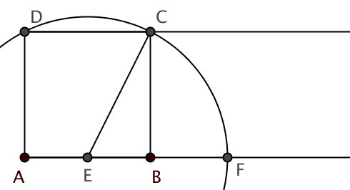

- Draw a circle with center E passing through C. Let F be the point where the circle intersects $\vec{AB}$.

Step (e)
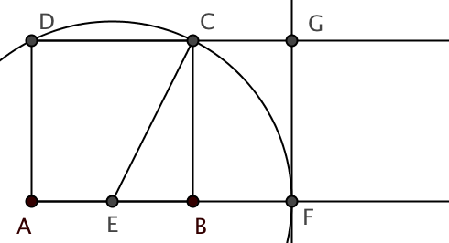
- Draw a line perpendicular to $\vec{AB}$ at F. Let G be the point where this line intersects $\vec{DC.}$

Step (f)

The result is a golden rectangle AFGD, one whose length to width ratio is the same as the total length plus width is to its length. Measure $\overline{AF}$ and $\overline{AD}$ and find the ratio $\frac{AF}{AD}$ to the nearest 0.01.

- Let’s verify that the rectangle you constructed in question 6 has the golden ratio:
$\frac{length}{width}$ =$\frac{ length+width}{length}$ This time it is helpful if we assume that the width of the rectangle is 2.

- Find the right triangle in 6(d) and use it to determine the length of the diagonal segment $\overline{EC}$.
- Find the $\frac{length}{width}$ ratio for rectangle AFGD. How do these results compare with the expression for phi you found in 5(c)?
- Find the $\frac{length+width}{length}$ ratio. We would like to show that this expression is the same as the one above. One way to simplify the radical expression in the denominator is to multiply by 1 in the form of $\frac{1-\sqrt{5}}{1-√5}$. Use this strategy to simplify your expression. The result should be the same as 7(b) and 5(c).

- Another surprising result of constructing the golden rectangle is that the narrow rectangle to the right of the original square is also a golden rectangle.
- Again, let the width of the original rectangle be 2. Note that this width is now the length of the smaller rectangle. Use what you have figured out to find the width of the new smaller rectangle.
- Write an expression for the ratio in the smaller rectangle of length to width. Simplify that expression. It should agree with earlier expressions for ϕ.

- At various points in this investigation we have suggested letting the width of the golden rectangle be 1 or 2. Why can we choose whatever value we like to check the golden ratio?

