Activity 8.4.4. Extensions for Investigating Pi

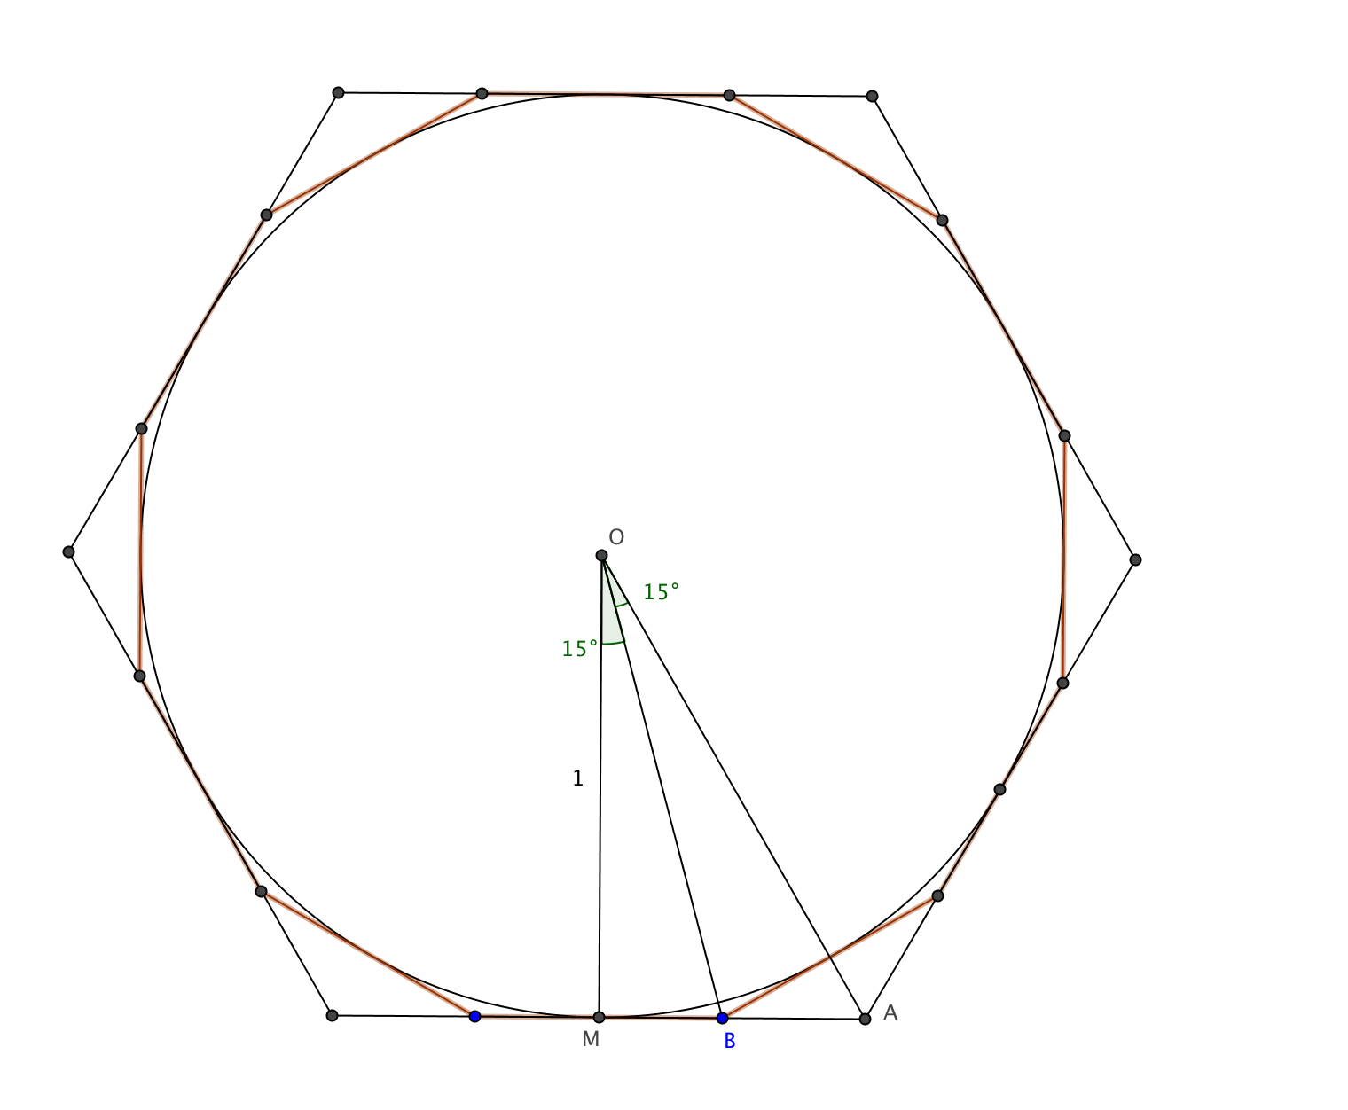
- Apply Archimedes’ method to circumscribed regular polygons. The figure shows a regular hexagon and a regular dodecagon circumscribed about a circle with radius = 1.
- Find the perimeter of the hexagon.
- Use this theorem to find the perimeter of the dodecagon: If a ray bisects an interior angle of a triangle then it divides the opposite side in the same ratio as the sides adjacent to the vertex of the angle. In the figure this means that $\frac{MB}{BA}$ = $\frac{OB}{OA}$. For more information see Stein, page 106.)

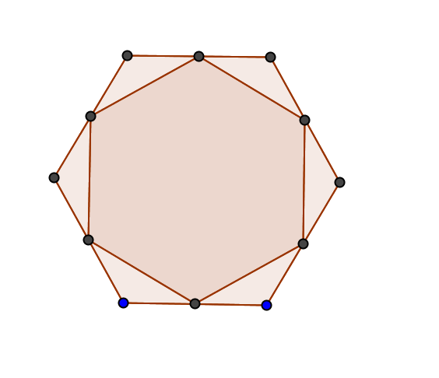
- Draw a regular hexagon. Make a new regular hexagon by joining the midpoints of the sides. What fraction is the area of the smaller hexagon as compared to the larger one? Examine similar questions for other regular polygons, for example equilateral triangles, squares, and regular pentagons.

- Learn more about Archimedes. What was particularly remarkable about his work? Explain one other mathematical idea he developed (besides the area and circumference of a circle.) One source is Archimedes: What Did He Do Besides Cry Eureka? (Stein, 1999).
- Make a timeline to show in what countries and what persons (if known) worked on estimating the ratio of the circumference of a circle to its diameter. One source is The Crest of the Peacock (Joseph, 1991).
- Learn more about the Rhind Mathematical Papyrus. It is a remarkable compendium of mathematical knowledge from around 1650 BC (over 3600 years ago). A man named Ahmes apparently transcribed the document from an earlier document. In the opening paragraphs of the papyrus, Ahmes presents the papyrus as giving "Accurate reckoning for inquiring into things, and the knowledge of all things, mysteries...all secrets" See Gillings (1972) for details.
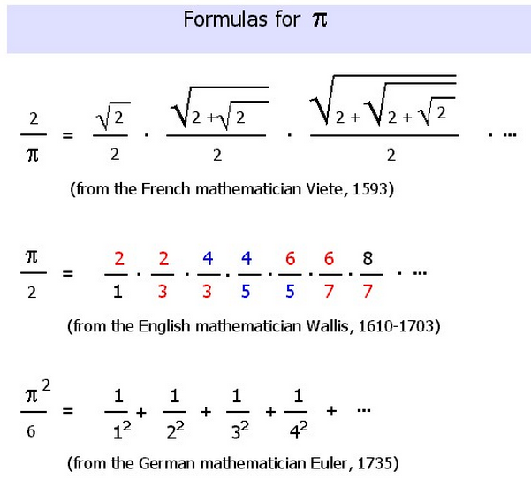
- With more advanced mathematics (trigonometry and calculus) people have been able to find patterned sequences (sums or products) that get closer and closer to π or to some expression related to π. Here are some examples:
- Find the first 10 or 20 values. To do this calculate the first term in the pattern. Then calculate the first two terms, then the first three, etc. For each, do the needed calculation to approximate pi π.
- How quickly do the different formulas converge (get very close to) 3.15159?
- For one of the infinite series, learn where it came from and explain this to others.

References:

Gillings, Richard J. (1972). Mathematics in the Time of the Pharaohs. New York: Dover Publications.
Joseph, George Gheverghese. (1991) The Crest of the Peacock: Non-European Roots of Mathematics. Hardmondsworth, England: Penguin Books.
Stein, Sherman (1999). Archimedes Traps Pi. In Archimedes: What Did He Do Besides Cry Eureka. Washington, D.C.: Mathematical Association of America.

