Activity 8.4.3 Archimedes’ Method of Doubling the Number of Polygon Sides

In this activity we will try to reconstruct more closely to his actual method (no trigonometry), how Archimedes made the first estimates for the value of π. First we will study his method for perimeters of regular polygons. Then we will study his method for areas of circles.
[Adapted from Redlands website and Jacobs Geometry.]

Archimedes (287-212 BCE) lived over 2200 years ago. He was able to use geometric reasoning to find an approximation for π, the ratio of the circumference of a circle to its diameter.

1. Archimedes’ overall plan was to sandwich the perimeter or circumference of a circle between two regular polygons, one inscribed inside the circle and the other circumscribed outside the circle.

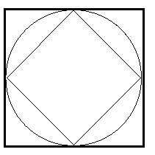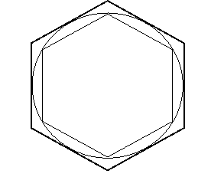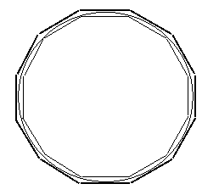

- How do the perimeters of the inscribed and circumscribed squares compare with the circumference of the circle?
- How do the perimeters for regular polygons with more and more sides compare with the circumference of the circle?

2. Let’s begin with a regular hexagon to help us find the circumference of the circle.

- Sketch a diagram to show a regular hexagon inscribed into a circle with radius 1.
- Use relationships you know about regular hexagons to show why the perimeter of the inscribed regular hexagon is 6.

- With this information alone, what is your estimate for the circumference of the circle?
- Sketch a diagram to show a regular hexagon circumscribed about a circle with radius 1.

- Where is the radius of 1 in this case?

- Use the small right triangle that is half of each equilateral triangle formed. (What special triangle is it?) Find s, the length of each side of the circumscribed hexagon. Show your reasoning.

- Find the perimeter of the circumscribed regular hexagon.

- Using the two perimeters what can you now say about the circumference of the circle?

- If you knew the circumference of the circle, how would you use it to find π, the ratio of the circumference to the diameter?

3. Archimedes recognized that he could get closer boundaries on the circumference of the circle if he had polygons with more sides. The easiest next step is to double the number of sides. So we will consider the regular dodecagon, the polygon formed by doubling the number of sides from the regular hexagon. We continue with the circle of radius 1.

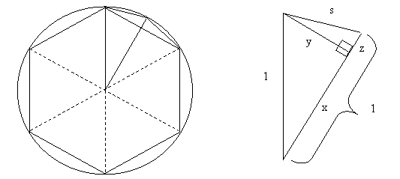

The diagram at the left shows the inscribed hexagon and the beginning of the inscribed dodecagon. At the right the important part of the diagram is magnified. Note that s is the new side length (of the regular dodecagon).

- Explain what is represented by each of the values y, x, z, and s.

- How do you know that the segment labeled y is perpendicular to the radius (x + z)?

- Find the value of y.

- With y and 1 you can find x. Use the Pythagorean Theorem. What is the value of x?

- Use what you know to find z.
- Use what you know to find the side of the dodecagon (the new s).

- Find the perimeter of the inscribed regular dodecagon.

- What can you now say about an estimate for the circumference of the circle?

- Finding the perimeter of the circumscribed dodecagon is an extension problem. See Activity 8.4.4 (Question 2).

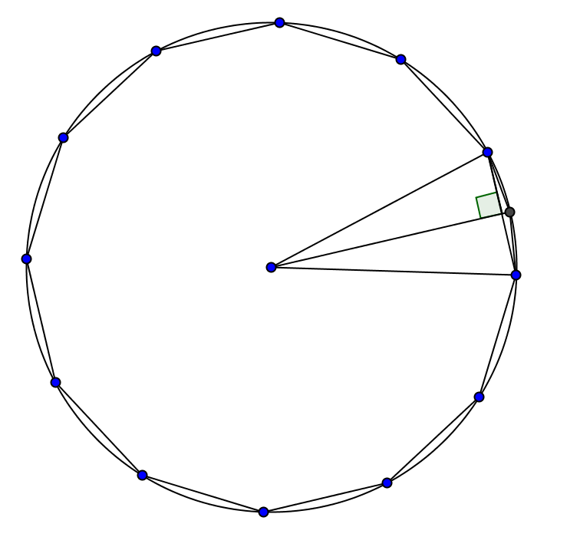
4. Once Archimedes found the perimeter of a regular dodecagon, he applied the same method to find the perimeter of a regular polygon with 24-sides. Use the value you found in questions 3(f) for the side of the dodecagon, shown in the figure at the left. Again, the radius of the circle is one unit. Follow steps (a) through (g) in question 3 to find the perimeter of the regular 24-gon.

5. You could repeat the steps in questions 3 and 4 to find the perimeters of a regular 48-gon and a regular 96-gon, as did Archimedes. (Remember he did not have a calculator and used fractions rather than decimals, so it took him a long time.) However, you may prefer to use this TI-84 program:

6N
1S
Lbl 1
S/2 Y
√(1–Y^2)X
1–XZ
√(Y^2+Z^2)S
2*NN
N*SP
Disp “NUMBER OF SIDES”
Disp N
Disp “PERIMETER”
Disp P
Disp “PRESS 1 TO GO ON”
Disp “OR 2 TO STOP”
Input A
If A = 1
Then
Goto 1
Else
End

- Use the calculator program to find the perimeter of a regular 96-gon inscribed in a circle with radius = 1 unit.
- Use the calculator program to find the perimeter of a regular 196,608-gon inscribed in a circle with radius = 1 unit.
- Now double the number of sides in (b), that is find the perimeter of a regular 393,216-gon. What do you notice?
- Find an estimate for π based on your results in (b) and (c). Compare that with your calculator’s value of π.

6. Carlos and Maria were having a debate. Carlos said, “When you have a fixed circle and regular polygons inscribed in it, if you double the number of sides, then you double the perimeter.” Maria said, “I disagree. The perimeter can’t be that big!” Take one of the sides and defend your position.

