Activity 8.4.2 Area of a Circle from Regular Polygons

In his book, Journey through Genius (1991), William Dunham described Archimedes of Syracuse (287 – 212 BC) as “a much revered, somewhat eccentric genius who dominated the mathematical landscape of the classical world.” (p.84) Among his multiple remarkable accomplishments Archimedes created a method for estimating the area of any circle, which, at the same time, created a surprisingly accurate estimate for what we now call π (pi.) We will use some of his ideas but with tools he did not have.
- The ancients knew that for all circles, the ratio of the circumference to the diameter is constant. Today we call that ratio π.
- Using what you know about similarity, explain why this constant ratio makes sense.
- What is the constant ratio for any square between its perimeter and side length?
- What is the constant ratio for any square between its perimeter and diagonal length?
- Show how to derive a formula for the circumference of a circle in terms of its radius from the constant ratio $\frac{c}{d}$= π
In this activity we are going to reconstruct Archimedes method using trigonometry, a tool not available to him.
- Archimedes’ idea was that the area of a circle could be estimated by finding areas of egular polygons inscribed in and circumscribed around a fixed circle.
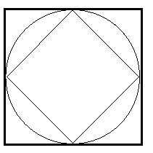
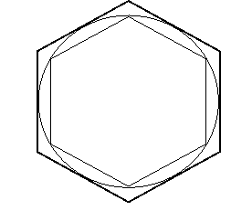
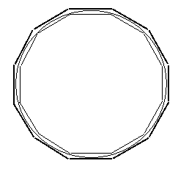

- What does it mean for a polygon to be inscribed in a circle?
- What does it mean for a polygon to be circumscribed around a circle?

- Suppose you could find the areas of both an inscribed and a circumscribed regular polygon. How would that help you estimate the area of the circle?
In Unit 5 you learned that you can circumscribe a circle about every triangle, but not every quadrilateral. So in general, not all polygons have circumcircles. However ,we can show that every regular polygon has a circumcircle. For a proof, see question 11 below. We’ll call the center of the circumscribed circle the center of the regular polygon.
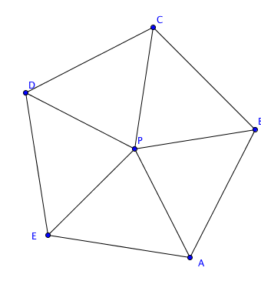
3. Let’s see how to find areas of regular polygons.
- One way to think about the area of a regular polygon is to decompose it into triangles with vertices at the center. Think about the case of the regular pentagon.

- How many triangles are formed?
- What types of triangles are they? How do you know?
- How do you know the triangles are congruent?
- The apothem of a regular polygon is the segment from the center of the regular polygon to the midpoint of any side. How do you know the apothem is also perpendicular to the side?

- Draw the apothem in one of the triangles. How do you know the apothem is the same regardless of which side you draw it to?

- Let a represent the length of the apothem. Let s represent the length of one side of the regular pentagon. Using a and s, write a formula for the area of each triangle.

- Use your formula in (g). What is a formula for the area of the entire regular pentagon?
- One general formula for the area of a regular polygon with apothem a is A = $\frac{1}{2}$ pa where p represents the perimeter of the polygon. Explain why this formula makes sense. Hint: Use your formula in (h) for the regular pentagon and see how you can generalize it.
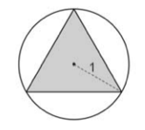
- Let’s begin to use Archimedes’ method. Consider the equilateral triangle inscribed in the circle. Let the radius of the circle be 1.

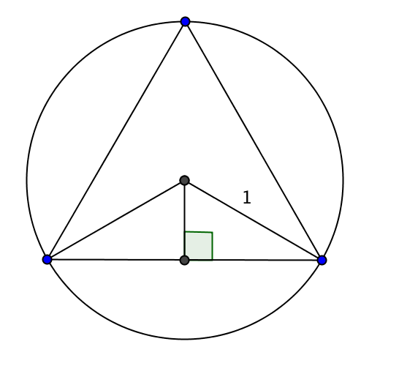
- Decompose the equilateral triangle into isosceles triangles. Find the angle measures in the isosceles triangle. Explain your reasoning.

- Draw an apothem to one side of the equilateral triangle forming two right triangles. What are the measures of the acute angles one of these triangles?
- Use the cosine ratio to find an expression for the height of the isosceles triangle.

- Use the sine ratio to find an expression for the length of the base of each isosceles triangle. Hint: Use the right triangle again.
- Find the area of each isosceles triangle.
- Find the area of the equilateral triangle.
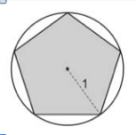
- Repeat the work from question 4 with a regular pentagon inscribed in a circle. Again, let the radius of the circle again be 1.

- Decompose the regular pentagon into isosceles triangles. Find the angle measures in the isosceles triangle.

- Draw an apothem to one side of the regular pentagon forming two right triangles. What are the measures of the acute angles one of these triangles?

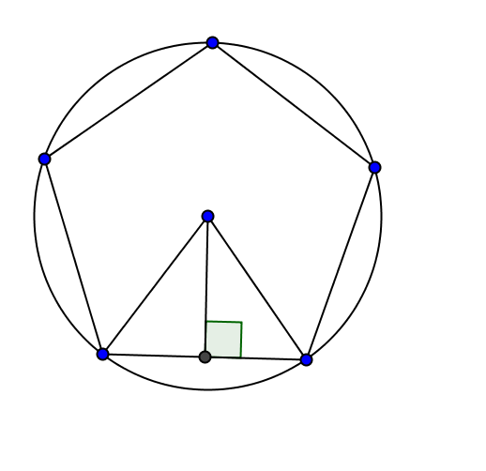
- Use the cosine ratio to find the height of the isosceles triangle. Hint: See 4(c).

- Use the sine ratio to find the base of each isosceles triangle.
- Find the area of each isosceles triangle.
- Find the area of the regular pentagon.

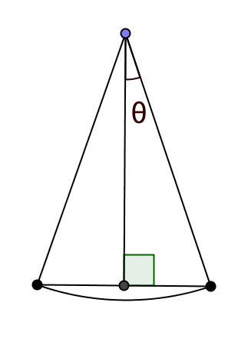
- Let’s generalize to find a formula for the area of any regular polygon inscribed in a circle of radius 1. Assume the regular polygon has n sides.

- How many isosceles triangles will you get when you decompose the n-gon by drawing radii to each vertex?
- What is the measure of central angle that intercepts one side of the regular polygon?
- Draw an apothem to one side of the regular polygon forming two right triangles with the radii and side. Let $θ$ be the measure formed by the apothem and the radius. Find $θ$ in terms of n.
- Use the cosine ratio to find the height of each isosceles triangle.
- Use the sine ratio to find the base of each isosceles triangle.
- Find the area of each isosceles triangle.
- Find a formula for the area of a regular n-gon inscribed in a circle of radius 1.

- Check your formula for a square. Inscribe a square in a circle of radius 1.
- Sketch your square inscribed in a circle of radius 1.

- Find the area of the square without trigonometry.
- Find the area of the square using the trigonometry formula you found in 6(g).

- Your results should agree. If not, rework your reasoning.

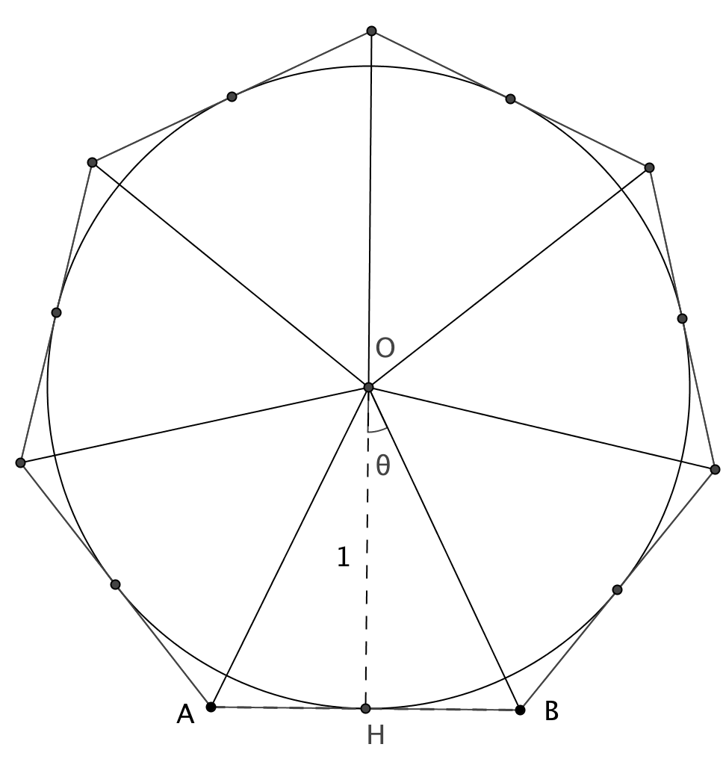
- Archimedes also circumscribed regular polygons around a circle. Our goal now is to find an expression for any regular n-gon circumscribed around a circle of radius 1. The diagram shows a regular heptagon (7 sides) but think about it as a general case.

- Subdivide the regular n-gon into isosceles triangles.

- Write an expression for the measure of each central angle (for example $∠OHB$ in the figure at the right).

- Draw a segment from the center of the circle to one of the points of tangency ($\overline{OH}$ in the figure above). Explain why this forms right triangles (e.g. ∆OHB in the figure).

- What role does the radius of 1 play in relation to the isosceles triangles?

- Study the small right triangle (half the isosceles triangle). Use the tangent ratio to write an expression for the base of the triangle.

- Find an expression for the area of the regular n-gon.

- Complete the table.
Note that (a) and (b) refer to inscribed regular polygons. (Use 6(g). Parts (c) and (d) refer to circumscribed polygons (Use 8(f)).

Regular  Polygon | a. Formula for Inscribed Polygon | b. Area for Inscribed Polygon | c. Formula for Circumscribed Polygon | d. Area for Circumscribed Polygon
Equilateral triangle  n = 3 | 3 sin60° cos60° | 1.299 | 3 tan 60° | 5.196
Regular quadrilateral
n = 4
Regular Pentagon
n = 5
Regular Hexagon
n = 6
Regular Heptagon
n = 7
Regular Octagon
n = 8
Regular Nonagon
n = 9
Regular Decagon
n = 10
Regular Dodecagon
n= 12

- a. What happens to the areas of the two polygons (inscribed and circumscribed)
as n gets larger?
- Choose an even larger value of n and fill in one more row of the table. What values to the inside and outside areas appear to be approaching? Why?

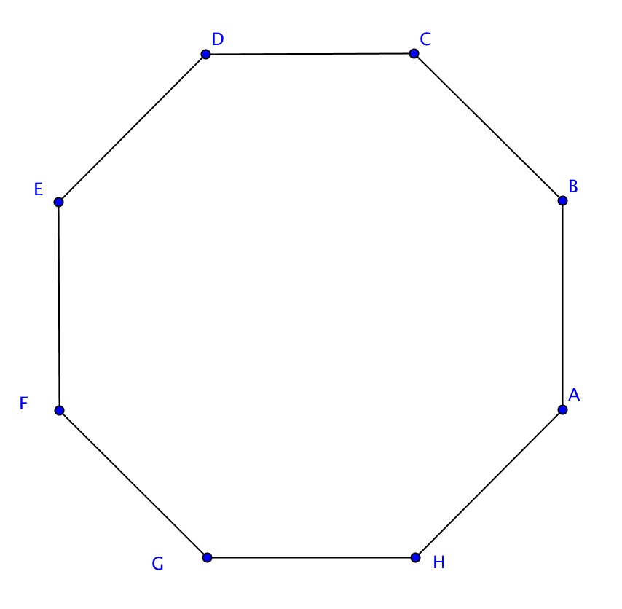
11. Prove that every regular polygon has a circumscribed circle.

- Start with a regular polygon. For our purposes we will use an octagon, ABCDEFGH.
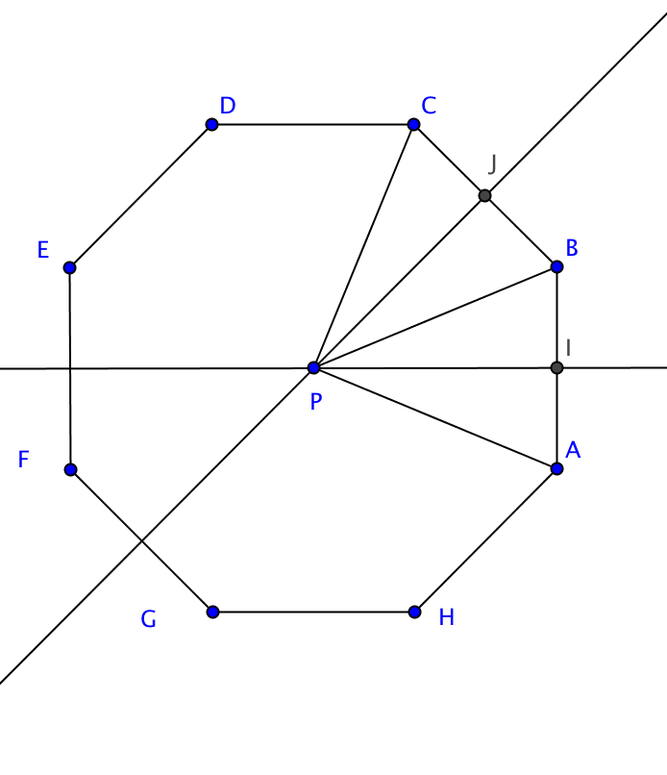
- Draw the perpendicular bisectors of two consecutive sides ($\overline{AB }$and $\overline{BC}$). Let P be the point where they intersect. Let I and J be the midpoints of $\overline{AB}$ and $\overline{BC}$ respectively.
Show that PA = PB = PC.

- Show that $\vec{BP}$ bisects $∠CBA$.
We have now shown that P is the same distance from vertices A, B, and C and that $\vec{BP}$ bisects $∠CBA.$To complete the proof we need to show that P is the same distance from the other vertices of the regular polygon.
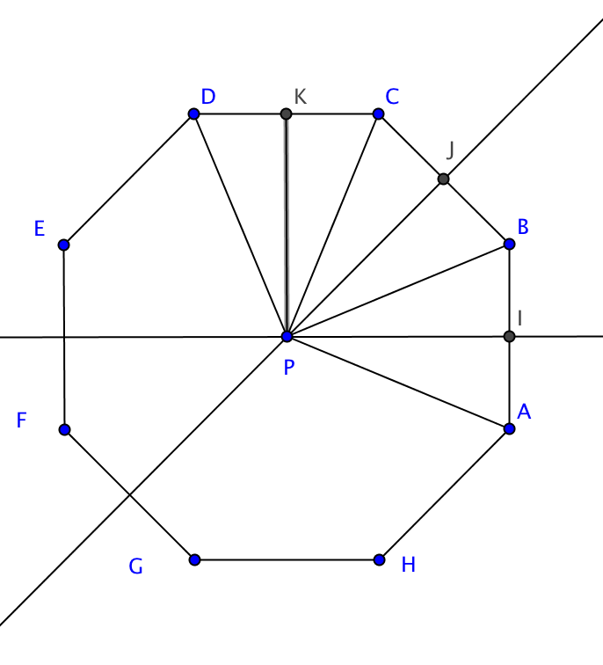
- Show that $∠PCB$ $≅∠PCD$.

- Show that PC = PD.

- Explain why steps (e) and (f) could be repeated for all the remaining vertices of the regular polygon, no matter how many sides there are.

- Explain why we now know why the circle with center P and radius = PA will pass through all the vertices of the regular polygon.

