Historical Estimates for Pi

In ancient times people had many conjectures about what value to give to the ratio of the circumference of a circle to its diameter. Today we call this constant value π (pi; Greek letter that begins the word perimeter, the meaning of circumference of a circle.) We take for granted that we have an approximate value (3.14159…) but people in the past worked very hard to find this value. With more advanced mathematics, we also have many formulas for determining pi to millions of decimal places. In this activity you will learn how ancients thought about this important ratio.

1. The Babylonians estimated the circumference of a circle to be about three times as long as the diameter. For the area of a circle they took, effectively, one-twelfth the area of a square whose side length was the length of the circumference.
a. Write a formula for the area of a circle according to the Babylonian method.
b. Rewrite the Babylonian formula to see clearly how it compares to A = πr².
2. The Rhind Mathematical Papyrus (from Egypt, 1650 BCE) gives the following method for finding the area of a circle:
- Start with the diameter.
- Find 1/9 of the diameter.
- Take that away from the diameter.
- Multiply that value by itself.
- That is the area of the circle.
- Translate these directions into a formula. Use d for the starting diameter.
- Substitute 2r for d. Simplify the new formula. What value for π does this formula yield? Write the answer with four decimal digits. How good is this estimate?
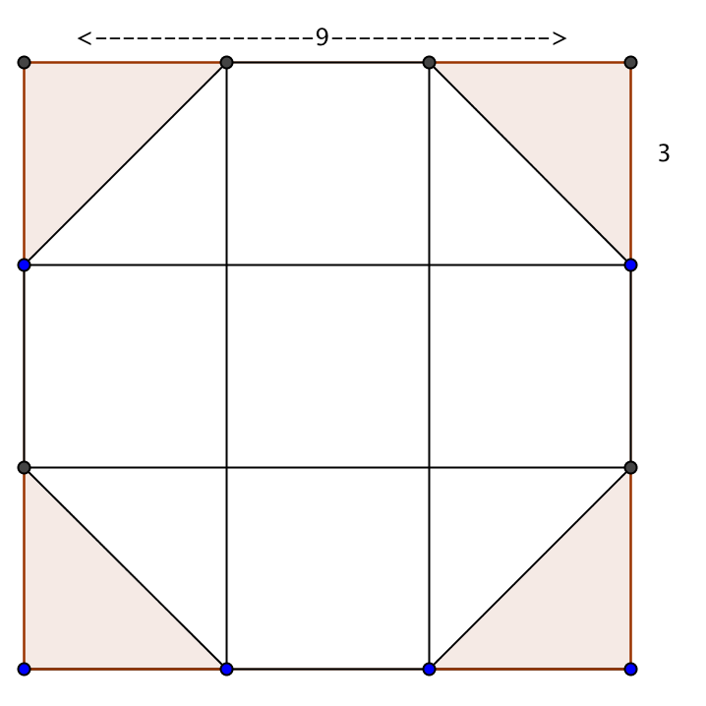
- One wonders where this formula or method came from. One explanation given by historian Kurt Vogel, is based on this octagon found in the Rhind Papyrus. Is the octagon regular?

from Gillings p. 143
- How is the octagon helpful in estimating the area of a circle?
- What is the area of the octagon?
- What whole number is very close to the square root of the area?
- The original square had edge of 9. What fraction of that length could be squared to produce nearly the same result for the area of the octagon (or circle)?
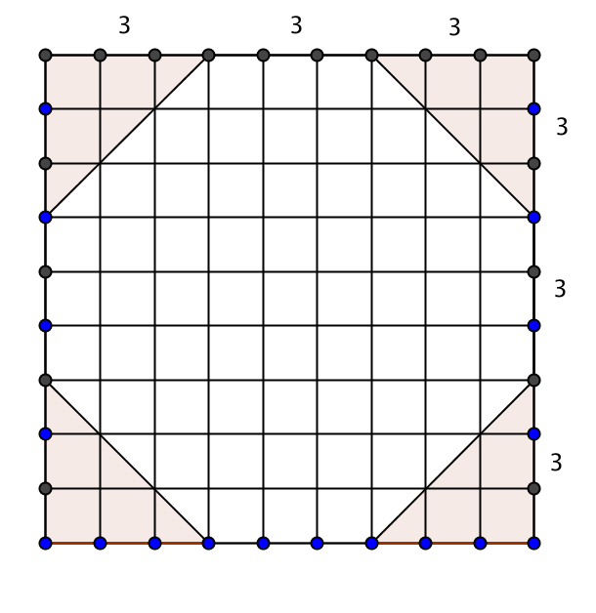
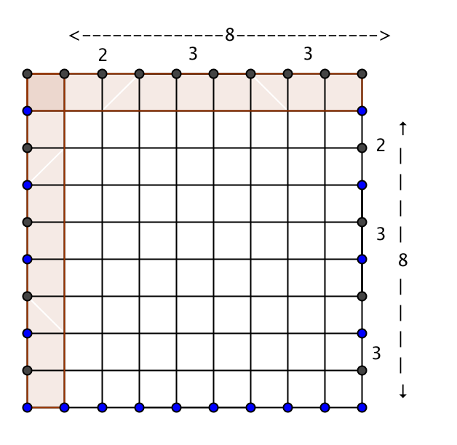
3. Here are other diagrams to help you think about the Egyptian formula of ($\frac{8}{9}d$)² for the area of a circle. (Gillings p. 145)
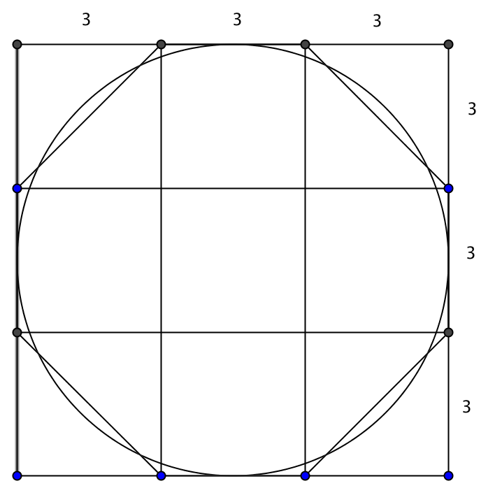
- How does the diagram of the octagon with the circle help you see why the area of the octagon is so close to the area of the circle?

- How does the area of the white square on the right compare to the area of the octagon (in the middle)?

- Use the diagrams to explain again why the Egyptian’s formula for area of a circle, ($\frac{8}{9}d$)² worked so well.

4. A Hindu mathematician, Bramaguptra (ca. A.D. 628) gave $\sqrt{10}$as the “exact value” of pi. (NCTM, 1969, p. 151).

a. What would have been Bramaguptra’s formula for finding the circumference of a circle?

b. What would have been Bramaguptra’s formula for finding the area of a circle?

c. What percent error does Bramaguptra’s value produce?

5. Liu Hui, a Chinese mathematician wrote in the 3rd century AD that the area of a circle was equal to the area of a right triangle formed by the radius of the circle and its circumference. (This relationship was also known by the Greek mathematician Archimedes, 500 years earlier)

a. How does this method compare to our standard practice of using A = πr² to find the area of a circle?
b. Sketch a diagram to show what this method looks like.
c. Does this method depend on knowing the value of π?

d. Try to imagine how the Chinese came to this idea.

References:
Gillings, Richard J. Mathematics in the Time of the Pharaohs. New York: Dover Publications, 1972.
National Council of Teachers of Mathematics. Historical Topics for the Mathematics Classroom. Thirty-first Yearbook of the National Council of Teachers of Mathematics. Washington, D. C.: NCTM, 1969.

