Activity 8.1.3 Classifying and Analyzing Border Designs

In the previous two activities you found mirror symmetries (some on horizontal mirrors, some on vertical mirrors), half-turn symmetries, and other ways of moving one part of a design to get it to repeat nicely on a border. You also matched Conway’s language of movement (walk, hop, spinning jump, etc.) to different foot patterns for each of the 7 possible designs.

Here is a partially completed chart to summarize what you have found and to add more mathematical language.
Conway  Name | Activity 8.1.2 items  1–7 | Feet Examples | Mathematical  Description | IUC Symbol
Hop |  |  | Translation (slide) only
Jump |  |  | Horizontal Mirror (only)
 |  | 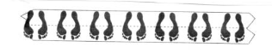 | Vertical Mirror (only)
Step |  |  | Glide Reflection
 |  |  | 180° Rotation (only)
Spinning Jump |  |  | Horizontal mirror & vertical mirror
 |  | 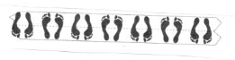 | Vertical mirror & 180° rotation

- Complete the first three columns. Be prepared to explain your reasoning.
- Study the table. What helps you best to recognize the different types of border designs?

- Return to the 12 cultural examples of border designs in Activity 1 and classify each of them using Conway’s terms. Explain your reasoning.

- The International Union of Crystallography (IUC) uses symbols to describe the seven frieze patterns. Each symbol consists of 4 characters:
- The first character is always “p” for “periodic” (repeating). This indicates that the pattern has translational symmetry.
- The second characters is “m” if the pattern has vertical mirror lines and “1” if it does not.
- The third character is “m” if the pattern has a horizontal mirror line, “g” if has glide reflection but no horizontal mirror line and “1” if it has neither.
- The fourth character is “2” if there are 2-fold (180°) centers of rotation, otherwise it is “1.”
The seven frieze pattern symbols are thus: p111, p1m1, p112, p1g1, pmm2, pm11, and pmg2. This flow chart can help you identify each pattern.
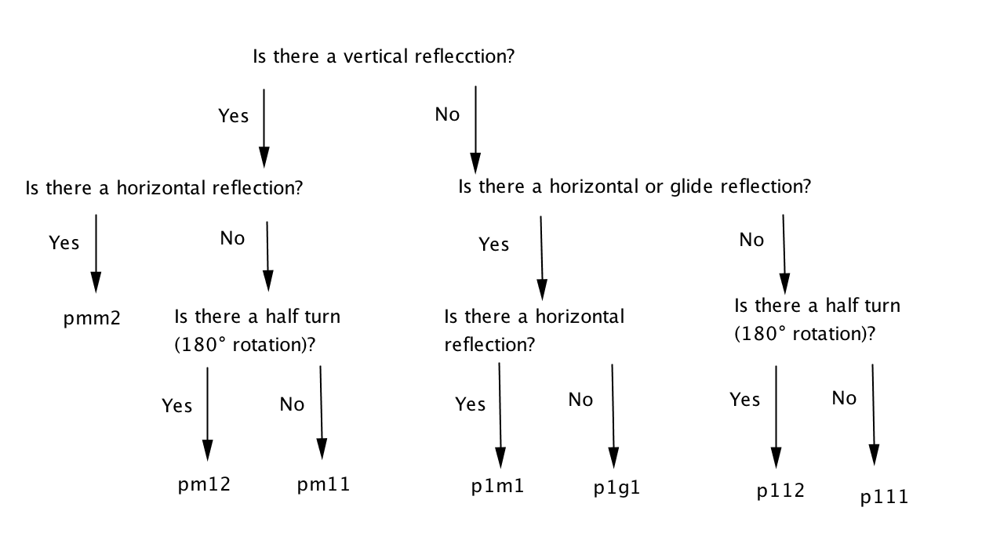

- Use the flow chart to help you fill in the last column in the chart on page 1 with the appropriate IUC symbol.

- Use the flow chart to help you find the IUC symbol for each example in Activity 1.

5. Use combinations of the lower case letters “b,” “d,”, “p,” and “q” to make each of the seven frieze patterns. For example bqbqbqbq could represent the pattern with IUC symbol p112. Find a similar pattern for each of the other six IUC symbols. You may need to use a second line of letters.

- pmm2

- pmg2

- pm11

- p1m1

- p1g1

- p111

