Activity 8.1.2 Creating Seven Types of Border Designs

Materials: adding machine tape, template for a scalene triangle, mira, tracing paper.

One way to see the few basic types of border designs is to make them yourself.
In this activity we will use a scalene triangle.

1–7. For each of the following use the border design below that has been started for you.

- Continue the design for each ‘starter.’
- Write in words what you had to do to continue the design.

- Say where you used or imagined a vertical or horizontal mirror.
- Say where you used or imagined a half-turn.
- Explain anything else you did or thought about to continue the design.
1.
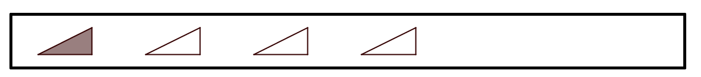

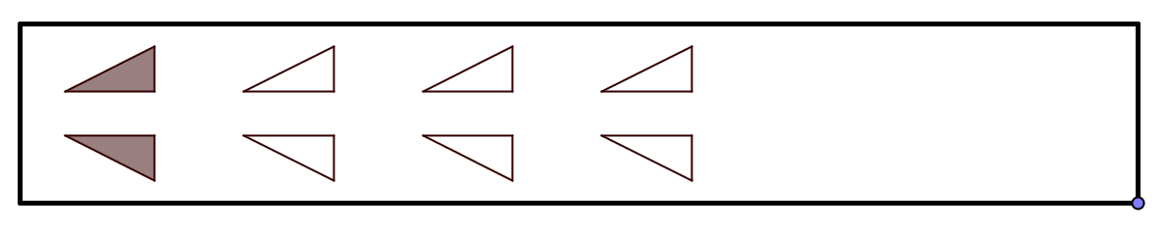
2.

3.
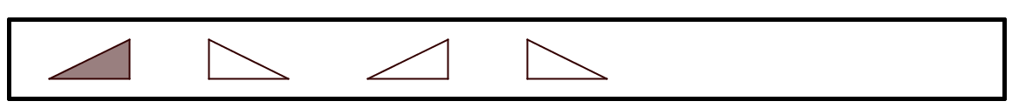

4.
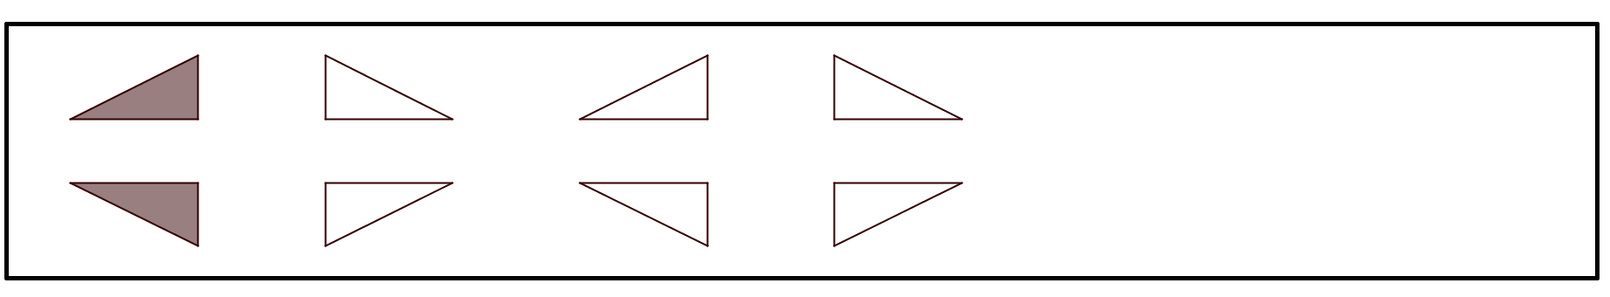

5.
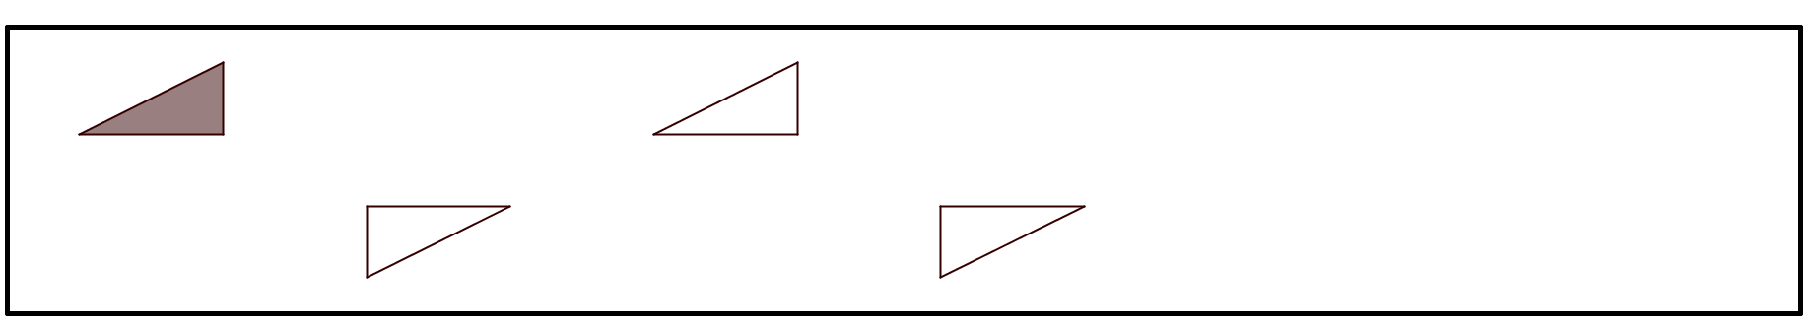

6.

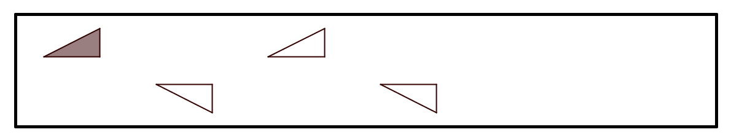

7.
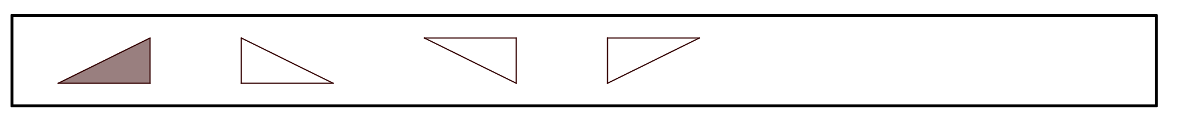
The English mathematician John H. Conway used images of feet along with words related to dance and movement to describe the seven patterns that you have made. Observe that no two of these patterns have the same set of symmetries. Border designs can be classified according to the symmetries they posses and there are exactly seven different types. This will be shown in Activity 8.1.3.
Here are Conway’s pictures:

a. b.
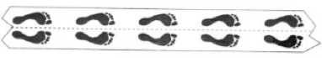

c. d.
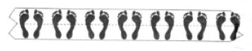
e. f.
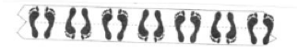

g.

- Below are the names are the names Conway chose to describe each type of border pattern. Match each phrase with one of the lettered feet patterns above. Tell why you believe each match makes sense. [Hint: Imagine moving from left to right as when you extended the scalene triangle patterns. Note that ‘spinning’ means doing a half-turn or 180° turn.]

- Hop (forward on one foot)
- Jump (on two feet)
- Sidle (move both feet sideways)
- Step (walk naturally)
- Spinning hop
- Spinning jump
- Spinning sidle

- Match Conway’s descriptions with each of the patterns in questions 1–7.

