**Activity 8.1.1 Introduction into Matrices**

1. Use the table below to make a list of several different categories of items that you organize into “containers” (Example: your clothing in a chest of drawers). Write down how organizing your items simplifies working with them.

|  |  |  |
| --- | --- | --- |
| Item | “Container” | Method for Organizing Items, how does this help? |
|  |  |  |
|  |  |  |
|  |  |  |
|  |  |  |

1. Share you lists with your classmates. Discuss as a group how organizing things makes working with them more efficient and decide if there is something in common that emerges from the discussions. Is there something that containers for organizing things have in common that makes organizing the contents easier?
2. Give some examples of situations that involve organizing data that makes it easier to work with. Make a list of “containers” that we use when working with data. (Example: a table) ____________________________________________________________________________

­­­­­­­­­­­­­­­­­­­­­­­­­­­­­­­

1. Compare and contrast these various methods.
2. What do they have in common? _________________________________________
3. How do they differ? ____________________________________________
4. Look at the data below that has been organized into a spreadsheet with rows and columns.

|  |  |  |  |  |
| --- | --- | --- | --- | --- |
|  | Food | Gas | Lodging | Show tickets |
| Hartford | 42 | 12 | 76 | 45 |
| New Haven | 63 | 16 | 64 | 76 |
| Danbury | 38 | 20 | 82 | 72 |

Make up a story about the data in the spreadsheet. This is a *matrix* that has the same data organized into rows and columns.

$$A=\left[\begin{matrix}42 & 12 & 76 & 45 \\ 63 & 16 & 64 & 76 \\ 38 & 20 & 82 & 72\end{matrix}\right]$$

A matrix is like a spreadsheet, except without the labels. We keep track of the data by knowing the row and column where it is located. It is like the storage container below. *Rows* are horizontal and numbered from top to bottom and *columns* are vertical and numbered from left to right. Just like the storage container, *every matrix has a specific number of rows and columns*.

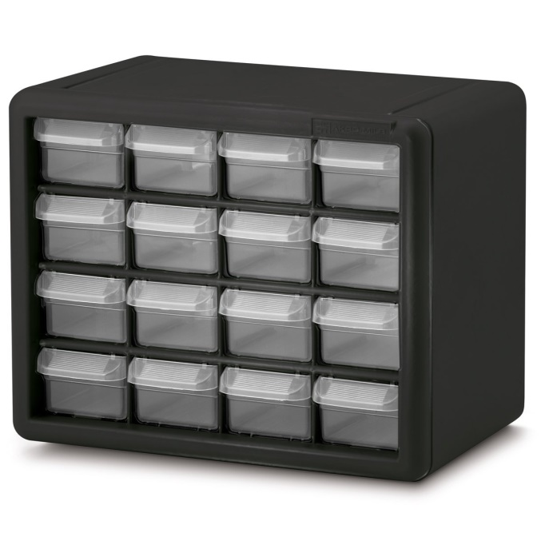

The green bin below is located in the ______ row and the ______ column.

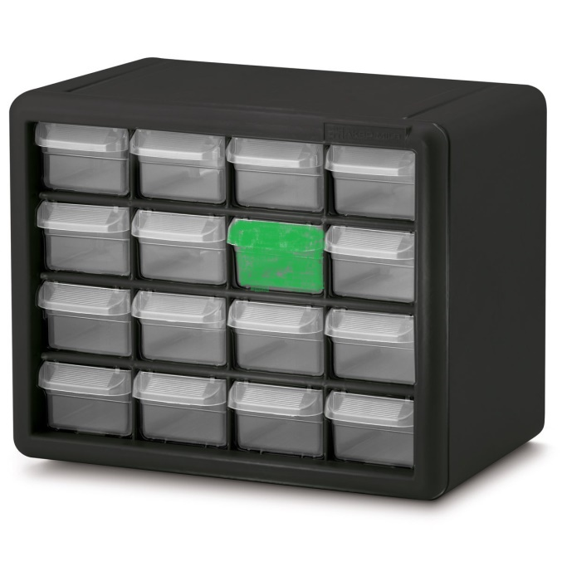

The plural for matrix is *matrices*. An *m* × *n* matrix has *m* rows which are numbered from top to bottom and *n* columns which are numbered from left to right. Matrices are named with a capital letter. We use brackets to enclose the data in the matrix.

This is the 3 × 4 matrix for your story above.

$$A=\left[\begin{matrix}42 & 12 & 76 & 45 \\ 63 & 16 & 64 & 76 \\ 38 & 20 & 82 & 72\end{matrix}\right]$$

1. What row and column is the highlighted number in? _____________________

How does that number relate to your story? _____________________________

We will be following a story about taking care of our environment for some of the activities in this unit. This story will give us plenty of data for our matrices. We will suppose that your school is working on a reduce-reuse-recycle project where students ask community members to donate used textile items for reuse. Reusing textile items has a major impact on reducing our carbon footprint since textile manufacturing is very energy intensive. These textile items include normal clothing articles, wool outerwear or blankets, pairs of shoes and rags. The project will have a major benefit in reducing greenhouse gas emissions that cause global warming. There will be three collection sites in town and your school will help educate the community about the benefits of reduce-reuse-recycle to reduce CO2 emission and provide funding to charities.

We are going to keep track of the quantity of donated items collected at each of the three locations week by week. In the spreadsheet below, collection locations are assigned to rows and type of items are assigned to columns. The spreadsheet for the first week is shown below:

|  |  |  |  |  |
| --- | --- | --- | --- | --- |
|  | Clothing (lbs) | Wool (lbs) | Shoes  (pairs) | Rags  (lbs) |
| Pickup Site A | 92 | 36 | 14 | 88 |
| Pickup Site B | 46 | 87 | 34 | 73 |
| Pickup Site C | 57 | 44 | 37 | 44 |

1. Write the data in the spreadsheet into a 3×4 matrix named *A* with the data for week one:

$$A=\left[\begin{matrix} & & & \\ & & & \\ & & & \end{matrix}\right]$$

Check that your matrix looked like this:

$$A=\left[\begin{matrix}92 & 36 & 14 & 88 \\ 46 & 87 & 34 & 73 \\ 57 & 44 & 37 & 44\end{matrix}\right]$$

Matrix *B* below is the results for the second week of the project. The project is catching on and the flyers that were placed around the community has increased awareness. A lot of people didn’t realize that rags can be reused and rags that can’t be reused can still be recycled. (Go online to the website.)

$$B=\left[\begin{matrix}78 & 40 & 22 & 68 \\ 56 & 67 & 34 & 65 \\ 60 & 55 & 36 & 75\end{matrix}\right]$$

1. The pounds of rags collected at site C during the second week was ___________.

The images below of the storage bins help explain how we can do operations with matrices.

1. If we combine the contents of the green and purple bins below and **also the contents of all the *corresponding* bins in the two storage containers**, what word from math would we use describe the process? ­­­­­­­­­­­­­_________________________

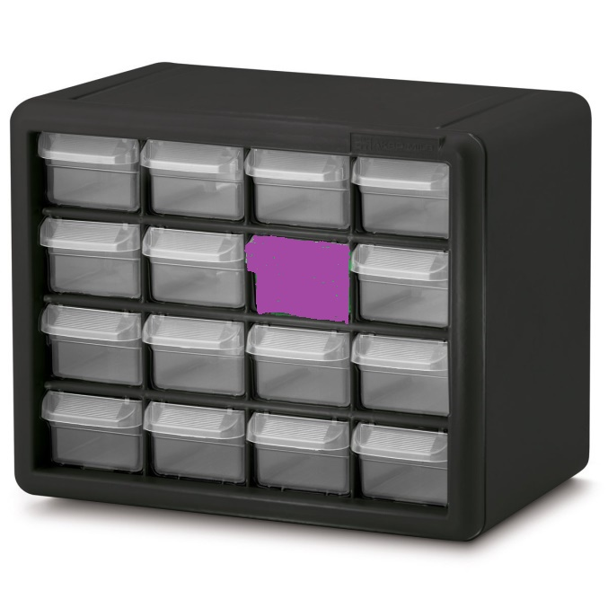



1. How many pairs of shoes were collected at the second collection site during the first two weeks?
2. What would we need to do with matrices *A* and *B* to find out the amount of each category of reuse items collected at each of the three collection sites during the first two weeks?
$$A=\left[\begin{matrix}92 & 36 & 14 & 88 \\ 46 & 87 & 34 & 73 \\ 57 & 44 & 37 & 44\end{matrix}\right] B=\left[\begin{matrix}78 & 40 & 22 & 68 \\ 56 & 67 & 34 & 65 \\ 60 & 55 & 36 & 75\end{matrix}\right]$$

3. Create a new matrix *C* with this information:

How many rows and columns should it have?

$$C=\left[\begin{matrix} & & & \\ & & & \\ & & & \\ & & & \end{matrix}\right]$$

 ______________________

1. What would be a logical way to represent this mathematically?
2. Write down a matrix *D* that shows the difference between collections in the second week compared with the first?
$$D=\left[\begin{matrix} & & & \\ & & & \\ & & & \\ & & & \end{matrix}\right]$$

3. What would be a logical way to write this mathematically?

1. What is the interpretation of Matrix *D*?