Activity 6.5.6 Just the Pendulum – no Pits
Pendulum Lab Activity

Students can either set up their own pendulum or use an online pendulum simulator to collect data. It is important to note that the distance the pendulum bob is from the horizontal as a function of time can be only approximated by a sinusoidal function, and only for small angles from the vertical. The website http://phet.colorado.edu/sims/pendulum-lab/pendulum-lab_en.html has an interactive pendulum that allows students to use sliders to change the length of the pendulum as well as the weight on the end of the pendulum “string.”

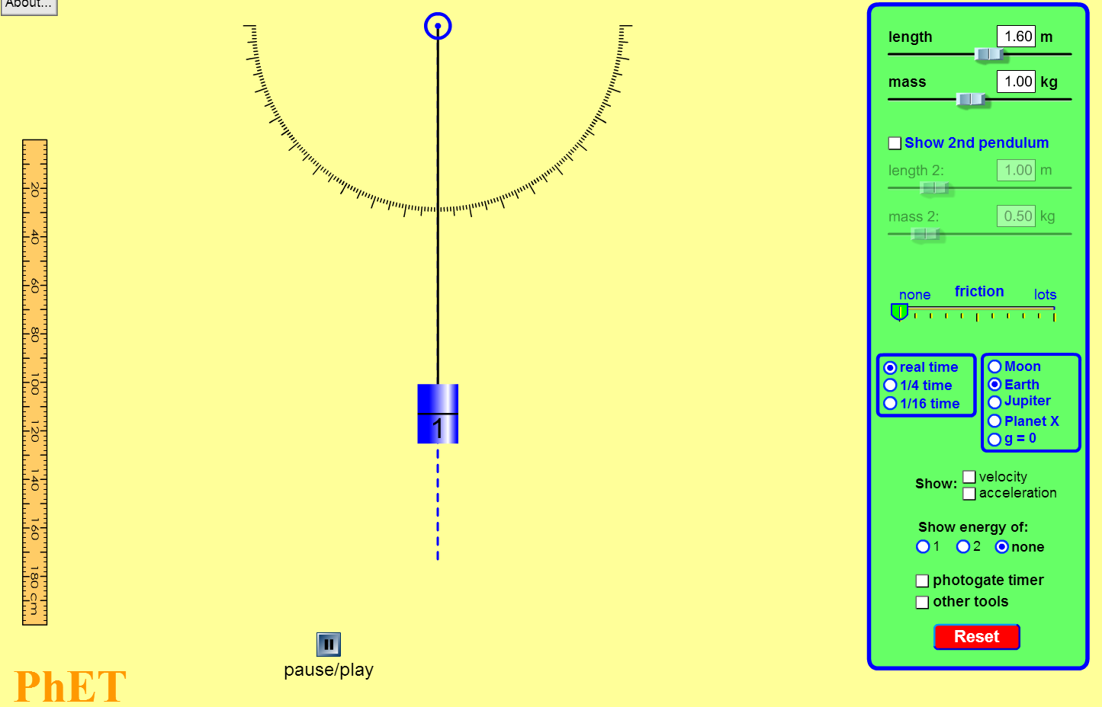

Three Questions to be analyzed in exercises #1-17 that follow:
- What effect, if any, does the length of a pendulum have on its period?
- What effects, if any, does the mass of a pendulum have on its period?
(Questions A and B pertain to how a parameter affects the motion)
- At any given time, how far, measured along a horizontal line, is the bob of the pendulum from the center vertical line?
(Question C is a question about the motion itself.)
In each of the three questions A, B and C, we are looking at three different functions regarding the same pendulum. Some of you may recall the pendulum experiment in Algebra 1, when you collected data that was not linear. Question A is about the same function you found in Algebra 1.
- a. For Question A, we will collect data and find a mathematical model for the data. What is the independent variable in question A that asks how length affects the period of a pendulum? ___________________? What is the dependent variable?_____________________

b. What is the independent variable when we investigate the effect that the mass of a pendulum has on its period( this is question B) ________________________ what is the dependent variable? ______________________

c. What is the independent variable when we investigate the pendulum bob’s horizontal distance from center at any given time? (this is question C) ________________________. What is the dependent variable? ______________________

- Let’s first consider the length of the pendulum. Make a hypothesis about what will happen to the period of the pendulum as the length increases. For this hypothesis, assume that the angle at which you are initially dropping the weight from will be constant.

If the length of the pendulum is increased, then …

- On the slider, set the length of the pendulum to 1 meter, and keep the mass setting at 1 kg. Pull the blue weight to the right to somewhere between = 20 and 60 degrees. Use this angle for all trials in this experiment, so record it as well. Then, let the weight go and observe the periodic motion of the pendulum. In the bottom right corner, toggle on the photogate timer. This will allow you to observer the period of the pendulum. With the pendulum still swinging, press start. The timer will record one period of the pendulum’s swing automatically. Note the time below.

Length: 1 meter Period: _____________ seconds Angle Used: ________ degrees

- Reset the applet, and experiment with different lengths. At this time, keep the mass setting at 1 kg and only alter the length. Make sure you use the same angle chosen in number 3. Increase the length of the pendulum 0.2 meters for each trial. For each iteration, record the length and period time in the provided data table. Round to the nearest ten thousandths of a second.

Length (m) | 1 | 1.2 | 1.4
Period (sec)

- Using your calculator (or some type of spreadsheet software), generate a scatterplot of the data from your table above. Sketch the graph below. Comment on whether the graph supports your hypothesis from #1.

Does the data support your hypothesis? ______________

- The relationship between the length of the pendulum and the period is in fact, not linear. Show this by calculating the slope for each consecutive ordered pair, (length, period) that you recorded above. Record those slope values in the table below. Round to the nearest ten thousandths.

Interval | 1 to 1.2 | 1.2 to 1.4 | 1.4 to 1.6 | 1.6 to 1.8 | 1.8 to 2.0 | 2.0 to 2.2 | 2.2 to 2.4
Slope

- What are the units of the slopes that you just calculated?

- How do the numeric values of the slopes confirm that the relationship between length and period is not linear? Briefly explain.

- Since the gathered data is not linear, let’s investigate other possible relationships between length and time for the pendulum. Find each of the following models, or based on number 8 state the model should not be considered. Note the correlation coefficient for each model you do obtain. Round all decimal values in the equations to the nearest hundredths, but carry out the r-values to 6 decimal places.

Model | Equation | Correlation
Quadratic

Exponential

Power

Which of the models best fits the data you collected?

- Use your model to predict the period for a pendulum of length 4 meters with an attached weight of 1 kg. Round your answer to the nearest hundredths of a second.

- If you knew the period of a given pendulum with a 1 kg weight was 6.9 seconds, predict the length of the pendulum to the nearest tenth of a meter.

- There is a known relationship between the period of a pendulum and its length, L, here on Earth. Look in a physics book, or go online and see if you can find this equation. Write the equation you found below, making sure to identify the variables that are used.

- Verify that the theoretical equation you found in a book or online works by substituting some of the data points that you collected. Input some of your lengths and see if the period is approximately correct. Show at least three calculations below.

- Explain how the equation you found using the experimental data relates to the equation you obtained online. Does substituting and simplifying with the known constants get you close to the equation you choose? (Hint: Use properties of square-roots to help you simplify.)

- If the pendulum is swung on a different planet, say Jupiter, would the period increase or decrease from the period found on Earth? Explain your reasoning.

PART B
- Notice that the equation to determine the period is not dependent on the mass of the object at the end of the pendulum. The period of the pendulum is NOT a function of the mass of the pendulum. Can that possibly be true?! Using the applet, try various different masses, with the same length and angle combinations. Note the period. Can you explain why this is so? Recall that Galileo dropped cannon balls of different masses from the Tower of Pisa. Did the heavier ball hit the ground before the lighter ball? ____ . If needed, reference an internet source that helps to explain this. Write a short explanation and properly cite the article/website that you used.

PART C
- Now we will find the horizontal distance of the pendulum from center as a function of time. Notice that the tape ruler that appears when you click on “other tools” that appears at the bottom of the green box on the right of the pendulum applet. Move the ruler so that it measures the horizontal distance of the pendulum bob from the vertical center line of the pendulum.
Start the pendulum swinging.
- Estimate the farthest distance that the pendulum is from the vertical center line. _____

- What is the period of the pendulum? _________

- Find an equation that describes the horizontal distance of the pendulum from center as a function of time. Negative numbers indicate left of center, zero indicates the bob is at the center, and positive numbers indicate right of center. You can start timing the pendulum swing when you choose. Make a table of values or a sketch a graph if it helps.

Extensions:

- Investigate the relationship that the starting angle has on the period of the pendulum. Do this with constant length measurements.

- Model damped sinusoidal behavior. Position a ruler horizontally and measure the maximum distance from center that the pendulum attains at each swing. Set the pendulum app to damping, so that eventually the swinging stops. Now follow the 3 steps:

- First find the sinusoidal function that models just the first period of the pendulum, ignoring the damping that occurs.
- For the damping or the decay part, record the maximum horizontal distances for each swing. Fit an exponential decay model to these maximum values for each swing as a function of time.
- Multiply the exponential function by the sinusoidal model to obtain a model for the damped pendulum motion.

