Activity 6.5.3 Ocean Waves

First some vocabulary:
- Wave height is the vertical distance between the crest (high point) and trough (low point) of 1 wave.
- Wave amplitude is half the wave height – half the distance from the high to the low point.
- Wave length is the horizontal distance between the crests (or troughs) of two consecutive waves.
- Wave period is the time it takes for two consecutive crests (or troughs) to pass a fixed point (how much time per cycle).
- Wave frequency is the reciprocal of wave period (how many cycles per unit of time)
- Wave speed is ratio of the wave length to the wave period (distance/time)
- Wave steepness is the ratio of the wave height to the wave length (rise/run)

If you have access to a computer or tablet, you can try out the wave simulator to understand waves better. If not, skip to the next section “More information about waves”.

Exploring Waves on a Wave Simulator:
The simulator is from “The Physics Classroom”. http://www.physicsclassroom.com/Physics-Interactives/Waves-and-Sound/Simple-Wave-Simulator/Simple-Wave-Simulator-Interactive If the simulator doesn’t work in one browser, try another, or you can search for your own wave simulator.

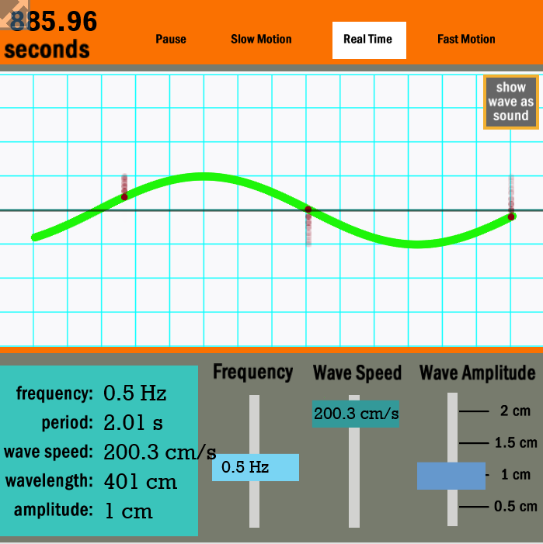
As you observe the wave motion in the applet, be sure to note the up and down motion of one of the 3 points or particles on the wave. You can think of the particle as if it were a stationary boat floating on ocean waves. For our purposes, when we graph a wave, we will be graphing the vertical distance of one of the particles from y = 0 as a function of time.
Observe what happens to the wave and the other readings as you move one of the sliders at a time. What you are seeing is a simulation of the wave itself. When we draw graphs for problems about waves, we will be graphing the vertical height of a single particle of the wave as it moves up and down over time. The vertical axis will be the height of the water, and the horizontal axis will be time.
DONE WITH WAVE SIMULATOR EXPLORATION

More information about waves: Why does a boat bob up and down on a wave without being pushed to shore by the wave?

Make a Sports Stadium wave of people with your classmates similar to the wave a crowd makes at a ballgame or a concert. Each individual moves their hands up and down without moving from their seat, as the wave moves horizontally around the stadium. Be sure to distinguish the wave itself from vertical motion of a particle in the medium that carries the wave. When we graph and find models of waves, we will be graphing the height of a particle as a function of time. You can demonstrate how wave speed differs from particle speed by having a person run along the length of the wave as the wave moves through the crowd. The person running along the length of the wave is running at the speed of the wave. Each person standing in the crowd that is creating the wave represents particle motion.

Another way to create a wave is to take a long rope secured at one end. Flick the other end of the rope. You’ll have to maintain a certain amount of tension. You will see a wave move down the rope, and maybe even rebound at the fixed end. The medium of the wave is the rope, yet every particle along the rope vibrates back and forth about a fixed position. However, the wave motion travels from your hand down the length of the rope. So we see that we need to distinguish particle motion from wave motion.

How do water waves work? Suppose a boat speeding along in the water creates a wave by pushing some water molecules down. The water then comes back up. The energy of the wave moves from the boat outward, yet the water molecules themselves just bob up and down in place.

Three websites for further study are:
- ‘Physclips: Wave and Sound , #1 Oscillations and #2 Travelling Waves’’ that shows how up and down motion becomes a sinusoidal graph: http://www.animations.physics.unsw.edu.au/waves-sound/oscillations/index.html .
- https://phet.colorado.edu/en/simulations/category/physics , click on ‘motion’ and on ‘sound and waves’.
- A video demonstration on You Tube shows how to make a wave machine with wooden skewers, tape and gummie bears. See: Jelibondan Dalga Makinesi wave machine on You Tube https://www.youtube.com/watch?v=FjPFW6gftas

You can see that that each particle on the wave moves up and down, like particles of water or a boat on ocean waves. Our sinusoidal models will be of the up and down position of a wave particle with respect to time. For water waves, it will be the depth of the water with respect to time.

- When a wave approaches shore, the bottom of the wave slows down because of friction against the floor of the shallow water, while the top of the wave keeps moving fast. This causes the wave to get taller as the top begins to topple over the slow moving bottom. When the wave steepness is roughly 1:7 or 1/7, the wave will break because it is unstable. Wave steepness is wave height/wave length.

a. What is the wave steepness for a wave that is 10 feet high and 100 feet long? Will a wave height of 10 feet with a wave length of 100 feet break or not? Show work.

b. If the length of the wave is 28 feet, how high is the wave when it breaks?

c. If the height of a wave is 10 feet, how long does it have to be to keep it from breaking?

- A typical ocean wave is a gentle swell on a calm sea. At a place where the ocean is 20 feet deep, the boater sees a gentle swell coming that has a period of 10 seconds and a wave height of 12 feet. That means the amplitude is 6 feet. Assume the ocean floor is flat, at least a few wave cycles are regular, and the height of the water as a function of time is sinusoidal. Assume that the water depth starts at 20 feet, first increasing, then decreasing.

a. Sketch a diagram of the height of the water as a function of time:

b. Find an equation of the sinusoidal function that models the height of the water as a function of time.

c. The wave length of this gentle swell is 300 feet, and its period is 10 seconds. What is the speed of the wave in feet per sec? _______ What is the speed of the wave in miles per hour?

d. If the length of a wave is 300 feet, at what height does it become unstable? That is, at what height will it break?

- A tsunami does not act like a normal wave that is formed by surface winds. It can be caused by an earthquake that creates wave energy far under the surface of the water. Do an internet search for videos or photos of the 2011 Tsunami that hit Japan, the 2004 Tsunami in India or the 1964 Good Friday Earthquake and Tsunami in Alaska that also traveled to Crescent City, California. The first 4 waves of the Crescent City Tsunami caused no damage. However, the fifth wave bigger than the others hit the town killing 12 people and destroying blocks of businesses and homes. A tsunami is often a great wall of water moving in toward shore at a speed faster than a person can run.

In the deep ocean, tsunamis have very long wave lengths such as 60 miles, lower wave heights like 20 feet and wave speeds like 500 miles per hour, yet the tsunami will feel like a gentle swell to a boat floating on the ocean.

- What is the period of such a wave? __________

- What is the frequency of this wave?

- Why doesn’t a 20-foot wave traveling 500 mph concern the boater? (hint: consider wave steepness.)

- When the Tsunami nears land the wave slows, the height increases and the wave length decreases. Assume that the period of the wave is 40 minutes, and the speed of the wave is 15 mph - that is faster than any human can run.

- Find the wave length in miles using the wave speed in miles per hour and the period of the wave.

You are gathering data for science. Should a tsunami come, your job is to measure the depth of the water in the harbor where the normal water depth is 11 feet. When you receive the warning that a tsunami is coming, you grab your extreme weather drone to measure the height of the water in the harbor, and head for the hills. By the time you make your escape to higher ground and have your drone recording water height measurements, the tsunami has sucked the water out of the harbor, so there is just one foot of water at this time t= 0. Then the water begins to come in. After 20 minutes the water is at its maximum height of 21 feet. By 30 minutes the water has receded to the normal 11-foot depth. Unless another wave comes, the water depth will stay at 9 feet. Sketch a graph of the height of the water at the dock as a function of time since the water height was 1 foot, until it returns to normal 30 minutes later. Assume that water height as a function of time is sinusoidal for this portion of the period: 0 ≤ t ≤ 30.

- Sketch a graph of the function of water height as a function of time. (0 ≤ t ≤ 30)

- Find a sinusoidal equation for the function.

- How high is the water in the harbor 10 minutes after the water was down to 1 foot?

- How high is the water after 15 minutes has elapsed?

