Activity 6.4.1 b: Move It! Trig with Geogebra

Part 1: Investigating Vertical Shifts with Geogebra Applet

- a. Open an applet for graphing translations of the sine function. One is provided in the file Activity_6_4_1_b_GeoGebra_Code_06_22_15
b. Type sin(x) into the input box for “Parent Function” and press enter.
c. Click the button to explore the graph of $g\left(x\right)=f\left(x\right)+k$.
d. Move the slider left and right to change the value of ‘k’ or enter a specific value for k in the rectangle.

- Here is a screen shot of the Geogebra Applet:
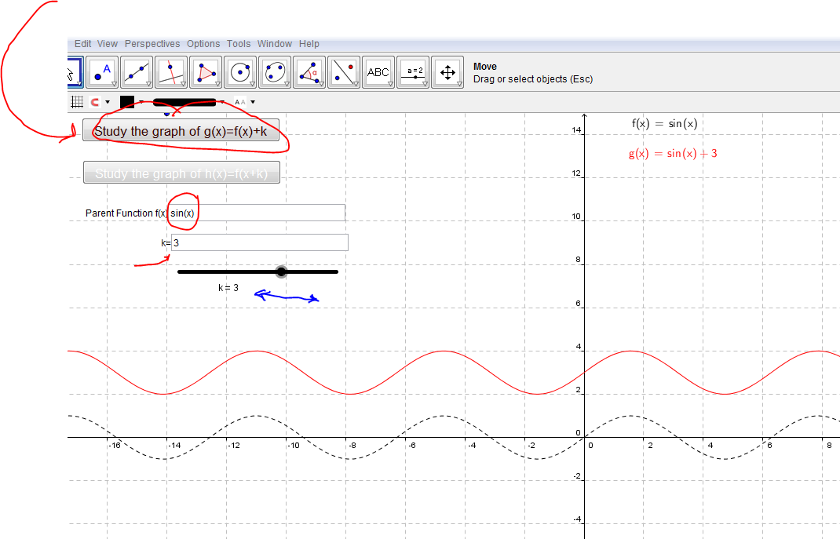
3. a. After experimenting with f(x) = sin(x), investigate the cosine and tangent functions by typing cos(x) and then tan(x) into the Parent Function rectangle. Make a conjecture about how the value of $k$ transforms the graph of f(x) to the graph of g(x), when $k$ is on the “outside” of the function.

b. Does your conjecture hold if $k<0$? If not, modify your conjecture.

c. Does your conjecture still hold if $k>0$? If not, modify your conjecture.

- Use what you learned about to graph two full periods of the following functions using translations. Suggestion: before you sketch the wave, determine the midline, the maximum and the minimum values. Sketch in the dotted horizontal lines for the midline, y = maximum value and y = minimum value. Then plot the 3 points at the beginning of a period, the end of the period, and halfway through the period. Be sure to label the scales on the x and y axes

- $g\left(x\right)=\sin\left(x\right)+1$

- $g\left(x\right)=\sin\left(x\right)+2$

- $g\left(x\right)=\sin\left(x\right)+3$

- $g\left(x\right)=\sin\left(x\right)-4$

- $h\left(x\right)=cosx+2$

- $j\left(x\right)=cosx-3$

- $k\left(x\right)=cosx+1/2$

5. Graph the parent function $f\left(x\right)=tanx$ by filling in the table and plotting points.

Recall that tan(x) is the slope of the terminal ray of angle x in standard position. Use what you know about the slope to answer the following questions and fill in the table of values.

If the answer is “not defined” you can abbreviate to ND. Not defined is the same as Does Not Exist, so you can write DNE, also.

- What is the slope of a horizontal ray? _______

- Name two values of x for which tan(x) = 0. __________

- What is the slope of a vertical line?_________

- Name two values of x for which tan(x) undefined. ______________

- Sketch dotted vertical lines in the graph to represent a vertical asymptote for the x values that make tan(x) undefined

- What is the slope of the terminal ray of an angle that is 45º or $\frac{π }{4} radians?______$

- Name another angle has slope 1. ________

- What is the slope of the terminal ray of an angle that is 135º or $\frac{3π }{4} radians?______$

- Name another angle has slope -1. _______
$f\left(x\right)=tanx$
x | y
0
$\frac{π}{4}$
$\frac{π}{2}$
$\frac{3π}{4}$
π
$\frac{5π}{4}$
$\frac{3π}{2}$
2π
2π

- The period is _____.

- Is $f\left(x\right)=tanx$ an even or an odd function?_______

- At x = 0, is the graph of $f\left(x\right)=tanx$ increasing or decreasing?________

m. Write the equations for 4 of the vertical asymptotes. Your answer should be

of the form “x = c”

_____________ _________________ ________________ _______________

6. Use translations to graph the following tangent functions. Indicate the coordinates of points where the x-intercepts moved to as a result of the translation.

Indicate the vertical asymptotes. You may or may not want to use the Geogebra applet.

a. $g\left(x\right)=tanx+2$

b. $h\left(x\right)=tanx-1$

