**Activity 6.2.2 Unit Circle Definition of Trigonometric Functions**

1. On page 2 of this activity is a coordinate plane that has a 1 cm scale.

(You may have to resize it with the photocopier so that it is actually 1 cm., or you can assume it is not drawn to scale.)

1. Find and label the approximate coordinates for each of the 5 points. If you use a centimeter ruler, you can avoid having to count all the tick marks. The main idea is that you can find the x and y coordinates of a point by measuring the length of a horizontal segment along the x axis and a vertical segment drawn from the point perpendicular to the x axis. Then determine whether the coordinate is positive or negative.

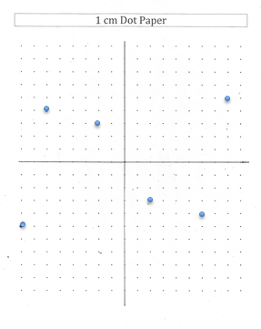



Challenge:

1. Tell the location of the same points using a different method.

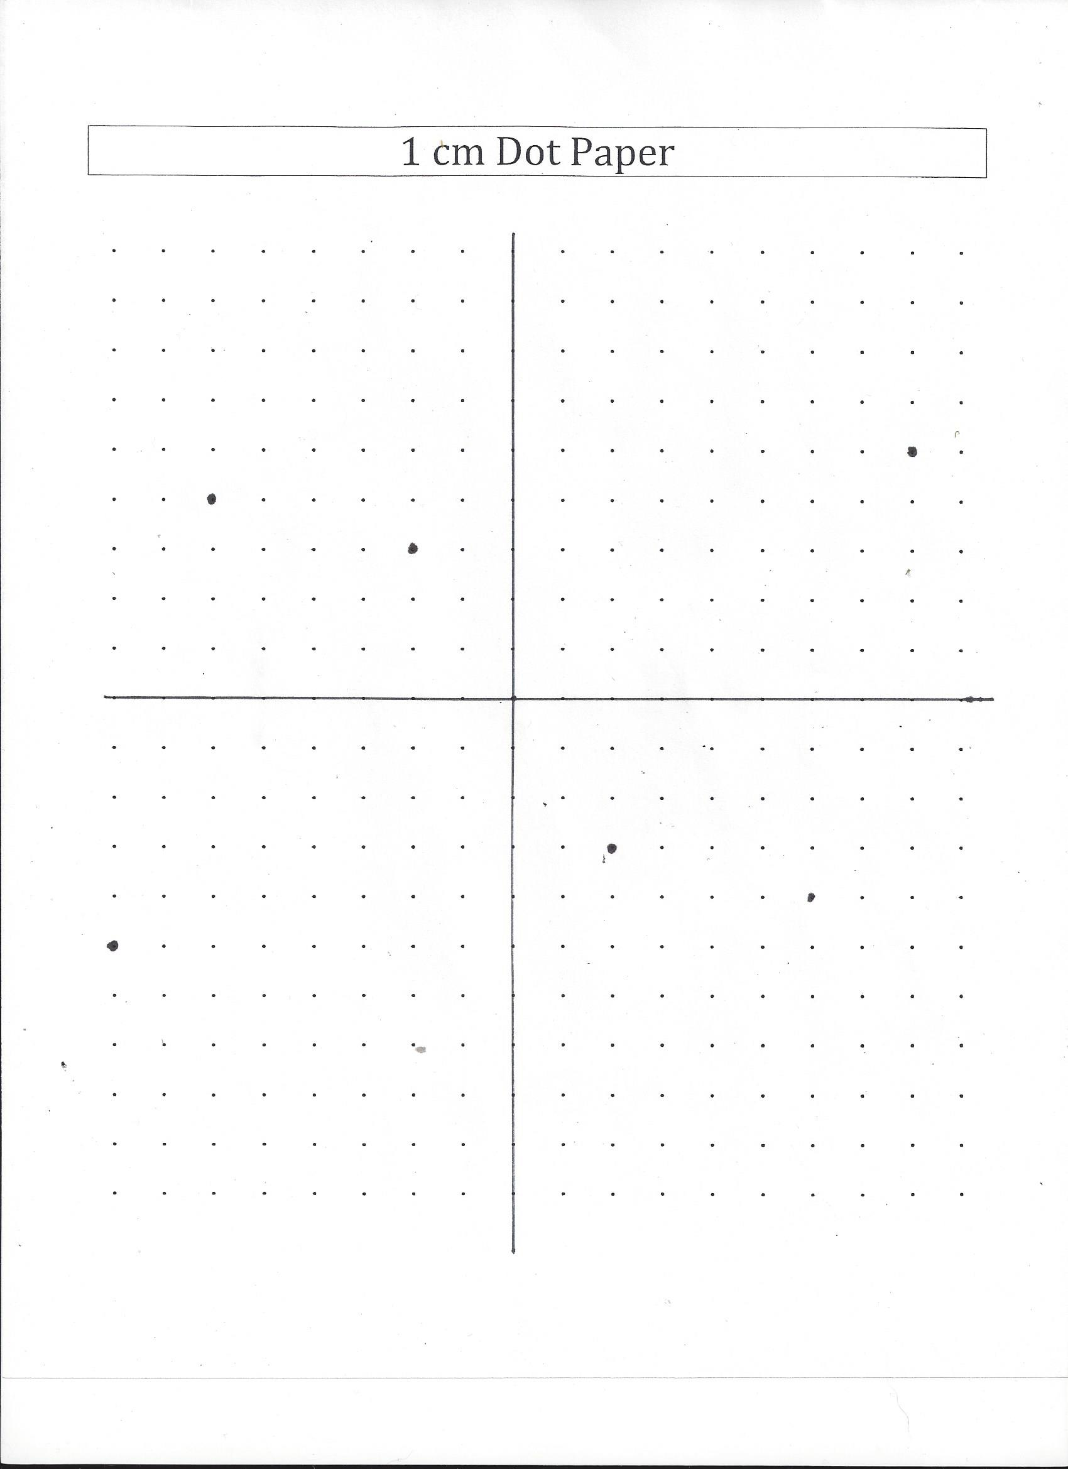



2. Now take out the 1 cm dot paper from investigation 6.1.8 that has the circle with the special angles and arcs labeled. If you want to make another copy, you will find a blank copy of the dot paper is at the end of this activity. You should have the following angles that are accurately measured: 0, 30º, 45º, 60º, 90º, 120º, 135 º, 150º, 180º, 210º, 225º , 240º , 270º, 300º, 315º, 330º, and 360º. You should have the radian equivalent for these angles. Also write the length of the arc t that the angle subtends near the terminal point of the arc along the circumference of the circle.

Use the decimeter for the linear unit of measure so that we are using a unit circle that has a radius of 1 decimeter. That makes the first tick mark to the right of the origin 0.1 decimeter, because 1 decimeter = 10 centimeters. The fifth tick mark is 0.5 decimeters.

**BIG TASK:**

Your task is to write the coordinates of the function W(t) on the one decimeter circle for each of the special arc lengths and subtended angles. Use decimal approximations. Try to estimate to the hundredth place.

Simplify your work by using a centimeter ruler to determine the coordinates this way:

1. Draw the vertical line from the terminal point of the arc to the x axis. Measure the vertical line segment. This corresponds to the y coordinate of the point.
2. Measure the horizontal lines along the x axis that corresponds to the x coordinate of each point. This is the x coordinate of the point.
3. You can make your work easier by using the odd-even symmetry of the coordinates of points on a circle.
4. On the next page you can see a picture showing how you might start.

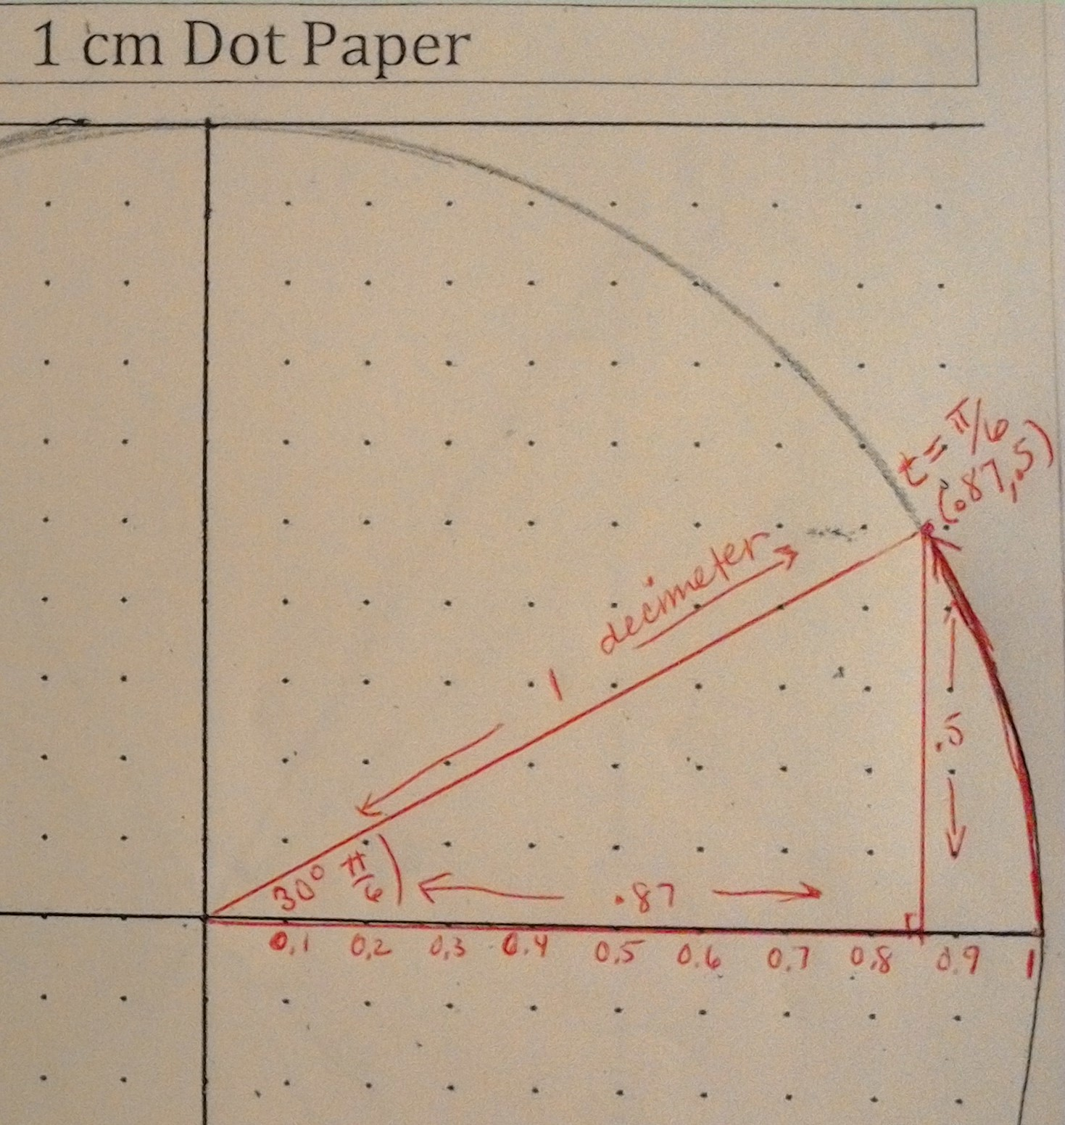

For the arc of length $\frac{π}{6}$, the coordinates W($\frac{π}{6}$) of the terminal point of the arc are approximated by measuring the vertical and horizontal segments. .

Continue estimating and labeling all the points on the circumference of the circle. You need not write in the lengths for each side of every triangle.

We now make the following definitions:

**The sine of t is the y coordinate of W(t) on the unit circle: sin(t) = y**

**The cosine of t is the x coordinate of W(t): cos(t) =x**

**The tangent of t is the ratio of the y to the x coordinates of W(t): tan(t) = $\frac{y}{x}$**

3.Think about why we would make such definitions.

1. In words, what are the sine and cosine of an angle in a right triangle?

b. Why would we define sine to be the y coordinate of the point W(t) and cosine to be the x coordinate of the point W(t) on the unit circle?

The y coordinate of the point W(t)

c. What is the slope of a line?

Note that tan(t) **= $\frac{y}{x}$** , and it is the slope of something in your sketches. Which line or ray or line segment has a slope that is the tan(t)? Sketch an illustration.

4. Compare some of the approximate decimal values you obtained from the circle with the sine and cosine you learned in geometry when you studied right triangle trigonometry.

i) From our circle: write the decimal approximation for the following:

sin(30°) =_______, sin(60°) =_______, cos(60°) = _______and sin(45°) = _________

ii) From the right triangles below, write exact values for the following:

sin(30°) =_______, sin(60°) =_______, cos(60°) =_______and sin(45°) =_______

2 $\sqrt{2}$

1 1

$\sqrt{3}$ 1

(a 30-60-90º triangle) (a 45-45-90º triangle)

iii) Do sine and cosine function values using the circular definition appear to be the same as the sine and cosine using the right triangle trigonometry? Explain using full sentences

iv) Why are the triangles you drew on the unit circle for t = $\frac{π}{6}$ and t = $\frac{π}{3}$ similar to the 1-2- $\sqrt{3}$ triangle? (Illustrate with a sketch)

v) Why is the triangle you drew on the unit circle for t = $\frac{π}{4}$ similar to the 1-1- $\sqrt{2}$ triangle?

vi) Why is the sin30° the same for the triangle with a hypotenuse of 2 as it is for a triangle on the unit circle that has a hypotenuse of 1? (Hint: Think about similarity, proportionality, and ratios)

d. Explain how the right triangle trigonometric functions that have a domain between 0° and 90° are generalized to define trigonometric functions for any real number.

5. Now you need to draw a final draft of the unit circle with the coordinates and the radian and degree measures for the special angles. Get out a clean piece of paper. You can make it the size that works for you. You will use this unit circle as a reference time and again. This time, write the exact coordinates for each point. That is, write $\frac{1}{\sqrt{2}}$ instead of .71 , and write $\frac{\sqrt{3}}{2}$ instead of .86

Checklist for making your final draft of the unit circle with the circular trigonometric values.

* Is it a unit circle? (radius = 1)?
* Is it subdivided into quarters, sixths, eighths and twelfths?
* Is each point W(t), labeled with the angle measure in radians and degrees?
* Did I write in the coordinates of each point W(t) using the numbers 0, ± $\frac{1}{\sqrt{2}}, ±$ $\frac{1}{2,}, ±\frac{\sqrt{3}}{2},$ $±1$.
* Did I include the ratio y/x, that is, the tan(t) for each of the special angles?
* Is there a key or legend that explains how your unit circle provides the trigonometric values for the special angles?

You can draw a unit circle the size that works for you – big enough to fit all the information, but small enough to be useable. You will refer to this unit circle time and again, so do a nice job. Put is in a plastic sleeve in a prominent place in your notebook.

Check your understanding #6-8.

Fill in the blanks with “x , y , $\frac{y}{x}$, horizontal, vertical, slope, adjacent, opposite, one .

6. Sin(t) is the _____coordinate of the terminal point for arc t on the unit circle. It measures the ___________________distance of the point from the x axis. In right triangles, sin(t) is the ratio of the _________________ leg to the hypotenuse. On the unit circle, the hypotenuse is the radius that measures _____. Therefore sin(t) on the unit circle is the length of the side ______________ the central angle of measure t. The length of that side is given by the ______coordinate of the terminal point of arc t on the unit circle.

7. Cos(t) is the _____coordinate of the terminal point for arc t on the unit circle. It measures the ___________________distance of the point from the y axis. In right triangles, cos(t) is the ratio of the _________________ leg to the hypotenuse. On the unit circle, the hypotenuse is the radius that measures _____. Therefore cos(t) on the unit circle is the length of the side ______________ the central angle of measure t. The length of that side is given by the ______coordinate of the terminal point of arc t on the unit circle.

8. Tan(t) is the ratio ____ of the coordinates of the terminal point for arc t on the unit circle. It measures the _______________of the terminal ray of angle t. In right triangles, tan(t) is the ratio of the _________________ leg to the _____________ leg. On the unit circle, tan(t) is the length of the side opposite angle t divided by the length of the side adjacent to angle t. The length of the opposite side is given by the ______coordinate of the terminal point of arc t on the unit circle. The side adjacent to the angle t lies on the ___ axis and its length is given by the ______ coordinate of the terminal point of arc t on the unit circle.

9. Tangents and slope. For each description, sketch the graph of the line and find its slope.

a. A line contains the points (1,2) and (5,7); b. A line contains the points (0,0) and (4,5)

Its slope is _________ Its slope is ______.

c. A line contains the points (-4,6) and (2,-1); d. A line contains the points (1, -1) and (3,-1);

Its slope is _________ Its slope is ______.

e. A line contains the points (0,0) and (-1,0); f. A line contains the points (3,2) and (3,5);

Its slope is _________ Its slope is ______.

g. A line contains the points (0,0) and (0,1); h. A line contains the points (0,0) and (-3,-3);

Its slope is _________ Its slope is ______.

i. A line is vertical through the point (0,1); j. A line is horizontal through the point (-1,0);

Its slope is _________ Its slope is ______.

10. Sketch the given angle in standard position. Determine the slope of the terminal ray of the angle. What is the tangent of the angle?

a. An angle measures 45° b. An angle measures 270°

What is the slope of its terminal ray? _________ Slope of its terminal ray:_________

What is the tan(45°)?______ What is the tan(270°)?______

c. An angle measures 0° d. An angle measures 90°

What is the slope of its terminal ray? _________ Slope of its terminal ray:_________

What is the tan(0°)?______ What is the tan(90°)?______

11. a. For what values of ‘t’ will the tan(t) be 0? Explain.

b. For what values of ‘t’ will the tan(t) be undefined? Explain.

