Activity 6.1.1 Angle Measure Can Be Any Number of Degrees
1 a. Think back to the variety of functions discussed in class. State a reasonable domain and range for one of the functions that models repeating behavior:
Situation: __________________
Domain: Range:

b. Think back to the right triangle trigonometry that you learned in Geometry. What was the domain for the sine, cosine and tangent functions? (Hint: What did you take the sine of?)

CENTRAL ANGLES FOR VERY LARGE NUMBERS AND CENTRAL ANGLES WITH A NEGATIVE MEASURE
If we are going to use trigonometric functions to model the functions in the launch, we need angles whose measures are larger than 90° and measures that are negative to indicate a direction change in the rotation. We want to apply the trigonometric functions to angles whose measures are very large or negative, not just angles that measure between 0° and 90°.
To solve this problem, we need to look at angles from a dynamic rather than a static view. In geometry you defined an angle as the union of 2 rays with a common endpoint. In a circle, a central angle is one that has the common endpoint at the circle’s center.

We now will look at an angle as a rotation.

You can think of two clock hands pointing at the ‘3’ on a round clock face. Fix one hand pointing toward the ‘3’ and rotate the other hand counterclockwise for positive angles and clockwise for negative angles.

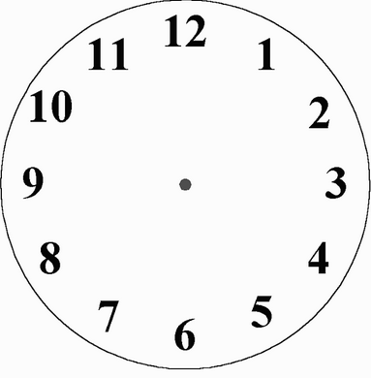
Angle in a positive direction Angle in a negative direction
We still need two rays with a common endpoint when we think of an angle as a rotation. One ray will be named the initial ray; the other is the terminal ray. To generate our angle, start with the terminal ray lying on the initial ray, both on the positive x axis. Then rotate the terminal ray in a counter clockwise direction so that it goes through the first quadrant first.

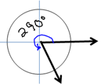
Terminal ray of the central angle
Initial ray of the central angle.

- A central angle in standard position has its initial ray on the positive x axis. The terminal ray rotates counter clockwise sweeping through Quadrant I, then Quadrant II and so on when the angle is positive.

- The terminal ray of angle can sweep around the circle infinitely many times.

The terminal ray of the angle in the sketch below went around the circle two times plus another 290°. 360° + 360° + 290° = 1010°
. 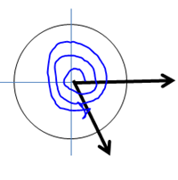
This angle measures 1010°

- The angle that measures 1010° is co-terminal with the angle that measures 290°, because their terminal rays coincide.

- An angle whose terminal ray rotates clockwise will start by sweeping through quadrant IV, and is indicated with a negative sign. This angle pictured below measures -70°.
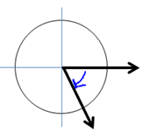
This angle is -70°.
The angles that measure 290°, 1010° and -70° are co-terminal.

2. Check your understanding by filling in the blank and sketching an angle in standard position to illustrate each concept.

a. What is the measure of an angle that describes
1 full rotation around a circle in the
counter clockwise direction?_____

b. What is the measure of an angle that describes 1 full
rotation around a circle in the clockwise direction?_____

c. If you start with an angle that measures 20°,
then you add one full rotation to that angle,
what is the measure of the new angle?_____

d. If you start with an angle that measures 20°,
then you subtract one full rotation from that angle,
what is the measure of the new angle?____

e. Start with an angle that measures -60°. Find the
measure of an angle that is co-terminal with this -60°
angle by adding 360° to -60°:______

f. To find the measure of an angle that is co-terminal with a given angle, you add _____ degrees to the angle measure or subtract _________degrees from the angle measure.

Disclaimer: It would be incorrect to say that an angle is 90°, because an angle is union of two rays with a common endpoint, not a unit of measure. However, in order to use fewer words, let’s agree to be a little sloppy with language and say (incorrectly) that an angle is 90°, when what we really mean is that the measure of the angle is 90°. This convention will be used from now on Unit 6.

3. Sketch the following angles in standard position. Find two other angles that are co-terminal with the angle, one positive and one negative.

a. 10° b. -210°
A 10° angle is coterminal with ______ A -210° angle is coterminal with ______
and ______ angles. and ______ angles.

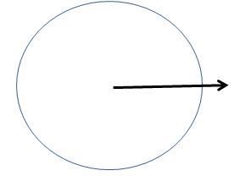

c. 1080° d. 1280 °
A 1080° angle is coterminal with ______ A 1280° angle is coterminal with ______
and ______ angles. and ______ angles.

