Activity 7.6.2 Using Probability for Decisions and Random Selection

1. Jordan decides to buy a smartphone. The phone costs $299.99 with a two-year contract. If the phone is lost, damaged or stolen before the two-year contract is up, then the cost to replace the phone is $749.99. Jordan can purchase insurance for $9 per month for a two-year plan. Then if his cell phone is stolen within the first two years, a replacement phone will cost only $299.99.

a. Jordan lives and works in New York City where 49% of smartphone customers have lost a cell phone or had it stolen. Suppose that Jordan decides not to purchase the insurance. Assume that if Jordan’s phone is stolen, he will replace it immediately. Complete the probability model for this situation in Table 1.

Smartphone status | Not lost or stolen | Lost or stolen
Cost
Probability
Table 1. Probability model for smartphone cost without insurance

b. Based on the probability model from (a), what is the expected cost of the smartphone if no insurance is purchased?

c. Suppose instead that Jordan decides to purchase the insurance for $9 per month when he buys his phone. If his smartphone is lost or stolen, he will immediately replace it and continue the insurance payments on the replacement phone. Complete the probability model in Table 2.

Smartphone status | Not lost or stolen | Lost or stolen
Cost
Probability
Table 2. Probability model for smartphone cost with insurance.

d. Based on the probability model from (c), what is the expected cost of the smartphone if insurance is purchased?

e. Based on the expected smartphone costs computed in (b) and (d), should Jason purchase the insurance for his new smartphone?

2. Before buying his smartphone, Jordan gets a job in Connecticut. In the area that he now lives and works, only 8% of smartphone customers lose or have their smartphones stolen. Repeat question 1 using the probabilities from Connecticut.

3. Your parents are trying to decide if they should buy the extended warranty on a new washing machine. Suppose there are two outcomes—an 80 percent probability of needing no repairs, and a 20 percent probability of needing a $300 repair during the extended warranty period.

a. What is the expected cost of repairs for this probability model?

b. Your answer to (a) would be the break-even price for a company selling the extended warranties. The company, of course, will charge more than this so it can make a profit. How much should the company charge if they want to add 25% to the expected value as their profit? Do you think your parents would be willing to pay this price?

4. On SAT multiple choice questions, there are five possible choices. You get 1 point if you answer the question correctly and lose $\frac{1}{4}$point if you answer the question incorrectly. Suppose you randomly select an answer.

a. Make a probability model for this situation by filling in the entries in Table 3.

Points earned
Probability
Table 3. Probability model for points earned on SAT question.

b. Find the expected value of a completely random guess on such a question. Does guessing in this situation help you, hurt you, or make no difference?

c. Suppose you eliminate one of the five choices as definitely not being the correct answer, and then randomly guess among the remaining four choices. Does guessing in this situation help you, hurt you, or make no difference? To answer this question, make a probability model and find the expected value.

Question 4 asks that you randomly guess answers on a multiple choice question. One way to do this would be to write the possible answers on slips of paper, place the slips in a container and randomly draw one out to be the answer. However, you would not be allowed to do that during an SAT exam.
There is another way to make a random selection. Recall the spinner challenge in Activity 7.6.1. Modify the perfectly balanced spinner in Activity 7.6.1 by wrapping a number line with numbers between 0 and 1 around the edge of the spinner as shown in Figure 1 below. Spin the spinner to assign a random number between 0 and 1 to each of the possible answers (a)–(e) on a multiple choice exam. Estimate the result to the nearest 0.01 (for example, 0.13 in Figure 1). Then select the answer that is assigned the smallest random number. Table 4 shows a list of five random numbers that result in choosing (d) for the answer.
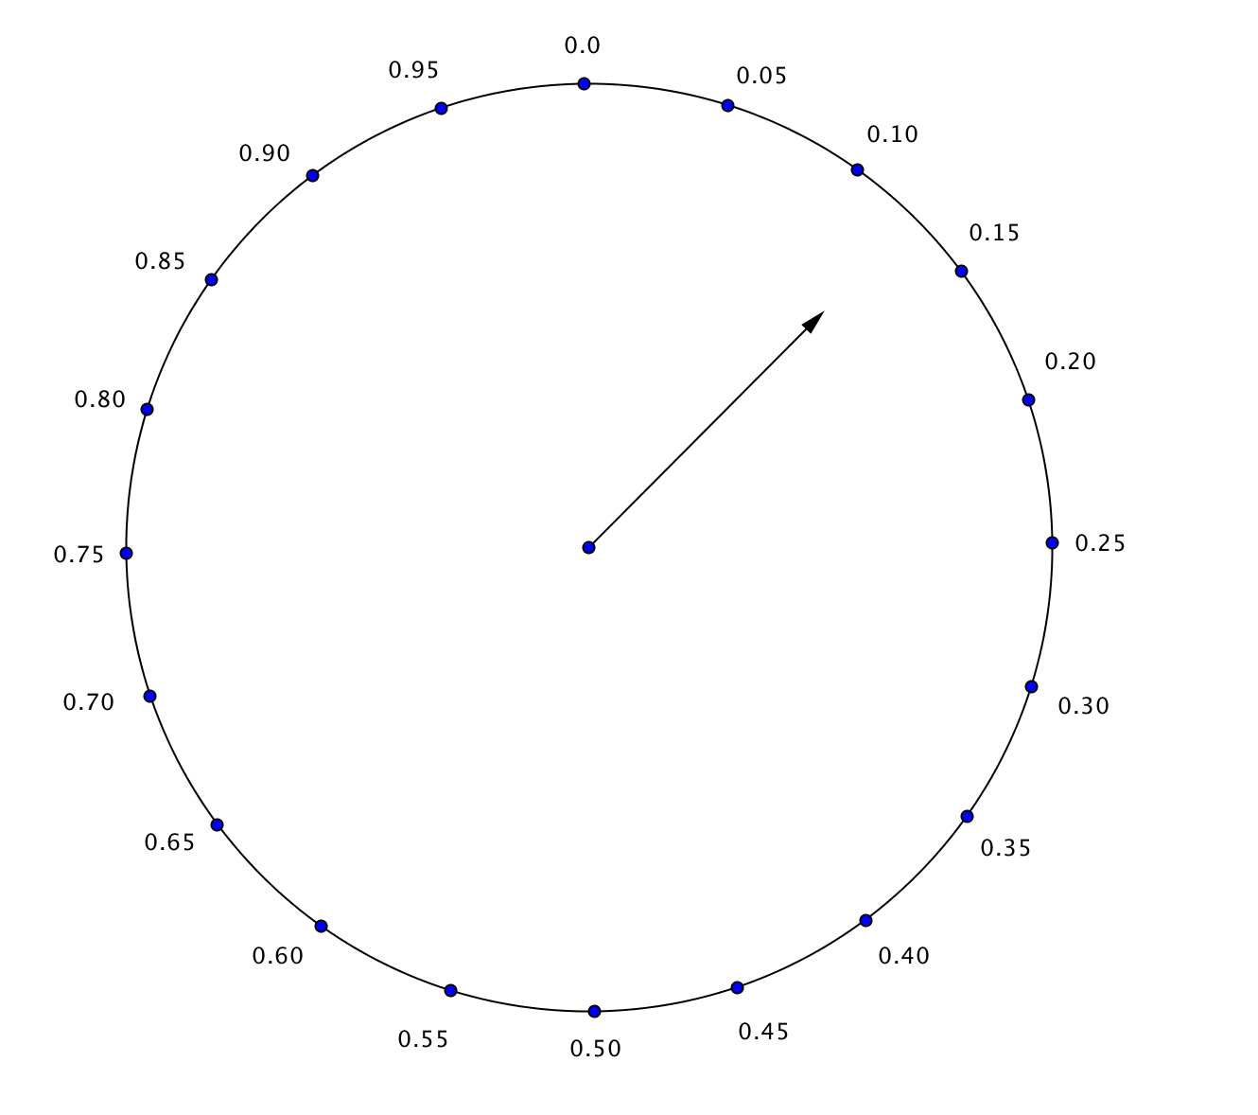

Answer | Random number assigned by spinner
(a) | 0.21
(b) | 0.27
(c) | 0.76
(d) | 0.03
(e) | 0.83

Figure 1. Spin the spinner to obtain a number Table 4. Choosing an answer based on random numbers.
Between 0 and 1.

5. You will not be allowed to bring a spinner to the SAT exams. But you are allowed to use a TI-84 graphing calculator. You can use a TI-84 graphing calculator’s random number generator rand to simulate the results of spinning the spinner from Figure 1. Here’s how:
- Press MATH and highlight PRB.
- Press 1 for rand and then ENTER. The result should be a number between 0 and 1.
- Continue pressing ENTER to generate additional random numbers.

Answer | Random number
(a)
(b)
(c)
(d)
(e)
Table 5. Assigning random numbers to answers.

a. Use rand to generate a list of five random numbers. Enter these numbers into Table 5. (You need only enter the first three decimal places of the number.)

b. One way to choose an answer from (a)–(e) at random is to select the answer that is assigned the smallest random number. What answer did you choose?
6. Table 6 lists the 10 seniors that belong to a high school Math Club. The club wants to randomly select three seniors as their representatives at a conference. Assign each senior a random number. Then determine how to adapt the process used in question 5 to select three seniors at random to attend the conference.

Member | Random number | Member | Random number
Jamal |  | Brad
Saras |  | Camila
Rashida |  | Alberto
Joseph |  | Megan
Jian |  | Kim
Table 6. Assigning random numbers to seniors in the Math Club.

