Activity 7.3.3b Informal Conditional Probability

1. Suppose a jar contains 3 white, 2 blue, and 5 red marbles. If you draw marbles from the container without replacing them, then probabilities change as more and more marbles are drawn from the container.

a. Let A be the event of getting a red marble on the first draw. Find P(A).

b. Let B be the event of getting a red marble on the second draw after draw.. Find the probability that B occurs given that we know that A has occurred. Using probability notation, we can express this probability as . Explain how you got your answer.

c. Let C be the event of getting a white marble on the third draw. Find the probability that C occurs given you know events A and B have occurred. Using probability notation, we can express this probability as . Explain how you got your answer.

In question 1 you calculated conditional probabilities, probabilities that one event will occur given that another event has already occurred. For the remainder of this activity, you will compare conditional and unconditional probabilities of events from everyday situations.

The notation for conditional probability, , is read as “the probability of B given A.”

2. Consider the probability pairs below. For each pair, state whether you think the conditional probability is higher, lower, or the same as the unconditional probability. Write a sentence justifying your answer. (Not every case has a single correct answer. Therefore, your justification is as important as your answer.)

a. P(person has blue eyes)
P(person has blue eyes | person is a Red Sox Baseball fan)

b. P(student watches Thursday Night Football)
P(student watches Thursday Night Football | student is female)

c. P(person drinks a cup of coffee most mornings)
P(person drinks a cup of coffee most mornings | person is under 12 years old)

d. P(it is going to rain)
P(it is going to rain | the sky is cloudy)

e. P(roll a die and get an even number)
P(roll a die and get an even number | roll a number greater than 3)

f. P(draw a card from a standard deck of cards and get a face card)
P(draw a card from a standard deck of cards and get a face card | card drawn is a heart)

g. Based on your answers to (a – f) decide whether the two events involved in the conditional distributions are independent or dependent.

Use Figure 1 for questions 3–6.

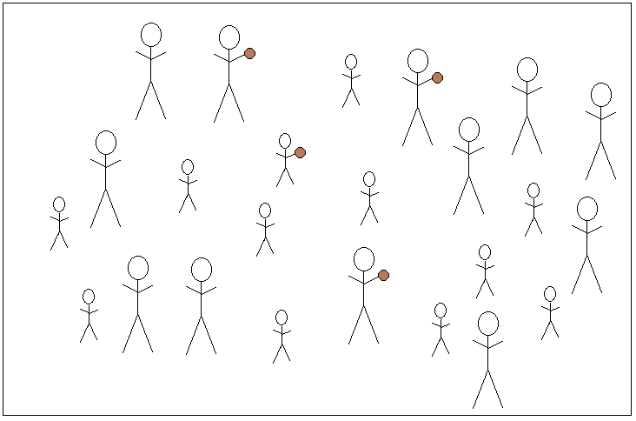
Figure 1. Tall and short men some of whom are professional basketball players.

In Figure 1, stick figures represent men. There are tall men and short men, based on the size of the stick figure. If a stick figure is holding a ball, then that man is a professional basketball player.

3a. In Figure 1, how many men are short? How many men are tall?

3b. Suppose a man in Figure 1 is randomly selected. Find P(man is tall).

4a. How many of the men are professional basketball players?

4b. Suppose a professional basketball player is randomly selected. What is the probability that he is tall? In other words, find P(man is tall | man is a professional basketball player).

5a. You know from 1(a) how many of the men are tall. How many of these tall men are professional basketball players?

5b. Suppose a tall man is randomly selected. What is the probability that he is a professional basketball player. In other words, find P(man is professional basketball player | man is tall).

6. Based on your work in questions 3–5, arrange these three probabilities in order from smallest to largest: P(man is tall), P(man is tall | man is professional basketball player), and P(man is professional basketball player| man is tall).

