**Activity 7.1.6 Area Models For Probability**

When Venn diagrams are drawn to scale (in terms of probability), we can see how likely it is that an event occurs by the proportion of the sample space that its region covers. Such Venn diagrams are called **area probability models**.

The Venn diagram in Figure 1 is an area probability model. We can use this model to find the probability that event *A* will occur from the ratio of *A*’s area to *S*’s area:

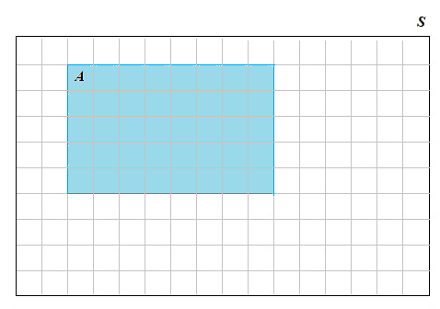

Figure 1. Area probability model.

1. Use the area probability model in Figure 1 to determine .

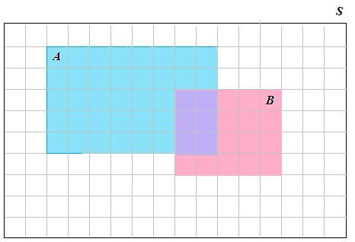

2. In Figure 2, event *B* (the rectangular region to the right outlined in pink) has been added to the area probability model from Figure 1. Find the following probabilities:

Figure 2. Adding an event *B* to the area   
probability model from Figure 1.

a. 

b. 

c. Jason decides that he can calculate  by just adding and ? Is Jason right? Explain why or why not.

d. Find the actual area of  in terms of the number of squares this event covers in the Venn diagram. Then determine .

e. How could you determine  from , , and ? Give a formula. Then use your formula and your answers to questions 1 and 2(a and b) to find . (Does your answer match your answer to (d)?)

3. a. Return to Figure 2. Determine the area representing  and use it to find . How did you determine the area in terms of the number of small squares in ? (Is there an easier way than counting every square?)

b. Find .

c. Find .

d. Given an event *E*, what is the value of ? Now, write a formula that tells you how to calculate  if you know .

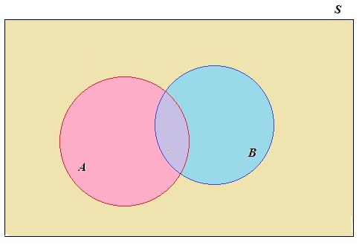

Figure 3. Venn diagram of two events

4. Figure 3 shows a Venn diagram of two events *A* and *B*. (This diagram is not drawn to scale so you cannot determine probabilities from areas.)   
  
Suppose that *P*(*A*) = 0.5, *P*(*B*) = 0.3, and .   
  
Use your formulas from questions 2(e) and 3(d) to find the following probabilities.

a. 

b. 

c. 

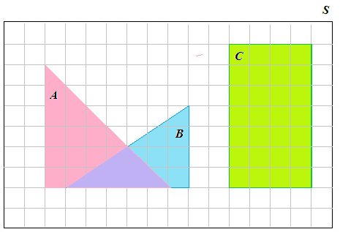

Figure 4. Area probability model containing *A*, *B* (triangular shaped regions), and *C*.

5. Find the following probabilities related to the events in the area probability model in Figure 4.

a. 

b. Using only your answer to (a), find .

c. 

d. 

e. 

f. Using only your answers to (c), (d), and (e), find .

6 (Extension question). Figure 3 shows a Venn diagram of two events *A* and *B*. Question 4 gives the probabilities for events *A*, *B*, and . Draw an area probability model for question 4.