**Activity 7.1.3 It’s All in the Cards**

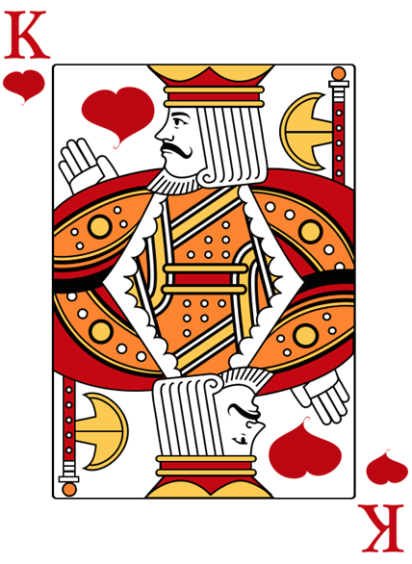

1. You will be given a group of 10 cards that consists of Kings, Queens, Jacks, 10s and 9s. Your set of cards will either be red (hearts, diamonds) or black (clubs, spades). Your set of cards forms the sample space for this activity. Specify an individual card with its rank and suit, for example, KH represents the King of hearts and 10C represents the 10 of clubs. Write your sample space using set notation.

Image from [www.clipartlord.com](http://www.clipartlord.com)

2. Let event *A* be a face card (that is, a jack, queen, or king). Sort out the cards in *A* and place them in a pile to the right. Put the remaining cards in a pile to the left.

a. Specify the cards in *A* using set notation. In other words, list the cards in the pile to the right and enclose the list with braces.

b. The cards in the pile to the left form the set . Specify the cards in using set notation.

3. If you have red cards, let event *B* be a heart. If you have black cards, let event *B* be a club. Sort out the cards in *B* and place them in a pile to the right. Put the remaining cards in a pile to the left.

a. Specify the cards in *B* using set notation.

b. The cards in the pile to the left form the set . Specify the cards in using set notation.

4. The intersection of events *A* and *B*, , consists of the cards that events *A* and *B* have in common. Look back at events *A* and *B*. Pick out the cards that are in both events and put them in a pile to the right. Put the remaining cards in a pile to the left.

a. Specify the cards in  using set notation.

b. Specify the cards in  using set notation. How did you determine the cards in this event?

5. Look back at the cards that were in  and  (questions 2(b) and 3(b)) and combine these cards into a single pile. This is the union of  and , which is denoted as.

a. Specify the cards in  using set notation. Compare this event to   
the event in 4(b).

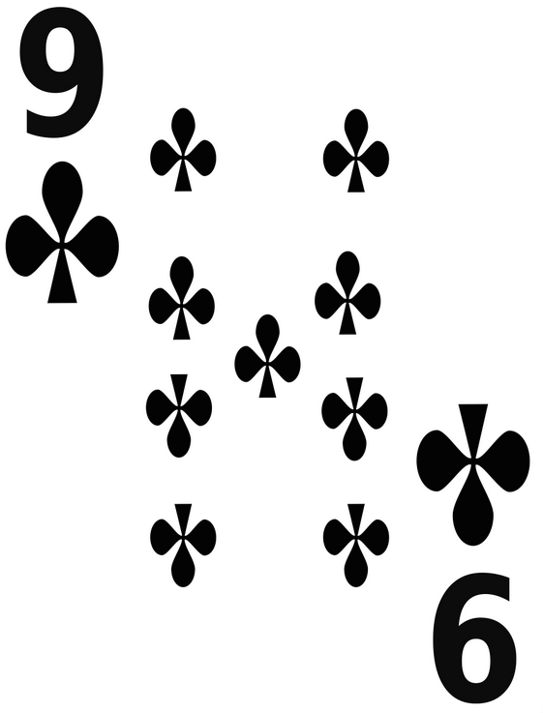b. What is event ? What is event .

Image from [www.freestockphotos.biz](http://www.freestockphotos.biz)

6. Let event *N* be a numbered card. Determine the following events.

a. *NC*

b. $A∩N$

c. $B∩N$

d. $A∪N$

e. $B∪N$

f. ${(B∩N)}^{c}$

g. $B∩N^{C}$