Unit 6 Investigation 4 (2 Days)

Cross Sections and Solids of Rotation

Common Core State Standards

G-GMD.4. Identify the shapes of two-dimensional cross-sections of three-dimensional objects, and identify three-dimensional objects generated by rotations of two-dimensional objects

Overview

Students will use concrete models to visual cross-sections of solid figures when intersected by planes. They will also rotate plane figures around an axis to create three-dimensional figures. They will have a brief introduction to three-dimensional rectangular coordinates and use a three-dimensional graphics program to create solids of revolution.

Assessment Activities

Evidence of Success: What Will Students Be Able to Do?

- Visualize the cross section of a three dimensional figure.
- Identify the solid figure formed by rotation a two-dimensional figure about an axis.
- Locate points in space with three-dimensional rectangular coordinates.

Assessment Strategies: How Will They Show What They Know?

- Exit slip 6.4.1 requires students to identify cross-sections of a three-dimensional figures.
- Exit Slip 6.4.2 ask students how to generate a solid of revolution.
- In the Journal entry students describe how cross-sections can help one visualize a three-dimensional figure
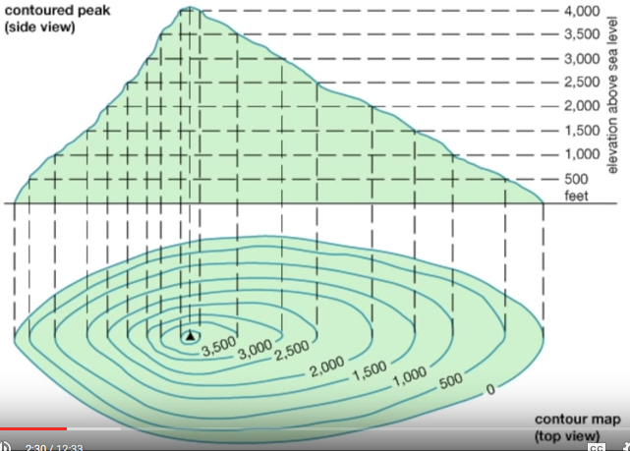
Launch Notes

Topographic maps show cross-sections of a terrain with contour lines. To illustrate this, show the first three or four minutes of this video: www.youtube.com/watch?v=AsQoY48i6z0. At about 2 ½ minutes into the video we see both vertical and horizontal cross-sections of a hill. This show how contour lines can help us visualize the steepness of the hill as various locations on the map. In this investigation we will be looking at cross sections of three dimensional shapes.

Teaching Strategies

In Activity 6.4.1 Seeing Cross-Sections students make cubes, rectangular prisms, cylinders, spheres, pyramids, and cones with modeling clay or play dough. They then use dental floss to create cross sections and observe the different shapes they can get with each of these figures.

Group Activity
Activity 6.4.1 lends itself well to working in small groups. Each member of the group can make the same three-dimensional figure, but if they cut from different directions they will get different cross-sections. They can compare their results with each other.

Following this activity you may give students Exit Slip 6.4.1

Activity 6.4.2 Axis of Rotation introduces solids of revolution by having students use note cards to generate different solids. Depending upon the shape that is rotated and its position students can generate cylinders, cones, frustums, and spheres.

Differentiated Instruction (For Learners Needing More Help)
Some students may have difficulty visualizing the figures formed by rotating a note card about an axis. Activity 6.4.4 Creating Solids of Rotation using GeoGebra may help them overcome this hurdle, after which they may return to Activity 6.4.2 and find that it now makes more sense to them.

Following this activity you may give students Exit Slip 6.4.2 although you may want to delaying doing that until after Activity 6.4.4.

Activity 6.4.3 Coordinates in Three-Dimensions uses the 3-D graphics screen of GeoGebra to introduce three-dimensional rectangular coordinates. Points are represented by ordered triples (x, y, z). Students draw a cube with given coordinates and observe in the Algebra window the equations of planes associated with the faces of the cube. They also observe the equation of a sphere centered at the origin and compare it with the equation of a circle in the coordinate plane.

Following Activity 6.4.3, students create solids of rotation in Geogebra in Activity 6.4.4. Detailed instructions are given for generating a cylinder and a cone. Then students are challenged to create other figures on their own.

Differentiated Instruction (Enrichment)
Some students may want to explore what happens when parabolas, ellipses, and hyperbolas are rotated about an axis.

‘
Journal Entry:
Explain how cross-sections are used to help us understand three-dimensional figures. Look for a variety of responses, ranging from how parallel planes are used in Cavalieri’s principle to the fact that the vertical cross-section of a solid of revolution reveals the two-dimension figure that generates the solid.

Closure Notes

You may close this investigation by showing a two-minute video of a how clay is thrown on a potters’ wheel. www.youtube.com/watch?v=u3_CAVv8gDI. Ask students to recognize that the outcome is a solid of rotation.

Vocabulary
axis of rotation
cross-section
Resources and Materials

Clay (or play dough) and dental floss for Activity 6.4.1

Note cards and compass for Activity 6.4.2

GeoGebra for Activities 6.4.3 and 6.4.4.

Activity 6.4.1 Seeing Cross Sections
Activity 6.4.2 Axis of Rotation
Activity 6.4.3 Coordinates in Three Dimensions
Activity 6.4.4 Creating Solids of Rotation Using GeoGebra

Exit Slip 6.4.1
Exit Slip 6.4.2

Videos
www.youtube.com/watch?v=AsQoY48i6z0 (contour lines) www.youtube.com/watch?v=u3_CAVv8gDI (potters’ wheel)

