Unit 6: Investigation 2 (2 Days)
Nets and Surface Area

CCSS:

G-GMD.1. Give an informal argument for the formulas for the circumference of a circle, area of a circle, volume of a cylinder, pyramid, and cone. Use dissection arguments, Cavalieri’s principle, and informal limit arguments.

Overview

In previous units we derived areas of parallelograms, trapezoids, triangles, and regular polygons based on area of a rectangle. We used an informal limit argument for circumference and area of a circle based on inscribed regular polygons. We now apply formulas for areas of plane figures to compute surface areas of prisms, pyramids, cylinders, and cones.

Assessment Activities

Evidence of Success: What Will Students Be Able to Do?

- Students will be able to examine a polyhedron, cylinder, or cone, identify the surfaces that make up the surface area, and compute the surface area using formulas for the related plane figures.

- They will draw nets for described solid figures, build the models and calculate

surface areas of the shapes..

Assessment Strategies: How Will They Show What They Know?

- In Exit Slip 6.2 students will compare the surface areas of a cylinder and a square prism.

- In the Journal Entry students will explain how nets are used to compute surface area.

Launch Notes

The design of packaging is a nice application to introduce this investigation. Product packaging designers and engineers need to have a combination of design and three-dimensional reasoning. They must be concerned about marketing issues, packing of materials in boxes as they travel to stores, minimizing packaging materials to save money and the environmental concerns about packaging waste and recycling. Here are two videos that introduce the idea of package design:

https://www.youtube.com/watch?v=E3RlwaMhfD4 – a video describing the way hair products are packaged (it covers the design of a can from the initial ideas to the metal printing of an aerosol can).

https://www.youtube.com/watch?v=POVCe_Plcso – a video about what a packaging engineer does. This video has also been used by PBS Kids. This YouTube link of the same video is more adolescent friendly.

Teaching Strategies

Introduce the first activity by introducing students to the term “net.” Ask them to define in their own words what is meant by the term. Students may think of real world examples such as fishing nets, hair nets, or computer networks. In mathematics we apply the term to a polyhedron that has been taken apart so that its faces are spread out in a plane.

Activity 6.2.1 Exploring Nets: Students will explore how to create nets for specific solids and how to determine if a flat collection of polygons is a net of a polyhedron. The first four questions require assess to a computer and so students may use the NCTM Illuminations activity http://illuminations.nctm.org/Activity.aspx?id=3521. If computer access is unavailable for individual students, you may work through these questions on the overhead. Students may then work on their own or in small groups for the remainder of the activity. Notice that the last question requires students to find a box at home and calculate its surface area.

Do not attempt to introduce formulas for surface areas of various figures but rather have students rely on the basic strategy of drawing or visualizing the net and then computing the area of each surface.

Differentiated Instruction (For Learners Needing More Help)
Encourage students who have difficulty interpreting drawings of three-dimensional figures to keep models of the figures with them as they work on problems involving surface area and volume.

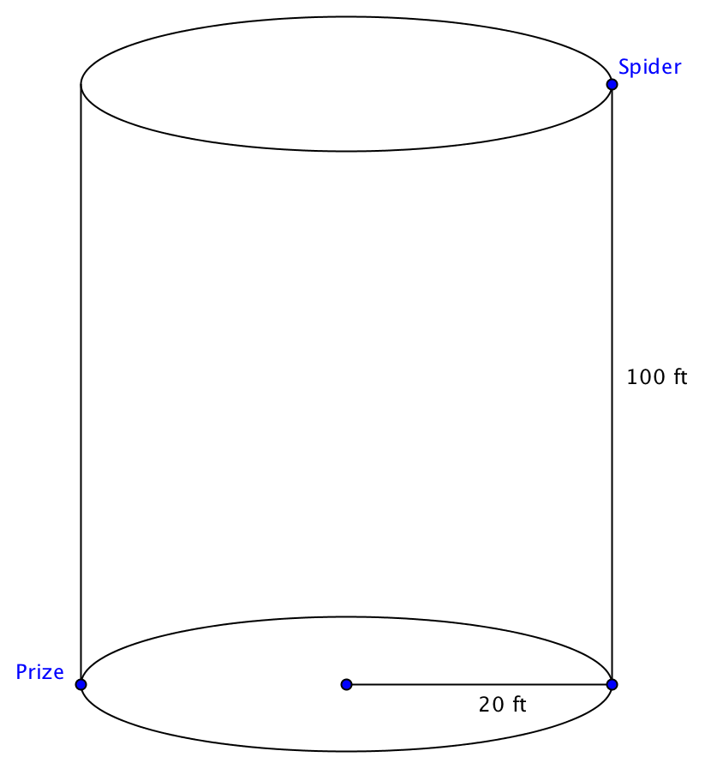
Introduce the next activity with this think-pair-share question:

Our friendly neighborhood spider has to rescue a prize in the bottom of a Silo (large cylinder). The radius of the cylinder is 20 feet and its depth is 100 feet. As our hero enters the top of the silo, he sees the prize directly across from him at the bottom. What is the shortest path he can crawl to reach his prize?

Posing this question should lead to a consideration of the lateral surface area of a cylinder. Encourage students to imagine peeling the label off a can of soup and observing that it forms a rectangle with dimensions equal to the height of the cylinder and the circumference of the base.

Then have students work on Activity 6.2.2 Nets for Cylinders and Cones. They are given a cylindrical can and asked to make an exact replica. Later they are given a coffee can and asked to make a cone that has the same base and the same height. The GeoGebra file ctcoregeomACT622.ggb is used to help them see the relationships among the radius, height, slant height, base, and lateral surface of a cone. They compute surface areas for both cylinders and cones.

Note: Technically the figures studied in Activity 6.2.2 are right circular cylinders and right circular cones. “Circular” refers to the shape of the base; some cylinders and cones have elliptical bases. “Right” indicates that the axis of the figure is perpendicular any radius drawn from the center of the base. Since right circular cylinders and cones are the most common type found, we will assume that when we refer to “cylinder” or “cone” we are assuming they are right and circular, unless stated otherwise.

Following Activity 6.2.2. you may give Exit Slip 6.2.

Differentiated Instruction (Enrichment) Although the emphasis in this investigation has been conceptual, and formulas have been avoided, advanced students may be asked to prove that that the lateral surface area of a cone is 2πrh and the lateral surface area of a cone is 2πrl where h is the height of the cylinder, l is the slant height of the cone, and r is the radius of the base.

Use the video at https://www.youtube.com/watch?v=Envs4h98F8c to motivate the next activity. The video shows the design of a package for a plastic skull starting with a sheet of paper and ending with a fully functional 3-dimensonal box. The emphasis is on creating the net for the packaging.

Activity 6.2.3 Building Packaging Nets: Students are given everyday objects such as soda cans, phones, fruit, etc. that need a container (see the video of a design for the packaging of a plastic skull). The container should fit the object closely enough that is does not move. Students are to design a package for the object, prepare a net for the package, make a mock-up of the package and prepare specifications that indicate the finished dimensions of the package, how the packages might be boxed for delivery including maximizing the units in a standard UPS box.

Group Activity
To review this investigation, have students work in groups of 3. One person names a type of three-dimensional figure, the second person gives the dimensions that are needed to find the surface area, all three work together to sketch a net, and the third person performs the calculations necessary to determine the surface area. Then rotate roles.

Journal Entry
Explain how you use the can use the net of a solid figure to compute its surface area. Include in your response examples of polyhedra, cylinders, and cones. Look for students to recognize that the surface of these figures is made up of plane figures, whose areas we already know how to find.

Closure
In this investigation students begin to think of polyhedra as objects that can be analyzed by decomposing their parts. Ask students to think about how this strategy might be used to compute volumes.

Vocabulary

lateral surface
net
slant height
surface area

Resources and Materials

Soda cans - http://illuminations.nctm.org/Lesson.aspx?id=2363 packaging soda cans in a box.

Preparing nets simplified by using Dynamic Paper - http://illuminations.nctm.org/Activity.aspx?id=3509

Geometric Solids – this has a simplified method of preparing your own original nets. May work well for some students who need help.
http://illuminations.nctm.org/Activity.aspx?id=3521

Isometric drawing tool: http://illuminations.nctm.org/Activity.aspx?id=4182

Websites
https://www.youtube.com/watch?v=E3RlwaMhfD4 for launch
https://www.youtube.com/watch?v=POVCe_Plcso for launch
http://illuminations.nctm.org/Activity.aspx?id=3521 for Activity 6.2.1
https://www.youtube.com/watch?v=Envs4h98F8c to introduce Activity 6.2.3.
GeoGebra file
ctcoregeomACT622 to be used with Activity 6.2.2

Materials
Tools: Scissors, compass, ruler and protractor (Activities 6.2.2 and 6.2.3)
Heavy paper or card stock (Activities 6.2.2 and 6.2.3)
Open coffee cans and other cans (for Activity 6.2.2)

