Unit 5: Investigation 2 (3 Days)

Radii and Chords

Common Core State Standards

- G-CO.9. Prove theorems about lines and angles. Theorems include: vertical angles are congruent; when a transversal crosses parallel lines, alternate interior angles are congruent and corresponding angles are congruent; points on a perpendicular bisector of a line segment are exactly those equidistant from the segment’s endpoints.
- G-C.3. Construct the inscribed and circumscribed circles of a triangle, and prove properties of angles for a quadrilateral inscribed in a circle.

Overview

In this investigation, students will build upon the idea of a locus of points by examining perpendicular bisectors. They will see that the center of a circle lies on the perpendicular bisector of any chord. This will also allow us to locate the center of any circle given two chords and to circumscribe a circle about any triangle

Assessment Activities

Evidence of Success: What Will Students Be Able to Do?

- Construct a perpendicular bisector
- Explain why the perpendicular bisector of any chord in a circle must include the center
- Use constructions to find the center of a circle given two chords
- Circumscribe a circle about a triangle

Assessment Strategies: How Will They Show What They Know?

- Exit Slip 5.2.1 asks students how to find the center of a circle given two chords.
- Exit slip 5.2.2 asks students how to circumscribe a circle about a triangle.
- Journal Entry asks students why the intersection of the perpendicular bisectors of any two chords in a circle is the center of the circle?

Launch Notes

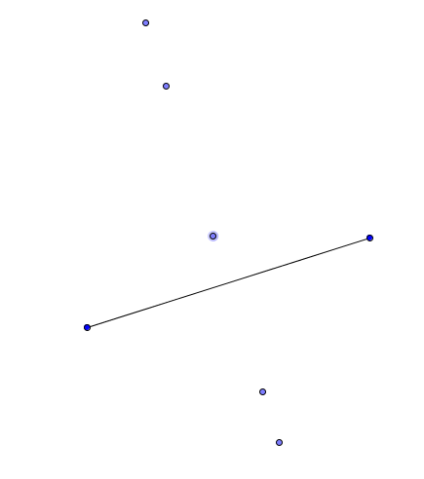
Ask students to recall what it means for a point to be equidistant from two other points. Have them work with a partner to draw a rough sketch of what this might look like and use a ruler to measure the distances. Once you’ve gone over some correct examples have them add four more points that are also equidistant from the original two points. Then ask students to come up with some conjectures about the relationship between the two initial points and the five points they have found. Encourage them to be creative and to follow hunches. You are looking for students to construct the segment with the two initial points as endpoints and develop hypotheses such as “it looks like the segment created by the two points is perpendicular to the line containing the constructed points” and “it looks like the line containing the constructed points goes through the midpoint of the segment”. They should also notice that the midpoint itself satisfies the condition since it is equidistant from the endpoints of the segment.

Teaching Strategies

Recall the definition of perpendicular bisector first encountered in Activity 2.7.5: The perpendicular bisector of a segment is the line that passes through the midpoint and is perpendicular to the segment. Activity 5.2.1 The Perpendicular Bisector As a Locus of Points builds on the launch by having measure distances from points on the perpendicular bisector to the endpoints of a line segment. In Activity 5.2.1a this is done with a ruler; in Activity 5.2.1b Geogebra is used.

After students have completed Activity 5.2.1 you may reinforce the concept by use the file PerpBisAsLocus.ggb for a classroom demonstration.

Differentiated Instruction (For Learners Needing More Help)
Some students will need help unpacking the meaning of perpendicular bisector. Draw a line segment $\overline{AB}$ and then show that there are many lines that are perpendicular to $\overline{AB}$ but only one of them passes through the midpoint M. Then draw a second line segment again labeled $\overline{AB}$ and show that many lines pass through its midpoint but only one of them is perpendicular. The perpendicular bisector is the unique line that is both a bisector AND is perpendicular to the segment.

Because the two words are used together, some students will draw the erroneous conclusion that if a line is perpendicular (to a given segment) then it is a bisector and vice versa.

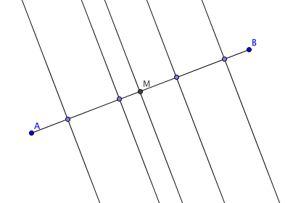
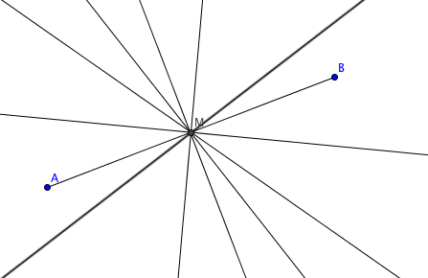

The activity will help students see that the perpendicular bisector of a segment may also be described as the locus of points equidistant from the endpoints of the segment. This becomes the Perpendicular Bisector Theorem. Emphasize the meaning of locus: every point on the perpendicular bisector is equidistant from the endpoints of the segment AND every point that is equidistant from the endpoints lies on the perpendicular bisector of the segment. This is critical because the proof of the theorem requires that both parts be proved.

That proof is found in Activity 5.2.2 Proof of the Perpendicular Bisector Theorem.. There are two versions of the activity. Activity 5.2.2a has less scaffolding than Activity 5.2.2b.

You should be able to finish the first two activities on the first day of the investigation.

Before introducing Activities 5.2.3 and 5.2.4, you may want give students a tactile understanding of chords, through the following group activity.

Group Activity
Have the class arrange themselves in the form of a circle. Give a student one end of a piece of string and give the other end to another student. Make sure they hold it tight and explain that the string represents a line segment. It is called a chord because it is a line segment whose endpoints are on a circle. Have different pairs of students create chords with string. If you stand in the center of the circle, students may discover that shorter chords are farther away from the center than longer ones. The longest chord will pass through the center. It is also called the diameter of the circle.

In addition to learning the definition of chord, make students recall the definitions of diameter and radius.

Differentiated Instruction (Enrichment)
In Part III of Activity 5.2.3 students will have conjectured that if two chords have the same length then they are the same distance from the center, and conversely. Some students may want to prove this. They may also want to prove that if one chord longer than the other, the longer chord is closer to the center. These proofs may be deferred until Investigation 4 where the Hypotenuse-Leg Congruence Theorem is introduced.

Activity 5.2.3 Chords and Perpendicular Bisectors in a Circle uses Geogebra to discover that the perpendicular bisector of any chord passes through the center of the circle and that a line through the center that is perpendicular to a chord bisects the chord. If you use this activity you may skip the first page of Activity 5.2.4. If you choose not to use this activity, be sure to do all of Activity 5.2.4.

In Activity 5.2.4 Radii and Chords activity students use compass and straightedge to construct the perpendicular bisector of a chord and discover that it passes through the center of the circle. They then prove the Perpendicular Bisector of a Chord Theorem. Because the perpendicular bisector is the locus of points equidistant from the endpoints of the chord and because the center is equidistant from every point on the circle, the center must lie on the perpendicular bisector.
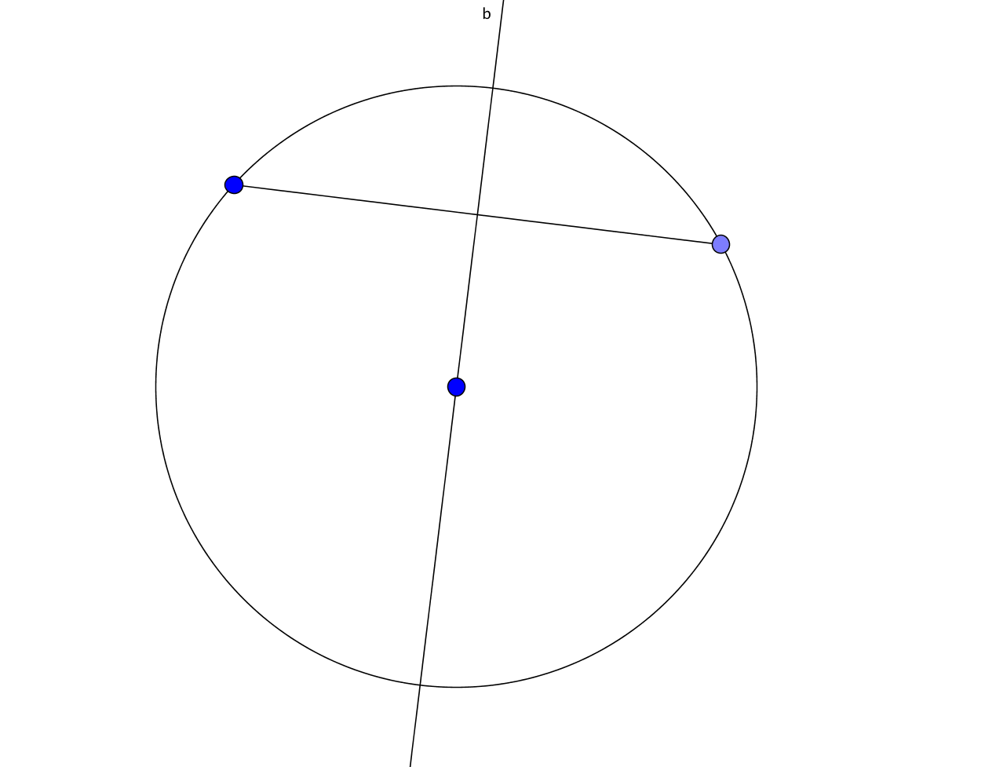
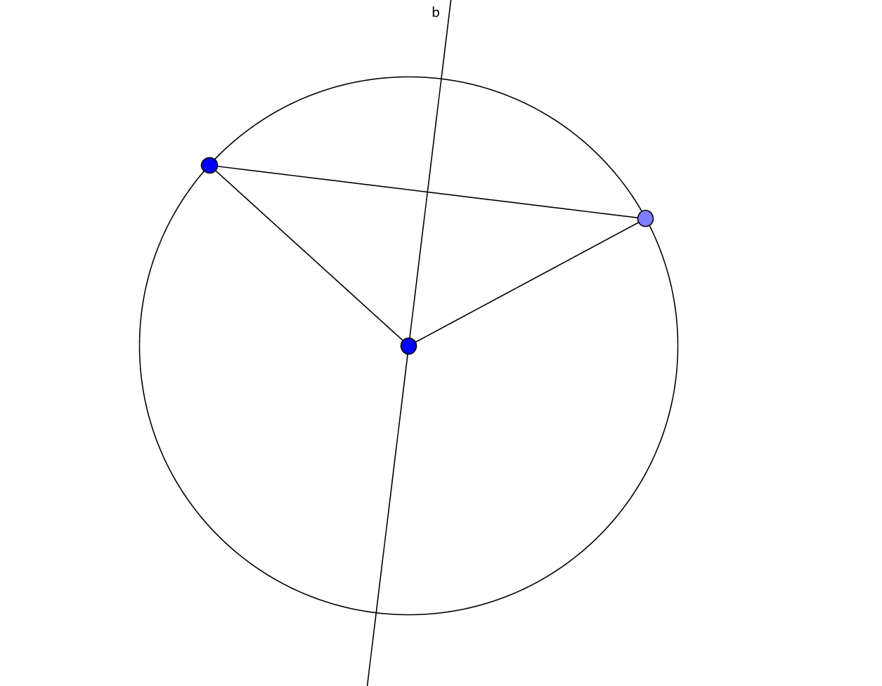

Two additional theorems are proved in this activity: the Radius Chord Midpoint Theorem: If a radius of a circle bisects a chord (that is not a diameter), then it is perpendicular to the chord, and its Converse: If a radius of a circle is perpendicular to a chord then it bisects the chord.

In Activity 5.2.5 Locating the Center of a Circle students find the center of a circle by drawing two chords and their perpendicular bisectors. The Perpendicular Bisector of a Chord Theorem guarantees that the two perpendicular bisectors will intersect at the center of the circle. Activity 5.2.5a uses compass and straightedge to perform the construction; Activity 5.2.5b uses Geogebra.

At the end of the second day you may give Exit Slip 5.2.1, which asks students to explain how to find the center of a circle given two chords.

The final activity of this investigation is Activity 5.2.6 Circumscribing a Circle about a Triangle. It leads students through the steps necessary to circumscribe a circle about a triangle. They change the shape of the triangle and conjecture where the center of the circumscribed circle lies. (If the triangle is acute, it is inside the triangle, if the triangle is obtuse it lies outside. If you have a right triangle the circumcenter lies on the hypotenuse.) Activity 5.2.6a uses compass and straightedge to perform the construction; Activity 5.2.6b uses Geogebra.

At the end of the third day you may give Exit Slip 5.2.2, which asks students to circumscribe a circle about a triangle.

Journal Entry: Why is the intersection of the perpendicular bisectors of any two (non-parallel) chords in a circle the center of the circle? Look for students to explain that the perpendicular bisector of a segment is the locus of points that are equidistant from the endpoints of the segment.

Closure Notes

Point out how the locus property of perpendicular bisectors has been used throughout this investigation including finding the center of a circle and circumscribing a circle about a triangle.

Vocabulary

chord
circumscribe
circumcenter
equidistant
locus

Resources and Materials

Activities:
Activity 5.2.1a The Perpendicular Bisector as a Locus of Points (physical tools)
Activity 5.2.1b The Perpendicular Bisector as a Locus of Points (Geogebra)
Activity 5.2.2a Proof of the Perpendicular Bisector Theorem (open ended)
Activity 5.2.2b Proof of the Perpendicular Bisector Theorem (scaffolded)
Activity 5.2.3 Chords and Perpendicular Bisectors in a Circle
Activity 5.2.4 Radii and Chords
Activity 5.2.5a Locating the Center of a Circle (physical tools)
Activity 5.2.5a Locating the Center of a Circle (Geogebra)
Activity 5.2.6a Circumscribing a Circle about a Triangle (physical tools)
Activity 5.2.6b Circumscribing a Circle about a Triangle (Geogebra)

String for Group Activity
Rulers, protractors, graph paper for Activity 5.2.1a, 5.2.4, 5.2.5a, and 5.2.6a
Geogebra for Activity 5.2.1b, 5.2.3, 5.2.5b, and 5.2.6b

Geogebra files:
ctcoregeomACT521.ggb
PerpendicularBisectorAsLocus.ggb

Theorems

Perpendicular Bisector Theorem: the locus of points that are equidistant from the endpoints of a segment is the perpendicular bisector of the segment.
Perpendicular Bisector of a Chord Theorem: The perpendicular bisector of any chord of a circle passes through the center.

Radius Chord Midpoint Theorem: If a radius of a circle bisects a chord (that is not a diameter), then it is perpendicular to the chord.

Radius Chord Midpoint Converse: If a radius of a circle is perpendicular to a chord then it bisects the chord.

Construction: To circumscribe a circle about a triangle.

