Investigation 6.4.4 Creating Solids of Rotation using GeoGebra.

Setting Up the File

This investigation explores using software to generate three-dimensional solids from rotating two-dimensional figures The strategy is to create a “turn table” that rotates a point around an axis. We then create a shape that includes this point. We rotate the shape by rotating the point and trace edges of our shape to generate an image of the solid.
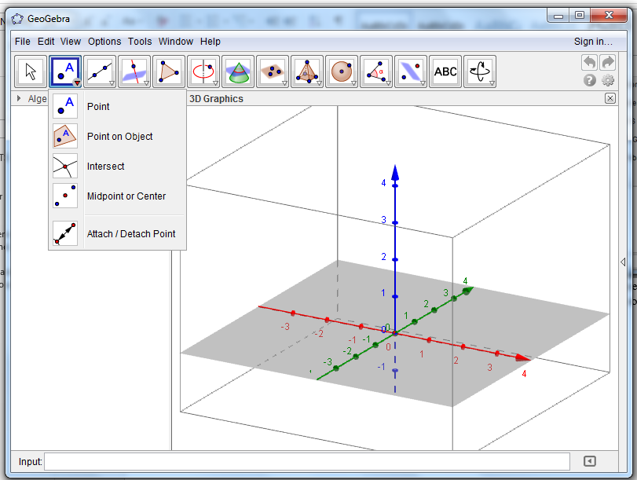
- Open Geogebra and select 3D Graphics. You will see the three axes marked in color, red for x, green for y and blue for z.
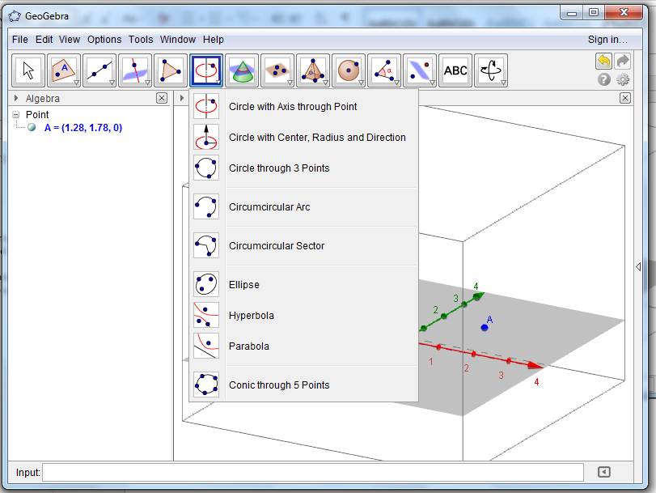
- We need to establish a “turn table.” In order to rotate around the z-axis, we need to place a point somewhere on the xy-plane. To do this, select the Point tool from the menu along the top of the screen. Choose Point on Object. Place a point on the plane.
- Our next task is to create a circle through our point that will be a “track” for a new turning point to travel along. Choose the Circle with Axis through Point option from the axis tool along the top tool bar. To use this tool select it, then select the z-axis (it will change to a dotted line when selected) and then select point A.

- You will see a circle that is centered at the origin and passes through point A. We will not move point A, but we will need another point that can move around the circle. Use Point on Object to place a point B on the circle. Note that it is easy to place the point on the plane but not on the circle. Use the arrow tool to test to make certain that your point B can travel around the circle. Save this file as “TurnTable.ggb” to use in the following experiments.

Experiments

1. Generating a cone

Form a triangle that can rotate around the z-axis.

a. Place point C a point on the z-axis. Either use Point on Object or type the coordinates C= (0,0,3) directly into the input window.

b. Place point D at the origin.

c. Use the line segment tool to create segments$\overline{ BC}$, $\overline{BD}$ and $\overline{CD}$.

d. Use the arrow tool to move the point B around the circle. You should see the triangle rotate around the axis.

e. Right click (or control-click) the sides of the triangle and turn trace on. Now as you move point B, the surface of the cone will appear.

F. You may also use the 3-D rotate tool at the right of the menu at the top of the page to view your solid from any direction.

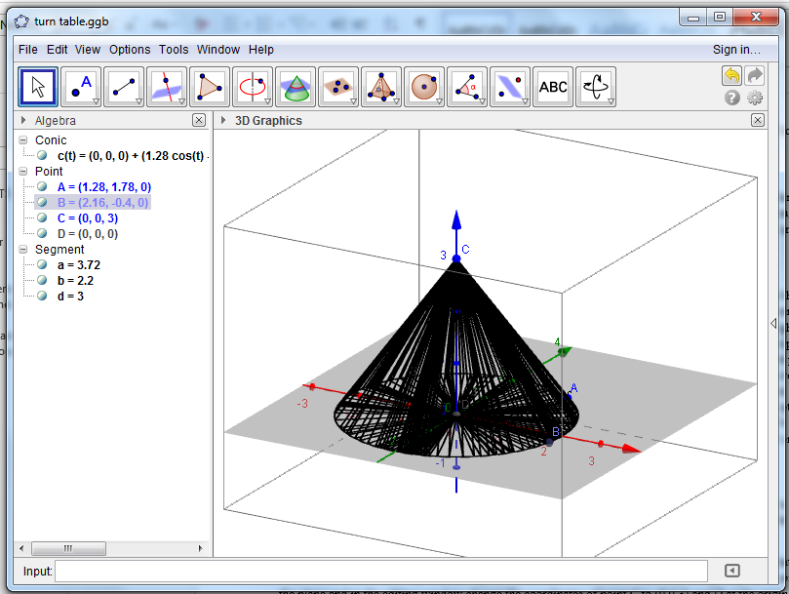

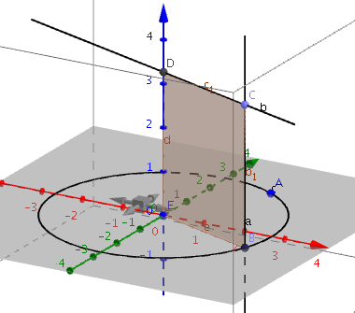
2. Generating a Cylinder

- Start again with the file saved as TurnTable.ggb.
- Use the perpendicular line tool to draw a line perpendicular to the =xy-plane through point B. Locate point C somewhere on this line.

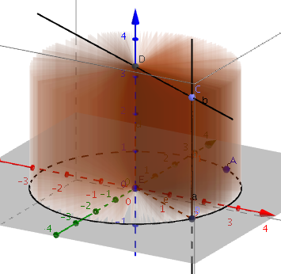
- Use the perpendicular line tool again to draw a line through point C perpendicular to the z-axis. Use the intersect tool to label D, the point where this line intersects the z-axis.

- In the input window, type E=(0, 0, 0) to locate the origin.

- Now use the polygon tool to draw rectangle BCDE. Right-click (or control click) on the polygon to turn trace on.

- Move point B around the turntable to generate the cylinder.

3. Additional Problems

Here are some challenges for you to try. You can take screen shots of your computer screen to document your solutions.

  - Make a cone that is 3 units high that has a diameter of 2 units. Hint: you can connect a segment from A to the origin and locate another point on the segment 1 unit away from the origin.
  - Make cylinder 3 units in diameter 5 units tall.
  - Find three ways to rotate a 4 unit by 6 unit rectangle to form different cylinders.
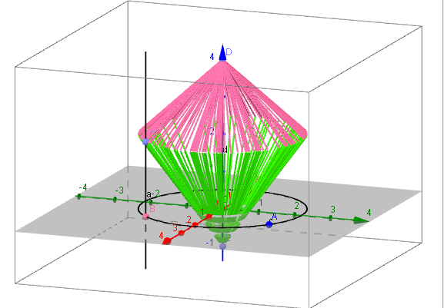
  - Make a plane figure that can form a frustum of a cone when rotated.
  - Rotate a triangle in such a way that it generates a shape that looks like this:

Note: you can change the color of a trace by right clicking on the object that is being traced, then select options from the menu and select color.

