Activity 6.3.5 Cones and Pyramids

In the previous activity you showed that the volume of a pyramid may be found by multiplying the area of its base by its height, that is V = $\frac{1}{3}$ Bh. In this activity we will show that the same formula applies to the volume of a cone.
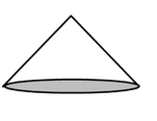
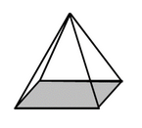

http://www.math-salamanders.com/image-files/3d-shape-sheets-identify-cones-pyramids.gif

- Begin with a cone with height 10 cm and base of diameter 8 cm. We consider two pyramids. One is a square pyramid with height 10 cm and a base of side 8 cm. Surely the volume of the cone is smaller than the volume of the pyramid.

  - Make a sketch of this pyramid and calculate the volume of this pyramid.

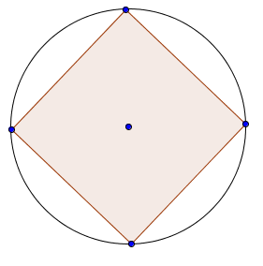
  - Now consider a square pyramid that has a base that joins four equally spaced points along the circular base of the cone with diameter 8 cm and the same altitude as the cone with altitude 10 cm. Draw a sketch below and calculate the volume of this pyramid.

  - From the results of (a) and (b) we can say that the volume of the cone must be less than ______________ but greater than _____________.

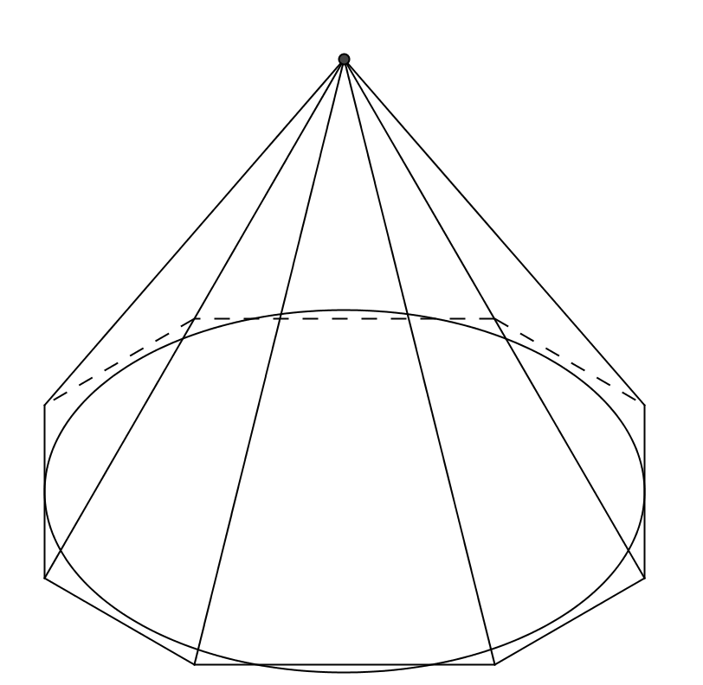

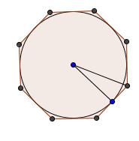
  - Now we will do the same thing with regular octagonal pyramids. The first one is tangent to the sides of the circular base of the cone with diameter 8 cm and altitude 10 cm. Use trigonometry and the properties of regular polygons to find the area of its base and the volume of the cone.
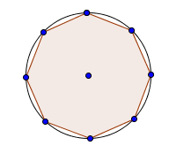
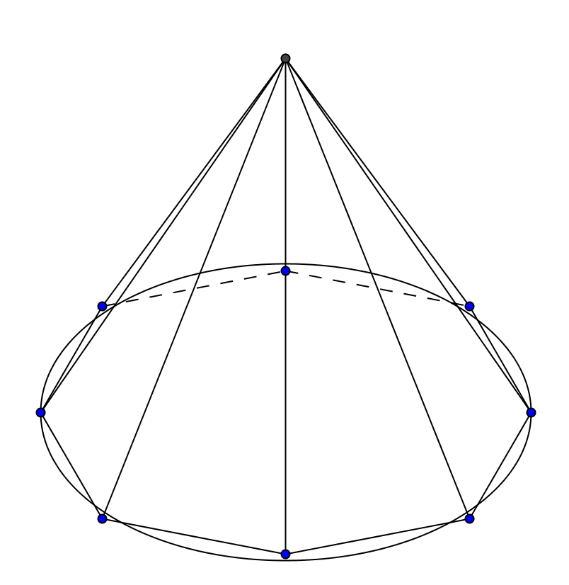
  - The base of the second pyramid is a regular octagon that is inscribed in the circular base. Find the area of this base and the volume of the second pyramid.
  - From the results of (d) and (e) we can say that the volume of the cone must be less than ______________ but greater than _____________.

- Suppose we increase the number of sides of the base of the pyramid to 16. Again we have a cone with a height of 10 cm and a diameter of 8 cm. Again we have a circumscribed pyramid and an inscribed pyramid both with regular polygons for bases. Without doing any calculations, answer these questions:
a. How would the volume of the circumscribed regular dohexagonal (16-sided) pyramid compare with the volume of the circumscribed regular octagonal pyramid?
b. How would it compare with the volume of the cone?
c. How would the volume of the inscribed regular dohexagonal pyramid compare with the volume of the inscribed regular octagonal pyramid?
d. How would it compare with the volume of the cone?
- If we could continue this to increase the number of sides of the base what do you think would be the limiting value of the volume of the circumscribed and inscribed pyramids?
- Find the volume of the cone with height = 10 cm and diameter = 8 m.
- Find a general formula for the volume of any cone with radius = r and height = h.
- Kaylee says that the formulas for the volumes of a cones and pyramids are the same. Vanessa disagrees. Who do you think is right? Explain.

