Model of a pyramid extended by parallel lines to a prism with the same base and altitude.

Print on card stock. Cut on black segments. Score along the dashed segments to make precise models. Fold on the dashed segments with the printing on the outside. The pale dashed segments show where the pyramids are in the interior of the prism.

Place glue ( Aleene’s ®Tacky Glue sets very quickly) on the tabs and press together to assemble the parts.
The original pyramid: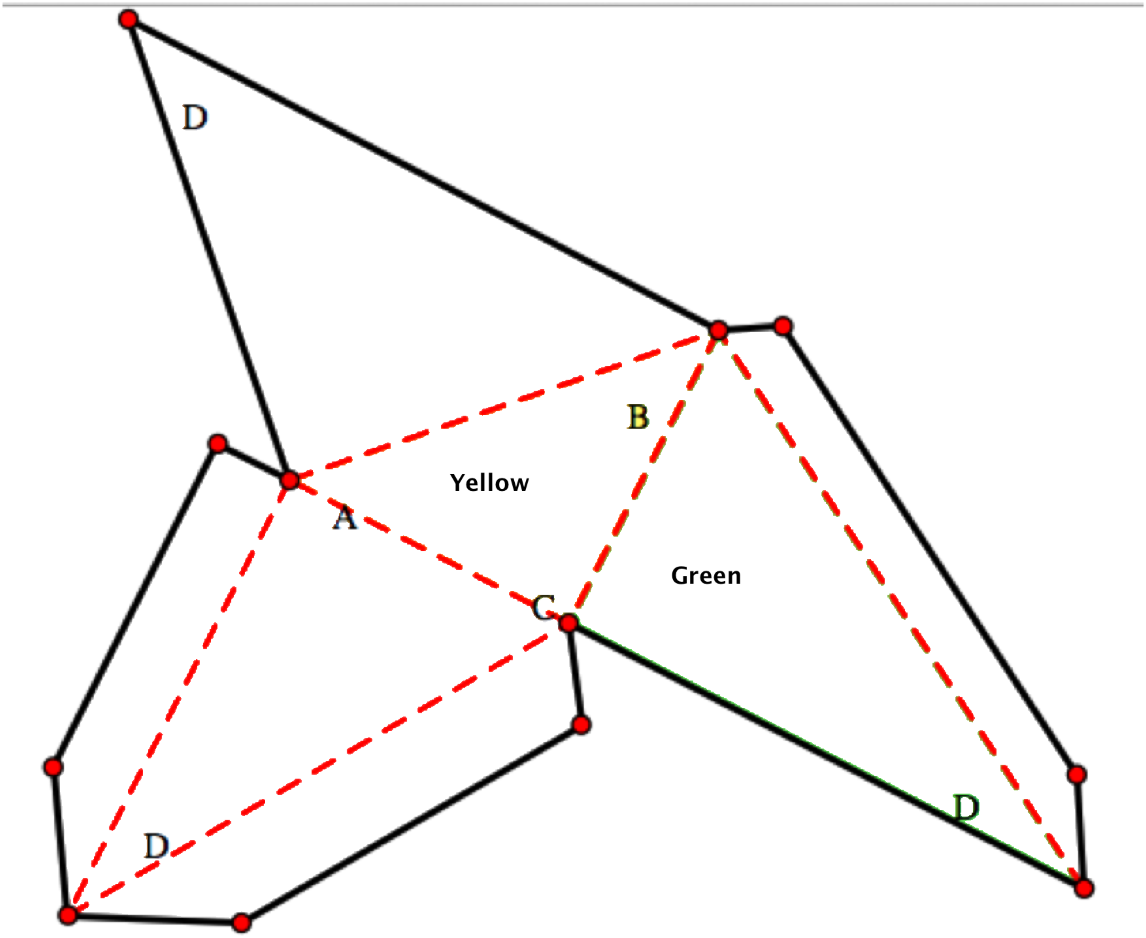

The prism “box” formed by lines parallel to the edges of the pyramid:
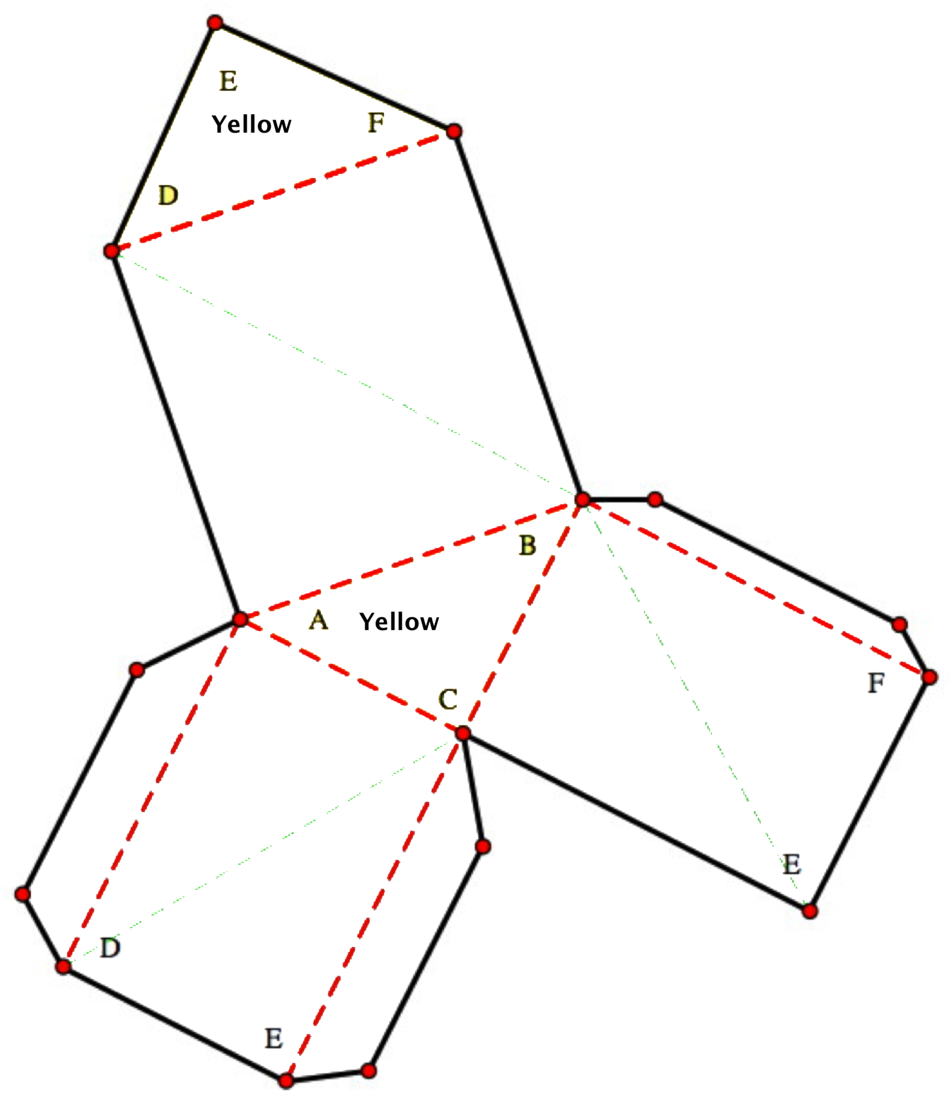

A pyramid congruent to the original pyramid:

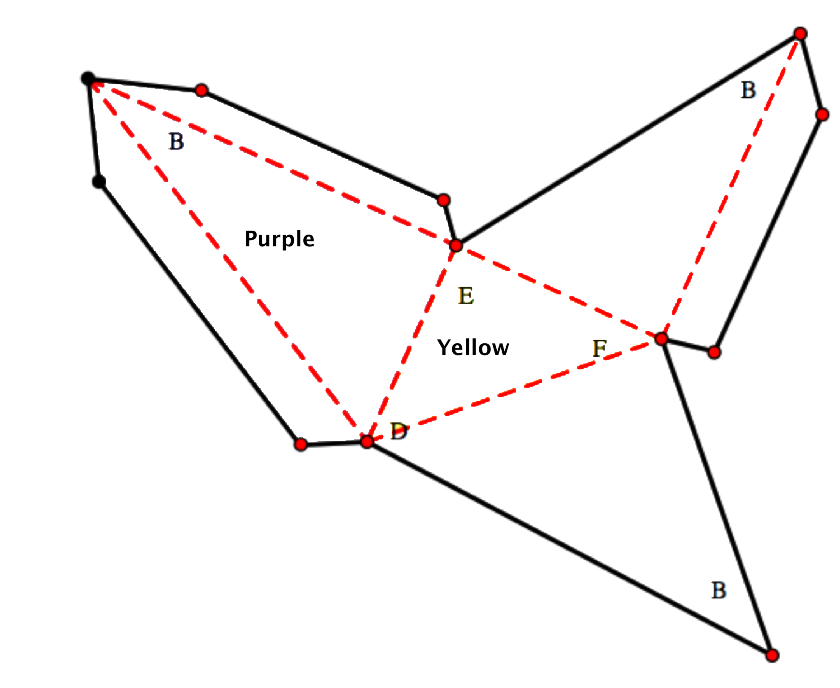

The pyramid in the interior of the prism:

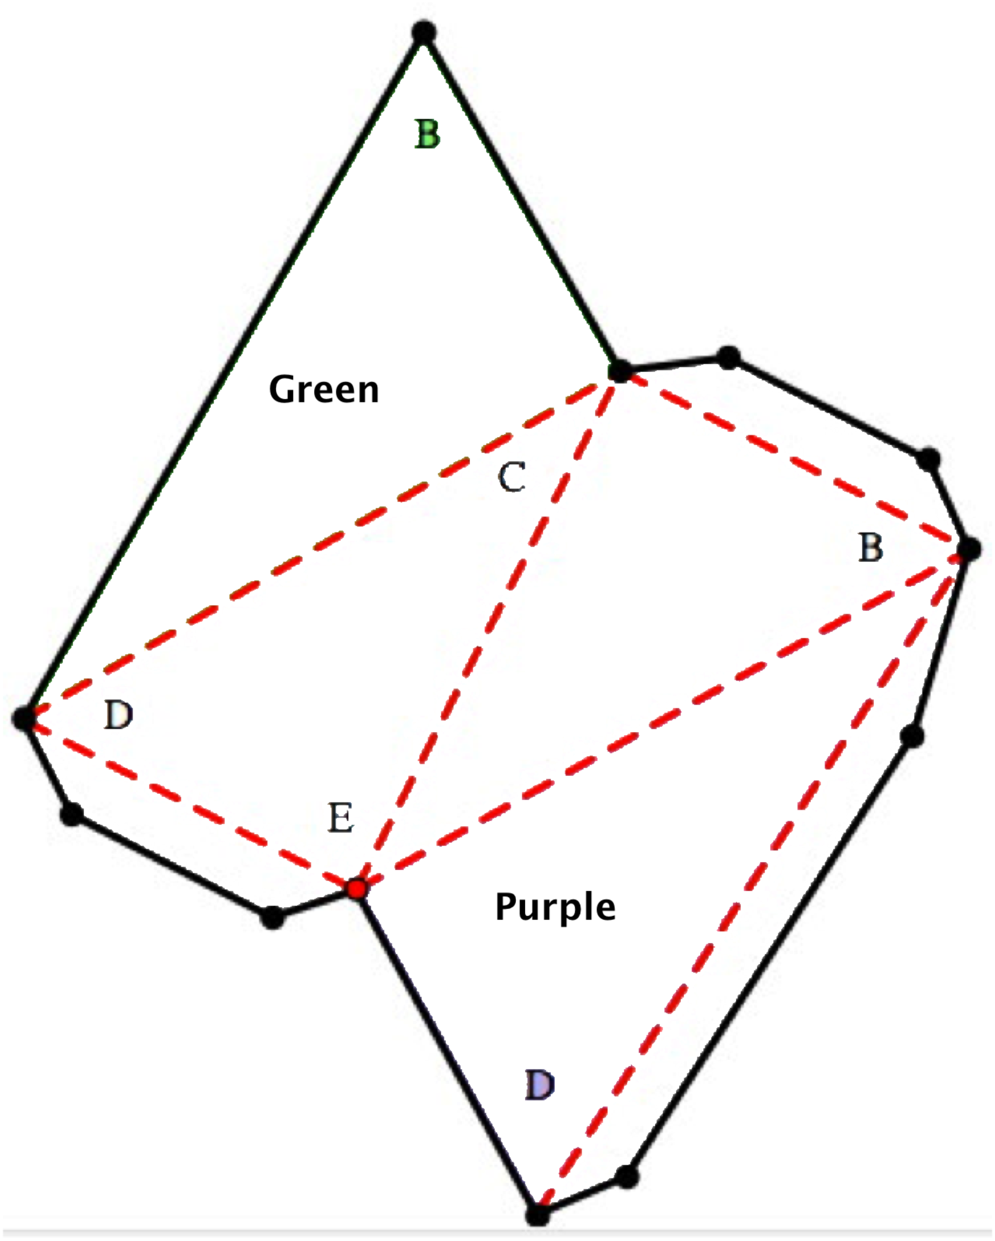

Note that faces that are marked purple and green will line up with the corresponding faces in the other pyramids when you insert the pyramids into the prism.

Note also that the scale of the prism is ever so slightly larger to accommodate the multiple thickness of card stock.

