Activity 6.3.3 Prisms and Cylinders

Postulates for Volume

In elementary or middle school you may have learned to find the volume of a rectangular prism, by counting the number of unit cubes that fit in the solid.
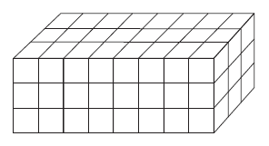
- Let’s find the volume of this prism:

- Find the area of its base (B) in square units.
- Find the height (h) of the prism.
- Find the volume (V) of the prism.
- Explain why the formulas V = length $×$ width$×$ height and V = Bh both work for rectangular prisms.

We prefer the formula V = Bh since as we will show it applies to every prism.

Recall from Unit 3 the Rectangle Area Postulate:

Rectangle Area Postulate: If b is the base and h is the height of a rectangle, then
Area = bh.

By analogy we have a postulate for volume:

Rectangular Prism Volume Postulate: If B is the area of the base and h is the height of a right rectangular prism, then Volume = Bh

- “B” and “b” both refer to something called the “base.” Explain the difference between b in the Rectangle Area postulate and B in the Rectangular Prism Volume Postulate.

To continue our work with prisms we need to make Cavalieri’s Principle, which you discovered in Activity 6.3.2 into another postulate:
Cavalieri’s Postulate: If two solid figures lie between two parallel planes and every plane parallel to these two planes intersects both solids in cross-sections of equal area, then the two solid figures have equal volumes.
Triangular Prisms

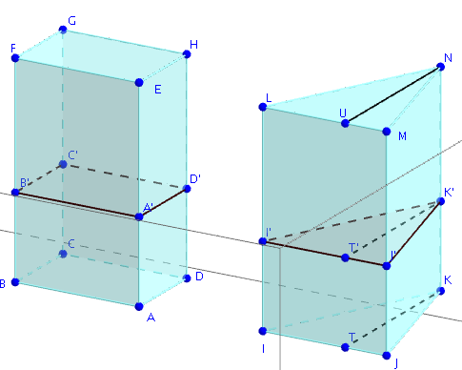
We can now show that the formula V = Bh applies to right triangular prisms as well as right rectangular prisms.

- Fill in the blanks in the proof below:
Given: Right triangular prism IJKLMN with ∆IJK as base and height = LI. Let the area of ∆IJK be “B” and the height of the prism “h.” $\overline{KT}$ is the altitude of ∆IJK to side $\overline{IJ.}$
Prove: The volume V for prism IJKLMN is equal to B times h.
First construct a right rectangular prism ABCDEFGH as follows:

- Construct rectangle ABCD with AB = IJ and AD = $\frac{1}{2}$KT = $\frac{1}{2}h$. Explain why the area of rectangle ABCD = area of ∆IJK.

- Now construct right rectangular prism ABCDEFGH with the same height as prism IJKLM. This means that BF = _______ (an edge of prism IJKLM).
- Pass a plane parallel to the bases to intersect the two prisms. We can show that the cross-sections formed are congruent to the bases, that is rectangle A’B’C’D’ $≅$ ____________ and ∆I’J’K’ $≅$ _______________. (See question 4 below for a formal proof.)
- But rectangle ABCD and ∆IJK have equal areas. Therefore rectangle A’B’C’D’ and ∆_______ also have equal areas.
- The plane that formed the cross sections could have been any plane parallel to the two bases. What can we now conclude by Cavalieri’s Postulate?

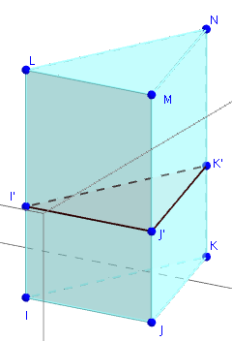
- In question 3c it was stated that the cross-sections of prism formed by planes parallel to the base are congruent to the base. Let’s show that this true in the case of the triangular prism.
a. In the figure at the right $\overline{I’J}$’ || $\overline{IJ}$, $\overline{J’K’}$ || $\overline{JK }$and $\overline{K’I’}$ || $\overline{KI}$. Also $\overline{I’I,}$ $\overline{J’J }$and $\overline{K’K}$ are all perpendicular to the base.
Explain why IJJ’I’ is a parallelogram.
By the same reasoning JKK’J’ and KII’K’ are also parallelograms.
b. Explain why IJ = I’J’, JK = J’K’ and KI = K’I’.
c. Which congruence theorem can now be used prove that ∆IJK $≅$ ∆I’J’K’?

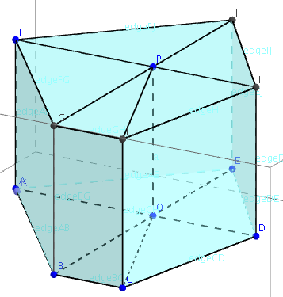
Prisms with Polygonal Bases

- Prism ABCDEFGHIJ is shown at the right.

a. Edges $\overline{FA}$, $\overline{GB}$, $\overline{HC}$, $\overline{ID}$, and $\overline{JE}$ are all perpendicular to the sides of the base. This prism may be described as a ______________ _______________ prism (two words).

b. Prism ABCDEFGHIJ has been divided into five right triangular prisms. One of them is ABOFGP. Name the four other triangular prisms.

c. We have already shown that the formula V = Bh may be applied to triangular prisms. Explain why this formula also applies to prism ABCDEFGHIJ.
d. Does the formula V = Bh apply to every right prism with a polygonal base? Explain.

- Now that you know that V = Bh applies to all right polygonal prisms, show that it also applies to oblique polygonal prisms. Draw two prisms with the same base and height, one right and one oblique. Then use Cavalieri’s Postulate.
- State the result of questions 5 and 6 as the Prism Volume Theorem:

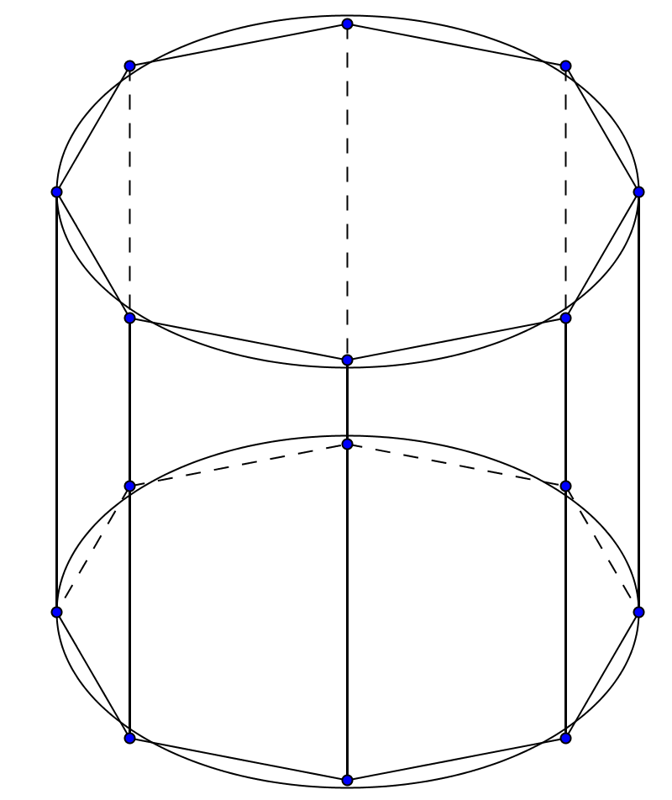
From Prisms to Cylinders

- In the figure at the right, the base of the prism is a regular octagon inscribed in a circle. The circle is also the base of a cylinder with the same height.
a. How does the volume of the prism compare with the volume of the cylinder?
b. Using trigonometry it may be shown that the area of a regular octagon is given by the formula Area = 2$\sqrt{2}$ r², where r is the radius of the circumscribed circle. To the nearest per cent, what per cent of the area of the circle is contained in the area of the octagon?
c. Suppose the size of the circle stays the same but the number of sides of the inscribed polygon is increased. What will happen to the ratio of the area of the polygon to the area of the circle?
d. And what will happen to the ratio of the volume of the prism to the volume of the cylinder.
e. You have seen that the volume of every prism can be found with the formula V = Bh, where B is the area of the base and height is the height of the prism. Does this formula also work for cylinders? Explain your reasoning.

