Activity 6.3.1 Informal Explorations with Volume

- Your teacher demonstrated filling three-dimensional containers with liquid from other containers. Summarize your findings here:

  - A square cube and a square pyramid have congruent bases and the same height. How many times can you fill the cube with the contents of the pyramid?
  - If you had a triangular prism and a triangular pyramid with the congruent bases and the same height, how many times do you think you could fill the prism with the contents of the pyramid?

  - A cylinder and a cone have congruent bases and the same height. How many times can you fill the cylinder with the contents of the cone?

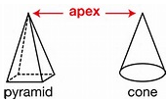
  - Both the cone and the pyramid have an apex. An apex is a point that joins all the points of the sides of a base with segments to form the lateral face(s) of the solid. How are the volumes of solids that have an apex related to the volumes of solids with two congruent parallel bases that have the same height?
mtb4dev.kendallhunt.com

- The next experiment that the teacher demonstrated was to fill the sphere that has the same radius as the cone with height 2 times the radius.
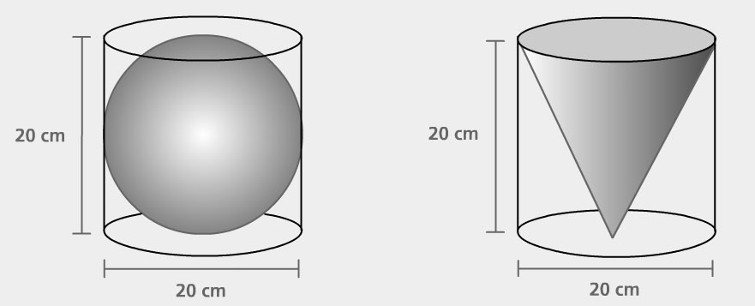
  - How many times could you fill the sphere with the cone?

www.pbslearningmedia.org
  - If you are familiar with the basic volume formulas for the cone and sphere, how would you explain your result?

- Summarize the formulas for volume that your experiments suggest:

- Do the demonstrations with liquids prove these formulas? Explain.

