Activity 6.1.5 Schlegel Diagrams
1. Here are some pictures of a Magformers wire-frame model of a regular dodecahedron. If we let our eye focus on the center of one of the faces and continue to move in closer and closer we can approximate the projection of the dodecahedron on the plane.
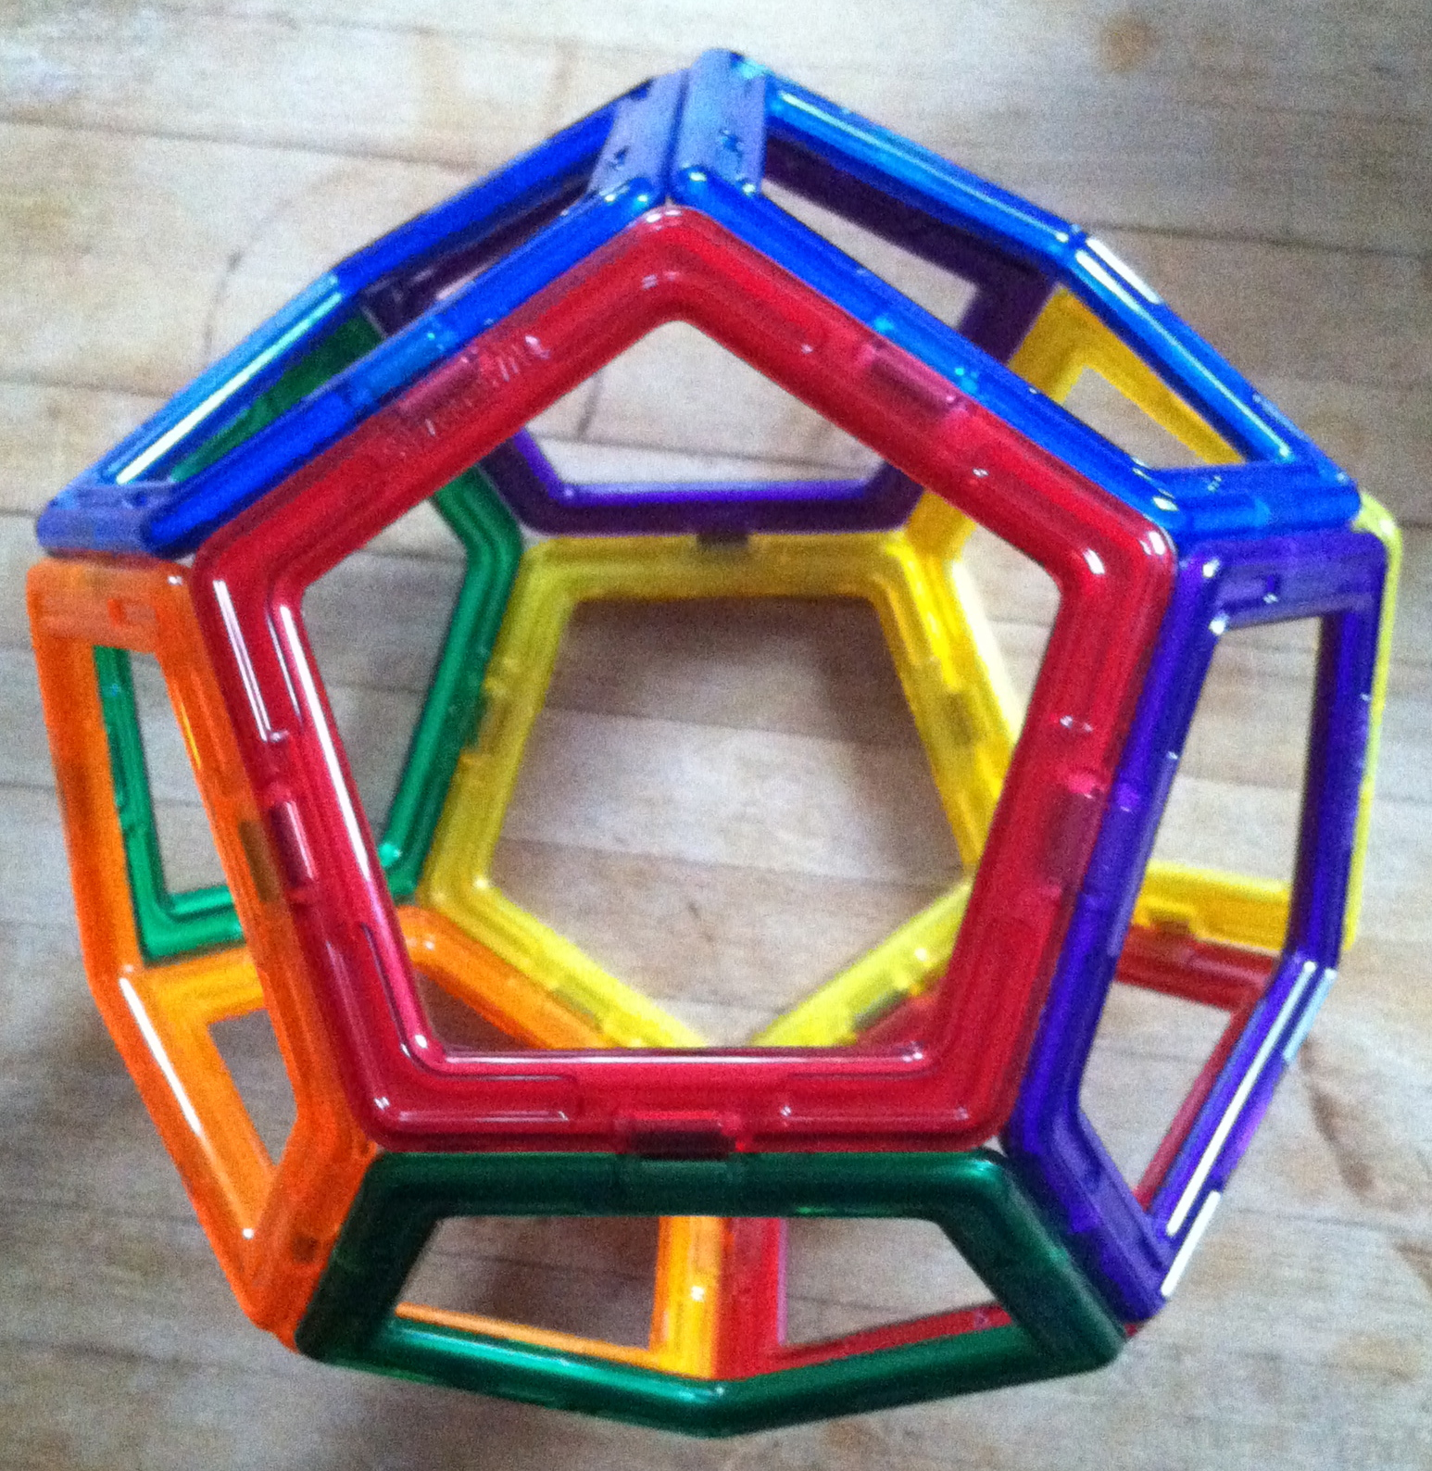
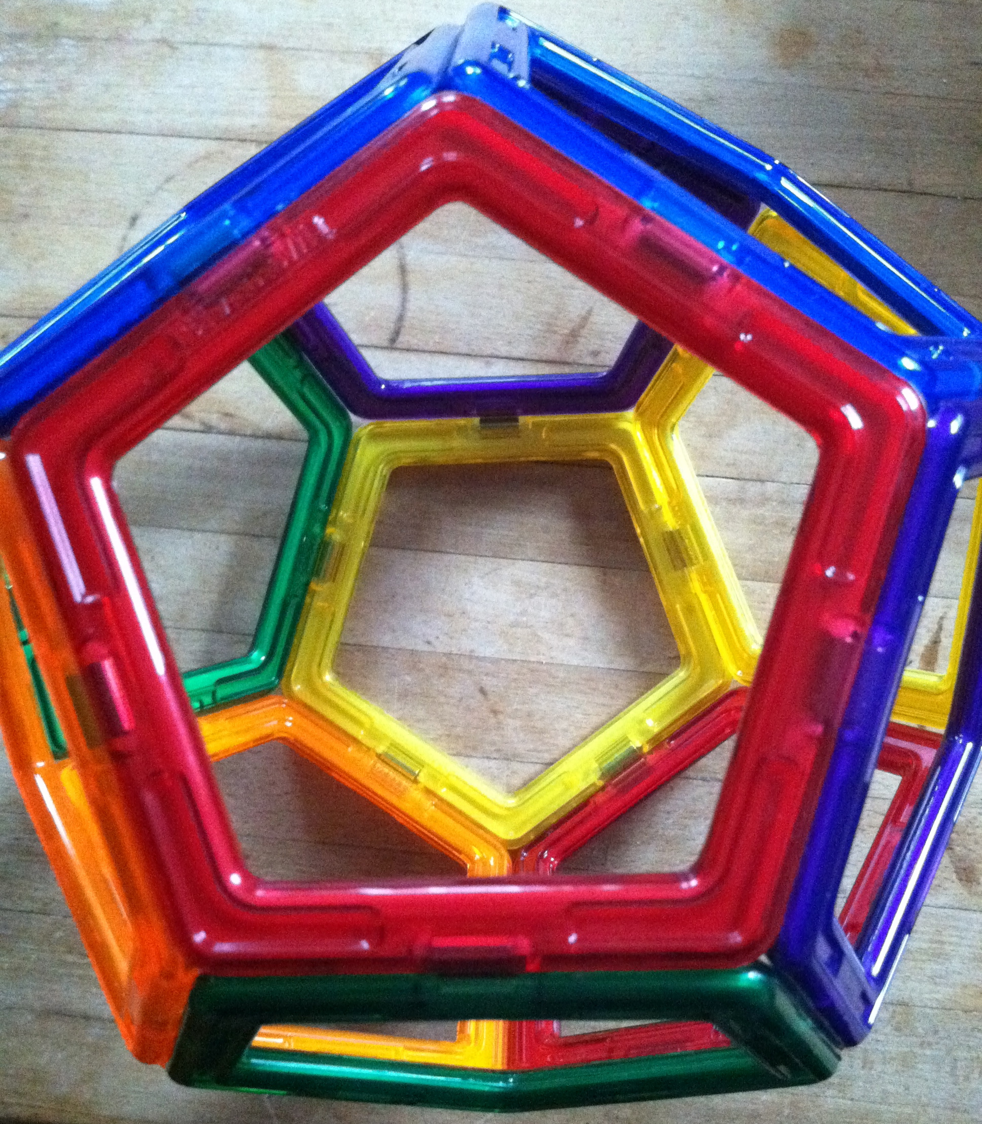
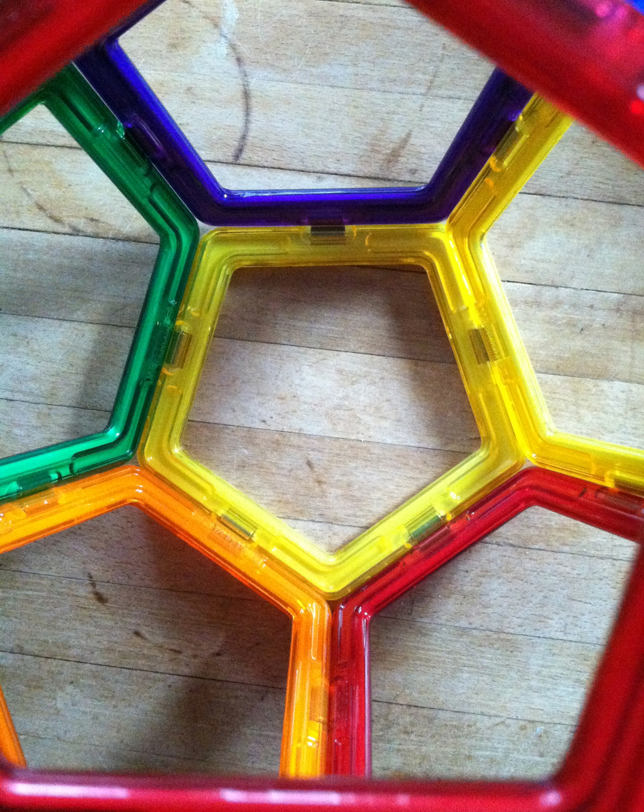
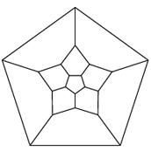
- Eventually the projection on the plane would look something like this with the face we look through represented by the pentagon around the outside of the projected diagram. Verify that each of the distorted faces is a pentagon:
  - Remembering that the polygon around the whole diagram also counts as a pentagon, how many pentagons are there in this diagram?

  - We can see the edges of each pentagon. How many edges are there in the diagram?

  - We can also see the vertices in the diagram. How many vertices are there in the diagram?

  - Do these numbers agree with what you found when you explored the regular dodecagon earlier in this investigation?

  - This diagram looks very symmetric. What kinds of symmetry do you see in this diagram?

  - Look at a three-dimensional model of a regular dodecahedron. What kinds of symmetry do you see in it?

- Use magformers to construct a polyhedron and then draw its Schlegel diagram in the space below.

- Here are some illustrations of polyhedra and their Schlegel diagrams. Match each diagram with the appropriate polyhedron.
a. 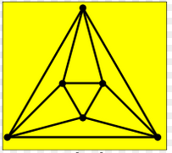 | U
b. 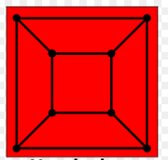 | V
c. 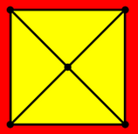 | W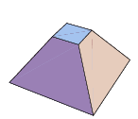
d. 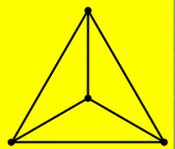 | X
e. 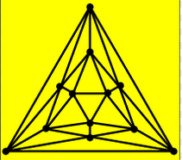 | Y
f. 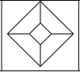 | Z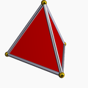
- Here is a polyhedron. Try to imagine what its projection would look like, and then sketch the Schlegel diagram for it.
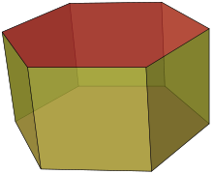

- The figure below is called a tesseract. It is a four-dimensional analog of the cube. You can think of a cube as the extension of a square in three-dimensions and a tesseract as the four-dimension extension of the cube. So the Schlegel diagram shows vertices, edges, faces and cubical cells. Schlegel diagrams give us an opportunity to explore tesseracts.
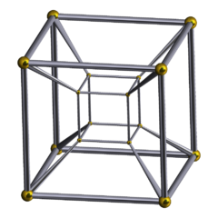
  - How many vertices does it have?
  - How many edges does it have?
  - How many faces does it have?
  - How many cells does it have?

