**Activity 6.1.2a Isometric Perspective Drawing**

**Use colored pencils and the isometric paper provided. Make extra copies of the sheet as necessary.**

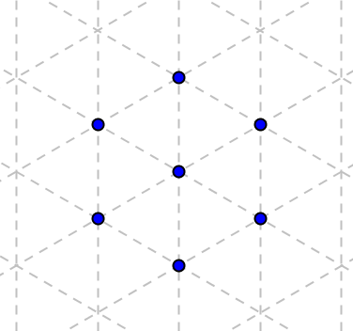

1. Start by drawing a small cube. Locate the seven vertices of a cube. (Actually there are eight, but the point in the center represents both the visible upper front corner and the lower back corner, which is hidden from view.)

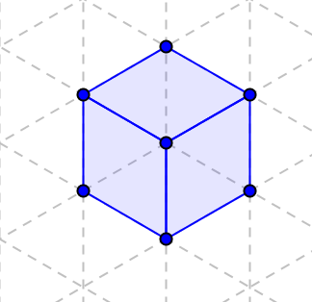

1. Connect the dots to make the three visible faces. Shade them with a color of your choice.
2. Here is how to draw a cube connected to an already drawn cube.

a. First erase the face that the two cubes share.

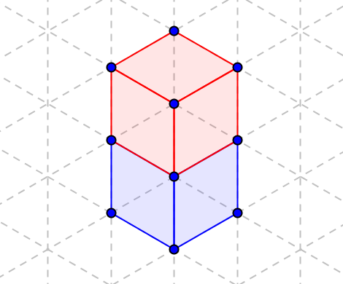b. Then locate additional vertices for the second cube and fill in the faces. Use a different color to distinguish the two cubes.

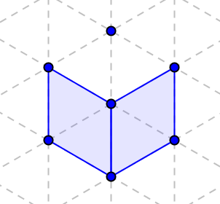

1. 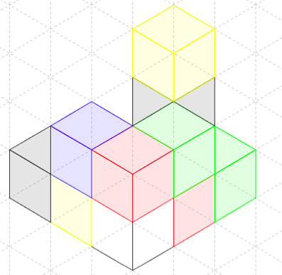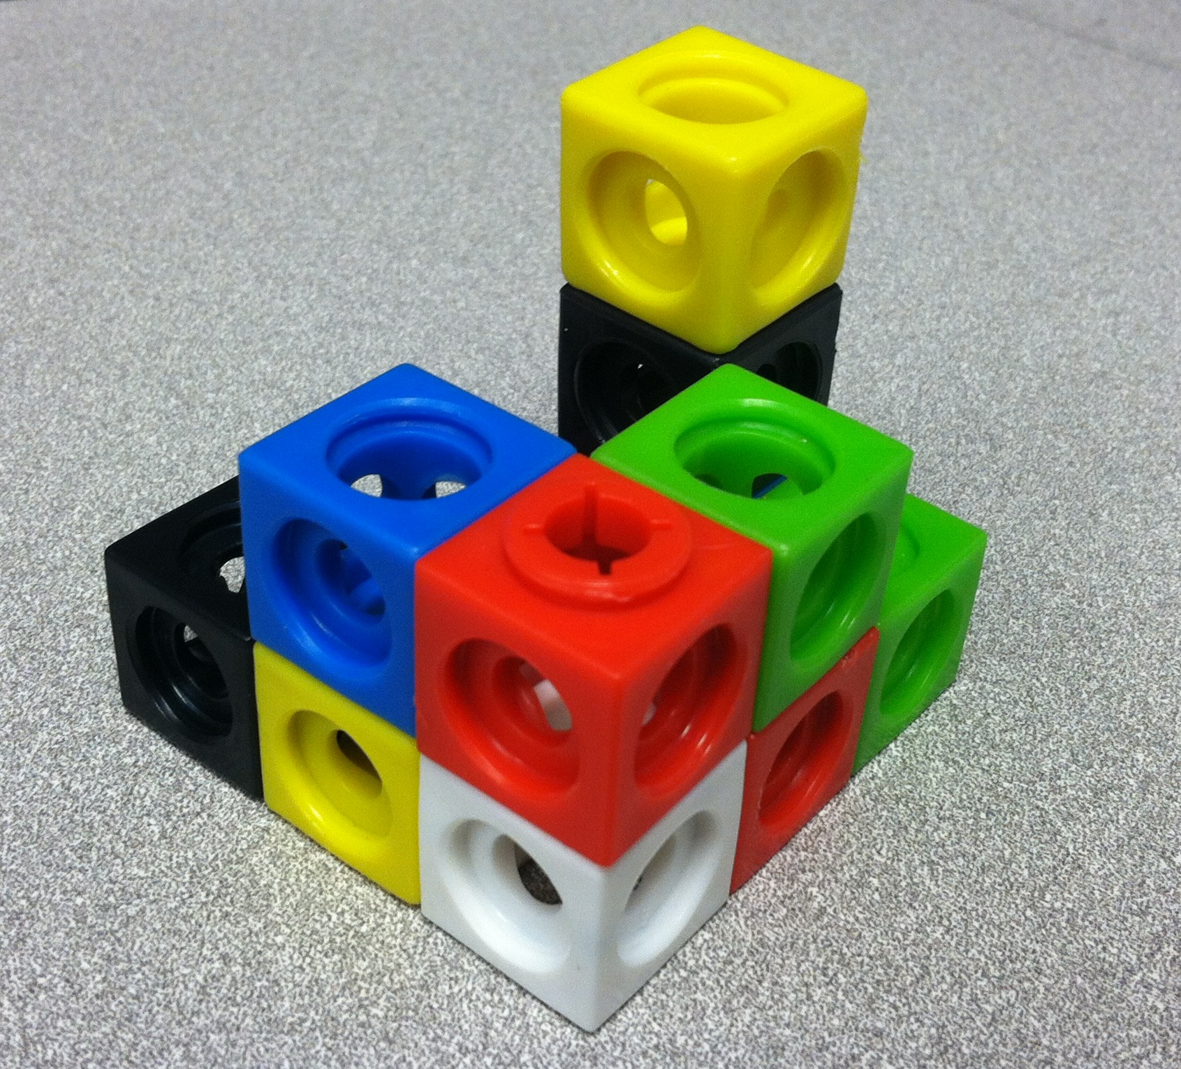Now draw a non-convex shape made up of small cubes, like the one shown below. Your teacher may give you a model to work with.

1. For further exploration of isometric drawing, try drawing pyramids and prisms with specific dimensions. (Below is a pyramid with a 3 x 3 square base and height 5.)

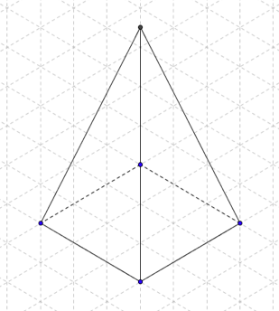

6. Share your results with your teacher and your classmates.

Isometric Grid Paper

