Activity 5.8.6 Eccentricity of the Conic Sections

Recall the locus definition of parabola: A parabola is the locus of points that are equidistant from a fixed point (called the focus) and a fixed line (called the directrix.)

Let’s modify our definition a bit and consider a curve that is the locus of points where the ratio between its distance to the focus and its distance to the directrix is a fixed positive number e.
(Recall from Activity 5.8.4 that for an ellipse, e = $\frac{c}{a}$ is defined as its eccentricity. We’ll show that the “e” we are using here is the same thing.)

What will this locus look like? And how will changing e affect the shape of the curve?

Open the file ctcoregeomACT586 and experiment. Note the instruction in the file and in the box below.

The directrix is located at y = –1
The focus is locate at (0,e) where e is the eccentricity.
The slider for d will give you points that are d units from the directrix
and ed units from the focus.

Move the slider to generate the curve.

To erase the trace go to “Refresh Views” in the view menu.

Change the eccentricity by typing e = whatever in the input window.
Experiment with different values of e and observe what happens

After performing your experiments, answer these questions:

- If the point on the locus is ed units from the focus and d units from the directrix, what is the ratio of the two distances? $\frac{Distance from focus}{Distance from directrix}$ = ________.
- If e > 1 what type of curve do we have?
- If e = 1, what type of curve do we have?
- If 0 < e < 1 what type of curve do we have?
- What happens when e = 0?

- Derive an equation for the locus from the definition given above:
Let the coordinates of the point on the locus be (x, y). Then
Distance from point to focus = e$∙$ distance from point to directrix
$\sqrt{{(x-0)}^{2}+{(y–e)}^{2}}$ = e(y+1)
Square both sides and simplify the equation.

- Let e = 1. Show that the equation you derived in question 6 gives you the standard equation for a parabola.

- If e ≠ 1, our experiments suggest that we have an ellipse or a hyperbola. How are these curves different from ellipses and hyperbolas in standard position?

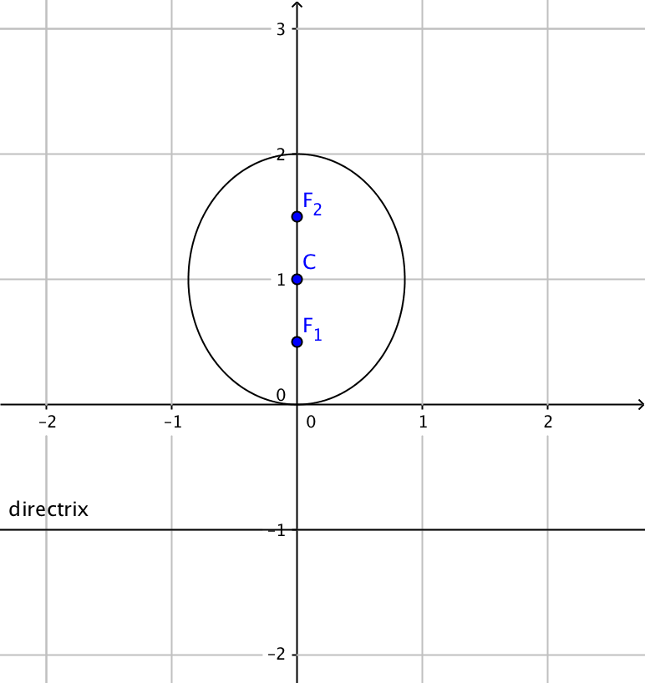
- If the major axis of an ellipse runs along the y-axis, then it can be shown that its equation is of the form $\frac{(y-{k)}^{2}}{a^{2}}+\frac{x^{2}}{b^{2}}=1,$ where (0, k) is the center of the ellipse, 2a is the length of the major axis, and 2b is the length of the minor axis.
a. In the ellipse pictured at the right the center is (0,1) and the foci are at ($0,\frac{1}{2})$ and ($0,\frac{3}{2})$.
The length of the major axis is 2a. Therefore a = ____
The distance from the center to a focus = c = ______
We can find b using the equation a² = b² + c². b = ______

b. Now substitute into $\frac{(y-{k)}^{2}}{a^{2}}+\frac{x^{2}}{b^{2}}=1$ to find an equation for this particular ellipse.
c. This ellipse can also be generated using focus-directrix definition introduced earlier in this investigation. In this case the directrix is the line y = – 1 and the focus F₁ is (0, __).
What is the eccentricity of this ellipse?
d. Substitute for e the equation you found in question 6. Then show that this agrees with the equation found in question 9b.

- If the transverse axis of a hyperbola coincides with the y-axis, then it can be shown that its equation is of the form $\frac{(y-{k)}^{2}}{a^{2}}-\frac{x^{2}}{b^{2}}=1,$ where (0, k) is the center of the figure, c is the distance from the center to each focus, 2a is the distance between the y-intercepts, and
b² = c² – a².
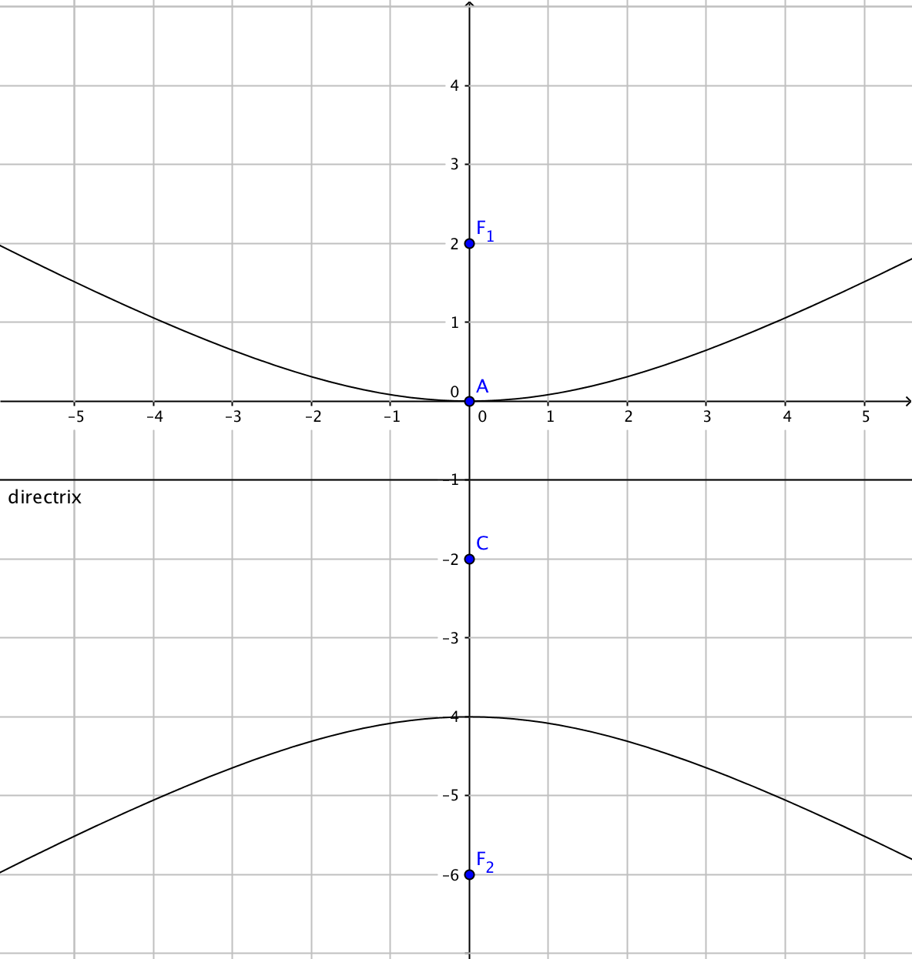
- In the hyperbola pictured at the right the center is (0,–2) and the foci are at ($0, 2)$ and (0, –6$)$. The distance between the y-intercepts, 2a = ____, so a = ____
The distance from the center to a focus = c =_____
We can find b using the equation b² = c² – a².
b = ______.
- Now substitute into $\frac{(y-{k)}^{2}}{a^{2}}-\frac{x^{2}}{b^{2}}=1$ to find an equation for this particular hyperbola. Solve it for $x^{2}.$
- This hyperbola can also be generated using focus-directrix definition introduced earlier in this investigation. In this case the directrix is the line y = – 1 and the focus F₁ is (0, __). What is the value of e is we were to general the hyperbola as we did in question in the experiments? (This value is the eccentricity of the hyperbola.)

- Substitute for e the equation you found in question 6. Then show that this agrees with the equation found in question 9b.

- The focus-directrix definition only gives us the upper branch of the hyperbola. The lower branch is generated by using F₂ (0, –6) as the focus. Find the equation of the directrix associated with this focus. Explain your reasoning.

