Activity 5.8.5 Hyperbolas

You’ll need the following materials for this activity:

1 piece of wax paper or parchment paper
Compass
Pen/Pencil

1. Follow these steps to carry out the construction.
- On your piece of wax paper, use your compass to construct a fairly large circle. (Be sure
to make the radius small enough so that the entire circle is contained on the wax paper.

- Label the center point of your circle. Label this point F₁.

- Plot and label another point in the exterior of this circle. Label this point F₂. (Note: this is the key difference between this construction and the one you made in Activity 5.8.2 for the ellipse.

- Plot approximately 20-25 points on the circle. (Just draw dots to represent these points).
Label any one of these points as P.

- Take the wax paper and fold it so that point P lies on top of point F₂. Crease sharply.

- Repeat step (5) above for all the other points you plotted on the circle (back in step 4).
That is, treat each point on the circle as another “point P.” Simply fold each “point P” on
the circle to point F₂. Be sure to crease sharply each time!

2. Describe the figure formed by the intersection of all the creases.

We will now examine some properties of the figure created by the creases.
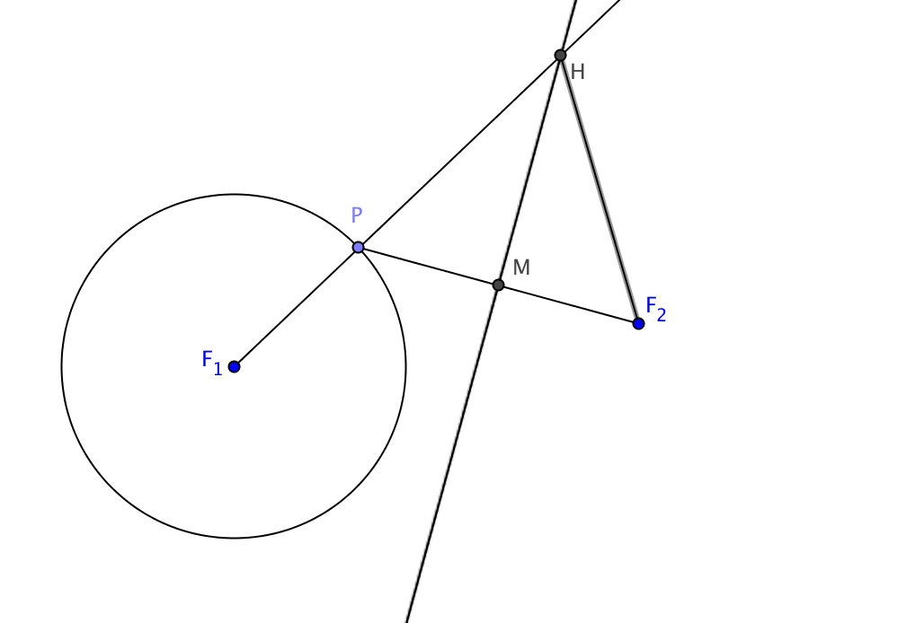
3. The figure at the right shows one of the points P that was folded onto F₂.

Draw the ray $\vec{F_{1}P}$ so that it intersects the fold line at H.

The fold line is the _________________ bisector of $\overline{PF_{2}}$. It passes through M, the ________________ of $\overline{PF_{2 }}$
4. Every point on $\overset{⃡}{HM }$is equidistant from points and .

This means that HP = _____.

5. We will now show that the difference of the distances from the two foci to H is constant, no matter which point on the circle was chosen as point P.

a. Since the radius of a circle never changes, it is said to be .

b. By segment addition, F₁H = _____ + _______

c. But we saw in question 4 that HP = _____. Therefore F₁H = _____ + _______.

d. Solve the above equation for F₁P, the radius of the circle.

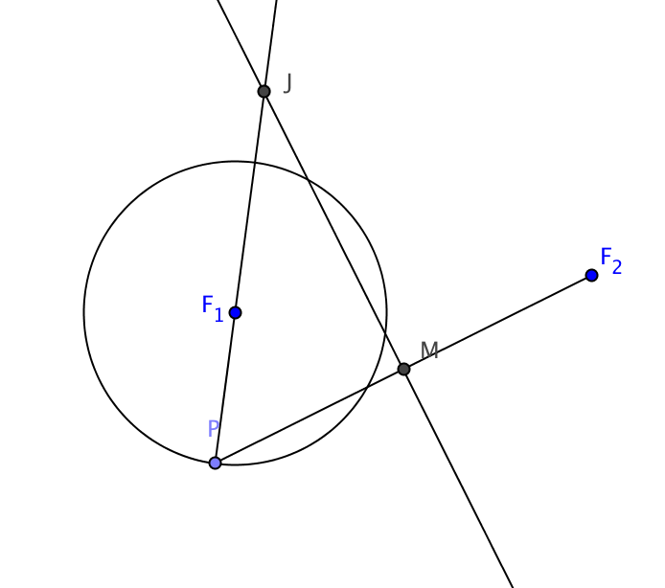
Therefore F₁H –F₂H is the same for all points H.
6. The curve traced by the points H described in question 3 is only one of the two branches of the curve generated by the paper folding construction. When P is on the other side of the circle the ray $\vec{F_{1}P}$ no longer intersects the fold line. Instead we need to draw the ray $\vec{PF_{1}}$ to locate a point “J” where it intersects the fold line.

Show that for all such points J, the quantity F₂J –F₁J is constant.

7. The figure formed by the paper folding construction is called a hyperbola. Fill in the blanks to create its definition:

Definition: A hyperbola is the locus of points the ________________ of whose distances from two fixed _________(called the foci) is a ____________.
8. Study the above definition. In what ways is it like the definition of ellipse? In what ways is it different?

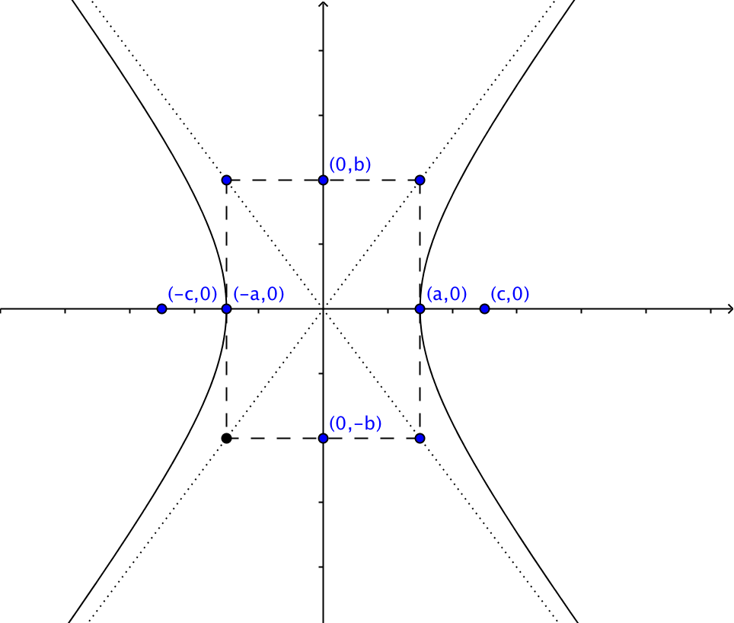
9. Here is a hyperbola in standard position in the coordinate plane.
The foci are located at (–c, 0) and (c, 0).
The two branches of the hyperbola cross the x-axis at (a, 0) and (–a, 0). The x-axis is the transverse axis of the hyperbola.
The points (0, b) and (0, –b) lie on the y-axis.

The rectangle shown by the dashed line contains the four points (a, 0), (–a, 0), (0, b), and (0, –b). The dotted lines containing the diagonals of this rectangle are the asymptotes to the hyperbola. You will learn more about asymptotes in a future course. In a future course it will also be shown that $c^{2}=a^{2}+b^{2}$.

Now with all that information, you can show that an equation for this hyperbola in standard position is
$\frac{x^{2}}{a^{2}}–\frac{y^{2}}{b^{2}}=1.$ The derivation of this equation is very similar to the derivation of equation of an ellipse in standard position, which was shown in Activity 5.8.3. Use that as an example to derive the equation $\frac{x^{2}}{a^{2}}–\frac{y^{2}}{b^{2}}=1.$

