**Activity 5.8.4 Ellipses in Our World**

1. Have you ever been behind a tanker truck like the one shown below? What do you notice about their trailer? Why do you think they design the trailer using this shape?

2. What is the name of this building? What shape is the “President’s Park South”?

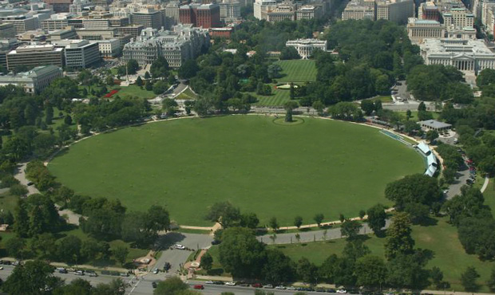

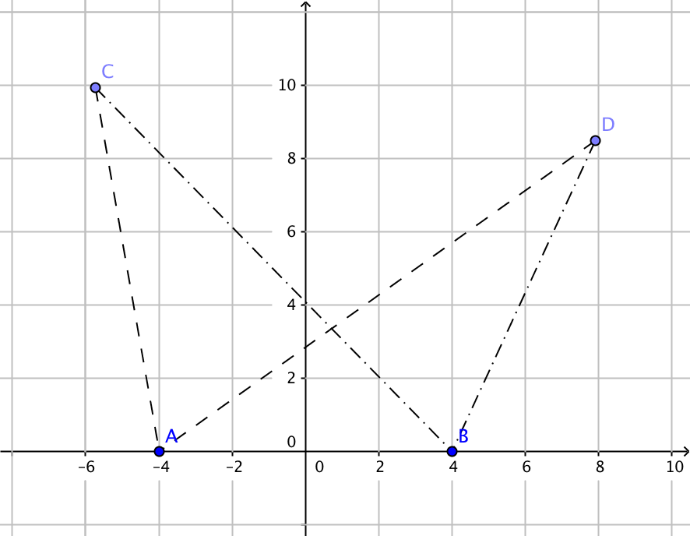3. A tour boat leaves island A to travel out to sea in a straight path. After a period of time, it changes direction and heads to a island B in a straight path. The reason why it travels to the Island B is due to the fact that it can only travel 24 miles before it runs out of fuel. The boat always brings its occupants to island B after traveling to some point out at sea and it always travels 24 miles so no customer feels cheated. The distance between the two islands is 8 miles.

1. Describe the set of all possible points where the boat could change direction to go to island B. (C and D are two possibilities as shown,)
2. If the midpoint of the islands is represented by (0,0) then write an equation that models all of the possible points where the boat could change direction.

4. Planets that orbit the Sun move in an elliptical path with the Sun as one focus of the ellipse. The **aphelion** of a planet is the greatest distance from the Sun whereas, the **perihelion** of a planet represents the shortest distance from the sun.

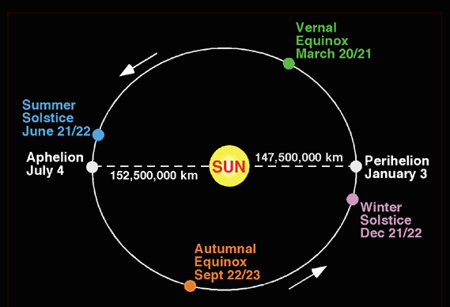

Earth’s orbit is almost circular. The aphelion is about 94.6 million miles from the sun, and the perihelion is about 91.4 million miles from the sun.

1. Find the average of the aphelion and the perihelion. Call this number (in million miles), *a.*

b. On a coordinate plane mark the points (–*a*, 0) and (*c*, 0) as the aphelion and perihelion of Earth’s orbit.

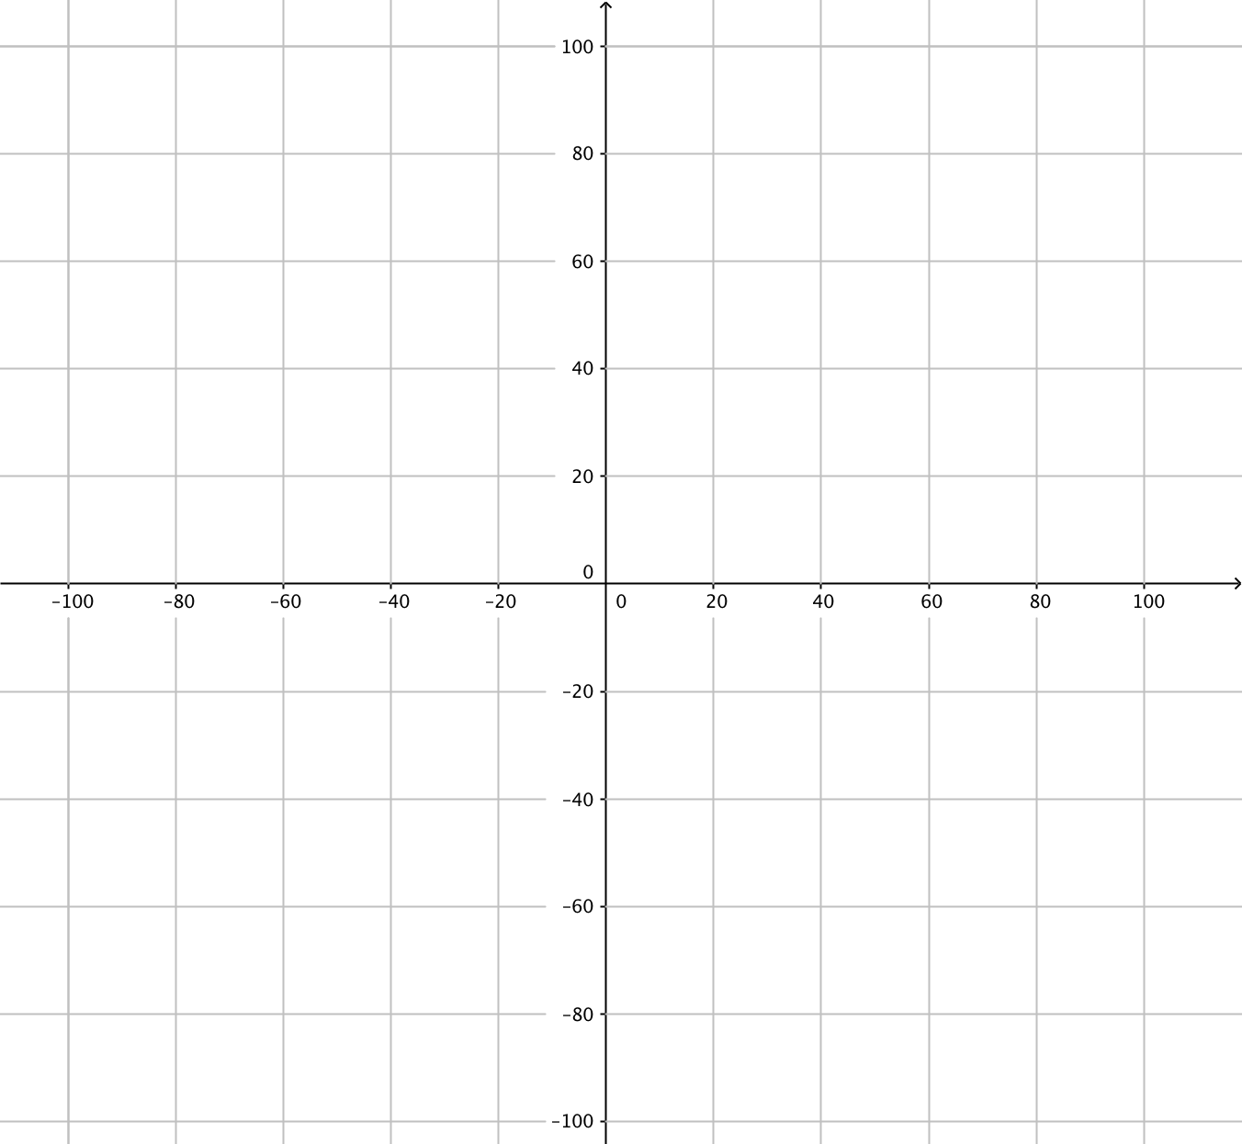  
Source: funnel.sfsu.edu

c. Locate the Sun’s position at a point on the *x-*axis. Call the *x*-coordinate of this point *c*.

d. Recall that an ellipse in standard position has the equation $\frac{x^{2}}{a^{2}}+\frac{y^{2}}{b^{2}}=1$ with $a^{2}=b^{2}+c^{2}$ 
 . The points (0, *b*) and (0, –*b*) are *y­-*intercepts of the ellipse. Find *b*.

e. The **eccentricity** of an ellipse is defined as $e=\frac{c}{a}$. Find the eccentricity of the earth’s orbit to the nearest 0.001.

5. Comets also travel around the sun in elliptical orbits. Their orbits, however, are much more eccentric.

Halley’s comment appears reaches its perihelion about every 76 years. (The last time was in 1986.) It’s perihelion is 0.586 astronomical units from the sun, and its aphelion is 35.014 astronomical units from the sun. One astronomical unit is the average distance from the earth to the sun, about 93 million miles.

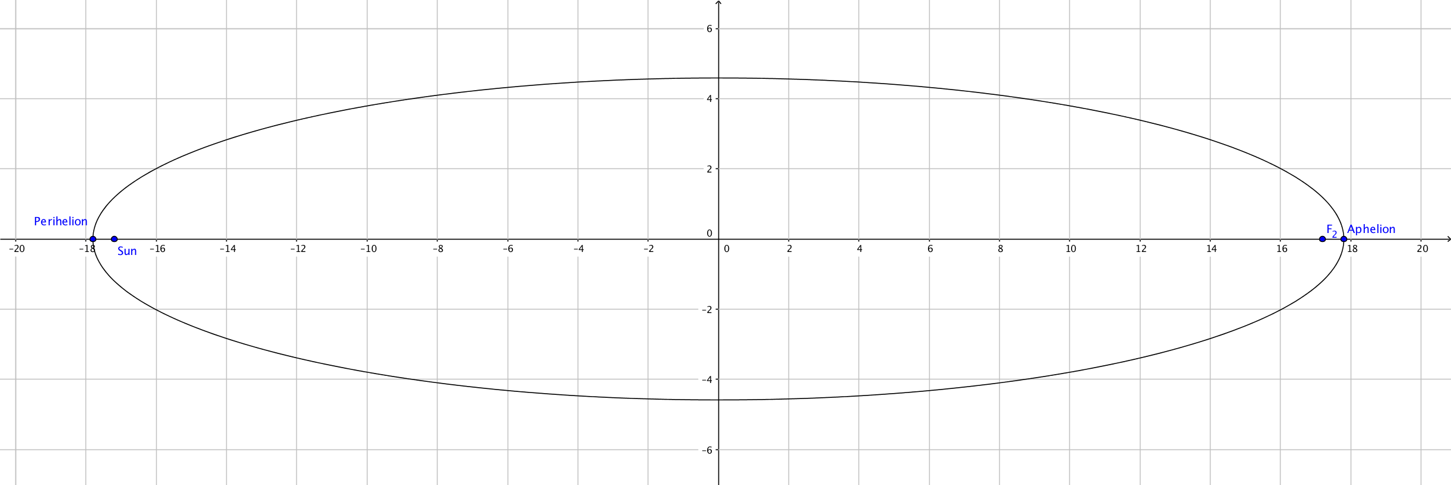

1. In what year is Halley’s comet expect to reach perihelion? (That’s when it is most likely to be visible from Earth.
2. The orbit of Halley’s comet is shown on the graph above, with center at the origin. Find the coordinates of

Perihelion = ( _____, ______)

Aphelion = (______, ______)

Sun = (_____, ______)

The other focus, F2 = (________, ________)

1. Calculate the eccentricity of the orbit of Halley’s comet.
2. Find an equation in the coordinate plane for Halley’s comet (in astronomical units)

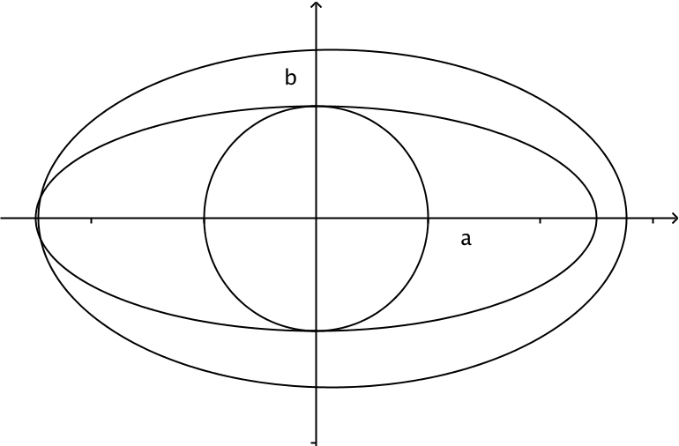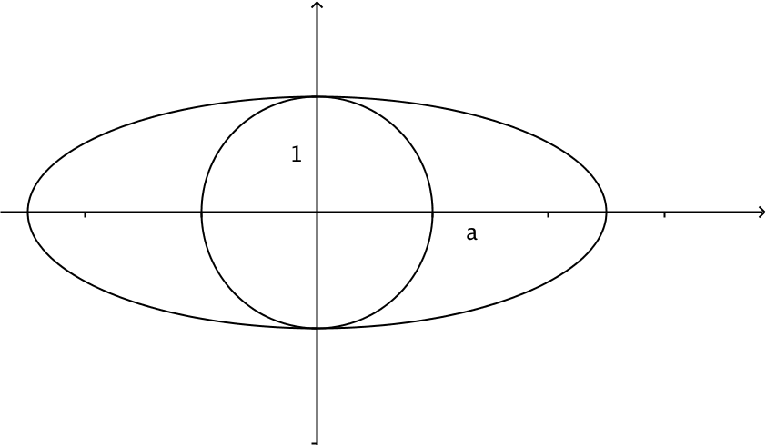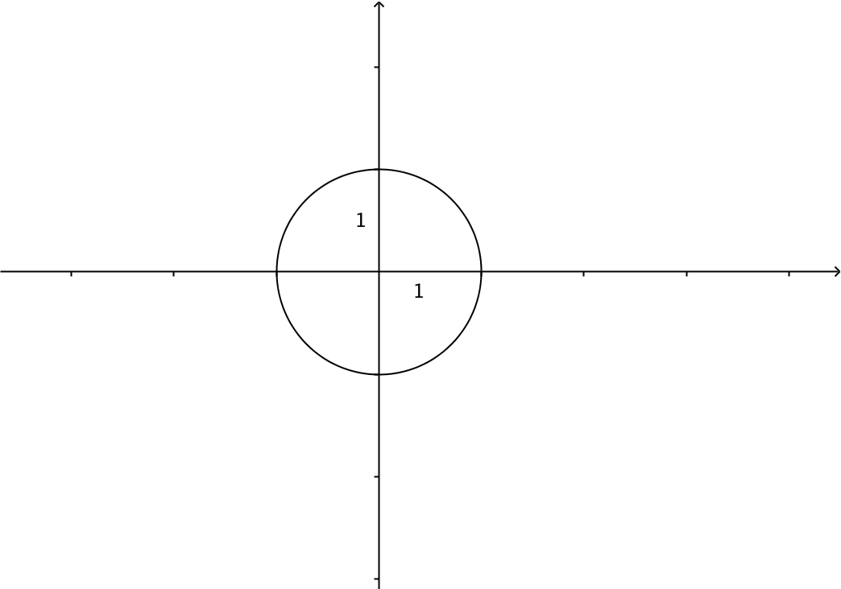6. The formula for the area of a circle is A = ____________. Think about how a unit circle with radius 1 could be transformed into an ellipse with a horizontal stretch by the factor *a* and a vertical stretch by the factor *b*. Then guess at a formula for the area of an ellipse. (Check with your teacher to see if you hunch is correct.)

7. The President’s Park South (shown in question 2) needs to be reseeded this spring for our new president. Three pounds of grass seed covers 1275 ft2. This elliptical park is 1058 ft long and 903 ft wide (Source: faculty.evansville.edu/ck6/ellipse.pdf). Determine the amount of seed needed to reseed the lawn.

8. Sanctuary Hall is an elliptical room in the United States Capital in Washington, D.C. The room is also called the Whispering Gallery because a person standing at one focus of the room can hear a even a whisper spoken by a person standing at the other focus. This occurs because any sound that is emitted from one focus of an ellipse will reflect off the side of the ellipse to the other focus. Statuary Hall is 46 feet wide and 97 feet long.

1. If the room were placed on a coordinate plane, find an equation that models the shape of the room.
2. How far apart are the two foci in the room?
3. What is the area of the floor?

9. What happens to the shape of an ellipse as the eccentricity gets close to 0? What happens when the eccentricity gets close to 1?