Activity 5.8.3 Deriving the Standard Equation of an Ellipse
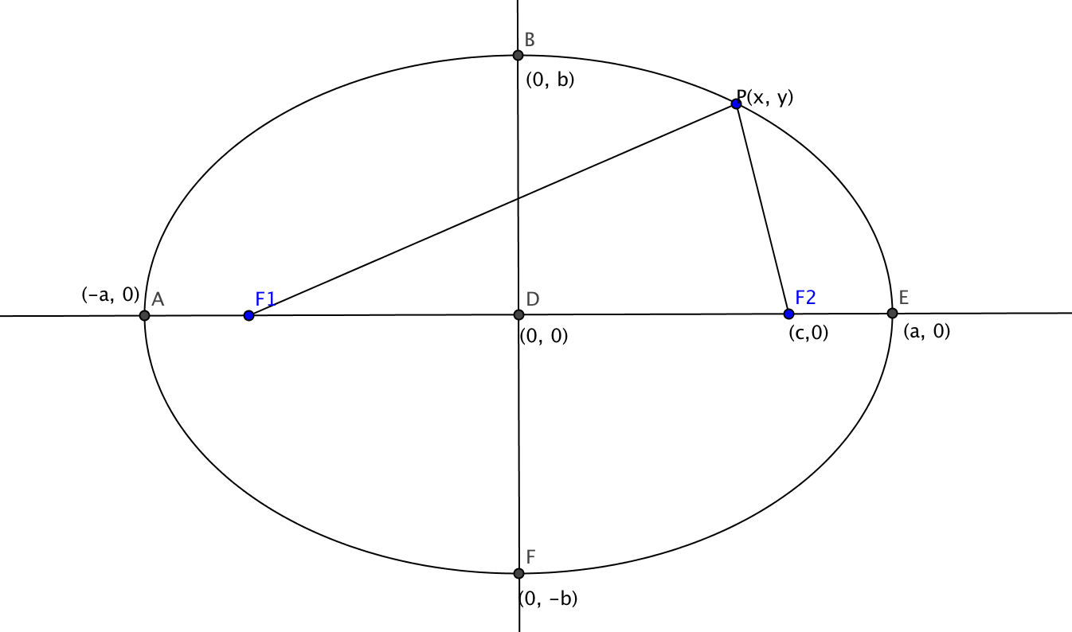

We will derive the equation of an ellipse in standard form. The foci are at (–c, 0) and (c, 0). The endpoints of the major axis are (–a, 0) and (a, 0). The endpoints of the minor axis are (0, –b) and (0, b).

- Sum of the distances from the point to the foci is constant. Why?
- Constant = $\sqrt{(x-(-c))^{2}+(y-{0)}^{2}}+\sqrt{(x-c)^{2}+(y-{0)}^{2}}$ using the __________________ formula.

If you move point P so that it coincides with point E, you can see that the sum of the distances is equal to the length of the major axis or 2a.
Therefore 2a = $\sqrt{(x-(-c))^{2}+(y-{0)}^{2}}+\sqrt{(x-c)^{2}+(y-{0)}^{2}}$

If you move point P so that it coincides with point B, you get a right triangle where a is the length of the hypotenuse and b and c are the lengths of the legs.
- This gives us $a^{2}={___}^{2}+{___}^{2}$

Using $2a=\sqrt{(x+c)^{2}+(y)^{2}}+\sqrt{(x-c)^{2}+(y)^{2}}$

We get $2a-\sqrt{(x-c)^{2}+(y)^{2}}=\sqrt{(x+c)^{2}+(y)^{2}}$
$$4a^{2}-4a\sqrt{(x-c)^{2}+(y)^{2}}+({x-c)}^{2}+y^{2}=(x+c)^{2}+(y)^{2}$$

4. What did we do to get this last step?

Now expand terms on both sides of the equation and simplify:

$$4a^{2}-4a\sqrt{(x-c)^{2}+(y)^{2}}+x^{2}-2cx+c^{2}+y^{2}=x^{2}+2cx+c^{2}+(y)^{2}$$
$$4a^{2}-4a\sqrt{(x-c)^{2}+(y)^{2}}=4cx$$
Get the radical by itself on one side:
$$-4a\sqrt{(x-c)^{2}+(y)^{2}}=4cx-4a^{2}$$
$$-a\sqrt{(x-c)^{2}+(y)^{2}}=cx-a^{2}$$

Square both sides again.

$$a^{2}((x-c)^{2}+(y)^{2})=(cx-a^{2})^{2}$$

$a^{2}((x-c)^{2}+(y)^{2})=c^{2}x^{2}-2a^{2}c^{2}x^{2}+a^{4}$

$${ a}^{2}x^{2}-2a^{2}c^{2}x^{2}+a^{2}c^{2}+a^{2}y^{2}=c^{2}x^{2}-2a^{2}c^{2}x^{2}+a^{4}$$

$${ a}^{2}x^{2}+a^{2}c^{2}+a^{2}y^{2}=c^{2}x^{2}+a^{4}$$
$${ a}^{2}x^{2}-c^{2}x^{2}+a^{2}y^{2}=a^{4}-a^{2}c^{2}$$
$${ x}^{2}(a^{2}-c^{2})+a^{2}y^{2}={a^{2}(a}^{2}-c^{2})$$

- Now use$a^{2}=b^{2}+c^{2}$, to make a simpler equation:

- Show that this equation can be rearranged to give $\frac{x^{2}}{a^{2}}+\frac{y^{2}}{b^{2}}=1$

${ x}^{2}(b^{2})+a^{2}y^{2}=a^{2}b^{2}$
$$\frac{x^{2}}{a^{2}}+\frac{y^{2}}{b^{2}}=1$$

