Activity 5.8.2 Constructing an Ellipse through Paper Folding

Definition: An ellipse is the locus of points the sum of whose distances from two fixed points (called the foci) is a constant.

You’ll need the following materials for this activity:

1 piece of wax paper or parchment paper
Compass
Pen/Pencil

1. Follow these steps to carry out the construction.
- On your piece of wax paper, use your compass to construct a fairly large circle. (Be sure
to make the radius small enough so that the entire circle is contained on the wax paper.

- Label the center point of your circle. Label this point F₁.

- Plot and label another point in the interior of this circle. Label this point F₂.

- Plot approximately 20-25 points on the circle. (Just draw dots to represent these points).
Label any one of these points as P.

- Take the wax paper and fold it so that point P lies on top of point F₂. Crease sharply.

- Repeat step (5) above for all the other points you plotted on the circle (back in step 4).
That is, treat each point on the circle as another “point P.” Simply fold each “point P” on
the circle to point F₂. Be sure to crease sharply each time!

2. Describe the figure formed by the intersection of all the creases.

3. Recall the definitions of secants and tangents of circles. Apply a similar definition to other closed curves. How would you describe how each of the creases is related to the figure they formed?

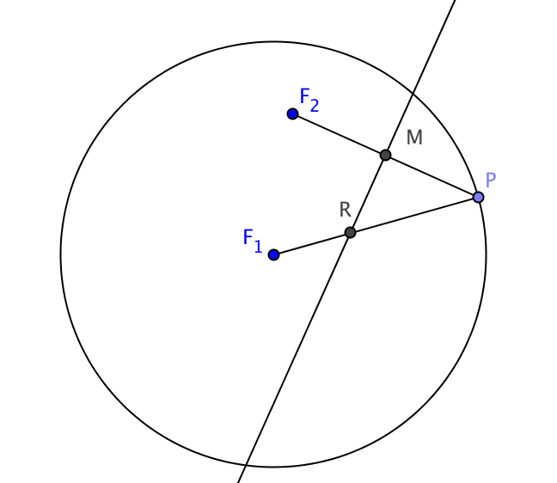
We will now prove that the figure is indeed an ellipse with foci at F₁ and F₂.

4. The figure at the right shows one of the points P that was folded onto F₂.

This fold line is the _________________ bisector of $\overline{PF_{2}}$. It passes through M, the ________________ of $\overline{PF_{2 }}$and intersects radius $\overline{F_{1}P}$at point _______.
5. Every point on $\overset{⃡}{RM }$is equidistant from points and .

This means that RP = _____.

6. We will now show that the sum of its distances from the two foci to R is constant, no matter which point on the circle was chosen as point P.

a. Since the radius of a circle never changes, it is said to be .

b. By segment addition, the radius F₁P = _____ + _______

c. But we saw in question 5 that RP = _____. Therefore F₁P = _____ + _______.

d. Therefore RF₁ + RF₂ is the same for all points R. Therefore all points R lie on an ___________ with foci _______ and _______.

7. It remains to show that each point R is the point where its crease is tangent to the ellipse.
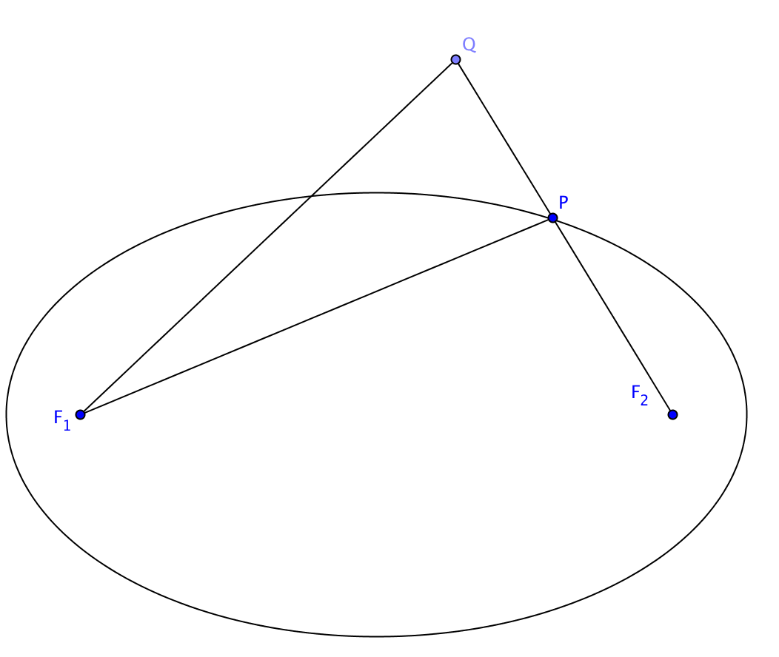
- First we must show that if a point is outside an ellipse then the sum of its distances from the two foci is greater than the sum of the distances from the foci to a point on the ellipse.
In the figure at the right we have an ellipse with foci at F₁ and F₂. Use the Triangle Inequality to prove that
QF₁ + QF₂ > PF₁ + PF₂.

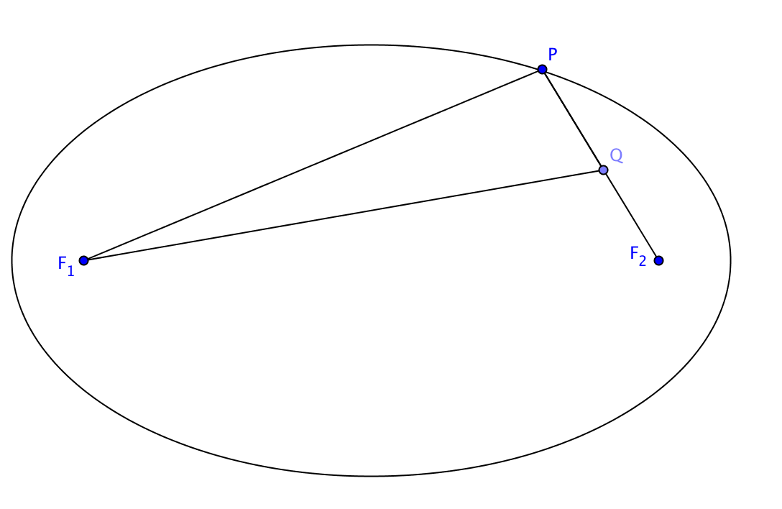
- Use a similar argument to show that if a point is inside an ellipse, then the sum of its distances from the two foci is less than the sum of the distances from the foci to a point on the curve. Use this fact to establish the converse of the statement in part (a).

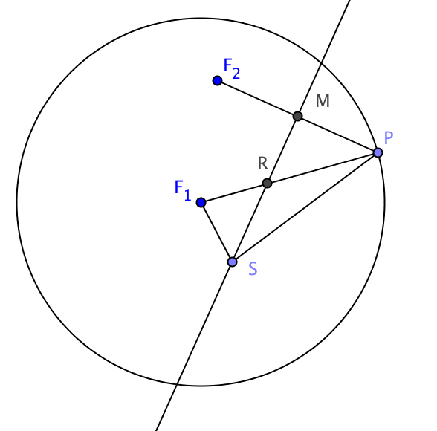
- Now go back to our original construction. R is the point where the perpendicular bisector of $\overline{PF_{2}}$
intersects radius $\overline{F_{1}P}$. Let S be any other point on the crease.
Show that SF₁ + SF₂ > RF₁ + RF₂.
- Our conclusion is that S must be ___________(inside outside, or on?) the curve.

- But S was any point the crease except for R. Therefore $\overset{⃡}{RM}$ and the ellipse have only one point in common, so$\overset{⃡}{RM}$ is ____________ to the ellipse

