Activity 5.7.5 Translating Parabolas
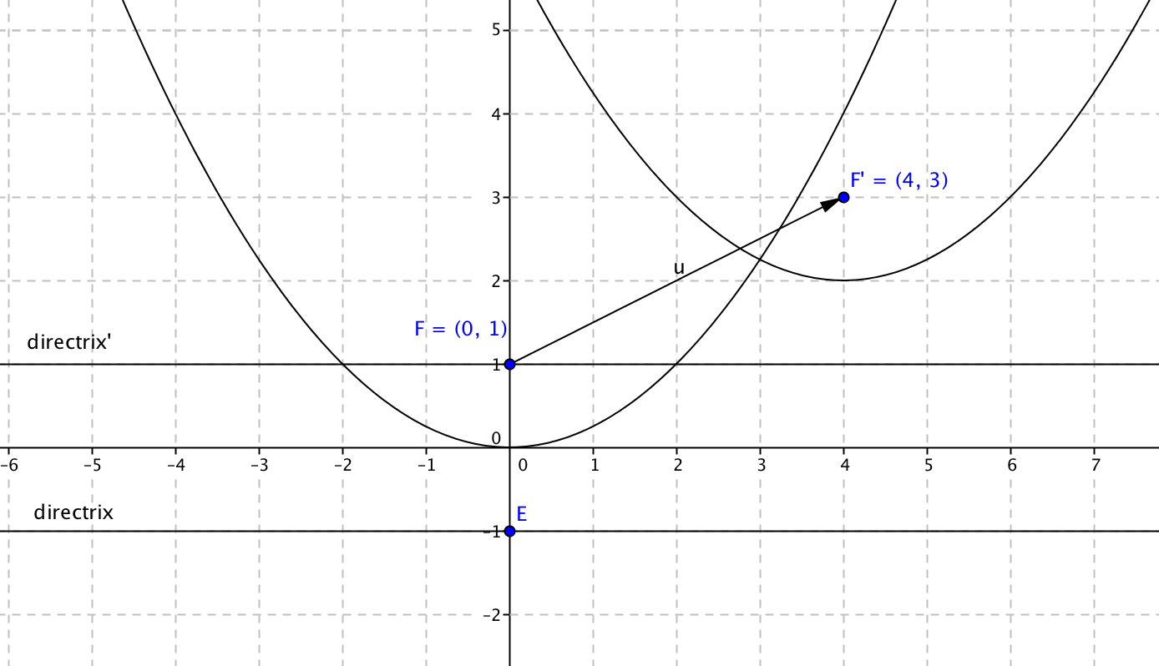
1. In the figure at the right the parabola in standard position has been translated by vector with mapping rule (x, y) _(x + h, y + k).
a. Find the values of h and k.
h = _______ k = _______
b. Find the coordinates of the vertex of the image.
c. Find the equation of the directrix of the image.

d. Are the two parabolas shown in the figure congruent? Explain.

2. Since not all parabolas will be in standard position, it will be helpful to have a general equation for any parabola that is the image of the standard parabola under translation. Suppose the vertex of the parabola is (h, k) and the distance from the vertex to the focus is p, and the parabola opens upward so that the focus is 2p units above the directrix.
a. The coordinates of the focus are then: (______, ______).
b. The directrix lies p units below the vertex. Its equation is y = _____________.
c. Now use the locus definition of the parabola to derive its equation. Let (x, y) be the coordinates of any point on the parabola.
The distance from this point to the focus is $\sqrt{{(___-____)}^{2}+{(___-____)}^{2}}$.
The distance from this point to the directrix is $\sqrt{{(___-____)}^{2}+{(___-____)}^{2}}$.
d. Equate the two distances, square both sides, and arrange the equation so that ${(x-h)}^{2}$ is on one side of the equation.

e. Show that your equation may be written in the form ${(x-h)}^{2}=4p\left(y-k\right).$

3. Apply the general equation to these specific cases:
a. Find the equation of a parabola with focus at (–2, 6) and directrix y = 2.
b. Find the equation of a parabola with vertex at (4, 0) and directrix y = – 3.
c. Find the equation of a parabola with vertex at (4, 0) and directrix y = 3. How is the parabola like the one in question 3b? How is it different?

d. Find the equation of a parabola focus at the origin and vertex at (0,5).

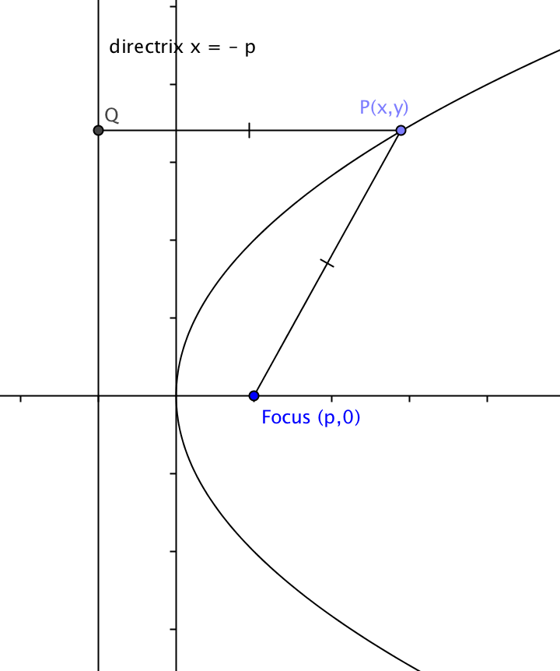
4. Not all parabolas have vertical lines of symmetry. The parabola shown has its vertex at the origin and the x-axis as its line of symmetry. The focus is (p, 0) and the directrix is the
line x = –p. Find an equation for this parabola.

