Activity 5.7.2a Parabolas in the Coordinate Plane

Definition: A parabola is the locus of points in a plane that are equidistant from a fixed point (called the focus) and a given line (called the directrix).

In the figure below, the directrix has equation y = – 1. The focus is F(0,1).
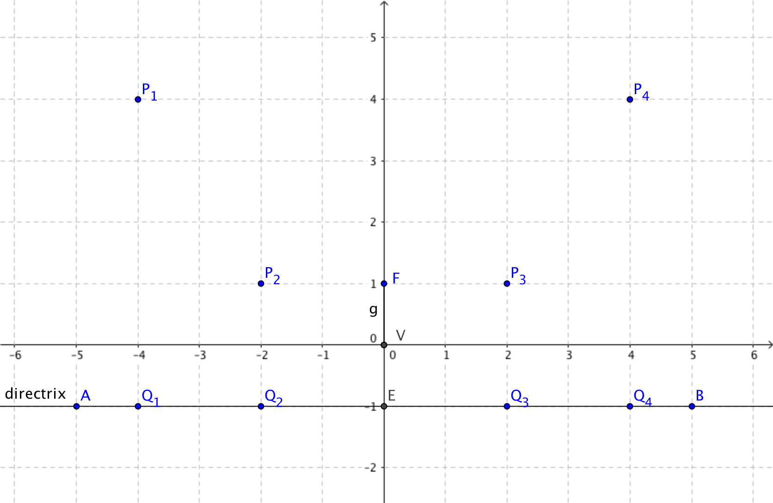

- Use the distance formula to find:

P₁Q₁ = _______________ P₁F = _______________
P₂Q₂ = _______________ P₂F = _______________
P₃Q₃ = _______________ P₃F = _______________
P₄Q₄ = _______________ P₄F = _______________
- What do you notice about the pairs of distances found in question 1?
- Point V(0,0) is the vertex of this parabola.
a. Show that V lies on the parabola.
b. V is the midpoint of which line segment?
- Draw a smooth curve through the points P_{1,} P_{2,} P_{3,} P₄ and V. This curve is the parabola with focus (0, 1) and directrix y = – 1.
- The parabola you drew has an equation of the form y = ax². Use the table below to experiment with various values of a until you find one that fits all five points on your parabola. (The case of a = 1 has been done for you. Add extra columns if needed.)
Point | x-value | a = 1 | a = ____ | a = ____ | a = ____ | a = ____
 |  | y = 1x² | y = ____x² | y = ____x² | y = ____x² | y = ____x²
P₁ (–4, 4) | –4 | 16
P₁ (–2, 1) | –2 | 4
V (0, 0) | 0 | 0
P₁ (2, 1) | 2 | 4
P₁ (4, 4) | 4 | 16

- Record the value of a you found in question 5: a = _______

