Activity 5.6.5 General Relationships between Arcs and Angles (Optional)

This activity explores many possibilities for how angles and arcs relate to each other. Use the file ctcoregeomACT565a to experiment. In each situation come up with a conjecture and prove it.

Note: Move points C, D, and E to change the positions of the lines. The letters will not necessarily match the letters shown in the scenarios below.

  - Two chords that intersect in the interior of the circle forming an angle such as $∠FCG,$which has the solid arcs in its interior and the interior of its vertical angle.
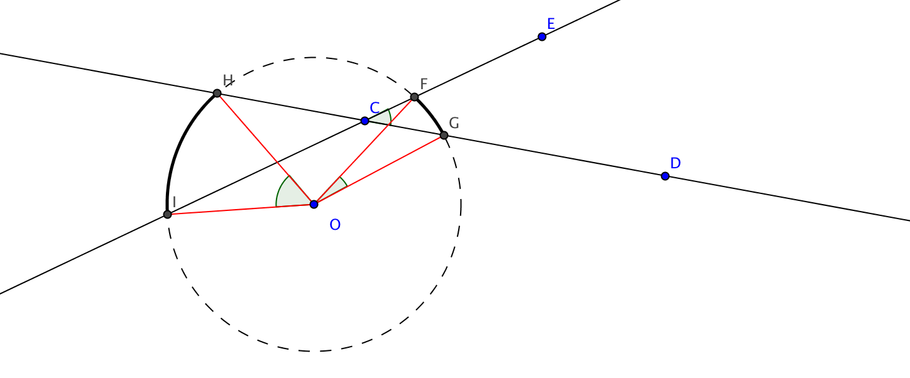

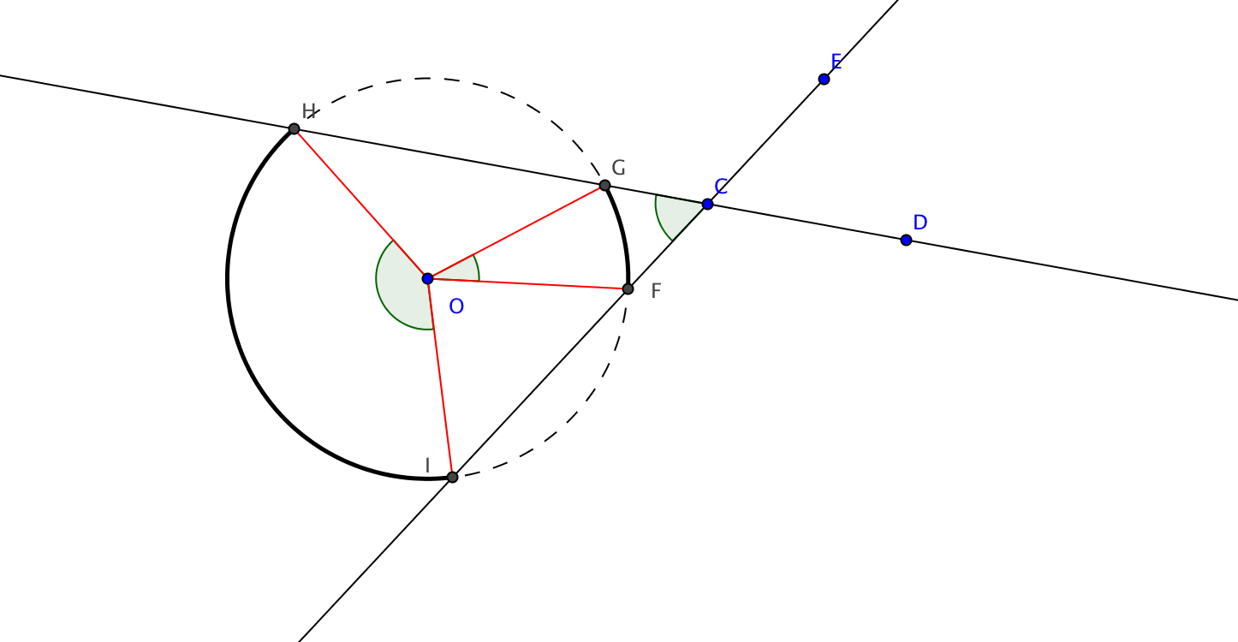
  - The angle formed by two secants from the same point in the exterior of the circle and the arcs in the interior of the angle (the solid arcs).

Now open the file ctcoregeomACT565bto continue the experiments.
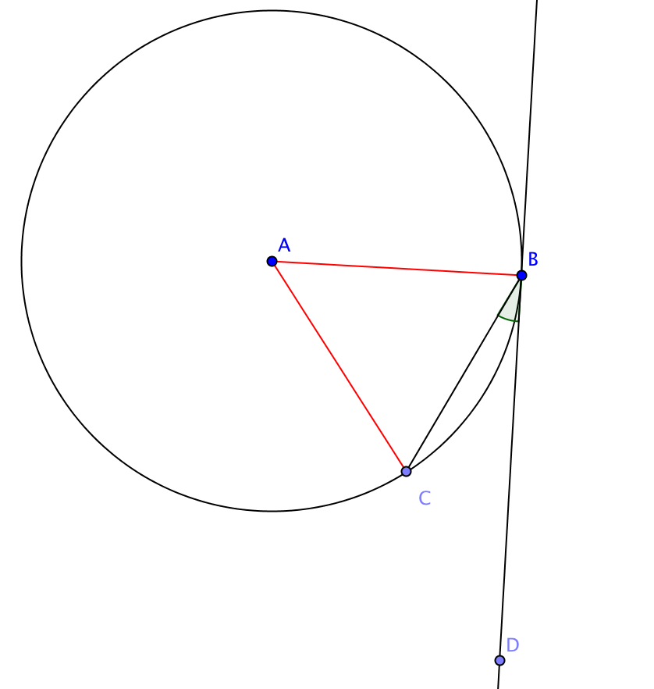
  - The angle formed by a tangent and a chord.

  - The angle formed between two tangents and the two arcs in the interior of the angle.

