**Activity 5.6.3 Cyclic Quadrilaterals**

You will look for a pattern by doing some experiments. Then you will state a conjecture and provide a proof for it.

1. If we join four points around a circle consecutively by chords we have a **cyclic quadrilateral**. Below are some examples: For each example measure the angles of the quadrilateral and see if you notice any patterns.. Mark the measurements on the diagrams.  
2. What did you notice about the measures of the opposite angles in each cyclic quadrilateral?
3. State your conclusion in the form of a conjecture:
4. Use this diagram to prove the **Cyclic Quadrilateral Theorem**: The opposite angles of a cyclic quadrilateral are supplementary.
   1. What information is given in terms of the diagram?
   2. What are we trying to prove in terms of the diagram?
   3. Work with others in your group to develop a proof.
   4. Designate one person to present your proof to the rest of the class.
   5. How is your group’s proof different from other proofs in the class?
5. 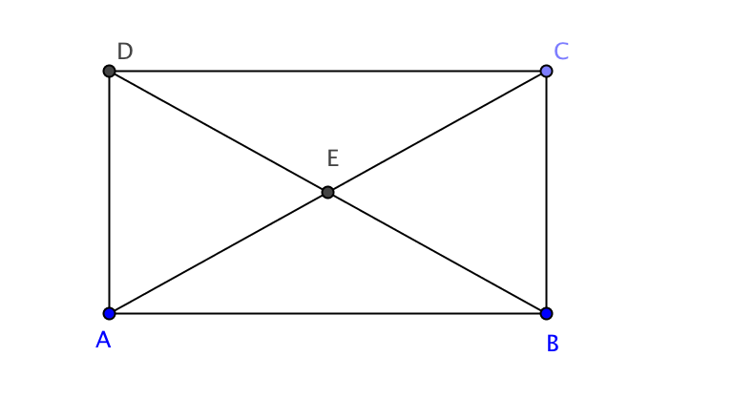Quadrilateral ABCD is shown.

* 1. Measure angles $∠DAC$, $∠ABC$, $∠BCD$, and $∠CDA$ to verify that *ABCD* is a rectangle.
  2. Draw a circle with center *E* passing through point *C.* What do you notice?
  3. Use the properties of rectangles you learned about in Unit 3 to explain why  
     *EA = EB = EC = ED*.
  4. Find m $∠CDA$ + m $∠ABC$. What theorem does this illustrate?
  5. True or false: All squares are cyclic quadrilaterals. Justify your answer.
  6. True or false: All parallelograms are cyclic quadrilaterals. Justify your answer.

1. 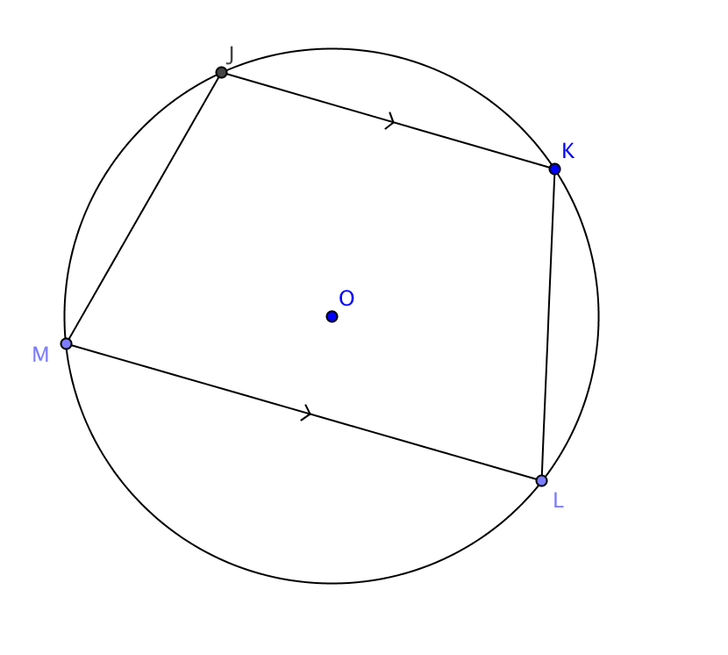Complete this proof.  
     
   Given: Points *J,* *K*, *L*, and *M* lie on circle *O*.  
    || .  
     
   Prove: m $∠M$ = m $∠L$ and m $∠J$ = m $∠K$

a. m $∠J$ + m $∠M$ = 180°. Why? _______________________________________________  
  
b. m $∠J$ + m $∠L$ = 180°. Why? _______________________________________________

c. m $∠J$ + m $∠M$ = m $∠J$ + m $∠L.$ Why? ________________________________________  
  
d. m $∠M$ = m $∠L.$ Why? ____________________________________________________  
  
e. Now use a similar argument to show that m $∠J$ = m $∠K.$ 
  
f. You have shown that quadrilateral *JKLM* has two distinct pairs of consecutive angles that are congruent. How would you classify this quadrilateral?  
  
  
g. Complete this statement: If a cyclic quadrilateral has one pair of parallel sides, then ____________________________.

h. Complete this statement: If a trapezoid is inscribed in a circle, _______________________.

7. a. The Cyclic Quadrilateral Theorem may be stated as conditional sentence: If quadrilateral is inscribed in a circle, then its opposite angles are ______________.

b. Write the converse of the Cyclic Quadrilateral Theorem.

c. Do you think the converse of the Cyclic Quadrilateral Theorem is true? Explain your reasoning.