Activity 5.6.2 Thales’ Theorem

Thales was one of the first Greek mathematicians. He lived around 600 B.C.E. The theorem we will prove is named after him although historians now believe that he learned it from the Babylonians (who lived in the country we now call Iraq); he was allegedly the first to prove it.
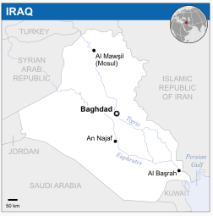
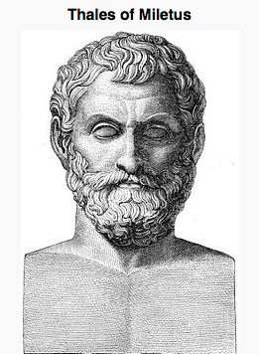

Both images are from Wikipedia

Thales’ Theorem: an angle inscribed in a semicircle is a right angle.

1. In the previous activity we showed that the measure of an angle inscribed in a circle is one half the measure on the central angle that intercepts the same arc. Our task in this activity is to prove a corollary of that theorem. A corollary of a theorem is an important theorem proved easily from another theorem. Work in a small group to prove this theorem. You will compare your proof to those of other groups in your class.

  - Begin by making a diagram that illustrates the situation. That is, you have an angle inscribed in a semi-circle.

  - In your diagram what information is given?

  - In your diagram what are you trying to prove?

  - Construct your argument here:

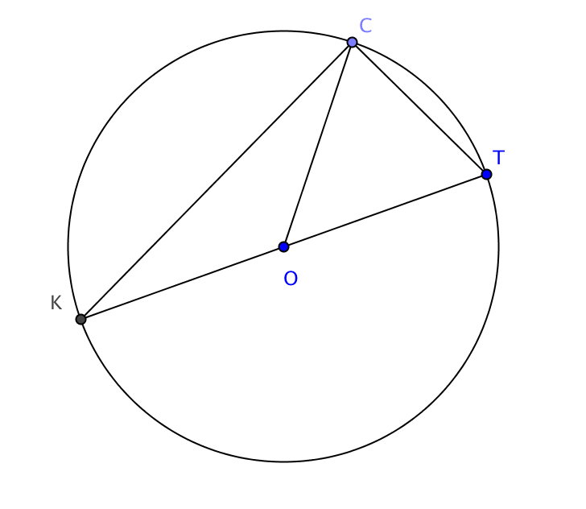

- In the figure at the right $\overline{KT}$ is a diameter of circle O.
CT = 5 cm and CK = 12 cm. Find CO.

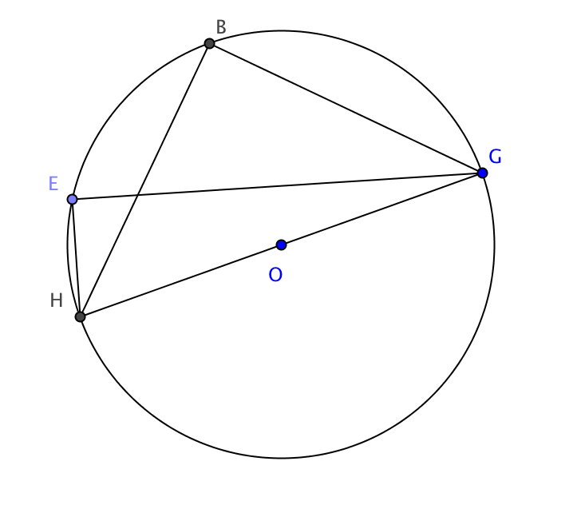
- In the figure at the right $\overline{HG}$ is a diameter of circle O.
EH = 1 ft EG = 7 ft and BG = 5 ft. Find BH.

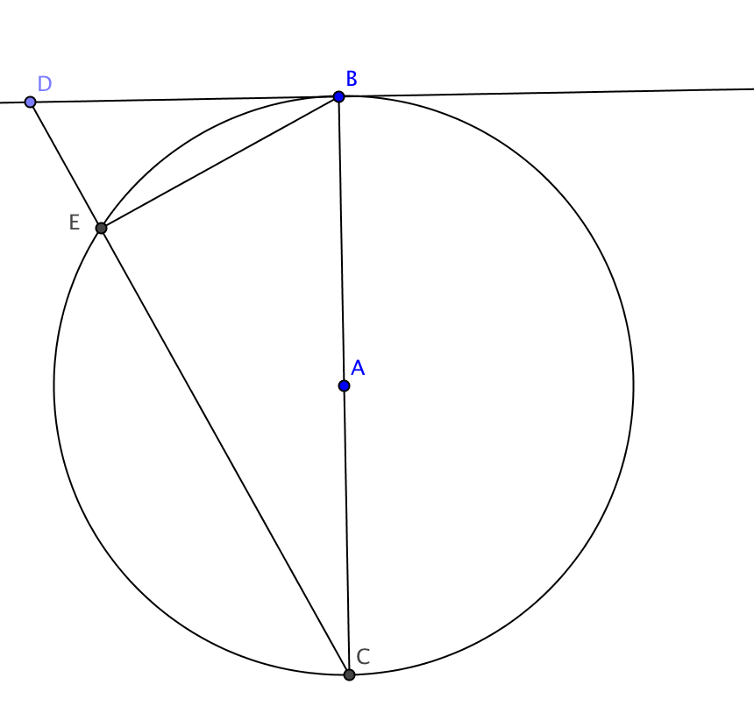
- Given: $\overline{BC}$ is a diameter of a circle with center A and $\overset{⃡}{DB}$ is tangent to the circle. Secant $\overset{⃡}{CD}$ intersects the circle at E.
Prove m $∠DBE$ = m $∠DCB$

5. Thales’ Theorem may be stated as conditional sentence: If an angle is inscribed in a semicircle, then it is a right angle.
a. Write the converse of Thales’ Theorem.

b. Prove the converse of Thales’ Theorem.

