**Activity 5.5.2 Inscribing a Circle in a Triangle**

In this activity we use the Angle Bisector Theorem to find the center of a circle inscribed in a triangle. Having located the center, we construct a perpendicular from that center to a side of the triangle to find the radius.

1. Begin with any triangle 
   1. Use your compass and straight edge to bisect ∠*A* and ∠*B*. Label the intersections of the angle bisectors with the opposite sides *D* and *E* respectively. Also label the intersection of ray $\vec{AE}$ and ray $\vec{BD}$ with as point *F*.
   2. Since *F* is on the bisector of ∠*A* it is equidistant to which two sides of the triangle? ____________________ and ___________________.
   3. Since *F* is on the bisector of ∠*B* it is equidistant to which two sides of the triangle? _____________________and __________________.
   4. Since we measure the distance from a point to a line along a line perpendicular to the line to which we are measuring, we should construct perpendiculars to each of the sides of the triangle from point *F*. Add those to your construction above.
   5. Label the intersections of these perpendiculars *G* for *F* to segment $\overline{AC}$, *H* for *F* to segment $\overline{BC}$ and *I* for *F* to segment $\overline{AB}$.
   6. What do you know about *DF* and *FI*?
   7. What do you know about *FI* and *FH*?
   8. What does this tell us about *DF*, *FI* and *FH*?
2. We should now be able to use $\overline{FG}$, $\overline{FI}$ or $\overline{FH}$ to construct a circle with center at *F*. This is called the circle **inscribed** in the triangle.
   1. How do you know that this circle is tangent to each side of the triangle?
   2. Why did we only have to construct two angle bisectors to find the center of the inscribed circle?
   3. In Investigation 2 we saw that the center of the circumscribed circle sometimes lies outside the triangle. Do you think the center of the inscribed circle will ever lie outside the triangle? Explain your reasoning.
3. Draw $\overset{⃑}{CF}$. Explain why $\vec{CF}$ must bisect ∠*C.*
4. 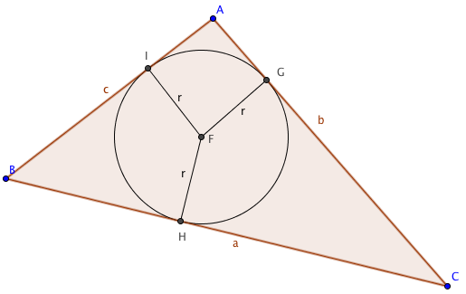How are the inscribed circle and circumscribed circle of a triangle alike? How are they different?
5. 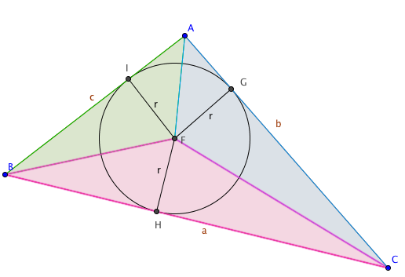Using the radius of the inscribed circle to find area:   
   Let *r* be the radius of the inscribed circle as shown.  
   Let *a*, *b*, and *c* be the lengths of the sides. Draw segments joining the center of the inscribed circle with the vertices to form three triangles, ∆*BFC*, ∆*CFA*, and ∆*AFB*.  
     
   a. In ∆*BFC*, name the altitude to side $\overline{BC}$. _________  
     
   b. Find an expression for the area of ∆*BFC*: _________  
     
   c. Find an expression for the area of ∆*CFA*: _________  
     
   d. Find an expression for the area of ∆*AFB*: _________  
     
   e. Explain how to find the area of any triangle if you know the lengths of three sides (*a*, *b*, and *c*) and the radius of the inscribed circle.