Activity 5.4.4 Applications of Tangents

Tangents to circles have useful applications, especially in the use of pulleys.

- Think of a shaft of a motor designed to turn something at the other end of an object. In the diagram below there are two pulleys. One has a center at A attached to a motor and one centered at G attached to a wheel. A belt wraps around the two pulleys so the motor can drive the wheel and is shown as dashed segments and arcs. The radii of both circles is 2 cm. The centers of the circle are 6 cm apart. Our task is to find the length of the belt.
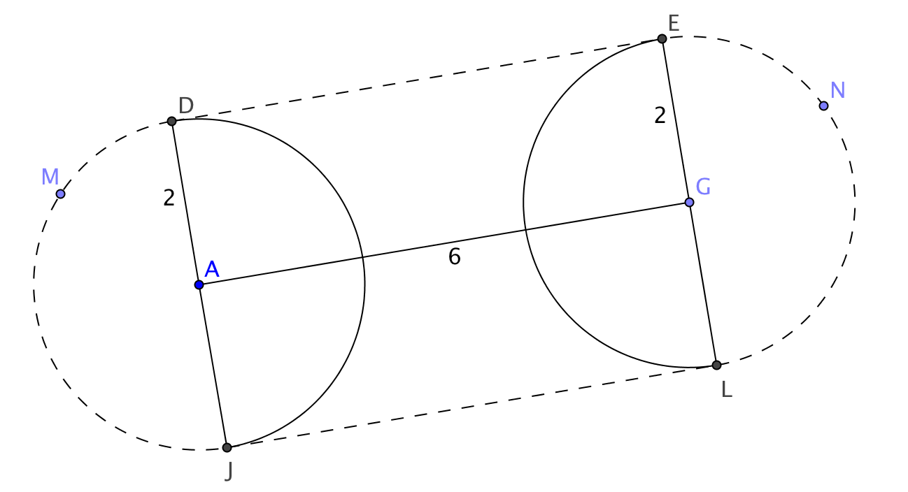
  - What kind of arcs are arc DMJ and arc LNE?____________________________

  - What is the circumference of circle A?_____________________

  - Find the lengths of arc DMJ___________________and arc LNE_____________

  - What kind of figure is DEGA?_________________________________________

  - Find the length of $\overline{DE}$___________________________

  - What is the length of the belt?___________________________

- It is common to use a large wheel connected to a small wheel by a belt to benefit from the mechanical advantage of turning a large wheel slowly to make a small wheel turn quickly. We can model this with two circles and lines tangent to both of them called common external tangents. Segments $\overline{EH}$ and $\overline{FG}$ are these tangent segments, the rest of the belt consists of the arcs of each circle joining the points of tangency. So, in the diagram below the belt is all of the dashed arcs and segments. In the diagram below we are given that AC is 13 cm, HC is 7 cm and AE is 2 cm. Again we would like to find the length of the belt.

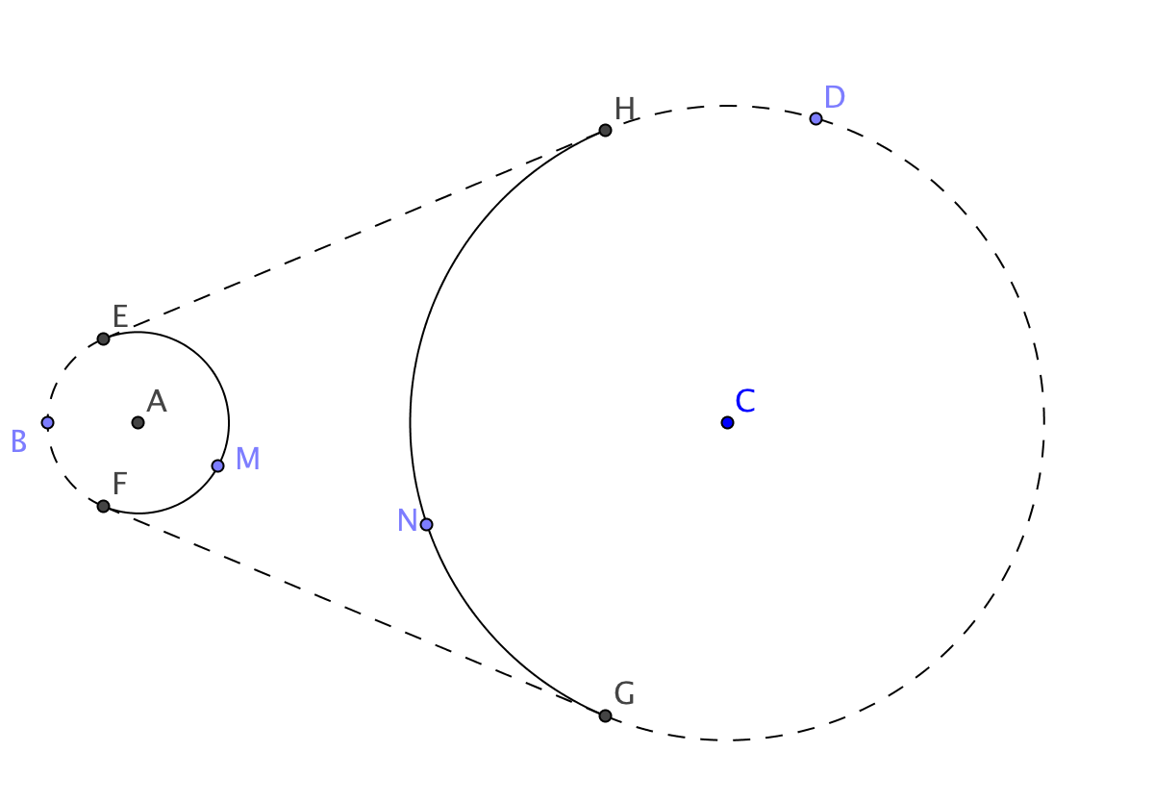

  - Add segments $\overline{HC}$ and $\overline{EA}$ to the drawing above. What kind of polygon is EHCA?___________________________________
  - What is the measure of ∠EHC?________________________________
  - What is the measure of ∠HEA?________________________________
  - Construct a perpendicular to $\overline{HC}$ through point A. Call the intersection point J.
  - What kind of polygon is EHJA?_______________________________
  - What kind of triangle is ∆AJC?_____________________________
  - What is the length of $\overline{JC}$? _____________
  - How could we find the length of $\overline{JA}$?____________________________
  - How can we find the central angle for the arcs HDG and EAF? (Hint, you may need to use trigonometry!)
  - What are the lengths of arcs EBF____________ and HDG_______________?
  - What are the lengths of the tangent segments $\overline{EH}$_______________and $\overline{FG}$_________________?
  - Finally, what is the length of the belt?_____________________________
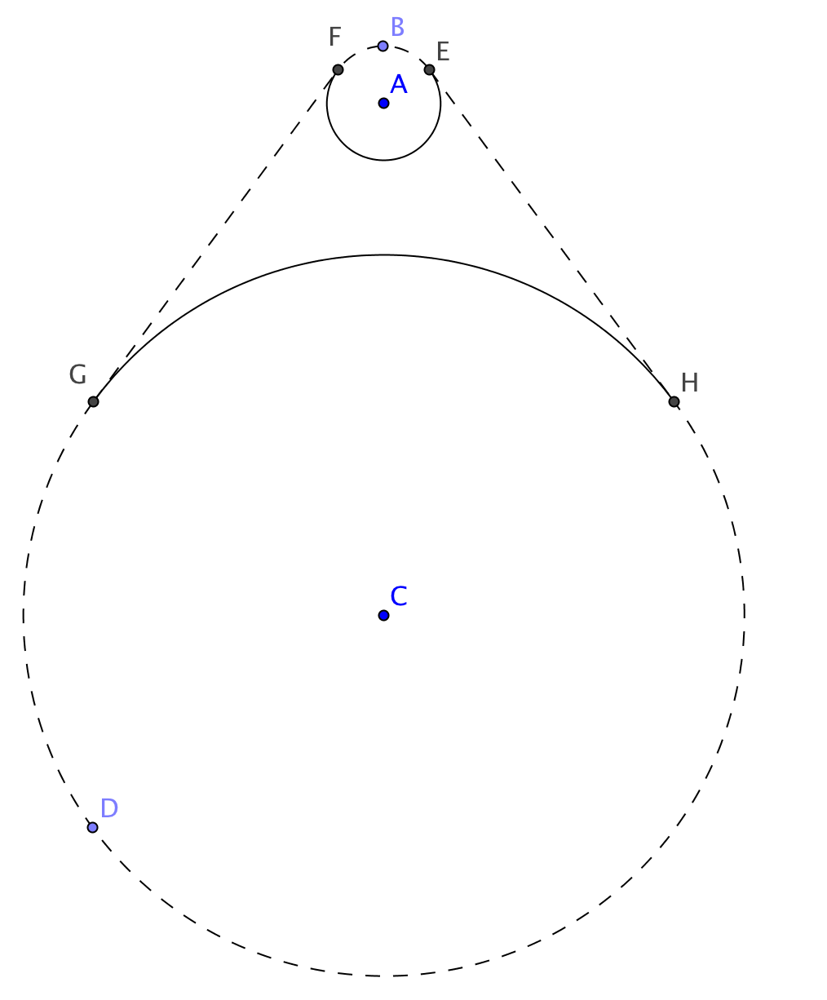
- A spinning wheel uses the mechanical advantage of attaching a belt to a large wheel that can be rotated to another smaller wheel called a flyer whorl turn much faster to add twist to fleece to make yarn. On the wheel shown the radius of the larger wheel is 9½ inches and the radius of the flyer whorl is 1½ inches. If the distance between the centers of the wheels is 13½ inches how long does the belt need to be? To the left is a picture of the spinning wheel and to the right is a picture that shows only the key parts of the construction.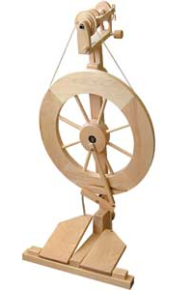

  - Label the picture. Add auxiliary segments as needed to find the parts of the belt, which includes the two tangent segments and two arcs. Then find the length of the belt.

  - When the wheel at C goes around once, how many times does the flyer whorl turn?

